IELTS Listening Practice - Test 83

Part 1: Questions 1-5
Complete the form below. Write NO MORE THAN TWO WORDS OR A NUMBER.
SARAH’S HEALTH AND FITNESS CLUB MEMBERSHIP FORM
First name: Harry
Last name: (1) _______
Questions 6-10
Answer the questions below. Write NO MORE THAN TWO WORDS.
Lifestyle questionnaire
What exercises do you do regularly? (6) _______
Do you have any injuries? Has a (7) _______
What is your goal or target? A better (8) _______
What is your occupation? A (9) _______
How did you hear about the club? (10) _______
Part 2: Questions 11-14
Choose the correct letter A, B or C.
11. The next event at the hotel will be
[ ] A. trade fair
[ ] B. wedding
[ ] C. party
12. The number of guests will be
[ ] A. less than 50
[ ] B. from 50 to 100
[ ] C. more than 100
13. Guests will start arriving at
[ ] A. 7.15
[ ] B. 7.30
[ ] C. 7.45
14. The entertainment will be a
[ ] A. live band
[ ] B. comedian
[ ] C. magician
Questions 15-17
Who will be responsible for the following jobs as the guests arrive?
Choose THREE answers from the box and write correct letter A-E.
A Susan
B Ahmed
C Gary
D Olav
E Monica
15. offer drinks to guests _______
16. take guests’ coats and hats _______
17. show guests where to go _______
Questions 18-20
Complete the sentences below. Write NO MORE THAN THREE WORDS for each answer.
General instructions
In order to get the guests to move to the restaurant the hotel manager will (18) _______
Seating plans will be placed on each table and also in the (19) _______
There will be a total of three (20) _______
Part 3: Questions 21-25
Complete the flow chart below. Write NO MORE THAN TWO WORDS for each answer.
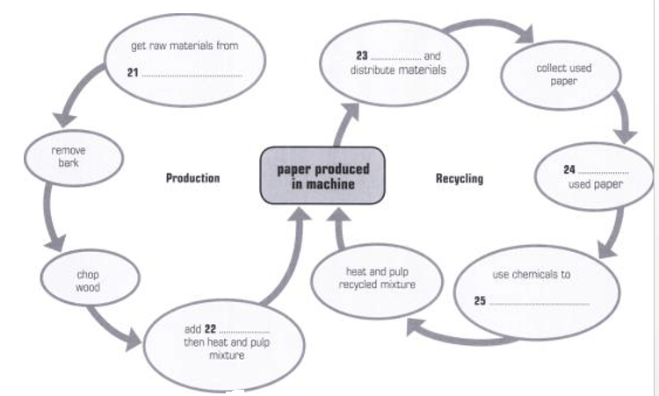
(21) _______ (22) _______
(23) _______ (24) _______
(25) _______
Questions 26-30
Answer the questions below. Write NO MORE THAN TWO WORDS for each answer.
26. What part of the assignment is Alan going to start working on? _______
27. Where will Melanie get more information on used paper collection? _______
28. What will they add to the assignment to make it more interesting? _______
29. What do they agree to complete by the end of the month? _______
30. Who will they ask to review their work? _______
Part 4: Questions 31-38
Complete the notes below. Write NO MORE THAN ONE WORD OR A NUMBER.
HAIR
FACTS ABOUT HAIR
• Main purposes – warmth and (31) _______
• Main component keratin – makes fingernails (32) _______
• Full head of hair can support a large weight – equal to two (33) _______
• Average number of strands of hair – (34) _______ for an adult
• Large amount of money spent on (35) _______ for hair in the UK
STRUCTURE OF HAIR
The three main parts:
a. Bulb – like a (36) _______ over end of hair follicle
b. Root – contains glands that supply (37) _______ to hair strand
c. Shaft – not (38) _______
Questions 39 and 40
Complete the summary below. Write ONE WORD ONLY for each answer.
Health and Hair
Changes in diet will take longer to affect your hair than your (39) _______
Vitamins C, D and E are all important for healthy hair and (40) _______ are one of the best sources of Vitamin C.

ANSWER KEY
1. Symonds
2. 1996
3. full time
4. swimming
5. monthly
6. jogging
7. bad ankle
8. fitness level
9. charity worker
10. radio
11. C
12. B
13. A
14. B
15. C
16. E
17. A
18. ring a bell
19. lounge
20. speeches
21. pine forests
22. water
23. print
24. sort
25. remove ink
26. introduction
27. council
28. data
29. first draft
30. tutor
31. protection
32. flexible
33. elephants
34. 100,000
35. products
36. cap
37. oil
38. active
39. skin
40. blue-berries

