IELTS Listening Practice - Test 84

Part 1: Questions 1-6
Complete the table below. Write NO MORE THAN ONE WORD OR A NUMBER.
Community Centre Evening Classes
Class | Where | When | What to bring | Cost
Painting with watercolors | in the hall | at (1)…………………pm on Tuesdays | water jar and set of (2)………….. | £ 45 – 4 classes
Maori language | the small room at (3)…………….of the building | starts in (4)……………. | small decoder | £ 40 – 5 classes
Digital photography | room 9 | 6 pm Wednesday evenings | the (5)………..for the camera | (6) £…….. – 8 classes
(1) _______
Questions 7-10
Complete the sentences below. Write ONE WORD ONLY for each answer.
7. The watercolours class suits people who are _______
8. To find out about the Maori language class, contact Jason _______
9. For the photography class, check the _______ for the camera.
10. There is a trip to a local _______ in the final week of the photography class.
Part 2: Questions 11 and 12
Choose TWO letters A-E.
Which TWO tasks will the volunteers in group A be responsible for?
[ ] A. widening pathways
[ ] B. planting trees
[ ] C. picking up rubbish
[ ] D. putting up signs
[ ] E. building fences
Questions 13 and 14
Choose TWO letters A-E.
Which TWO items should volunteers in group A bring with them?
[ ] A. food and water
[ ] B. boots
[ ] C. gloves
[ ] D. raincoats
[ ] E. their own tools
Questions 15-20
Label the plan below. Write the correct letter A-I next of questions 15-20.
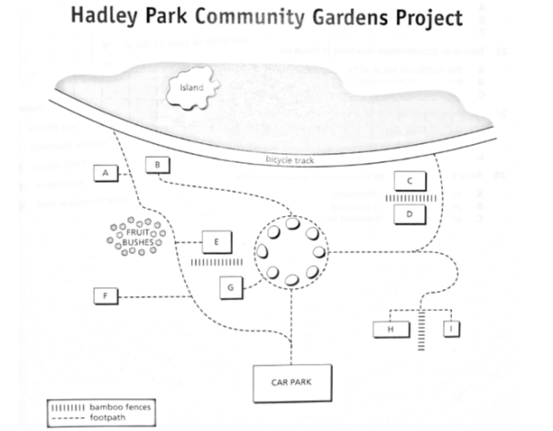
15. Vegetable beds _______
16. Bee hives _______
17. Seating _______
18. adventure playground _______
19. Sand area _______
20. Pond _______
Part 3: Questions 21-25
Choose the correct letter; A, B or C
Food Waste
21. What point does Robert make about the 2013 study in Britain?
[ ] A. It focused more on packaging than wasted food.
[ ] B. It proved that households produced more waste than restaurants.
[ ] C. It included liquid waste as well as solid waste.
22. The speakers agree that food waste reports should emphasise the connection between carbon dioxide emissions and
[ ] A. food production.
[ ] B. transport of food to landfill sites.
[ ] C. distribution of food products.
23. Television programmes now tend to focus on
[ ] A. the nutritional value of food products.
[ ] B. the origin of food products.
[ ] C. the chemicals found in food products.
24. For Anna, the most significant point about food waste is
[ ] A. the moral aspect.
[ ] B. the environmental impact.
[ ] C. the economic effect.
25. Anna and Robert decide to begin their presentation by
[ ] A. handing out a questionnaire.
[ ] B. providing statistical evidence.
[ ] C. showing images of wasted food.
Questions 26-30
What advantage do the speakers identify for each of the following projects?
Choose FIVE answers from the box and write the correct letter, A-G, next to Questions 26-30.
Advantages
A. it should save time
B. it will create new jobs
C. it will benefit local communities
D. it will make money
E. it will encourage personal responsibility
F. it will be easy to advertise
G. it will involve very little cost
Projects
26. edible patch _______
27. ripeness centre _______
28. waste tracking technology _______
29. smartphone application _______
30. food waste composting _______
Part 4: Questions 31-40
Complete the notes below. Write ONE WORD for each answer.
Kite making by the Maori people of New Zealand
Making and appearance of kites
• The priests who made the kites had rules for size and scale
• (31) _______ was not allowed during a kite’s preparation
Kites:
• Often represented a god, a bird or a (32) _______
• Had frames that were decorated with grasses and (33) _______
• Had a line of noisy (34) _______ attached to them.
• Could be triangular, rectangular or (35) _______ shaped.
• Had patterns made from clay mixed with (36) _______ oil.
• Sometimes had human head masks with (37) _______ and a tattoo.
Purpose and function of kites:
• A way of sending (38) _______ to the gods
• A way of telling other villages that a (39) _______ was necessary
• A means of (40) _______ if enemies were coming.

ANSWER KEY
1. 7.30
2. pencils
3. top
4. August
5. instructions
6. 55
7. beginners
8. Kahui
9. battery
10. show
11. B
12. E
13. B
14. C
15. G
16. I
17. B
18. E
19. C
20. A
21. C
22. A
23. B
24. C
25. A
26. G
27. A
28. D
29. C
30. E
31. food
32. hero
33. feathers
34. shells
35. diamond
36. shark
37. teeth
38. messages
39. meeting
40. escape

