IELTS Listening Practice - Test 85

Part 1: Questions 1-10
Complete the form below. Write ONE WORD OR A NUMBER for each answer.
CITY TRANSPORT LOST PROPERTY ENQUIRY
Main item lost: suitcase
Description of main item: black with thin (1) _______ stripes
Other items: a set of (2) _______
Personal details
Name: Lisa (8) _______
Address: 15A (9) _______ Rd. Highbury
Phone number: (10) _______
Part 2: Questions 11-15
Label the map below. Write correct letter A-H next to questions 11-15.
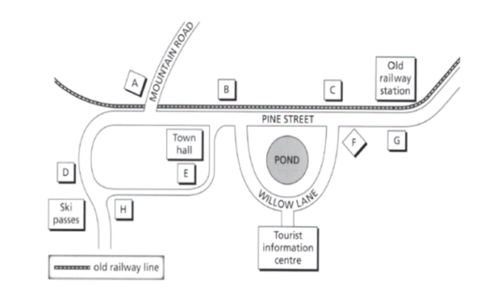
11. supermarket _______
12. climbing supplies store _______
13. museum _______
14. bike hire _______
15. café _______
Questions 16-20
What comment does the speaker make about each of the following tracks?
Write correct letter A, B or C next to questions 16-20.
Track
16. North point _______
17. Silver river _______
18. Valley crossing _______
19. Stonebridge _______
20. Henderson ridge _______
A It is possible to get lost here.
B It only offers basic accommodation.
C It requires physical strength.
Part 3: Questions 21-25
Choose the correct letter A, B or C.
21. Why has James chosen to do a case study on the company Furniture Rossi?
[ ] A It has enjoyed global success.
[ ] B It is still in a developmental phase.
[ ] C It is an example of a foreign company being rebranded for Australia.
22. According to James, why did Luca Rossi start a furniture company?
[ ] A Furniture-making was already a family occupation.
[ ] B Rossi saw a need for hand-crafted furniture.
[ ] C The work Rossi had done previously was unrewarding.
23. What gave Furniture Rossi a competitive advantage over other furniture companies?
[ ] A its staff
[ ] B its lower prices
[ ] C its locally sourced products
24. What does the tutor recommend James does when writing the second draft of his case study?
[ ] A provide more detailed references
[ ] B check for written accuracy
[ ] C add his own views
25. What do the tutor and James agree was wrong with James’ last presentation?
[ ] A It was too short.
[ ] B It focused too much on statistics.
[ ] C There was not enough interaction with the audience.
Questions 26-30
Complete the flow chart below. Choose FIVE answers from the list below and write the correct letter A-G next to questions 26-30.
A website
B locations
C designs
D TV advertising campaigns
E quality
F values
G software programs
History of Furniture Rossi
The product (26)………………..led to a wider customer base
Greater customer demand meant other (27)…………….were needed
Better (28)…………………..increased overall profitability
Changes to the (29)…………………..were brought on by customer complaints
Furniture Rossi wants to make people more aware of its (30)…………………
(26) _______ (27) _______
(28) _______ (29) _______
(30) _______
Part 4: Questions 31-36
Complete the notes below. Write ONE WORD for each answer.
ROCK ART
Why rock art is important to researchers
It provides evidence about
• Evolution
• (31) _______
Global similarities in rock art
• Humans often had large (32) _______
• Animals were common but a (33) _______ was always drawn from the side or from above.
• Unlikely that contact through (34) _______ resulted in similar artistic styles
Why our ancestors produced rock art
Research suggests rock art was produced
• Firstly for reasons of (35) _______
• Later for social, spiritual and (36) _______ reasons.
Questions 37-40
Answer the questions below. Write ONE WORD ONLY for each answer.
What TWO images drawn by Aboriginal people show their contact with Europeans?
• (37) _______
• (38) _______
Which human activities does the lecturer say are the main threats to Aboriginal rock art?
• (39) _______
• Vandalism
• (40) _______
_______ _______ _______ Show Answers

ANSWER KEY
1. white
2. office
3. camera
4. umbrella
5. 13 May
6. airport
7. taxi
8. docherty
9. river
10. 07979605437
11. G
12. D
13. A
14. E
15. C
16. B
17. A
18. C
19. C
20. A
21. B
22. A
23. A
24. C
25. B
26. E
27. B
28. G
29. A
30. F
31. migration
32. eyes
33. lizard
34. trade
35. survival
36. political
37. ships
38. horses
39. industry
40. tourism

