IELTS Listening Practice - Test 87

Part 1: Questions 1-6
Complete the table below. Write NO MORE THAN ONE WORD OR A NUMBER for each answer.
Hostel Accommodation in Darwin
Name | Price per person | Comments and reviews
Top end backpackers | $ 19 | – parking available  – staff are (1)…………..  – nice pool  – air conditioning is too (2)…………………
Gum tree lodge | (3)………………… | – good quiet location  – pool and gardens  (4)……………..in the dormitories
Kangaroo lodge | $ 22 | – downtown location  – reception at the lodge is always open  – no lockers in the rooms  – the (5)………………….are very clean  – seems to be a (6)……………every night
(1) _______
Questions 7-10
Complete the notes below. Write ONE WORD ONLY for each answer.
Kangaroo lodge
Address: on (7) _______ Lane
General information about hostel accommodation
• Sheets are provided
• Can hire a (8) _______
• (9) _______ is included
• A shared (10) _______ is available
Part 2: Questions 11-16
Choose the correct letter A, B, C or D.
Anglia Sculpture Park
11. The land where the Sculpture Park is located was previously
[ ] A completely covered by forest.
[ ] B the site of a private house.
[ ] C occupied by a factory.
12. What is unusual about the Anglia Sculpture Park?
[ ] A Artists have made sculptures especially for it.
[ ] B Some of its sculptures were donated by the artists.
[ ] C It only shows contemporary sculptures.
13. What is the theme of Joe Tremain’s ‘burnt’ sculptures?
[ ] A the contrast between nature and urban life
[ ] B the effect of man on the environment
[ ] C the violence of nature
14. The path by the Lower Lake
[ ] A is rather wet in some places.
[ ] B has recently been repaired.
[ ] C is difficult to walk on.
15. What does the speaker say about the Visitor Centre?
[ ] A It is being enlarged at present.
[ ] B It has received an international award.
[ ] C It was designed by a Canadian architect.
16. Today, visitors can buy snacks and sandwiches
[ ] A at the kiosk.
[ ] B in the Terrace Room.
[ ] C at the Lower Lake Cafe.
Questions 17-20
Label the map below. Write the correct letter A-F next to questions 17-20.
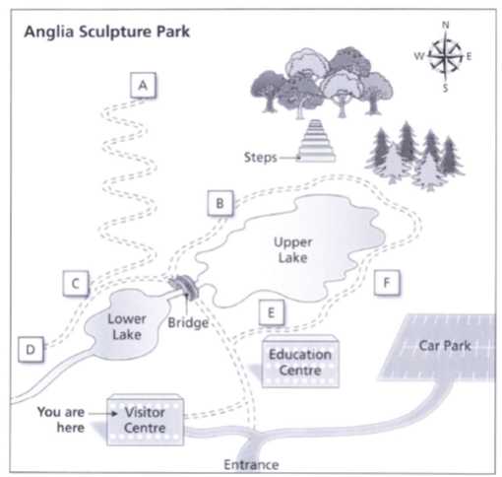
17. Joe Tremain sculptures _______
18. Giorgio catalucci bird sculptures _______
19. Garden gallery _______
20. Long house _______
Part 3: Questions 21-26
Choose the correct letter A, B or C.
Marketing report
21. Why did Leo choose instant coffee as the topic for his marketing report?
[ ] A He found plenty of material on the topic.
[ ] B He had some practical experience in the area.
[ ] C He had an idea of a brand he wanted to target.
22. Leo discovered that in Australia, recent technological developments
[ ] A are producing less healthy types of instant coffee.
[ ] B are reducing the demand for instant coffee.
[ ] C are improving the quality of instant coffee.
23. What do the speakers agree about Leo’s table of coffee products?
[ ] A It needs more explanation in the text.
[ ] B It is factually inaccurate in some places.
[ ] C It would be best to put this in the appendix.
24. What do they decide about the description of Shaffers coffee as a market follower?
[ ] A Leo needs to define his terms.
[ ] B Leo needs to provide more evidence.
[ ] C Leo needs to put it in a different section.
25. What does Anna say about originality in someone’s first marketing report?
[ ] A Clear analysis of data can be considered original.
[ ] B Graphs and diagrams should be original, not copied.
[ ] C Reports should contain some original data collected by the student.
26. What difference between his school assignments and this report has surprised Leo?
[ ] A not knowing the criteria for getting a good mark
[ ] B being required to produce work without assistance
[ ] C having to do a great deal of research
Questions 27-30
Complete the notes below. Write ONE WORD ONLY for each answer.
Notes on specific sections of marketing report
Executive summary
• Give a brief overview including the (27) _______
Problems
• Link each problem to a (28) _______ which explains it
Implementation
• Practical solutions to problems
• Include details such as participants, (29) _______ and sequence
• Section is often poorly done because of lack of (30) _______
Conclusion
• Don’t use new material here
Part 4: Questions 31-40
Complete the notes below. Write ONE WORD ONLY for each answer.
History of fireworks in Europe
13th-16th centuries
• Fireworks were introduced from China
• Their use was mainly to do with:
o War
o (31) _______ (in plays and festivals)
17th century
• Various features of (32) _______ were shown in fireworks displays
• Scientists were interested in using ideas from fireworks displays:
o To make human (33) _______ possible
o To show the formation of (34) _______
• London:
o Scientists were distrustful at first
o Later they investigated (35) _______ uses of fireworks
• St Petersburg:
o Fireworks were seen as a work of (36) _______ for people
• Paris:
o Displays emphasized the power of the (37) _______
o Scientists aimed to provide (38) _______
18th century
• Italian fireworks specialists became influential
• Servandoni’s fireworks display followed the same pattern as an (39) _______
• The appeal of fireworks extended to the middle classes
• Some displays demonstrated new scientific discoveries such as (40) _______

ANSWER KEY
1. unfriendly
2. noisy
3. 23.50
4. insects
5. bathrooms
6. party
7. Shadforth
8. towel
9. breakfast
10. kitchen
11. B
12. A
13. C
14. B
15. A
16. A
17. E
18. C
19. F
20. A
21. A
22. B
23. A
24. B
25. A
26. A
27. background
28. theory
29. costs
30. time
31. religions
32. nature
33. flight
34. stars
35. practical
36. education
37. king
38. entertainment
39. opera
40. electricity

