IELTS Listening Practice - Test 88

Part 1: Questions 1-10
Complete the notes below. Write NO MORE THAN TWO WORDS OR A NUMBER for each answer.
Hilary Lodge Retirement House
Manager’s Name – Cathy
Activities programme involving volunteers
Monday evenings: computer training
• Training needed in how to produce (1) _______
Tuesday afternoons: singing
• The home has a (2) _______
Interview
• Go in on (5) _______ any time
• Interview with assistant called (6) _______
• Address of home: 73 (7) _______ road
Open house days
• Agreed to help on (8) _______
• Will show visitors where to (9) _______
• Possibility of talking to a (10) _______ reporter
Part 2: Questions 11-15
Label the plan below. Write the correct letters A-H next to questions 11-15.
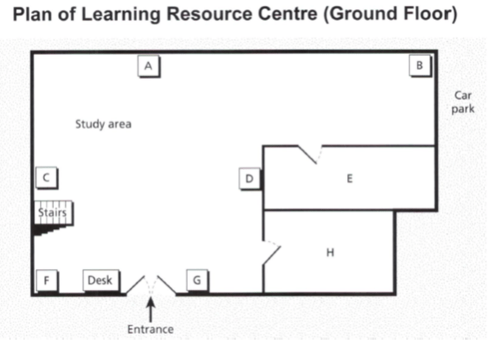
11. Newspapers _______
12. Computers _______
13. Photocopier _______
14. Café _______
15. Sports books _______
Questions 16-20
Complete the table below. Write ONE WORD ONLY for each answer.
New staff responsibilities
Name | New responsibility
Jenny Reed | buying for the (16)……………..centre
Phil Penshurst | help with writing (17)……………….for courses
Tom Salisbury | information on topics related to the (18)………………
Saeed Aktar | finding a (19)……………………..
Shilpa Desai | help with (20)………………….
(16) _______ (17) _______
(18) _______ (19) _______
(20) _______
Part 3: Questions 21-27
What helped Stewart with each of the following stages in making his training film for museum employees?
Choose SEVEN answers from options below.
What helped Stewart
A advice from friends
B information on a website
C being allowed extra time
D meeting a professional film maker
E good weather conditions
F getting a better computer
G support of a manager
H help from a family member
I work on a previous assignment
Stages in making the training film for museum employees
21. finding a location _______
22. Deciding on equipment _______
23. writing the script _______
24. Casting _______
25. filming _______
26. Editing _______
27. designing the DVD cover _______
Questions 28-30
Complete the notes below. Write ONE WORD ONLY for each answer.
Stewart’s work placement: benefits to the Central Museum Association
• His understanding of the Association’s (28) _______
• The reduction in expense
• Increased co-operation between (29) _______
• Continuous (30) _______ which led to a better product
• Ideas for distribution of the film
Part 4: Questions 31-40
Complete the notes below. Write ONE WORD ONLY for each answer.
New Caledonian crows and the use of tools
Examples of animals using tools
• Some chimpanzees use stones to break nuts
• Betty (new Caledonian crow) made a (31) _______ out of wire to move a bucket of food
New Zealand and Oxford experiment
• Three stages: crows needed to move a (32) _______ in order to reach a short stick
Oxford research
• Crows used sticks to investigate whether there was any (33) _______ from an object
• Research was inspired by seeing crows using tools on a piece of cloth to investigate a spider design
• Barney used a stick to investigate a snake made of (34) _______
• Pierre used a stick to investigate a (35) _______
• Corbeau used a stick to investigate a metal toad
• The crows only used sticks for the first contact
Conclusions of above research
• Ability to plan provides interesting evidence of the birds’ cognition
• Unclear whether this is evidence of the birds’ (36) _______
Exeter and Oxford research in New Caledonia
• Scientist have attached very small cameras to birds’ (37) _______
• Food in the form of beetle larvae provides plenty of (38) _______ for the birds
• Larvae’s specific (39) _______ composition can be identified in birds that feed on them
• Scientists will analyse what the birds include in their (40) _______
_______ _______ _______ Show Answers

ANSWER KEY
1. douments
2. keyboard
3. flowers
4. tools
5. saturday
6. Mairead
7. bridge
8. May 14
9. park
10. newspaper
11. C
12. B
13. A
14. H
15. G
16. films
17. reports
18. region
19. job
20. housing
21. E
22. I
23. C
24. G
25. B
26. D
27. A
28. aims/ goals
29. staff
30. feedback
31. hook
32. string
33. danger
34. rubber
35. light
36. intelligence
37. tails
38. energy
39. chemical
40. diet

