IELTS Listening Practice - Test 9

Part 1:Questions 1 and 2
Complete the notes below. Write NO MORE THAN THREE WORDS OR A NUMBER.
Type of job required: Part-time
Student is studying (1) _______
Student is in the (2) _______
Questions 3-5
Complete the table below. Write NO MORE THAN TWO WORDS.
Position available | Where | Problem
Receptionist | In the (3)…………….. | Evening lectures
(4)…………………….. | In the child care centre | Too early
Clerical assistant | In the (5)………………… | Evening lectures
(3) _______
(4) _______
(5) _______
Questions 6-10
Complete the form below. Write NO MORE THAN THREE WORDS OR A NUMBER.
Student Details
Name: | Anita Newman
Address: | (6)…………………………..
 | Room no. (7)……………….
Other skills: | Speaks some Japanese
Position available: | (8)……………….at the English language centre
Duties: | Respond to enquiries and (9)……………
Time of interview: | Friday at (10)……………….am
(6) _______ (7) _______
(8) _______ (9) _______
(10) _______
Part 2: Questions 11-16
Choose the correct letter A, B or C.
SPONSORED WALKING HOLIDAY
11. On the holiday, you will be walking for
[ ] A 6 days
[ ] B 8 days
[ ] C 10 days
12. What proportion of the sponsorship money goes to charity?
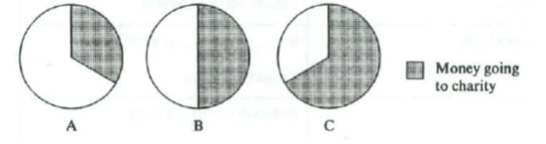
[ ] A
[ ] B
[ ] C
13. Each walker’s sponsorship money goes to one
[ ] A student
[ ] B teacher
[ ] C school
14. When you start the trek you must be
[ ] A interested in getting fit
[ ] B already quite fit
[ ] C already very fit
15. As you walk you will carry
[ ] A all of your belongings
[ ] B some of your belongings
[ ] C none of your belongings
16. The Semira Region has a long tradition of
[ ] A making carpets
[ ] B weaving blankets
[ ] C carving wood
Questions 17-20
Complete the form below. Write ONE WORD ONLY.
ITINERARY
Day 1 | Arrive in Kishba
Day 2 | Rest day
Day 3 | Spend all day in a (17)………………..
Day 4 | Visit a school
Day 5 | Rest day
Day 6 | See a (18)……………………with old carvings
Day 7 | Rest day
Day 8 | Swim in a (19)……………………..
Day 9 | Visit a (20)………………..
Day 10 | Depart from Kishba
(17) _______ (18) _______
(19) _______ (20) _______
Part 3: Questions 21 and 22
Complete the notes below. Write NO MORE THAN TWO WORDS OR A NUMBER.
OCEAN RESEARCH
The Robotic Float Project
• Float is shaped like a (21) _______
• Scientists from (22) _______ have worked on the projects so far
Questions 23-25
Complete the diagram below. Write ONE WORD OR A NUMBER.
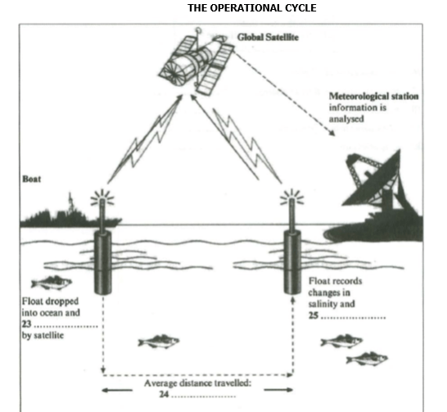
(23) _______
(24) _______
(25) _______
Questions 26-30
In what time period can data from the float projects help with the following things?
Write the correct letter A, B or C next to questions 26-30.
26. understanding of El Nino _______
27. understanding of climate change _______
28. naval rescues _______
29. sustainable fishing practices _______
30. crop selection _______
A At present
B In the near future
C In the long term future
Part 4: Questions 31-34
Choose the correct letter A, B or C.
Hotels and Tourist Industry
31. According to the speaker, how might a guest feel when staying in a luxury hotel?
[ ] A impressed with the facilities
[ ] B depressed by the experience
[ ] C concerned at the high costs
32. According to recent research, luxury hotels overlook the need to
[ ] A provide for the demands of important guests
[ ] B create a comfortable environment
[ ] C offer an individual and personal welcome
33. The company focused their research on
[ ] A a wide variety of hotels
[ ] B large, luxury hotel chains
[ ] C exotic holiday hotels
34. What is the impact of the outside environment on a hotel guest?
[ ] A It has a considerable effect
[ ] B It has a very limited effect
[ ] C It has no effect whatsoever
Questions 35-40
Complete the notes below. Write ONE WORD ONLY.
A company providing luxury serviced apartments aims to:
• cater specifically for (35) _______ travellers
• provide a stylish (36) _______ for guests to use
• set a trend throughout the (37) _______ which becomes permanent
Traditional holiday hotels attract people by:
• offering the chance to (38) _______ their ordinary routine life
• making sure that they are cared for in all respects – like a (39) _______
• leaving small treats in their rooms – e.g. cosmetics or (40) _______

ANSWER KEY
1. busines
2. third
3. sports centre
4. cleaner
5. library
6. international house
7. B659
8. office assistant
9. answer phone
10. 11.30
11. B
12. C
13. A
14. C
15. B
16. A
17. forest
18. temple
19. waterfall
20. village
21. cigar
22. 13 countries
23. activated
24. 50km
25. temperature
26. A
27. C
28. A
29. B
30. C
31. B
32. B
33. A
34. C
35. business
36. kitchen
37. world
38. escape
39. baby
40. chocolate

