IELTS Listening Practice - Test 92

Part 1: Questions 1-10
Complete the notes below. Write NO MORE THAN ONE WORD OR A NUMBER for each answer.
Cycle tour leader: Applicant enquiry
Name: Margaret Smith
About the applicant:
• Wants a (1) _______ job
• Will soon start work as a (2) _______
Contact details
• Address: 27 (7) _______ Place, Dumfries
• Postcode: (8) _______
Interview:
• Interview at 2.30 pm on (9) _______
• Will plan a short (10) _______ about being a tour guide
Part 2: Questions 11-14
Choose the correct letter A, B or C.
Visiting the Sheepmarket Area
11. Which is the most rapidly growing group of residents in the sheepmarket area?
[ ] A. young professional people
[ ] B. students from the university
[ ] C. employees in the local market
12. The speaker recommends the side streets in the sheepmarket for their
[ ] A. international restaurants
[ ] B. historical buildings
[ ] C. arts and crafts
13. Clothes designed by entrants for the Young Fashion competition must
[ ] A. be modelled by the designers themselves
[ ] B. be inspired by aspects of contemporary culture
[ ] C. be made from locally produced materials
14. Car parking is free in some car parks if you
[ ] A. stay for less than an hour
[ ] B. buy something in the shops
[ ] C. park in the evenings or at weekends
Questions 15-20
Label the map below. Write correct letter A-I next to questions 15-20.
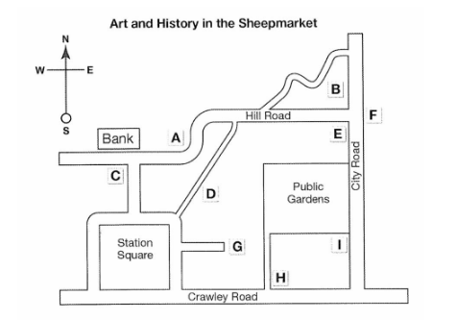
15. the Reynolds House _______
16. the Thumb _______
17. the Museum _______
18. the Contemporary Art Gallery _______
19. the Warner Gallery _______
20. Nucleus _______
Part 3: Questions 21-24
Complete the table below. Write ONE WORD ONLY for each answer.
Presentation of film adaptations of Shakespeare’s play
Stages of presentation | Work still to be done
Introduce Giannetti’s book containing a (21)……………of adaptations | organize notes
Ask class to suggest the (22)………………….adaptations | no further work needed
Present Rachel Malchow’s ideas | prepare some (23)………………..
Discuss relationship between adaptations and (24)…………………..at the time of making the film | no further work needed
(21) _______ (22) _______
(23) _______ (24) _______
Questions 25-30
What do the speakers say about each of the following films?
Choose SIX answers from below and write the correct letter A-G next to questions 25-30.
Comments
A clearly shows the historical period
B contains only parts of the play
C is too similar to another kind of film
D turned out to be unpopular with audiences
E presents the play in a different period from the original
F sets the original in a different country
G incorporates a variety of art forms
Films
25. Ran _______
26. Much Ado About Nothing _______
27. Romeo and Juliet _______
28. Hamlet _______
29. Prospero’s Books _______
30. Looking for Richard _______
Part 4: Questions 31-40
Complete the notes below. Write ONE WORD ONLY for each answer.
Noise in Cities
Past research focused on noise level (measured in decibels) and people’s responses.
Noise ‘maps’
• Show that the highest noise levels are usually found on roads
• Do not show other sources of noise e.g. when windows are open or people’s neighbours are in their (31) _______
• Ignore variations in people’s perceptions of noise
• Have made people realize that the noise is a (32) _______ issue that must be dealt with
Problems caused by noise
• Sleep disturbance
• Increase in amount of stress
• Effect on the (33) _______ of school children
Different types of noise
Some noises can be considered pleasant e.g. the sound of a (34) _______ in a town
To investigate this, researchers may use methods from (35) _______ sciences
What people want
Plenty of activity in urban environments which are (36) _______ but also allow people to relax
But architects and town planners
• Do not get much (37) _______ in acoustics
• Regards sound as the responsibility of engineers
Understanding sound as an art form
We need to know
• How sound relates to (38) _______
• What can be learnt from psychology about the effects of sound
• Whether physics can help us understand the (39) _______ of sound
Virtual reality programs
• Advantage: predict the effect of buildings
• Current disadvantage: they are (40) _______
_______ _______ _______ Show Answers

ANSWER KEY
1. temporary
2. doctor
3. africa
4. youth
5. May
6. cheese
7. Arbuthnot
8. DG74PH
9. tuesday
10. talk
11. A
12. C
13. B
14. B
15. H
16. C
17. F
18. G
19. I
20. B
21. classification
22. worst
23. slides
24. issues
25. F
26. A
27. E
28. C
29. G
30. B
31. gardens
32. political
33. work/ study
34. fountain
35. social
36. lively
37. training
38. culture
39. nature
40. silent

