IELTS Listening Practice - Test 94

Part 1: Questions 1-6
Label the floor plan below. Choose FIVE answers from the floor plan and write the correct letters A-I next to questions 1-6.
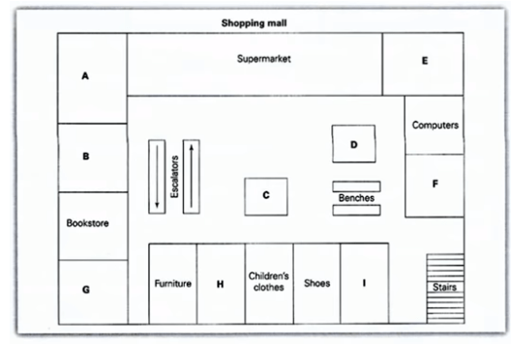
Questions 7-10
Answer the questions below. Write NO MORE THAN TWO WORDS AND/ OR A NUMBER for each answer.
7. How much does it cost to leave your car in the car park for four hours? _______
8. What is the minimum age for children at the children’s play centre? _______
Part 2: Questions 11-20
Complete the notes below. Write NO MORE THAN TWO WORDS AND/ OR A NUMBER for each answer.
The agency
• Contented Homes agency began in (11) _______
• Agency does most work using the (12) _______
How the system operates
• Minimum time period for housesitting is (13) _______
• Housesitters do not pay (14) _______
• Homeowners check (15) _______ of housesitters
• Housesitters have fewer (16) _______ than normal tenants
Advantages of having housesitters
• Prevent (17) _______
• Take care of your (18) _______ and _______
Charges
• Agency charges housesitters (19) _______ to register
• Agency recommends that homeowners organize (20) _______
Part 3: Questions 21-25
Where did a majority of the nationalities listed below settle?
Choose your answers from the list and write correct letters A-C next to questions 21-25.
A Melbourne
B Sydney
C Other places in Australia
21. British _______
22. Chinese _______
23. Lebanese _______
24. Malaysians _______
25. New Zealanders _______
Questions 26-30
Choose the correct letter A, B or C.
26. Most migrants chose where to live based on
[ ] A employment
[ ] B community
[ ] C real estate
27. There is a trend for people born in Australia to leave Sydney
[ ] A because it is becoming too busy and crowded
[ ] B due to the inadequate infrastructure
[ ] C so they can have more money in retirement
28. Among people who recently migrated to Australia, the percentage who settled in Sydney and Melbourne was
[ ] A 40%
[ ] B 50%
[ ] C 60%
29. The government is considering encouraging migrants to settle in other areas by
[ ] A offering tax incentive to employers
[ ] B making it easier for farmers to migrate
[ ] C employing people outside Sydney and Melbourne
30. The number of migrants living in Sydney is likely to be
[ ] A higher than the statistics indicate
[ ] B lower than the statistics indicate
[ ] C the same as the statistics indicate
Part 4: Questions 31-37
Complete the table below. Write NO MORE THAN THREE WORDS AND/ OR A NUMBER for each answer.
Product | Traditional source | Advantages of using hemp
Paper | wood | – ready to harvest in (31)……………..  – no need for (32)……………
Clothing | cotton | – need less (33)…………….fertilizer and pesticides  – provides better protection for people against (34)………………
Lamps | (35)…………….. | – causes less smell
Cars | metal | – is (36)……………………  – decomposes sooner
Fuel | petrol | – causes less (37)………………..
(31) _______ (32) _______
(33) _______ (34) _______
(35) _______ (36) _______
(37) _______
Questions 38-40
Complete the summary below. Choose your answers from the box and write correct letter A-G next to questions 38-40.
A. Dry | B. Cheese | C. Flour | D. Long-lasting
E. Non-toxic | F. Shady | G. Versatile
Hemp can be a source of foods and health products. It can produce (38) _______ containing a higher level of protein. It has many applications in the home. Pain made from hemp is (39) _______ Hemp grows well under (40) _______ conditions. It is an environmentally friendly solution to many problems.
_______ _______ _______ Show Answers

ANSWER KEY
1. A
2. H
3. I
4. G
5. D
6. F
7. $6
8. 18 months
9. 5
10. cinema
11. 1989
12. internet
13. one month
14. rent
15. references
16. rights
17. theft/ thieves
18. pets, gardens
19. $375
20. (home) insurance
21. C
22. B
23. B
24. C
25. B
26. B
27. C
28. C
29. A
30. A
31. 4 months
32. bleach
33. water/ irrigation
34. skin cancer
35. whale oil
36. cheaper/ less expensive
37. (air) pollution
38. C
39. E
40. A

