LAP 08
Nguyễn Ngọc Mỹ Dung
1150080006 – THMT
Hình ảnh
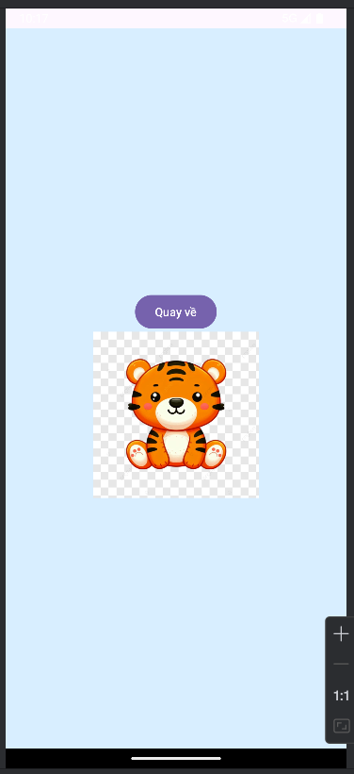
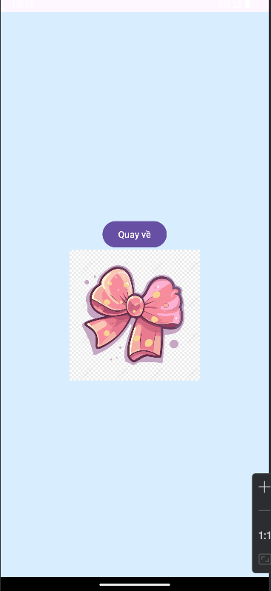
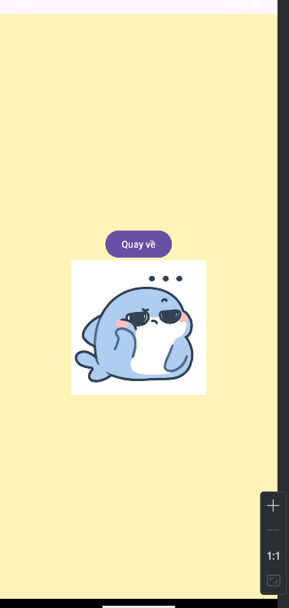
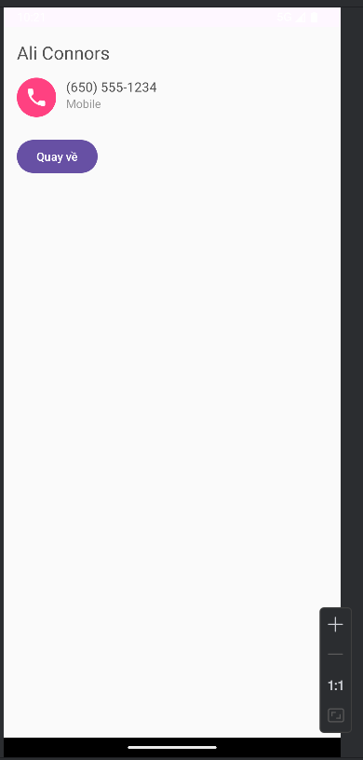
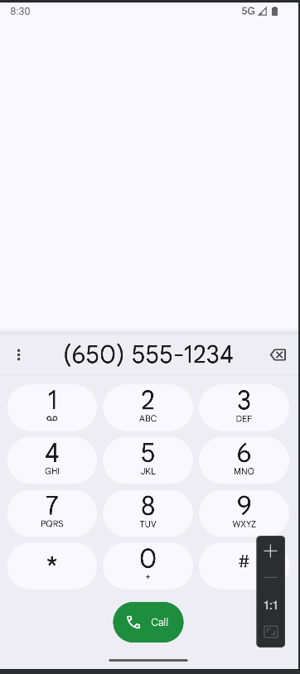
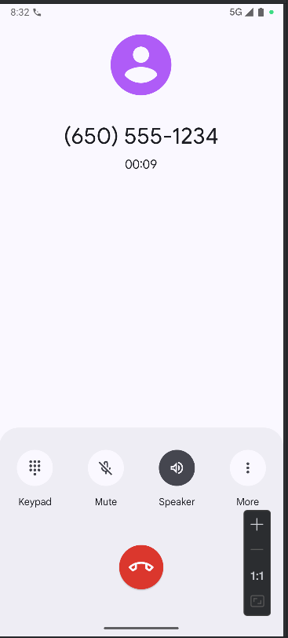

SOURCE CODE
Activity_main.xml
<?xml version="1.0" encoding="utf-8"?>
<LinearLayout xmlns:android="http://schemas.android.com/apk/res/android"
android:layout_width="match_parent" android:layout_height="match_parent"
android:orientation="vertical" android:padding="24dp" android:gravity="center">
<Button
android:id="@+id/btnSplash"
android:layout_width="match_parent"
android:layout_height="wrap_content"
android:text="Mở BT1: Splash" />
<Button
android:id="@+id/btnLoading"
android:layout_width="match_parent"
android:layout_height="wrap_content"
android:layout_marginTop="12dp"
android:text="Mở BT2: Loading" />
<Button
android:id="@+id/btnProfile"
android:layout_width="match_parent"
android:layout_height="wrap_content"
android:layout_marginTop="12dp"
android:text="Mở BT3: Profile" />
</LinearLayout>
MainActivity
package com.example.lap08.ui
import android.content.Intent
import android.os.Bundle
import android.widget.Button
import androidx.appcompat.app.AppCompatActivity
import com.example.lap08.R
class MainActivity : AppCompatActivity() {
override fun onCreate(savedInstanceState: Bundle?) {
super.onCreate(savedInstanceState)
setContentView(R.layout.activity_main)
findViewById<Button>(R.id.btnSplash).setOnClickListener {
startActivity(Intent(this, M000ActSplash::class.java))
}
findViewById<Button>(R.id.btnLoading).setOnClickListener {
startActivity(Intent(this, M001ActLoading::class.java))
}
findViewById<Button>(R.id.btnProfile).setOnClickListener {
startActivity(Intent(this, M001ActProfile::class.java))
}
}
}
AndroidManifest
<?xml version="1.0" encoding="utf-8"?>
<manifest xmlns:android="http://schemas.android.com/apk/res/android">
<application
android:allowBackup="true"
android:icon="@mipmap/ic_launcher"
android:label="@string/app_name"
android:roundIcon="@mipmap/ic_launcher_round"
android:supportsRtl="true"
android:theme="@style/Theme.Lap08">
<activity android:name=".ui.M001ActProfile" />
<activity android:name=".ui.M001ActLoading" />
<activity android:name=".ui.M000ActSplash" />
<!-- MainActivity có intent-filter nên PHẢI có exported khi targetSdk >= 31 -->
<activity
android:name=".ui.MainActivity"
android:exported="true">
<intent-filter>
<action android:name="android.intent.action.MAIN" />
<category android:name="android.intent.category.LAUNCHER" />
</intent-filter>
</activity>
</application>
</manifest>

