QN=<<No>> | <<Question Text>>  [file:<<image_file_name>>]  <<image>>
a. | <<choice a>>
b. | <<choice b>>
c. | <<choice c>>
d. | <<choice d>>
e. | <<choice e>>
f. | <<choice f>>
ANSWER: | <<correct answer>>
MARK: | <<mark>>
UNIT: | <<the chapter in the text book related to the question>>
MIX CHOICES: | <<yes/no>>

QN=1 | Which cities are in Vietnam
a. | Ha Noi
b. | Ho Chi Minh
c. | Da Nang
d. | All of the above
e.
f.
ANSWER: | D
MARK: | 0.5
UNIT: | 2
MIX CHOICES: | no

QN=2 | Which statements are true?
a. | 1+1=2
b. | 1+1=3
c. | 1-1=0
d. | 1/1=1
e.
f.
ANSWER: | ACD
MARK: | 1.0
UNIT: | 1
MIX CHOICES: | yes

QN=3 | What does the flag look like?  [file: image3.gif]  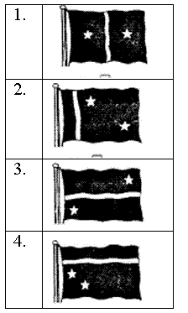
a. | 1
b. | 2
c. | 3
d. | 4
e.
f.
ANSWER: | A
MARK: | 1
UNIT: | 2
MIX CHOICES: | yes

