# **Chapter 0**: Preface

Currently, there are plenty of apps that can track your workout and show the current process however, very few apps demonstrate how the exercises are done and devise a plan. We will develop a mobile application based on android operating system. The motivation for this project came from the group meeting and we discussed all of the project options available to us. The gym project idea resonated with the team as it was applicable to each of our daily lives and it is something we could benefit from ourselves. The main objectives of our project is to create an app which enables the user to effectively lose weight, maintain weight and gain muscle in a sustainable manner with clear and concise plans and videos. The project will be scheduled around the deadlines outlined in the coursework specification, the milestones we have developed ourselves and the problems which may arise and how quick it is overcomed. The schedule will also depend on assigned tasks, how long they will take to complete. The goal of the project is to develop and design an app that meets our users’ requirements.

* Our fitness application aim to help user in improving their health status. Our app is continously improve overtime by taking feedback of our user, from the beta app version with only contain some simple functions with lots of limitations, to a more complete version with friendly user interface, more functions to help create motivate when using our app. We continue to improve more future update to meet the requirement of a good fitness app.

# **Chapter 1:** Introduction

## **1.1 Purpose**

This document outlines the usage and implementation of the GYM app.

## **1.2 Document Conventions**

This Document was created based on the IEEE template for System Requirement Specification Documents.

## **1.3 Scope**

The app is mainly for those who plan to lose or gain weight and require a planned medium for the same. The intended audience of this document is anyone who needs a platform where they find a sustainable and clear plan with videos to lose/maintain/gain weight

* The reason why our group choose to do fitness application is to impove people’s health when the state of obesity is becoming common and severe.

## **1.4 Overview**

First thing we wanted to do in designing is avoid boring formal user interface. So we tried todevelop modern graphic user interface system. This application is for gym owners as well as fortheir staffs to register new member, and take body measurements and see the reports of financialand individual body progress. To use features of our application user has to enter password and username.

The app will initially take some inputs from the user whether he/she is interested in losing/maintaining/gaining muscle and some extra information regarding the same. Based on the inputs, the software will map the videos, diet and schedule them for the particular user. Further, the app keeps track of the workouts and diet maintained by the user and gives him a score to assess his discipline.

Our application guide users keep and improve their fits through ideal exercises and useful functions. Our model application can be applied to nowadays general business or strategic objectives of the organization commissioning the software because of low cost and user friendly. The app can be easily run on several environment (ios, android,…), which lead to an amount of organises being attracted by our product.

## **1.5 Need for the System**

We all know health is a wealth. We do not need a fancy car, big apartment, a doctor degreewithout a health. Being healthy is a first thing we need to keep in mind. Because most of time our attitude depends on how we feel. Being healthy and fit gives us energy to do anything. Sohow do we stay fit? Be active, eat green and hit a gym! Physical fitness is very necessary for a healthy and tension free life. Physical fitness includesdiet, exercise and sleep. These three basic things have their own importance in eachindividuals life and everyone should be sensible with regard to these for a healthy life.

There are many apps for tracking the running and daily activities of every individual. However, each individual has a different need of either losing/maintaining/gaining the weight. There are no apps which address all these issues. Further, there are different apps for diet control and schedule maker. One has to install many apps to meet one unique goal. In addition to suggesting the workouts, this GYM app also plans a schedule where every day's diet and videos related to the same are conveyed. Our app provides a great deal of approriate method and ideal services for client to use in order to keep fits.

# **Chapter 2**: Glossary

**Macronutrient (Macro):** macronutrients are most often defined to be the chemical compounds that humans consume in large quantities that provide bulk energy. Specifically, they refer to carbohydrates, proteins, and fats.

**Body Mass Index (BMI):** Body Mass Index is a simple calculation using a person’s height and weight. The formula is BMI = kg/m2 where kg is a person’s weight in kilograms and m2 is their height in metres squared.

# **Chapter 3:** User requirement defenition

**Login:** User can log in their account into the system based on database by inputing their username/email and password in login form

**Signup:** User can create a new account into the system by inputing some basic information of them in sign up form

**Exercise**: User can choose a type of exercise (abs, biceps, legs) to improve their fitness and muscle

**Macro Calculator:** User input some information(gender, weight,…) to calculate

**Timer**: User can set time for their exercise and schedule their routine for keeping fit

**Calculate BMI:** User input their weight,height,… by choosing type of input(standard and metric)

**Routine Schedule:** User can schedule their routine and make plan for their goal

**Schedule Reminder:** User can be reminded by the system in order to do their plan

**Challenge:** Set challenges for some exercise for high level users

**Achievement:** Unlock medals for completing challenges

**Friendlist:** To add friends for online competion

**Leaderboard(online function):** Ranking users for more motivation

**Duel:** Compete with other user (1 vs 1)

**My favorite:** List all of user’s favorite exercises to save time when using system

**Sound and Music:** User can relax and avoid being boring during doing exercises

# **Chapter 4:** System Architecture

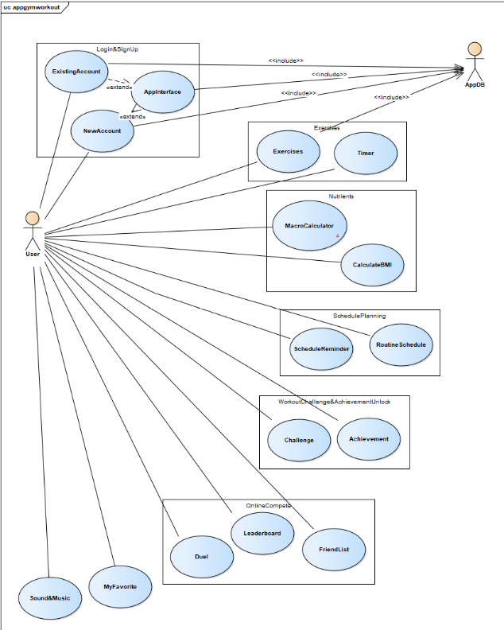

# **Chapter 5:** System requirements specification

## **\* Functional requirements:**

- Client requirements: has all the privileges on exercise seeker and the exercise seeker details. Client cannot make any change to the systems except register and add to my favorite.

### **a) Business requirement**

|  |  |  |
| --- | --- | --- |
| Num | Requirement | Input and Processing |
| 1 | Login | An UI appears for the user to input their username and password(String). Based on the database, the system will check the input and then go to the home pase if the given information is correct |
| 2 | Signup | An UI apppears for user to input their basic information in order to regist to the system. The system will check that the username is not already in the database and then save the new user into the system |
| 3 | Excercise | An UI apppears for user to choose the given exercise in order to add to their current routine. |
| 4 | Macro Calculator | An UI apppears for user to input some information(gender, weight,…) to calculate. The user must input their state’s information of fitness into the form for calculating. |
| 5 | Timer | An UI apppears for user to set time for their exercise and schedule their routine for keeping fit. The user must set time for exercise for more effective execise and schedule their time for that. |
| 6 | Calculate BMI | An UI apppears for user to input their weight, height,… by choosing type of input(standard and metric). The user must choose inputing type (standard(inches, pounds) and metric (cm, kg)) and input their height and weight |
| 7 | Routine Schedule | An UI apppears for user to schedule their routine and make plan for their goal. The user may schedule for themselves by inputing their routine and make a plan to keep fit in their leisure time. |
| 8 | Schedule Reminder | An UI apppears for user to be reminded by the system in order to do their plan, The user may set time for each milestone and the schedule reminder will work as clock assistant to remind user to doing exercise |
| 9 | Challenge | An UI apppears for user to set challenges for some exercise for high level users. The high level user may input some challenge for their own exercise for not only more effective result but also more motivation. |
| 10 | Achievement | An UI apppears for user to unlock medals for completing challenges. The user can get one medal after they accomplish an achievement and can share their achiement with friends or other users |
| 11 | Friendlist | An UI apppears for user to add friends for online competion. The user can addfriend in order to share experience and create motivation when competing with your friend. |
| 12 | Leaderboard(online function) | An UI apppears for user to know the ranking of them for more motivation. The admin update the new list monthly for user follow. User can base on that list and compete with each other to get higher rank. |
| 13 | Duel | An UI apppears for user to compete with other user (1 vs 1). The list of exercise and challenge for both user to do and to compare after finish |
| 14 | My favorite | An UI apppears for user to see the list of their favorite exercises to save time when using system. User can choose some specific exercise to do frequently in order to save time instead of confusing which one they should do. |
| 15 | Sound and Music | An UI apppears for user to relax and avoid being boring during doing exercises owing to listen to music. The user can add some music to their list in order to listen during doing exercise. |

1. Login

**Criticality:** The feature is important because without this user will have no right to access. This forms the launch of the app.

**Risks:** The user might enter the wrong username or password and this lead to false respone.which may affect the reaction of the user and subsequently the app.

**Dependency:** This depends on the database and user input. Without right input, the user cannot access to the app and error message will appear to require user to rewrite the input

1. Signup

**Criticality:** The feature is important because without this user cannot create a new account to have right to access to the system. This forms the additional function of the login function.

**Risks:** The system will have to check user’s input whether the user is already on the system so the process will take time to accomplish or or the user have to input again if the username already exists

**Dependency:** This depends on the database and user input. Without proper input, the user cannot create a new account in the system.

1. Exercise

**Criticality:** The feature is important because without this user will have no directions to proceed. This forms the heart of the app.

**Risks :** The user might enter the wrong data to top the chart and measures are to be taken to address the issue. Further, this may lead the app to suggest wrong and intense exercises which may affect the performance of the user and subsequently the app.

**Dependency:** This depends on the calendar app of the device. Without proper interface with the calendar app, this makes GYM app malfunction. Further, effectiveness of the accounting by the user also has impact on the performance.

1. Criticality: The feature is important because without this user will have no directions to
2. proceed. This forms the heart of the app.
3. Macro Calculator

**Criticality:** The feature is quite important because the user can set appropriate target based on the results. This forms the goal of the app.

**Risks:** The user might enter the wrong data to top the chart and measures are to be taken to address the issue. Further, this may lead the user to set wrong and intense goal which may affect the improvement of the user and subsequently the app.

**Dependency:** This depends on the user’s input. Without proper input, the system cannot give the accurate results for users.

1. Timer

**Criticality:** The feature is not important because the user can skip it and user can apply their own method to calculate exercise time.

**Risks:** The stored data might eat up a lots of space. Moreover, there are a lot of alternative approaches for this function

**Dependency:** This depends on the user’s input and the clock to calculate the time to do exercise.

1. Calculate BMI

**Criticality:** The feature is quite important because the user can rise up their motivation based on the results. This forms the goal of the app.

**Risks:** The user might enter the wrong data to top the chart and measures are to be taken to address the issue. Further, this may lead the user to lose or over-looking forward to their target which may affect the improvement of the user and subsequently the app.

**Dependency:** This depends on the user’s input. Without proper input, the system cannot give the accurate results for users.

1. Routine Schedule

**Criticality:** The feature is not important because the user can skip it and user can apply their own method to plan for their schedules.

**Risks:** The user can set unappropriate goal and plan for unideal schedule so the user cannot achieve their targer.

**Dependency:** This depends on the user’s input. Without proper input, the user cannot accomplish their goal.

1. Schedule Reminder

**Criticality:** The feature is not important because the user can skip it and user can apply their own method to follow their routine.

**Risks:** The stored data might eat up a lots of space. Moreover, there are a lot of alternative approach for this function and this function may waste an amount of device’s battery.

**Dependency:** This depends on the clock of the device and the user’s input. Without proper input and stable system operation, the user cannot follow their routine and reach their goal.

1. Challenge

**Criticality:** The feature is quite important because the user can rise up their motivation of practicing. This form is an additional tool for user to get more passion.

**Risks:** The user may set an unappropriate challenge which is not suitable to their level, and this lead the user to lose their passion and give up on practicing.

**Dependency:** This depends on the user’s option and admin list. Without right list/option, the user cannot plan for an ideal schedule.

1. Achievement

**Criticality:** The feature is quite important because the user can rise up their motivation of practicing. This form is an additional tool for user to get more passion.

**Risks:** The user should not exercise too much to get many achievement as fast as they can. Instead, we should exercise regularly to get the better result in our health.

**Dependency:**Depend on the user selection, each exercise will have a different achievement to motivate the user.

1. Friendlist

**Criticality:** The feature is not important because the user add friends when doing exercise to widen their social relationship or they do not want to make friend with anyone because they want to keep their private life away from app. This form is additional tool for user to get more friend.

**Risks:** User need to be careful when accept another person. For the security, user can accept only person they know, prevent the bad people.

**Dependency:** Depend on user setup and choose accept or not. Moreover, they can use social network account to get the friend list with their friend.

1. Leaderboard(online function)

**Criticality:** The feature is quite important because the user can rise up their motivation based on their ranking level. This form is additional tool for user to reach higher goal.

**Risks:** The user should not exercise too much to get the high rank in the leaderboard. We should just do our best to get the better health.

**Dependency:** Depend on the number of exercise the user has done, they will get the higher rank.

1. Duel

**Criticality:** The feature is not important because the user can skip it if they want to use app in peace with no competion. This form is additional tool for user to have chance to compete with other users.

**Risks:** This function also help the user to get the higher rank in leaderboard. Once again remember that, the user should not exercise too much to get the high rank in the leaderboard. We should do our best to get the better health.

**Dependency:** This function will help the user to duel with another person who also want to duel in the same exercise that both of them choose.

1. My favorite

**Criticality:** The feature is quite important because the user can see the list of their daily used exercise so they can save time when using system. This form is additional tool for optimating the performance of the system.

**Risks :** This is the list of the exercise that user selected. So, remember not to select the exercise which too hard for the user to finish to avoid bad effect.

**Dependency:** Depend on the user thinking and their hobby, so that this function are done by the selection of the user.

1. Sound and Music

**Criticality:** The feature is not important because the user can skip it if they want to use app in peace with no competion. This form is additional tool for user to have chance to compete with other users.

**Risks:** Music will have the user get more energy and more active in the exercise. So that, choose the suitable will get music are very important. The user can follow the music that the app already setup or remember to select the suitable music by themselves to get the better result.

**Dependency:** Depend on the user thinking and their hobby, this function are done by the selection of the user.

### **b) System requirements**

- Environment

-Simulation

- Automation

- Authentication

- Backup/restore

## **\* Non-funtional requirement (user related)**

Resilence: Update routine, update listfriend (the user can change the number of friends/exercises in their private list)

Rusability: the app should be convenient, comfortable and intuitive.

Efficency: Speed of performing must be optimal. The timer calculation must be accurate. The routine/exercise should be effective.

Compatibility: allows insert new song/exercises from an existing Excel file

# **Chapter 6:** System models

## **6.1 Data flow**

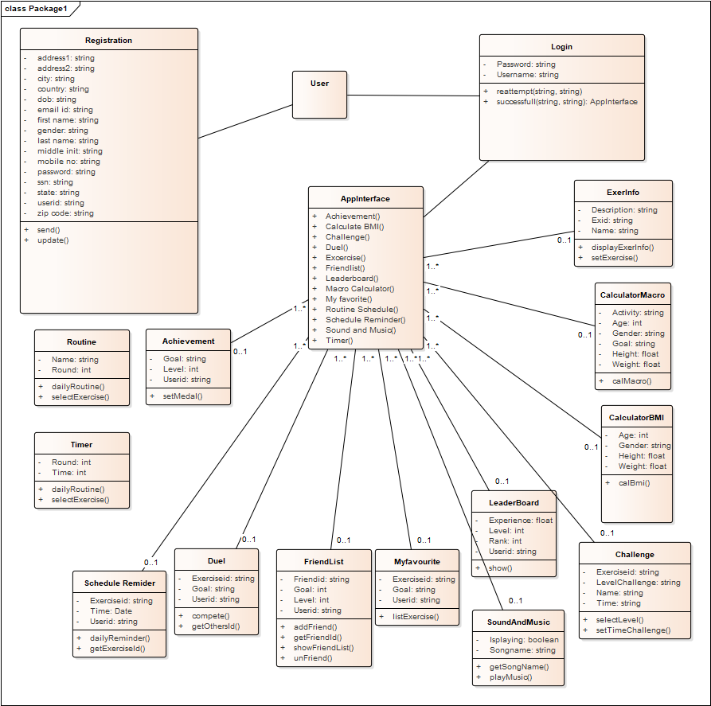

## **6.2 Function design**

### *User usecase login*

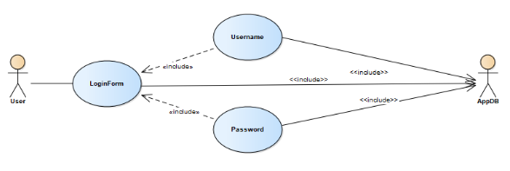

|  |  |
| --- | --- |
| **User usecase login** | |
| Actors | User, Database |
| Description | An user can log in their account into the system based on database by inputing their username/email and password in login form |
| Data | Users (database) |
| Stimulus | Interface including form and button |
| Response | User’s home page |
| Comments | The user must have a vaid account and correctly input it into the form. In some system, the user may have to confirm their account by using email/phone verification |

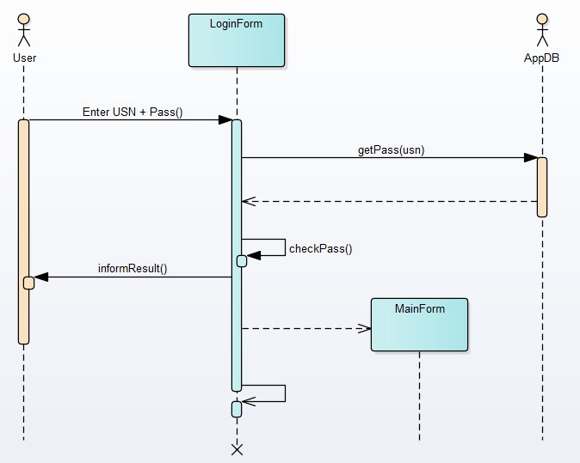

### *User usecase sign up*

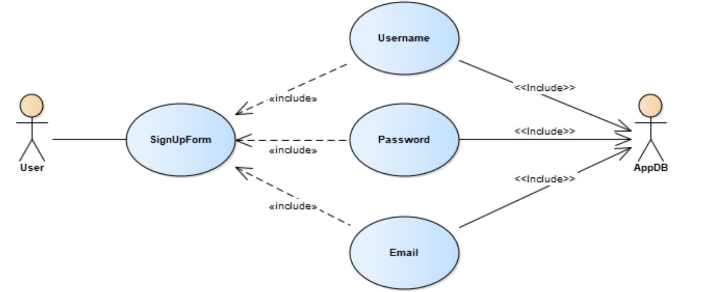

|  |  |
| --- | --- |
| **User usecase signup** | |
| Actors | User, Database |
| Description | An user can create a new account into the system by inputing some basic information of them in sign up form |
| Data | Users (database) |
| Stimulus | Interface including form and button |
| Response | Message: successfully creating a new account |
| Comments | The user must input some basic and valid information (username is unique) into the form. Some system, the user may have to verify by using email/phone or to wait for accepting by admin. |

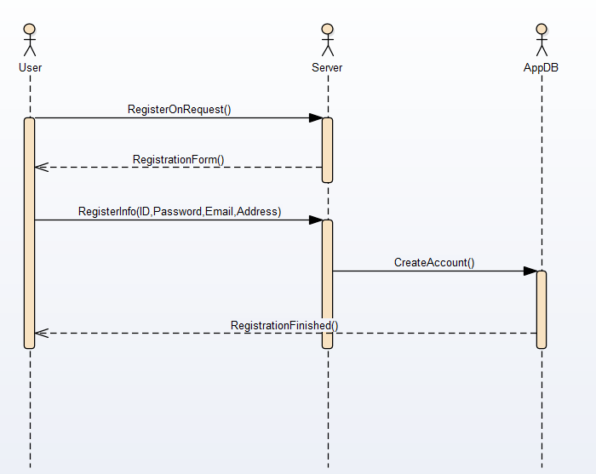

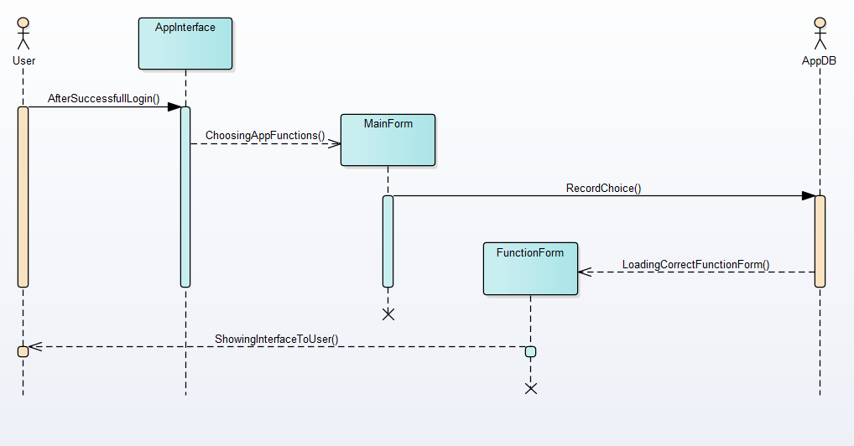

### *User usecase excercises*

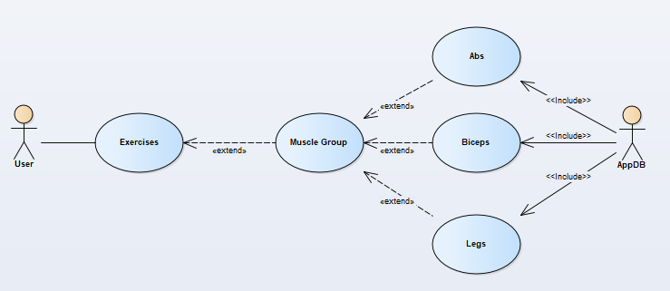

|  |  |
| --- | --- |
| **User usecase exercises** | |
| Actors | User, Database |
| Description | An user can choose a type of exercise (abs, biceps, legs) to improve their fitness and muscle |
| Data | Exercise (database) |
| Stimulus | Interface including the list of exercise and the button |
| Response | Message: Successfull choose the excise |
| Comments | The user may choose exercise based on their purpose, routine and diet in order to keep fit effectively |

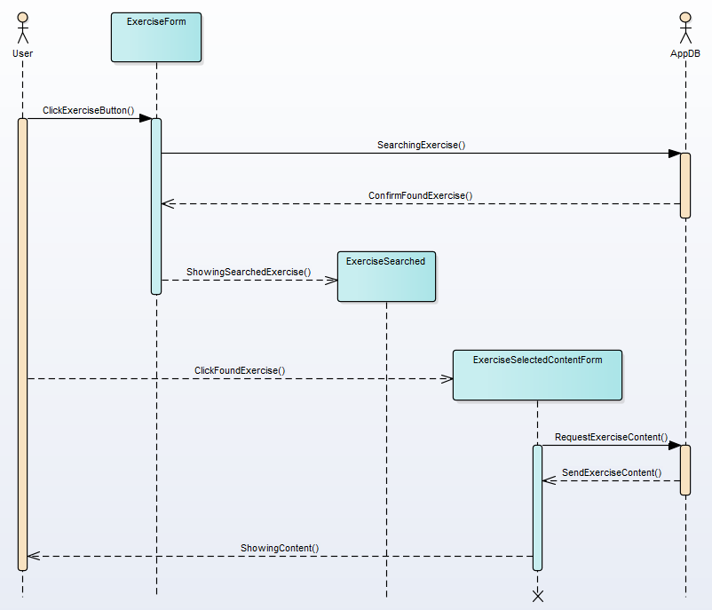

### *User usecase Macro Calculator*

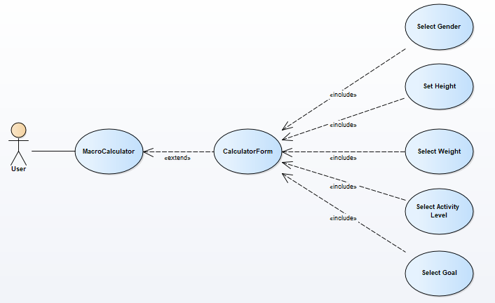

|  |  |
| --- | --- |
| **User usecase Macro Calculator** | |
| Actors | User |
| Description | An user input some information(gender, weight,…) to calculate |
| Data | User’s input |
| Stimulus | Interface include input form and submit button |
| Response | Message: result and recommend macronutrient ratio |
| Comments | The user must input their state’s information of fitness into the form for calculating. Some system, users just need input their age and gender and using digital scale and ruler for more accurate calculation |

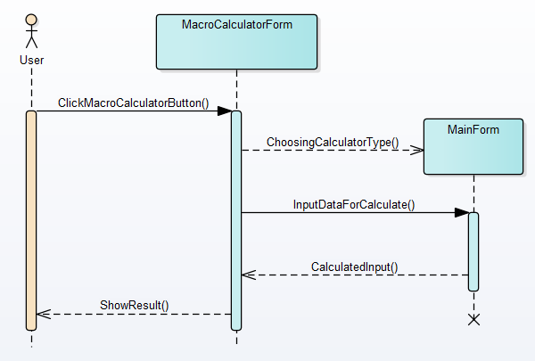

### *User usecase timer*

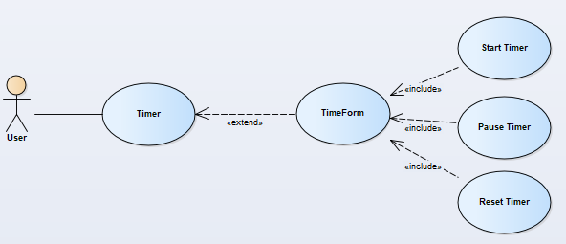

|  |  |
| --- | --- |
| **User usecase timer** | |
| Actors | User |
| Description | An user can set time for their exercise and schedule their routine for keeping fit |
| Data | User’s input |
| Stimulus | Interface include input form (start/pause/reset time) |
| Response | time form |
| Comments | The user must set time for exercise for more effective execise and schedule their time for that. Some system, the system automatically set time for user for optimal exercise |

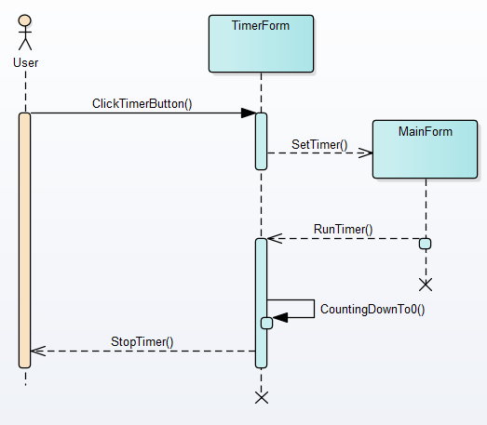

### *User usecase calculate BMI*

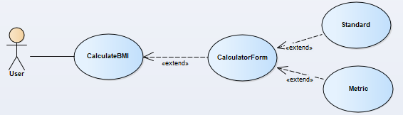

|  |  |
| --- | --- |
| **User usecase calculate BMI** | |
| Actors | User |
| Description | An user input their weight,height,… by choosing type of input(standard and metric) |
| Data | User’s input |
| Stimulus | Interface include input form and submit button |
| Response | Result and recommendation that is more suitable for healthy state |
| Comments | The user must choose inputing type (standard(inches, pounds) and metric (cm, kg)) and input their height and weight. Some system, The height and weight are inputed automatically by using digital scale and ruler |

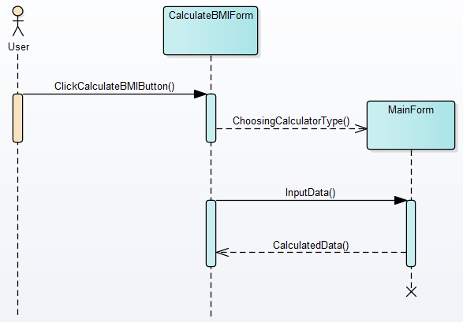

### *User usecase Routine Schedule*

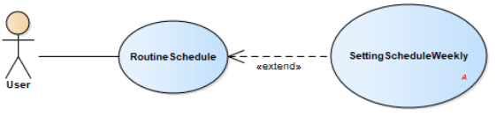

|  |  |
| --- | --- |
| **User usecase Routine Schedule** | |
| Actors | User |
| Description | User can schedule their routine and make plan for their goal |
| Data | User’s input |
| Stimulus | Interface include input form and button |
| Response | Your routine for you to follow when doing exercise |
| Comments | The user may schedule for themselves by inputing their routine and make a plan to keep fit in their leisure time |

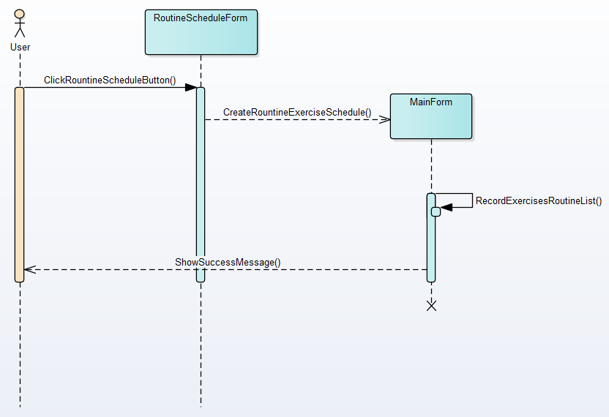

### *User usecase Schedule Reminder*

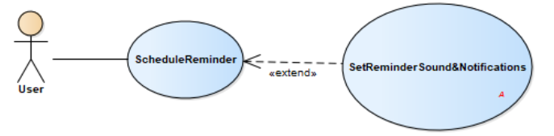

|  |  |
| --- | --- |
| **User usecase Schedule Reminder** | |
| Actors | User |
| Description | User can be reminded by the system in order to do their plan |
| Data | User’s input |
| Stimulus | Interface include input form and button |
| Response | The clock |
| Comments | The user may set time for each milestone and the schedule reminder will work as clock assistant to remind user to doing exercise |

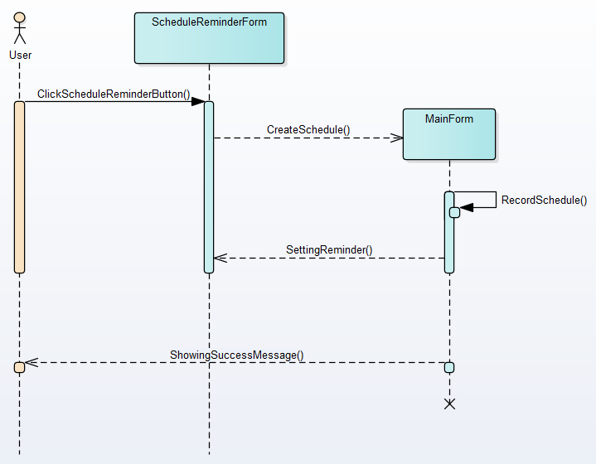

### *User usecase Challenge*

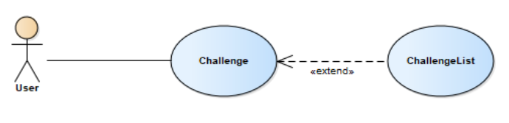

|  |  |
| --- | --- |
| **User usecase Challenge** | |
| Actors | User |
| Description | Set challenges for some exercise for high level users |
| Data | User’s input |
| Stimulus | Interface include input form and button |
| Response | Interface include the list of challenge |
| Comments | The high level user may input some challenge for their own exercise for not only more effective result but also more motivation |

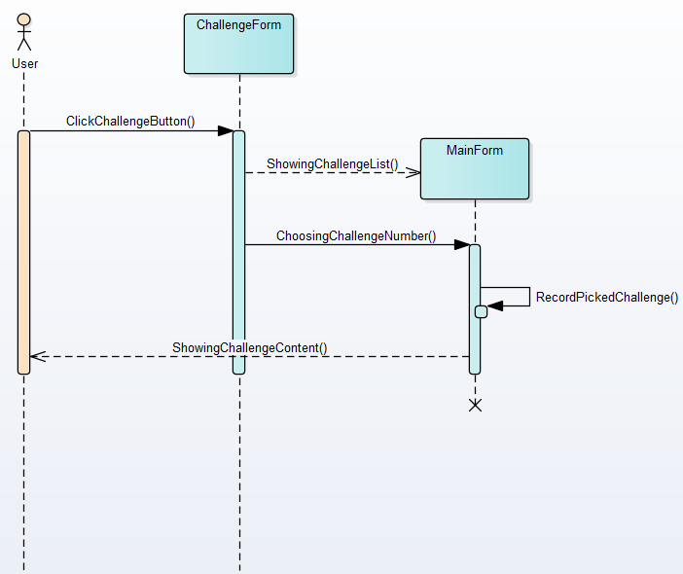

### *User usecase Achievement*

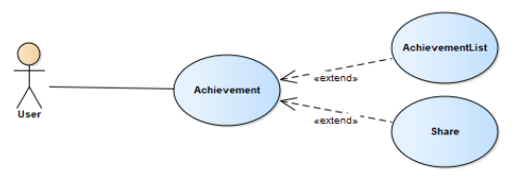

|  |  |
| --- | --- |
| **User usecase Achievement** | |
| Actors | User |
| Description | Unlock medals for completing challenges |
| Data | Admin’s input |
| Stimulus | Interface include list form and share button |
| Response | User’s achievement |
| Comments | The user can get one medal after they accomplish an achievement and can share their achiement with friends or other users |

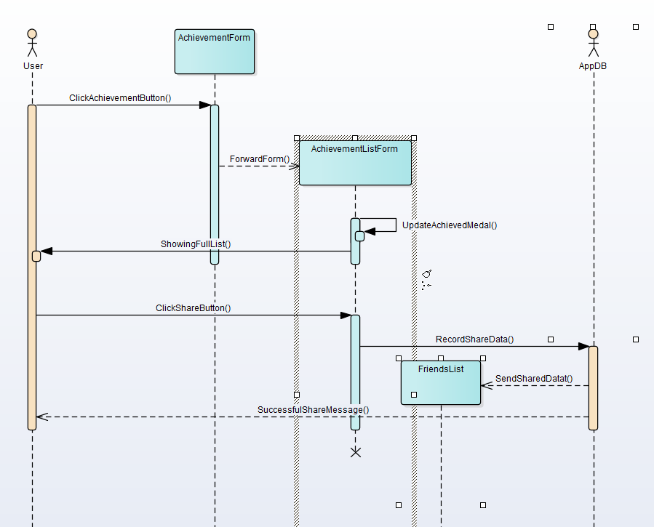

### *User usecase Friendlist*

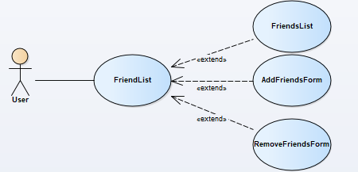

|  |  |
| --- | --- |
| **User usecase Friend** | |
| Actors | User |
| Description | To add friends for online competion |
| Data | Users(database) and user’s input |
| Stimulus | Interface include input form and addfriend button |
| Response | Successfully added your new friends |
| Comments | The user can addfriend in order to share experience and create motivation when competing with your friend |

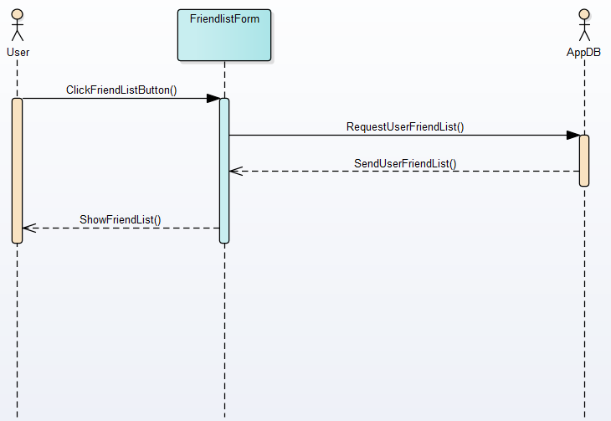

### *User usecase Leaderboard(online function)*

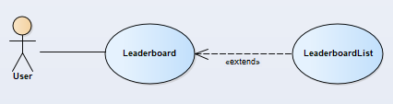

|  |  |
| --- | --- |
| **User usecase Leaderboard(online function)** | |
| Actors | User |
| Description | Ranking users for more motivation |
| Data | Admin’s input |
| Stimulus | Interface that is the list of high level user who has effective improvement or excellent result |
| Response | The list of high level user |
| Comments | The admin update the new list monthly for user follow. User can base on that list and compete with each other to get higher rank |

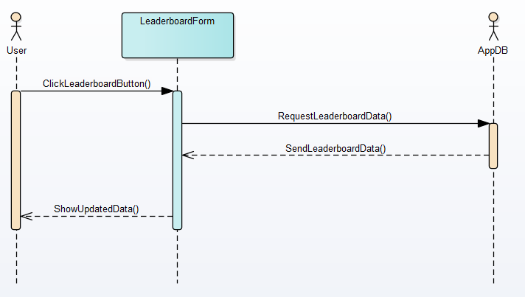

### *User usecase Duel*

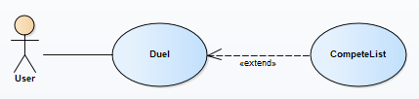

|  |  |
| --- | --- |
| **User usecase Duel** | |
| Actors | User |
| Description | User can compete with other user (1 vs 1) |
| Data | User’s choice |
| Stimulus | Interface that is the list of user to choose to compete |
| Response | The list of exercise and challenge for both user to do and to compare after finish |
| Comments | User can invite another user to compete in order to improve themselves and create more motivation |

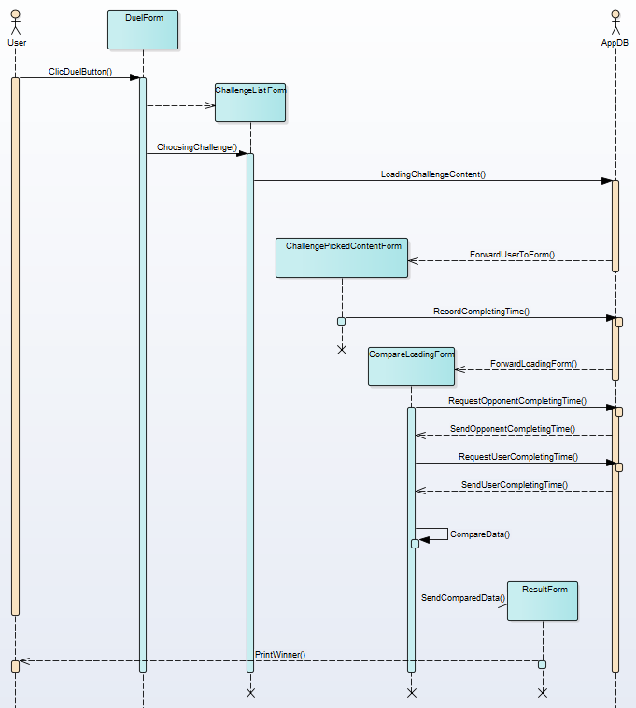

### *User usecase My favorite*

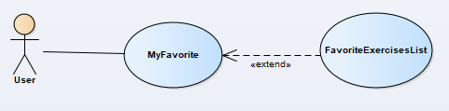

|  |  |
| --- | --- |
| **User usecase My favorite** | |
| Actors | User |
| Description | List all of user’s favorite exercises to save time when using system |
| Data | User’s input |
| Stimulus | Interface that is the list of exercises for user to do and submit button |
| Response | The list of user’s favorite exercise to do frequently |
| Comments | User can choose some specific exercise to do frequently in order to save time instead of confusing which one they should do |

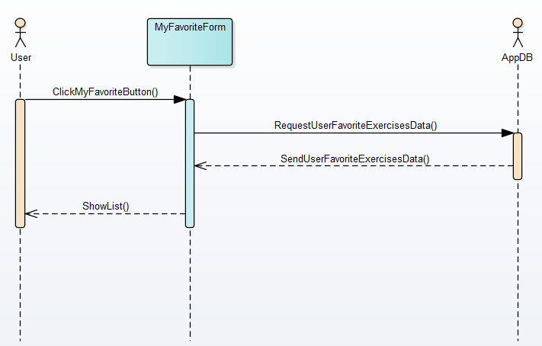

### *User usecase Sound and Music*

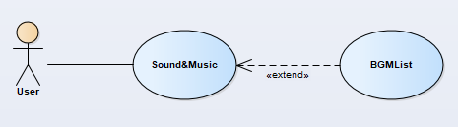

|  |  |
| --- | --- |
| **User usecase Sound and Music** | |
| Actors | User |
| Description | User can relax and avoid being boring during doing exercises |
| Data | User’s input |
| Stimulus | Interface that is the list of exercises for user to do and submit button |
| Response | The list of user’s favorite exercise to do frequently |
| Comments | The user can add some music to their list in order to listen during doing exercise |

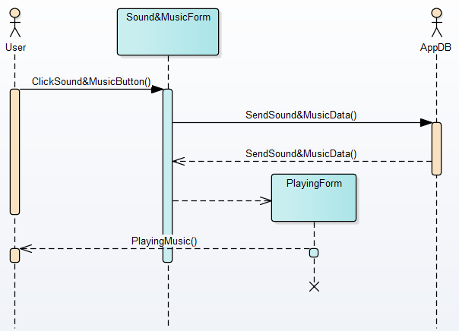

# **Chapter 7:** System evolution

*Our proposed “Smart Gym System” is for those who runs a gym business. Before doinganything we did a decent research on major difficulties for gym owners. We examined carefullyabout how to make a huge registering system without failure as well as different functions fordifferent kind of user depending on their privilege.*

**Adidas Mi-Coach:** This app has a GPS based tracker for running. It also gives a score for individual's daily performance. It is a more robust and a well-designed app, but doesn't have features of conveying related videos of exercises and the diet plan.

**Seven-7 Minute Workout Challenge:** This app has universal and scientifically approved exercises for maintaining the muscle. But the app has only 15 activities for 7 minutes, and the scoring is just based on them. As mentioned earlier, this too doesn't have the suggestion of videos and diet planner. Further, this app doesn't have the tracking feature too.

# **Chapter 8**: Appendices

## 8.1 Application Requirements

|  |  |
| --- | --- |
| **Operating system** | Windowns XP, Windowns 7, ios, android |
| **Front end** | Microsoft Visual Basic 6.0 |
| **Database** | Microsoft Access 2003 |
| **Connectivity** | ActiveX Data Object |
| **Report** | Data Report |

## 8.2 Hardware Requirements

|  |  |
| --- | --- |
| **RAM** | 512MB or higher |
| **Hard Disk** | 10GB or higher |
| **Conputer Processor** | Pentium IV |
| **Clock Speed** | 700 MHZ Processor |

# **Chapter 9**: Index

Contents

**Chapter 0**: Preface 1

**Chapter 1:** Introduction 1

**1.1 Purpose** 1

**1.2 Document Conventions** 1

**1.3 Scope** 1

**1.4 Overview** 2

**1.5 Need for the System** 2

**Chapter 2**: Glossary 3

**Chapter 3:** User requirement defenition 3

**Chapter 4:** System Architecture 4

**Chapter 5:** System requirements specification 5

**\* Functional requirements:** 5

**a) Business requirement** 5

**b) System requirements** 10

**\* Non-funtional requirement (user related)** 10

**Chapter 6:** System models 11

**6.1 Data flow** 11

**6.2 Function design** 12

*User usecase login* 12

*User usecase sign up* 13

*User usecase excercises* 15

*User usecase Macro Calculator* 17

*User usecase timer* 18

*User usecase calculate BMI* 19

*User usecase Routine Schedule* 21

*User usecase Schedule Reminder* 22

*User usecase Challenge* 23

*User usecase Achievement* 25

*User usecase Friendlist* 26

*User usecase Leaderboard(online function)* 27

*User usecase Duel* 28

*User usecase My favorite* 30

*User usecase Sound and Music* 32

**Chapter 7:** System evolution 33

**Chapter 8**: Appendices 33

8.1 Application Requirements 34

8.2 Hardware Requirements 34

**Chapter 9**: Index 34