Overview

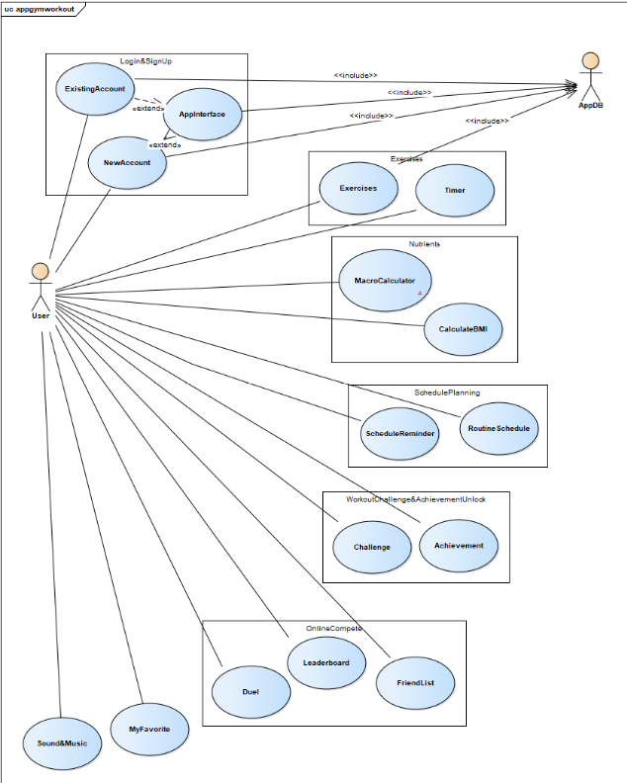

User usecase login

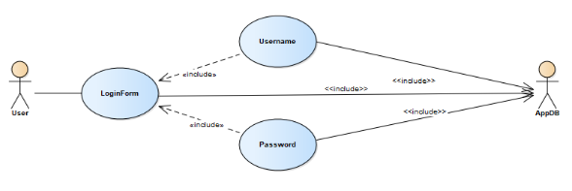

|  |  |
| --- | --- |
| **User usecase login** | |
| Actors | User, Database |
| Description | An user can log in their account into the system based on database by inputing their username/email and password in login form |
| Data | Users (database) |
| Stimulus | Interface including form and button |
| Response | User’s home page |
| Comments | The user must have a vaid account and correctly input it into the form. In some system, the user may have to confirm their account by using email/phone verification |

User usecase sign up

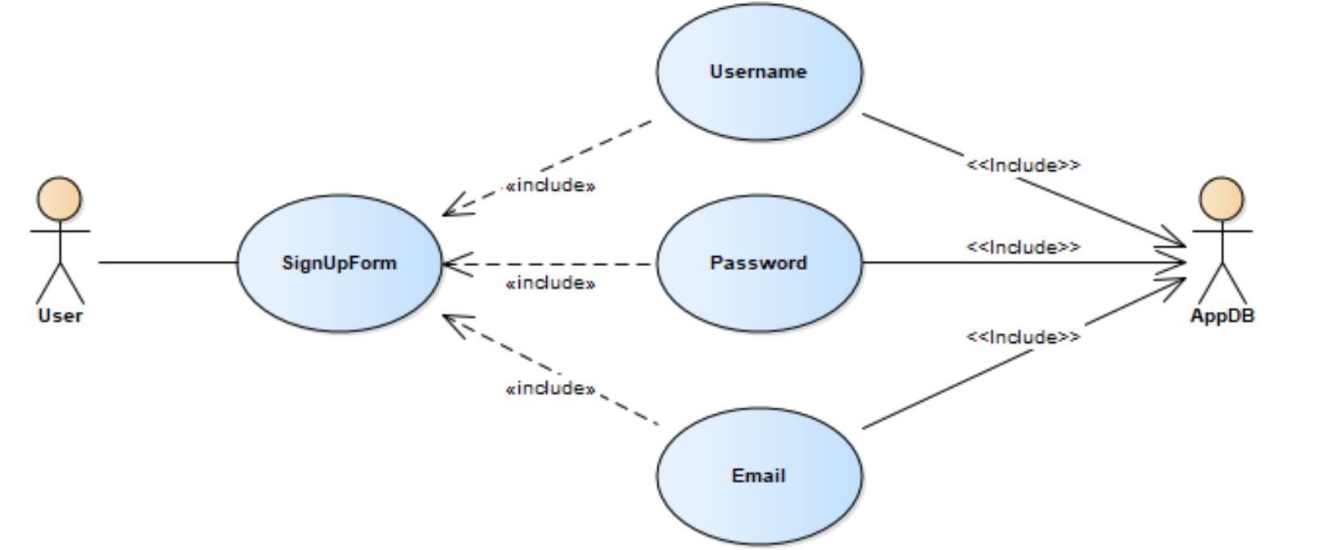

|  |  |
| --- | --- |
| **User usecase signup** | |
| Actors | User, Database |
| Description | An user can create a new account into the system by inputing some basic information of them in sign up form |
| Data | Users (database) |
| Stimulus | Interface including form and button |
| Response | Message: successfully creating a new account |
| Comments | The user must input some basic and valid information (username is unique) into the form. Some system, the user may have to verify by using email/phone or to wait for accepting by admin. |

User usecase excercises

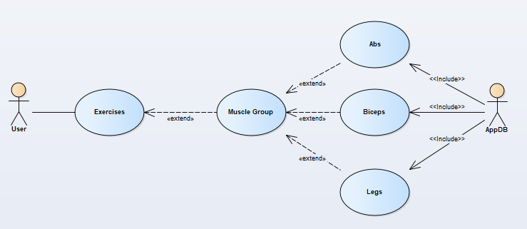

|  |  |
| --- | --- |
| **User usecase exercises** | |
| Actors | User, Database |
| Description | An user can choose a type of exercise (abs, biceps, legs) to improve their fitness and muscle |
| Data | Exercise (database) |
| Stimulus | Interface including the list of exercise and the button |
| Response | Message: Successfull choose the excise |
| Comments | The user may choose exercise based on their purpose, routine and diet in order to keep fit effectively |

User usecase Macro Calculator

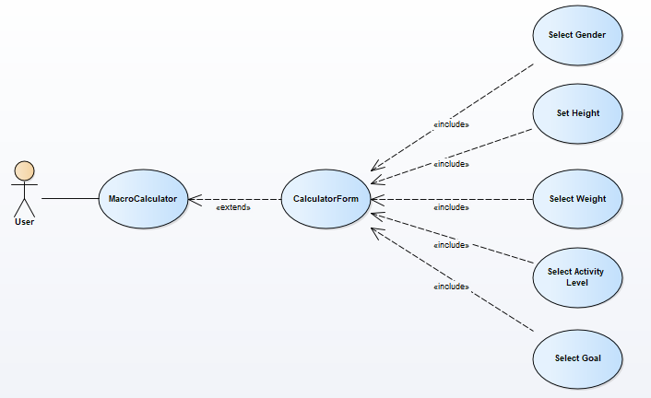

|  |  |
| --- | --- |
| **User usecase Macro Calculator** | |
| Actors | User |
| Description | An user input some information(gender, weight,…) to calculate |
| Data | User’s input |
| Stimulus | Interface include input form and submit button |
| Response | Message: result and recommend macronutrient ratio |
| Comments | The user must input their state’s information of fitness into the form for calculating. Some system, users just need input their age and gender and using digital scale and ruler for more accurate calculation |

User usecase timer

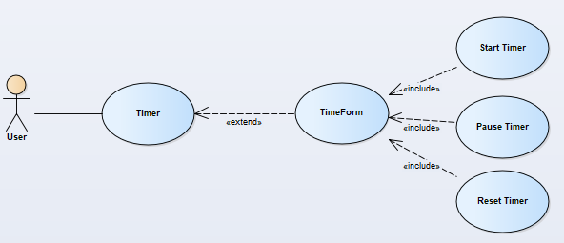

|  |  |
| --- | --- |
| **User usecase timer** | |
| Actors | User |
| Description | An user can set time for their exercise and schedule their routine for keeping fit |
| Data | User’s input |
| Stimulus | Interface include input form (start/pause/reset time) |
| Response | time form |
| Comments | The user must set time for exercise for more effective execise and schedule their time for that. Some system, the system automatically set time for user for optimal exercise |

User usecase calculate BMI

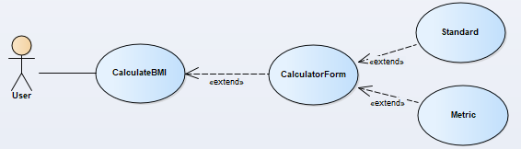

|  |  |
| --- | --- |
| **User usecase calculate BMI** | |
| Actors | User |
| Description | An user input their weight,height,… by choosing type of input(standard and metric) |
| Data | User’s input |
| Stimulus | Interface include input form and submit button |
| Response | Result and recommendation that is more suitable for healthy state |
| Comments | The user must choose inputing type (standard(inches, pounds) and metric (cm, kg)) and input their height and weight. Some system, The height and weight are inputed automatically by using digital scale and ruler |

User usecase Routine Schedule

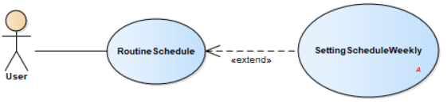

|  |  |
| --- | --- |
| **User usecase Routine Schedule** | |
| Actors | User |
| Description | User can schedule their routine and make plan for their goal |
| Data | User’s input |
| Stimulus | Interface include input form and button |
| Response | Your routine for you to follow when doing exercise |
| Comments | The user may schedule for themselves by inputing their routine and make a plan to keep fit in their leisure time |

User usecase Schedule Reminder

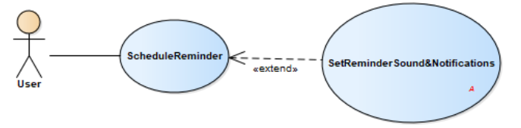

|  |  |
| --- | --- |
| **User usecase Schedule Reminder** | |
| Actors | User |
| Description | User can be reminded by the system in order to do their plan |
| Data | User’s input |
| Stimulus | Interface include input form and button |
| Response | The clock |
| Comments | The user may set time for each milestone and the schedule reminder will work as clock assistant to remind user to doing exercise |

User usecase Challenge

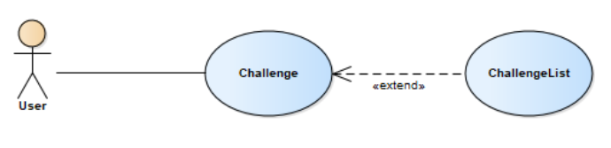

|  |  |
| --- | --- |
| **User usecase Challenge** | |
| Actors | User |
| Description | Set challenges for some exercise for high level users |
| Data | User’s input |
| Stimulus | Interface include input form and button |
| Response | Interface include the list of challenge |
| Comments | The high level user may input some challenge for their own exercise for not only more effective result but also more motivation |

User usecase Achievement

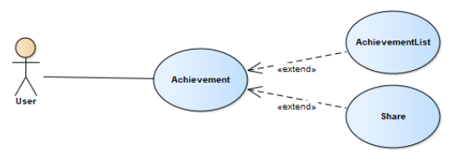

|  |  |
| --- | --- |
| **User usecase Achievement** | |
| Actors | User |
| Description | Unlock medals for completing challenges |
| Data | Admin’s input |
| Stimulus | Interface include list form and share button |
| Response | User’s achievement |
| Comments | The user can get one medal after they accomplish an achievement and can share their achiement with friends or other users |

User usecase Friendlist

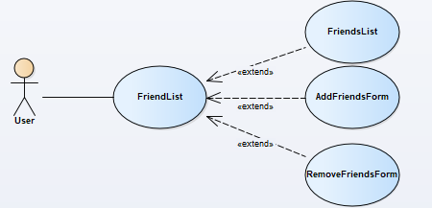

|  |  |
| --- | --- |
| **User usecase Friend** | |
| Actors | User |
| Description | To add friends for online competion |
| Data | Users(database) and user’s input |
| Stimulus | Interface include input form and addfriend button |
| Response | Successfully added your new friends |
| Comments | The user can addfriend in order to share experience and create motivation when competing with your friend |

User usecase Leaderboard(online function)

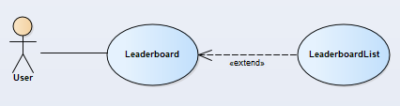

|  |  |
| --- | --- |
| **User usecase Leaderboard(online function)** | |
| Actors | User |
| Description | Ranking users for more motivation |
| Data | Admin’s input |
| Stimulus | Interface that is the list of high level user who has effective improvement or excellent result |
| Response | The list of high level user |
| Comments | The admin update the new list monthly for user follow. User can base on that list and compete with each other to get higher rank |

User usecase Duel

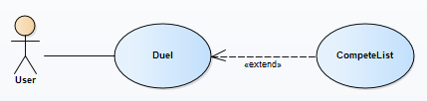

|  |  |
| --- | --- |
| **User usecase Duel** | |
| Actors | User |
| Description | User can compete with other user (1 vs 1) |
| Data | User’s choice |
| Stimulus | Interface that is the list of user to choose to compete |
| Response | The list of exercise and challenge for both user to do and to compare after finish |
| Comments | User can invite another user to compete in order to improve themselves and create more motivation |

User usecase My favorite

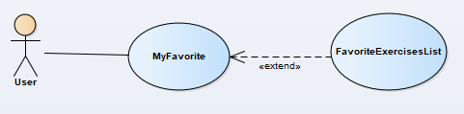

|  |  |
| --- | --- |
| **User usecase My favorite** | |
| Actors | User |
| Description | List all of user’s favorite exercises to save time when using system |
| Data | User’s input |
| Stimulus | Interface that is the list of exercises for user to do and submit button |
| Response | The list of user’s favorite exercise to do frequently |
| Comments | User can choose some specific exercise to do frequently in order to save time instead of confusing which one they should do |

User usecase Sound and Music

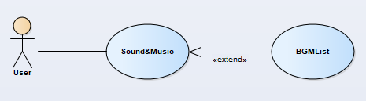

|  |  |
| --- | --- |
| **User usecase Sound and Music** | |
| Actors | User |
| Description | User can relax and avoid being boring during doing exercises |
| Data | User’s input |
| Stimulus | Interface that is the list of exercises for user to do and submit button |
| Response | The list of user’s favorite exercise to do frequently |
| Comments | The user can add some music to their list in order to listen during doing exercise |