Overview

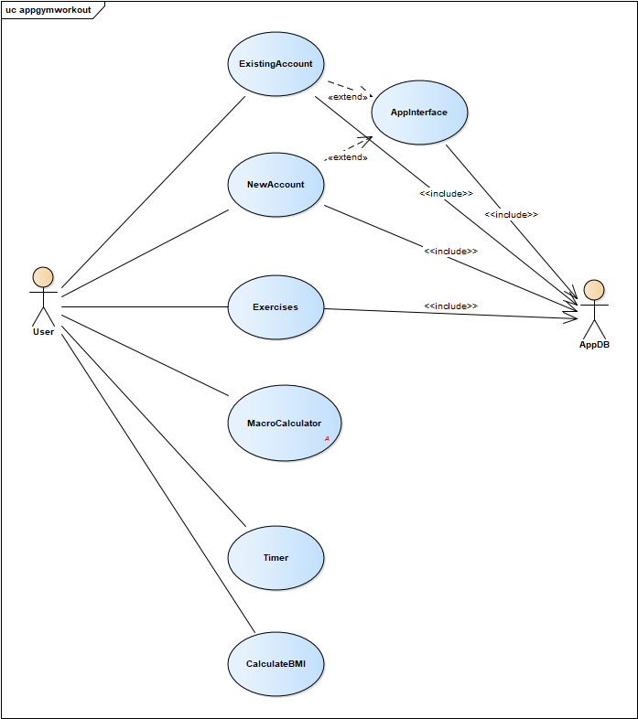

User usecase login

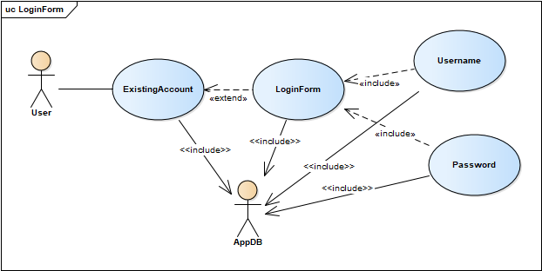

|  |  |
| --- | --- |
| **User usecase login** | |
| Actors | User, Database |
| Description | An user can log in their account into the system based on database by inputing their username/email and password in login form |
| Data | Users (database) |
| Stimulus | Interface including form and button |
| Response | User’s home page |
| Comments | The user must have a vaid account and correctly input it into the form. In some system, the user may have to confirm their account by using email/phone verification |

User usecase sign up

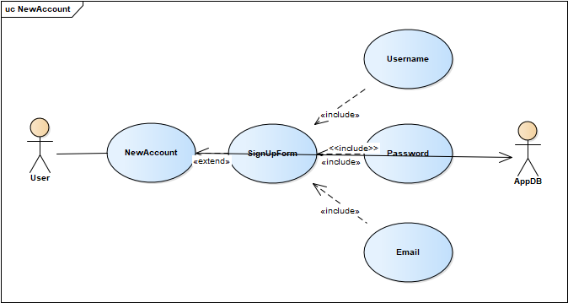

|  |  |
| --- | --- |
| **User usecase login** | |
| Actors | User, Database |
| Description | An user can create a new account into the system by inputing some basic information of them in sign up form |
| Data | Users (database) |
| Stimulus | Interface including form and button |
| Response | Message: successfully creating a new account |
| Comments | The user must input some basic and valid information (username is unique) into the form. Some system, the user may have to verify by using email/phone or to wait for accepting by admin. |

User usecase excercises

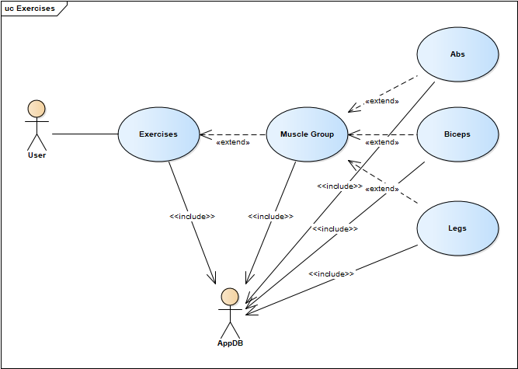

|  |  |
| --- | --- |
| **User usecase exercises** | |
| Actors | User, Database |
| Description | An user can choose a type of exercise (abs, biceps, legs) to improve their fitness and muscle |
| Data | Exercise (database) |
| Stimulus | Interface including the list of exercise and the button |
| Response | Message: Successfull choose the excise |
| Comments | The user may choose exercise based on their purpose, routine and diet in order to keep fit effectively |

User usecase Macro Calculator

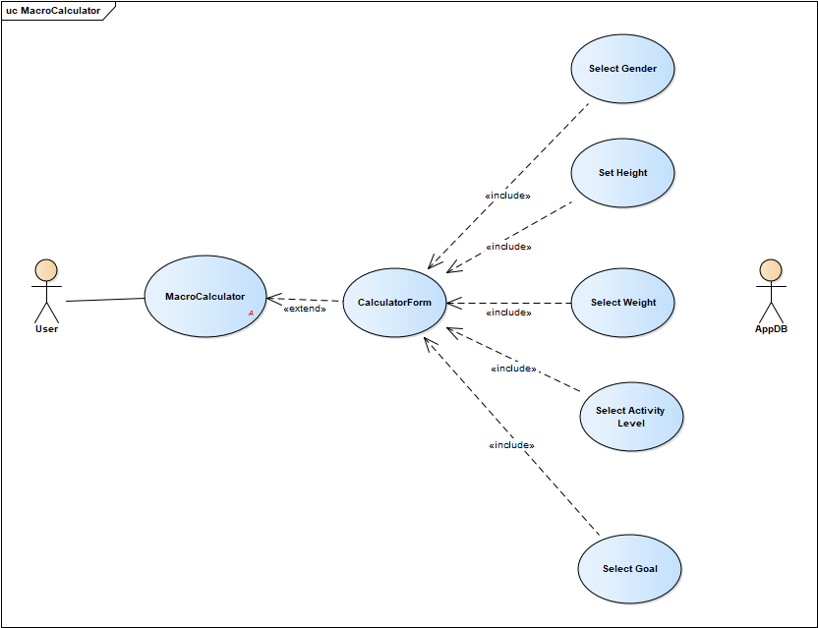

|  |  |
| --- | --- |
| **User usecase Macro Calculator** | |
| Actors | User |
| Description | An user input some information(gender, weight,…) to calculate |
| Data | User’s input |
| Stimulus | Interface include input form and submit button |
| Response | Message: result and recommend macronutrient ratio |
| Comments | The user must input their state’s information of fitness into the form for calculating. Some system, users just need input their age and gender and using digital scale and ruler for more accurate calculation |

User usecase timer

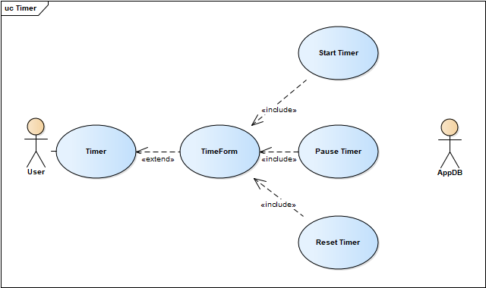

|  |  |
| --- | --- |
| **User usecase timer** | |
| Actors | User |
| Description | An user can set time for their exercise and schedule their routine for keeping fit |
| Data | User’s input |
| Stimulus | Interface include input form (start/pause/reset time) |
| Response | time form |
| Comments | The user must set time for exercise for more effective execise and schedule their time for that. Some system, the system automatically set time for user for optimal exercise |

User usecase calculate BMI

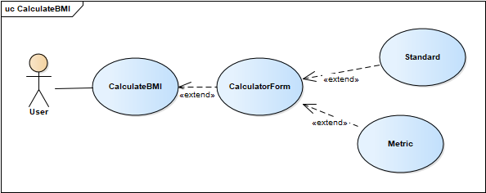

|  |  |
| --- | --- |
| **User usecase calculate BMI** | |
| Actors | User |
| Description | An user input their weight,height,… by choosing type of input(standard and metric) |
| Data | User’s input |
| Stimulus | Interface include input form and submit button |
| Response | Result and recommendation that is more suitable for healthy state |
| Comments | The user must choose inputing type (standard(inches, pounds) and metric (cm, kg)) and input their height and weight. Some system, The height and weight are inputed automatically by using digital scale and ruler |