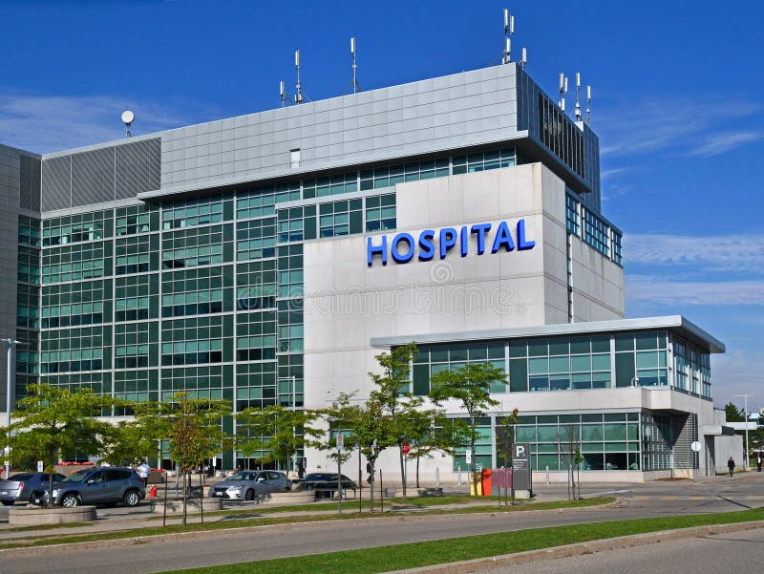  Smart Hospital Patient Triage System  Comparing Priority Queue and Tree-Based Priority Grouping for Emergency Patient Ordering | Abstract  Emergency departments must manage patients according to medical urgency rather than simple arrival order. However, fairness must still be preserved when patients have the same triage priority. This mini-report presents a Smart Hospital Patient Triage System implemented as a Java console-based program using core data structures and algorithmic scheduling principles. The system supports patient registration, patient record management, fast lookup, triage priority assignment, priority-based queue management, re-triage, queue display, status tracking, and discharge management. The main data structures include a doubly linked list for flexible patient records, a HashMap for average O(1) patient lookup by ID, a sorted linked-list priority queue with arrival-time tie-breaking, and a FIFO discharge queue. The study compares this design with an alternative Tree<Priority, Queue<Patient>> structure. Experimental results show that the tree-based grouping structure performs better for larger input sizes, reaching 15.293 ms at n = 10000 compared with 176.848 ms for the sorted linked-list priority queue. The findings suggest that both structures preserve priority and fairness, but the tree-based design scales better for larger workloads, while the sorted linked-list priority queue remains simpler and suitable for smaller systems.  Bui Dinh Long, Duong Thi Ngoc Thom, Nguyen Dinh Thien Phuc, Nguyen Ha Huu Thuan  CSD201 – SE2035 – Mentor: Vũ Thị Thùy Dương

Table of Contents
I. Introduction 1
II. Methodology 1
A. System Design 1
B. Data Structures Selected 2
C. Algorithms Implemented 3
D. Experiment Setup 5
III. Results 5
IV. Discussion 7
V. Conclusion 8
References 8

I. Introduction
Emergency departments must handle patients under time pressure, limited resources, and changing levels of medical urgency. In this environment, a simple first-come, first-served queue is not suitable because a patient with a critical condition may need treatment before another patient who arrived earlier but has a less urgent condition. Previous studies on emergency department queueing and performance also show that patient flow, waiting time, length of stay, and triage efficiency are important concerns in emergency care [1], [3], [4]. Therefore, a triage system needs to support priority-based ordering while still preserving fairness among patients with the same priority level.
This project focuses on a console-based Smart Hospital Patient Triage System implemented in Java. The system supports patient registration, triage priority assignment, patient record management, fast patient lookup, priority-based queue management, patient status tracking, re-triage, queue display, and discharge management. The project does not aim to build a full hospital information system or medical diagnosis system. Instead, its objective is to evaluate how different data structure choices affect emergency patient ordering.
The research question of this report is: How does the choice between a Priority Queue with arrival-time tie-breaking and a Tree<Priority, Queue<Patient>> affect the efficiency, fairness, and re-triage handling of a hospital emergency patient triage system?
This paper is organized as follows. Section II describes the system design, selected data structures, implemented algorithms, and experiment setup. Section III presents the experimental results and discusses observed time complexity. Section IV analyzes the findings, limitations, and possible improvements. Section V concludes the report and answers the research question.

II. Methodology

A. System Design
The Smart Hospital Patient Triage System is designed as a modular object-oriented Java system. Each class is responsible for a specific part of the triage workflow, including patient information storage, patient status tracking, priority-based treatment ordering, queue display, and discharge processing. The system design is based on the UML class diagram from Report 2 and the finalized use case, sequence, and activity diagrams from Report 3.
The main entity class is Patient, which stores basic patient information such as patient ID, name, gender, date of birth, symptoms, and contact information. PatientNode stores a Patient object and includes prev and next references so that patient records can be managed in a doubly linked list. PatientRecord manages the full patient record list and also uses a HashMap<String, PatientNode> to support fast patient lookup by ID.
PatientStatusNode stores the current treatment status of a patient, such as WAITING, UNDER_TREATMENT, or DISCHARGED. PatientStatusList manages these status nodes using linked storage, allowing the system to update and search patient states during the treatment process. TriageNode stores a PatientStatusNode, a priority level, and an arrival-time counter. TriagePriorityQueue manages the active emergency queue by keeping patients sorted according to medical priority and arrival time. Higher-priority patients are placed before lower-priority patients, while arrival time is used to preserve FIFO fairness among patients with the same priority. Since the highest-priority patient is always kept at the head of the queue, dequeue can be performed in O(1) time.
DischargeQueue is used as a FIFO buffer for patients who have completed treatment. This separates discharge processing from the active emergency queue and prevents completed cases from affecting current triage operations.
The alternative design uses TreeMap<PriorityEnum, Queue<PatientStatusNode>>. In this structure, patients are grouped by priority level, and each priority group stores patients in FIFO order. This design reduces unnecessary traversal because patients can be inserted directly into their priority group, making it more scalable for larger workloads.

B. Data Structures Selected
Table I. Selected Data Structures and Their System Roles
Data Structure | Java Implementation | Use Case in System | Time Complexity (Key Op)
Doubly Linked List | Custom PatientNode with prev and next | Store and update patient records | Insert at head: O(1); traversal search: O(n)
HashMap | HashMap<String, PatientNode> | Search patient by ID | Average search: O(1)
Sorted Linked-List Priority Queue | Custom TriagePriorityQueue | Maintain treatment order by priority and arrival time | Enqueue: O(n); Dequeue: O(1)
FIFO Queue | Custom DischargeQueue with head and tail | Store discharged patients before final processing | Enqueue: O(1);  Dequeue: O(1)
Tree-Based Priority Grouping | TreeMap<PriorityEnum, Queue<PatientStatusNode>> | Alternative triage structure grouped by priority | Insert: O(log p);  Dequeue: O(log p), where p is number of priority levels
Linked Status List | Custom PatientStatusList | Track waiting, treatment, and discharged states | Insert: O(1);  search: O(n)

The doubly linked list is selected because patient records may need flexible insertion, update, deletion, and traversal. The HashMap improves patient lookup by avoiding repeated linear search when searching by patient ID. The sorted linked-list priority queue directly maintains the full treatment order. Patients with higher priority are placed before lower-priority patients, while arrival time is used as a tie-breaker for equal-priority patients. The FIFO discharge queue is used because discharge processing follows normal first-in-first-out order. The TreeMap-based alternative is included because it groups patients by priority and naturally preserves FIFO order inside each priority group. The complexity discussion follows standard algorithm analysis [2], and the Java collection choices such as HashMap and TreeMap are aligned with the Java SE 8 API Specification [5].

C. Algorithms Implemented
The main algorithms are patient registration, patient lookup, priority queue insertion, dequeue, re-triage, and discharge.
Algorithm 1: Enqueue Patient into Sorted Priority Queue
ALGORITHM enqueue(patientStatusNode, priority)
insertionCounter ← insertionCounter + 1
newNode ← new TriageNode(patientStatusNode, priority, insertionCounter)
IF queue is empty OR newNode has higher priority than head THEN
newNode.next ← head
head ← newNode
RETURN
END IF
iterator ← head
WHILE iterator.next is not null AND newNode does not have higher priority than iterator.next DO
iterator ← iterator.next
END WHILE
newNode.next ← iterator.next
iterator.next ← newNode
END ALGORITHM
This algorithm inserts the new patient into the correct position based on priority and arrival time. Its worst-case time complexity is O(n) because it may need to scan the queue to find the correct insertion position.
Algorithm 2: Dequeue Next Patient
ALGORITHM dequeue()
IF queue is empty THEN
RETURN null
END IF
result ← head
head ← head.next
RETURN result
END ALGORITHM
This operation is O(1) because the highest-priority patient is always stored at the head of the queue.
Algorithm 3: Update Triage Priority
ALGORITHM updatePriority(patientStatusNode, newPriority)
oldNode ← searchTriage(patientStatusNode)
removeTriageNode(oldNode)
enqueue(patientStatusNode, newPriority)
END ALGORITHM
This algorithm supports re-triage when a patient’s condition changes. It removes the old queue entry and reinserts the patient using the new priority. Its worst-case time complexity is O(n) for the sorted linked-list implementation.
For the TreeMap alternative, each priority level stores a FIFO queue:
ALGORITHM treeEnqueue(patientStatusNode, priority)
IF tree does not contain priority THEN
tree[priority] ← new Queue
END IF
tree[priority].enqueue(patientStatusNode)
END ALGORITHM
This structure makes FIFO fairness natural inside each priority group. Since the number of priority levels is small, the practical cost is low.

D. Experiment Setup
The experiment compares two triage queue structures:
Algorithm A: Sorted Linked-List Priority Queue with arrival-time tie-breaking.
Algorithm B: Tree<Priority, Queue<Patient>>, implemented as TreeMap<PriorityEnum, Queue<PatientStatusNode>>.
The input sizes are 100, 500, 1000, 5000, and 10000 patients. Each experiment is repeated for five trials, and the average execution time is recorded in milliseconds. The workload includes inserting patients, updating selected patient priorities, and dequeuing patients. FIFO fairness is checked by confirming that patients with the same priority are served according to their arrival order. The test environment is Java 8, NetBeans 13, Windows 11, and an Intel Core processor.

III. Results
Table II. Experimental Results
Input Size (n) | Priority Queue + Arrival Time (ms) | Tree<Priority, Queue<Patient>> (ms)
100 | 0.029 | 0.023
500 | 0.346 | 0.120
1000 | 1.423 | 0.306
5000 | 45.769 | 4.659
10000 | 176.848 | 15.293

Figure 2 Execution time comparison between Priority Queue with arrival-time tie-breaking and Tree<Priority, Queue<Patient>>.

The results show that the Tree<Priority, Queue<Patient>> structure performed faster than the Priority Queue with arrival-time tie-breaking for all tested input sizes. At n = 100, the difference was small: Algorithm A required 0.029 ms, while Algorithm B required 0.023 ms. However, the performance gap became much larger as the input size increased. At n = 10000, Algorithm A required 176.848 ms, while Algorithm B required only 15.293 ms.
This trend matches the theoretical expectation. In the sorted linked-list priority queue, inserting a patient may require traversal to find the correct position based on priority and arrival time. As the number of patients increases, this traversal cost becomes more visible. In contrast, the tree-based priority grouping structure places patients into priority groups and stores equal-priority patients in FIFO queues. Since the number of priority levels is limited, this structure avoids much of the repeated traversal cost found in the sorted linked-list implementation.
Both structures preserved FIFO fairness among patients with the same priority. Algorithm A achieved this by storing arrival time inside each TriageNode and comparing it when priority values were equal. Algorithm B achieved this naturally by using a FIFO queue inside each priority group.

IV. Discussion
The experimental results show a clear trade-off between simplicity and scalability. The sorted linked-list priority queue is easy to implement and directly maintains the full treatment order. Its main advantage is that dequeue is O(1), because the next patient is always stored at the head of the queue. This makes the structure suitable for small or medium emergency queues where implementation simplicity and direct queue display are important.
However, the results show that the sorted linked-list design becomes slower as the input size increases. This is mainly because insertion and re-triage require traversal. When many patients are inserted or updated, the O(n) cost becomes significant. The chart confirms this behavior because the execution time of Algorithm A rises sharply from 45.769 ms at n = 5000 to 176.848 ms at n = 10000.
The tree-based priority grouping structure scales better for larger input sizes. Since patients are grouped by priority, the system does not need to scan the entire queue to place every new patient. FIFO fairness is also easier to maintain because each priority group has its own FIFO queue. This makes Algorithm B more efficient for larger workloads.
The main limitation of this project is that the experiment uses generated test data rather than real hospital records. The system is also implemented as a console-based Java program, so it does not include database storage, user authentication, web interface, real-time monitoring, or integration with hospital information systems. Another limitation is that priority is manually assigned rather than predicted from medical data. Future work could improve the system by adding persistent storage, a graphical or web-based interface, and more detailed triage criteria. A hybrid design could also be explored, combining direct patient lookup with tree-based grouping and efficient removal for re-triage.

V. Conclusion
This mini-report presented a Smart Hospital Patient Triage System that manages emergency patients using priority-based data structures. The system supports patient registration, fast lookup, status tracking, queue display, re-triage, and discharge management. The research question asked how the choice between a Priority Queue with arrival-time tie-breaking and a Tree<Priority, Queue<Patient>> affects efficiency, fairness, and re-triage handling. Based on the experiment, the tree-based priority grouping structure is more efficient for larger input sizes, while the sorted linked-list priority queue is simpler and still suitable for smaller workloads. Both structures preserve FIFO fairness among patients with equal priority. Overall, the project shows that data structure selection has a direct impact on emergency triage queue performance and should be matched to expected system size and update frequency.

References
[1] A. Elalouf and G. Wachtel, “Queueing Problems in Emergency Departments: A Review of Practical Approaches and Research Methodologies,” SN Operations Research Forum, vol. 3, no. 1, Art. no. 2, 2022.
[2] T. H. Cormen, C. E. Leiserson, R. L. Rivest, and C. Stein, Introduction to Algorithms, 3rd ed. Cambridge, MA, USA: MIT Press, 2009.
[3] J.-K. Kim, “Enhancing Patient Flow in Emergency Departments: A Machine Learning and Simulation-Based Resource Scheduling Approach,” Applied Sciences, vol. 14, no. 10, Art. no. 4264, 2024.
[4] E. E. Austin, B. Blakely, C. Tufanaru, A. Selwood, J. Braithwaite, and R. Clay-Williams, “Strategies to measure and improve emergency department performance: a scoping review,” Scandinavian Journal of Trauma, Resuscitation and Emergency Medicine, vol. 28, Art. no. 55, 2020.
[5] Oracle Corporation, “Java Platform, Standard Edition 8 API Specification,” Oracle. [Online]. Available: https://docs.oracle.com/javase/8/docs/api/. [Accessed: Jun. 29, 2026].

