**SV: Trần Thị Ngoc Trang**

MSSV: 21133109

**Cài đặt Hadoop Ecosystem**

# **Cài đặt OpenJDK**

# apt update

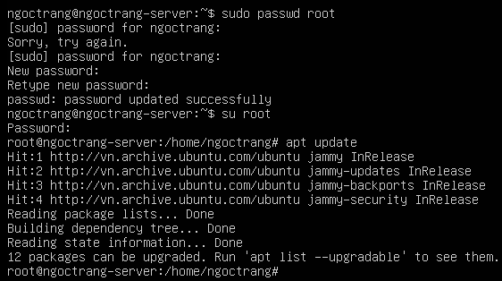

# reboot

# **apt install default-jdk**

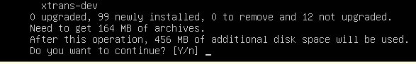

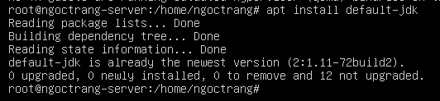

# **Cài đặt SSH**

# apt-get install ssh

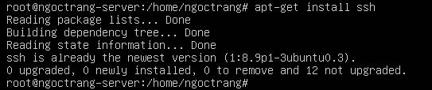

# apt install openssh-server

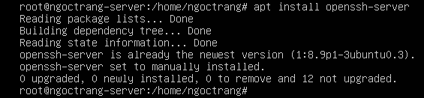

# reboot

# vim /etc/ssh/sshd_config

# service sshd restart

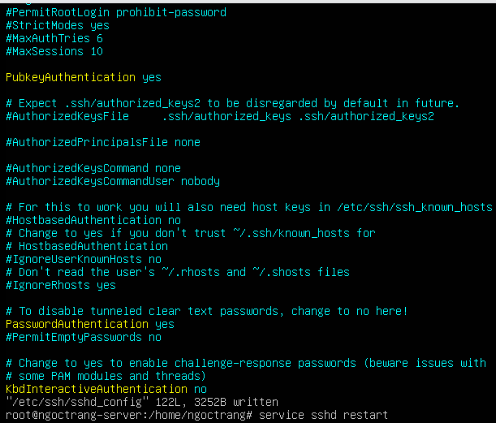

# **Tạo user hadoop**

# adduser hadoopngoctrang

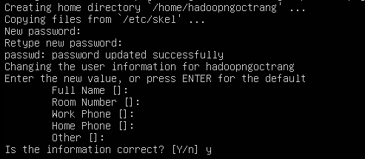

# **Cài đặt Hadoop 3.3.6**

# su hadoopngoctrang

wget <https://dlcdn.apache.org/hadoop/common/hadoop-3.3.6/hadoop-3.3.6.tar.gz>

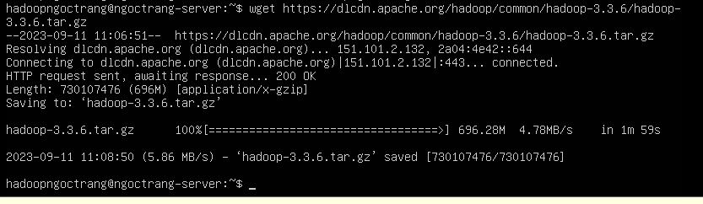

# tar -xzf hadoop-3.3.6.tar.gz

# mv hadoop-3.3.6 hadoop



# **Thiết lập JAVA_HOME**

# vim ~/hadoop/etc/hadoop/hadoop-env.sh

# export JAVA_HOME=/usr/lib/jvm/java-1.11.0-openjdk-amd64

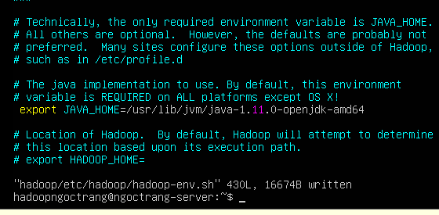

# **Standalone Operation**

# mkdir input

# cp hadoop/etc/hadoop/*.xml input

# hadoop/bin/hadoop jar hadoop/share/hadoop/mapreduce/hadoop-mapreduce-examples-3.3.6.jar grep input output 'dfs[a-z.]+'

# cat output/*





# **Pseudo-Distributed Operation**

# ssh-keygen -t rsa -P ""

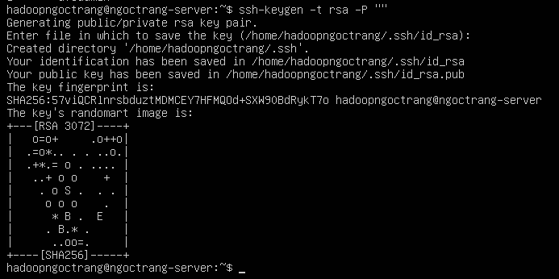

# cat /home/hadoopngoctrang/.ssh/id_rsa.pub >> /home/hadoopngoctrang/.ssh/authorized_keys

# chmod 600 /home/hadoopngoctrang/.ssh/authorized_keys



## **Cấu hình core-site.xml**

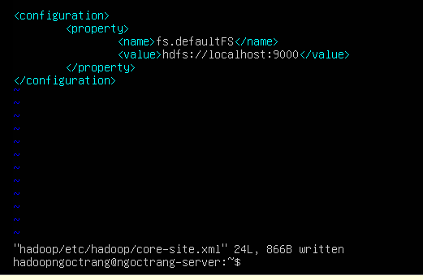

## **Câu**

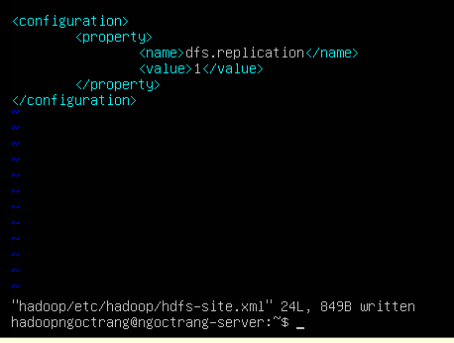

## 

$ hadoop/bin/hdfs namenode -format

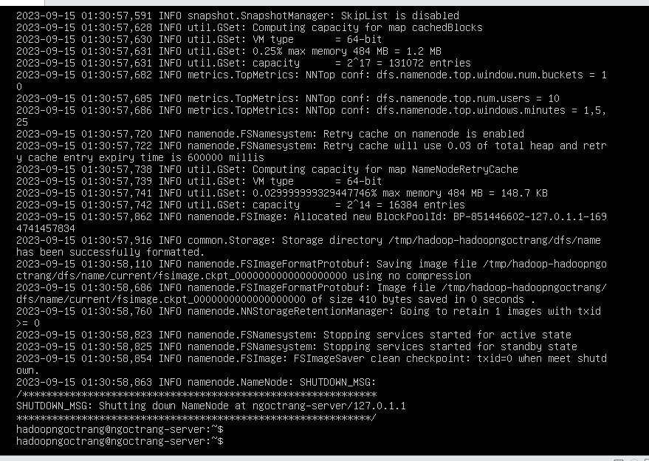

$ hadoop/sbin/start-dfs.sh

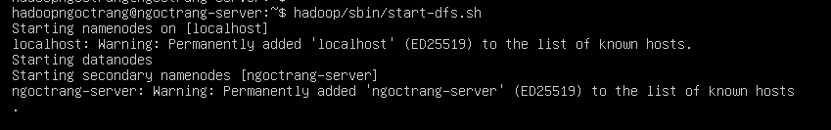

$ jps

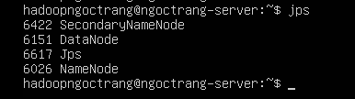

$ ~/hadoop/bin/hdfs dfsadmin -report

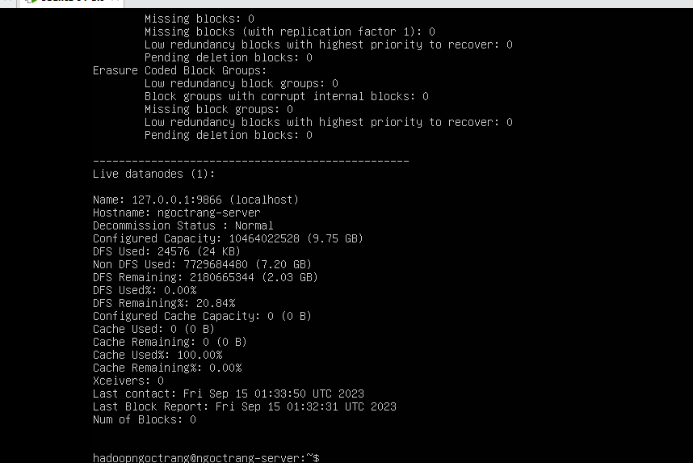

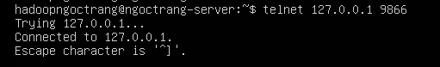

$ ~/hadoop/bin/hdfs dfs -mkdir /user

$ ~/hadoop/bin/hdfs dfs -mkdir /user/hadoopngoctrang

$ ~/hadoop/bin/hdfs dfs -mkdir /user/hadoopngoctrang/input



$ ~/hadoop/bin/hdfs dfs -put hadoop/etc/hadoop/*.xml /user/hadoopngoctrang/input



$ ~/hadoop/bin/hadoop jar hadoop/share/hadoop/mapreduce/hadoop-mapreduce-examples-3.3.6.jar grep input **output** ‘dfs[a-z.]+’

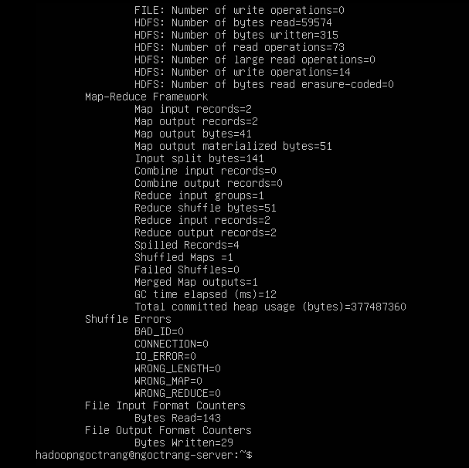

vim

$ ~/hadoop/bin/hdfs dfs -get output/ **output**

$ cat output/*

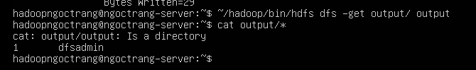

$ hadoop/sbin/stop-dfs.sh

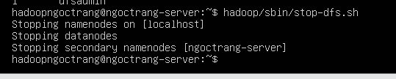

## **B**

## **vim ~/.bashrc**

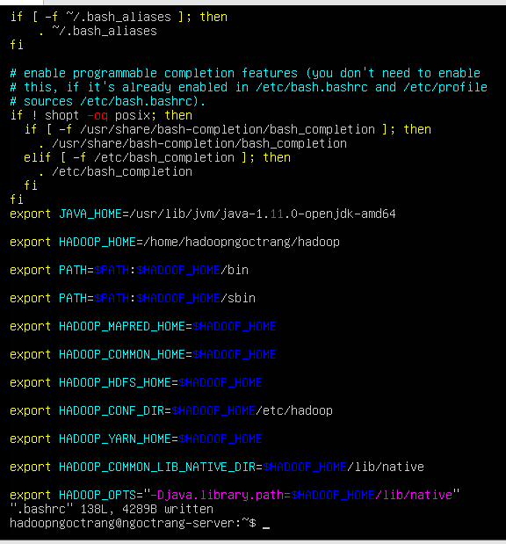

$ vim hadoop/etc/hadoop/mapred-site.xml

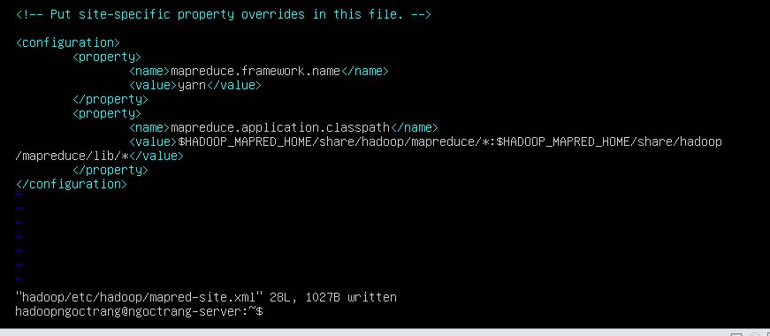

## **Cấu hình file yarn-site.xml**

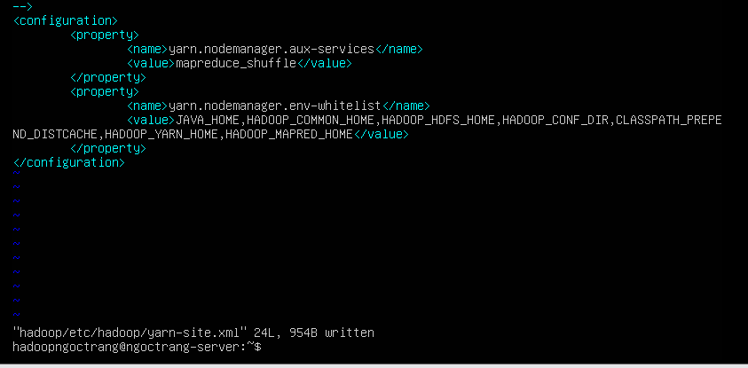

$ hadoop/sbin/start-dfs.sh

$ hadoop/sbin/start-yarn.sh

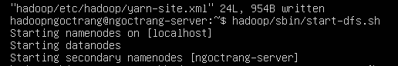

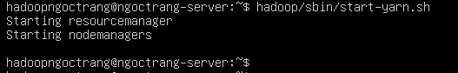

$ rm -rf output

$ ~/hadoop/bin/hdfs dfs -rm -r /user

$ ~/hadoop/bin/hdfs dfs -mkdir /user

$ ~/hadoop/bin/hdfs dfs -mkdir /user/hadoopngoctrang

$ ~/hadoop/bin/hdfs dfs -mkdir /user/hadoopngoctrang/input



$ ~/hadoop/bin/hdfs dfs -put hadoop/etc/hadoop/*.xml /user/hadoopngoctrang/input



$ ~/hadoop/bin/hadoop jar hadoop/share/hadoop/mapreduce/hadoop-mapreduce-examples-3.3.6.jar grep input **output** ‘dfs[a-z.]+’

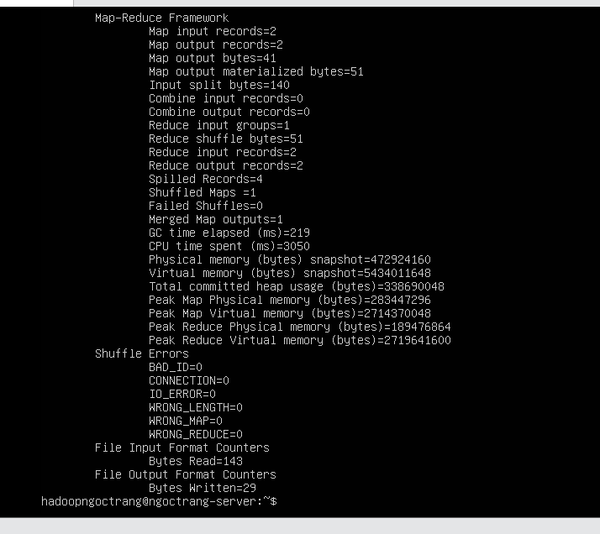

$ ~/hadoop/bin/hdfs dfs -get output/ **output**

$ cat output/*

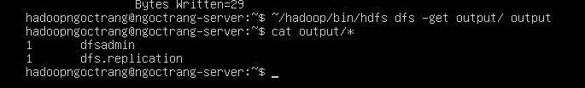

$ hadoop/sbin/stop-dfs.sh

$ hadoop/sbin/stop-yarn.sh

