BUSINESS REQUIREMENTS,
Prepared for Tripto
Sunday, Mar 22, 2026
Version 1.0

Prepared by
Vo Xuan Ngoc
Hoang Quang Nghia
Revision History
Date | Version | Author | Change Description
22/03/2026, 09:00 PM | 0.1 | Hoang Quang Nghia | Initial creation
16/05/2026, 11:00 PM | 0.2 | Vo Xuan Ngoc | Format
Approval
Date | Version | Approver Name | Position
20/11/2023 | 0.1 |  | Application Owner
20/11/2023 | 0.1 |  | ITPM
21/11/2023 | 0.2 |  | Application Owner
21/11/2023 | 0.2 |  | ITPM

Table of Contents
1 Objective and Scope 4
2 Business Requirement 4
2.1. Application Overview 4
2.2. Domain Model 5
2.2.1. Diagram 5
2.2.2. Domain Objects Description 5
2.3. Workflow 7
2.4. Use Cases and Actors 7
2.4.1. Diagram 7
2.4.2. Description of Actors 8
2.4.3. Description of Use Cases 8
2.5. Security Matrix 9
2.6. User Story 11
2.7. Change Requirement 12
3 Appendix 13
3.1. Glossary 13
3.2. Open Issues 13

Objective and Scope
This document specifies the business requirements for the Tripto Hotel Booking System. The application is built using a Microservices architecture with gRPC to ensure high performance and scalability. The scope includes user management, hotel listing management, real-time booking, and administrative oversight.

Business Requirement

Application Overview
Tripto is an online hotel booking platform that allows customers to search for hotels, view hotel and room details, make reservations, complete payment, manage booking history, and review hotels after their stay.
Customers can search for hotels by destination, stay dates, number of guests, and room quantity. After choosing a suitable hotel, customers can view detailed hotel information, available room types, prices, amenities, policies, and customer reviews. Customers can then create a booking by selecting rooms, entering contact and guest information, and choosing a payment method. The system supports online payment through VNPay and payment at the hotel. Customers can also view their booking history and submit hotel reviews for completed stays.
Hotel owners can manage their hotels through the host management area. They can create and update hotel information, manage room types, view bookings made for their hotels, confirm onsite payments, update booking statuses such as check-in and check-out, and view customer reviews for hotels they own.
Administrators can manage the platform by reviewing hotel registration requests, approving or rejecting hotel information, monitoring system data, and accessing administrative statistics and reports. This helps ensure that hotel information shown to customers is valid and reliable.
Tripto also includes supporting features such as user authentication, profile management, password reset, loyalty points, booking payment tracking, room availability holding, and notification-related processing. These features help customers complete bookings safely while allowing hotel owners and administrators to manage hotel operations efficiently.

Domain Model

Diagram
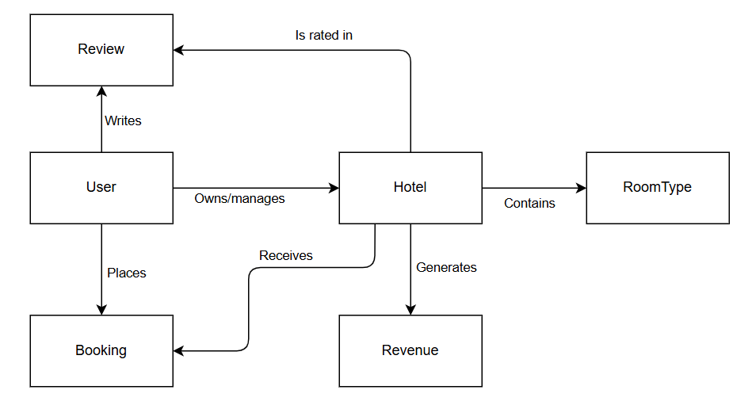

Domain Objects Description
# | Object Name | Object Description
1 | User | Core entity for authentication and roles.
2 | Hotel | Property details including location, star rating, and policies.
3 | Room type | Categorization of rooms (Deluxe, Suite) with pricing logic.
4 | Booking | Transactional record of a stay.
5 | Review | Customer feedback and rating data.
6 | Revenue | Financial data for reporting.

Use Cases and Actors

Diagram
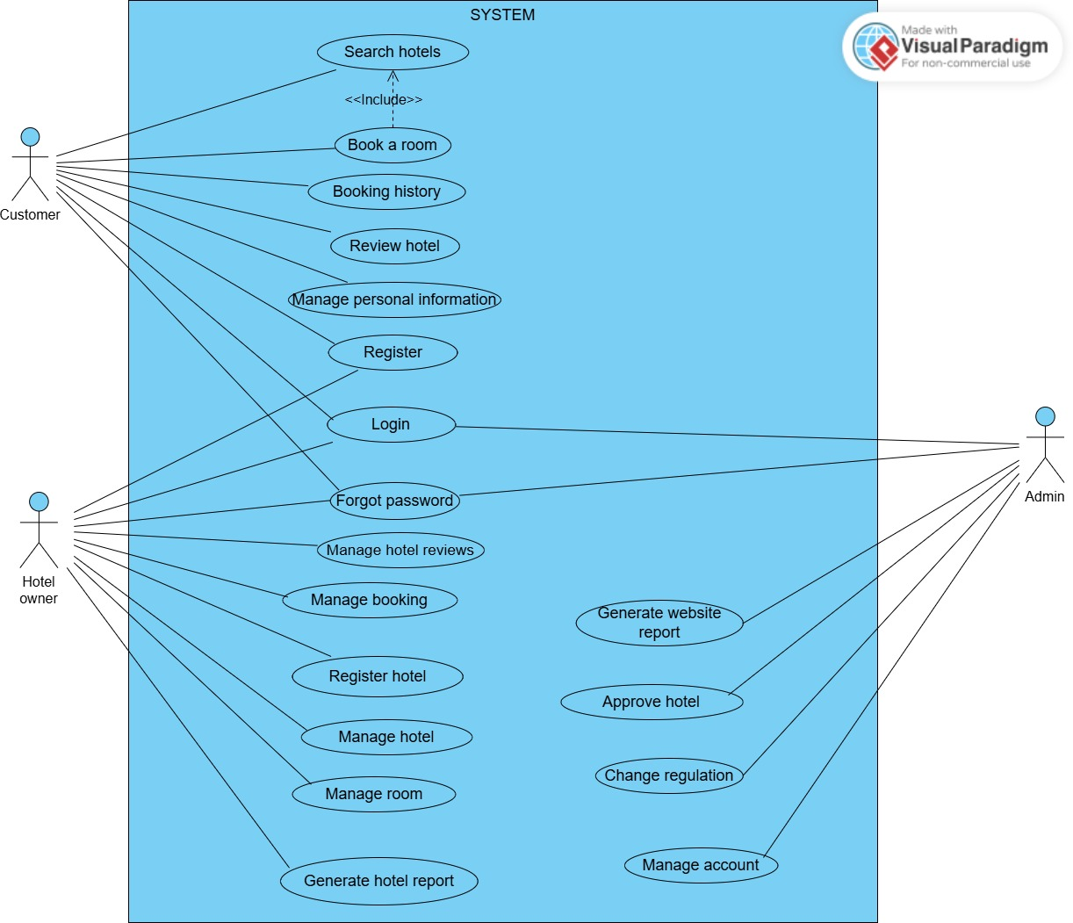

Description of Actors
# | Actor Name | Definition
1 | Customer | End-user seeking accommodation.
2 | Hotel Owner | Business user providing lodging services.
3 | Admin | System overseer and moderator.

Description of Use Cases
ID | Use Case Name | Actor | Description
UC01 | Login | All Actors | The user logs in to the system using a valid username/email and password.
UC02 | Register | Customer | The customer registers a new account and verifies the account email using OTP.
UC03 | Forgot Password | All Actors | The user requests to reset their password, verifies their identity using an OTP sent to their registered email, and sets a new password.
UC04 | Search Hotels | Customer | The user searches for hotels by destination or hotel name, stay dates, number of guests, and number of rooms.
UC05 | Book a Room | Customer | The customer books a hotel room through the system after selecting a hotel and room, entering contact information, and choosing a payment method.
UC06 | Booking History | Customer | The customer views the list of hotel bookings they have made in the system.
UC07 | Review Hotel | Customer | The customer submits a rating and written review for a hotel after completing their stay.
UC08 | Manage Personal Information | Customer | The customer views and updates their personal account information, including full name, phone number, birthday, gender, country, address, loyalty point summary, and password. The email address is displayed but cannot be edited.
UC09 | Manage hotel reviews | Hotel Owner | The hotel owner views the list and content of customer reviews submitted for hotels they own.
UC10 | Register Hotel Owner | Hotel Owner | Specialized registration for business entities and partners.
UC11 | Update Hotel | Hotel Owner | Hotel owners update overall information for the hotels they own.
UC12 | Add room | Hotel Owner | The hotel owner added more rooms to the hotel.
UC13 | Update room | Hotel Owner | The hotel owner updates the hotel room listings.
UC14 | Deactivate/Activate room | Hotel Owner | The hotel owner can deactivate/activate the hotel rooms.
UC15 | Manage Bookings | Hotel Owner | The hotel owner monitors customer bookings for hotels they own, views booking details, confirms onsite hotel payments, and updates stay progress when allowed by the booking status.
UC16 | Generate hotel reports | Hotel Owner | The hotel owner compiles and reports on revenue and bookings over time.
UC17 | Generate website reports | Admin | The administrator compiles system-wide reports including the number of users, hotels, transactions, etc.
UC18 | Approve hotel | Admin | Admins review and approve new hotel registration requests from hotel owners.
UC19 | Deactivate/Activate accounts | Admin | Admin can deactivate/activate user and hotel owner accounts.
UC20 | Change regulations | Admin | Admins update system regulations such as service fees, hotel listing rules, or price limits.

Security Matrix
Actor  Function | Admin | Hotel Owner | Customer
Login | x | x | x
Register |  | x | x
Forgot password | x | x | x
Search hotels |  |  | x
Book a room |  |  | x
Booking history |  |  | x
Review hotel |  |  | x
Manage personal information |  |  | x
Manage hotel reviews |  | x
Manage booking |  | x
Register Hotel Owner |  | x
Update Hotel |  | x
Add room |  | x
Update room |  | x
Deactivate/Activate room |  | x
Generate hotel reports |  | x
Generate website reports | x
Approve hotel | x
Deactivate/Activate accounts | x
Change regulations | x

User Story
No. | User Story
1 | As a new user, I want to create an account requiring email verification, so that I can ensure no one else can sign up using my identity
2 | As a registered user, I want to log in within 500ms so that I can access the platform without frustrating delays.
3 | As a user who forgot their password, I want to reset it via a secure multi-factor verification so that my account recovery process cannot be hijacked.
4 | As a registered user, I want to log out from my current session so that my account cannot be reused from the same browser session, with the session token removed immediately after logout.
5 | As a customer, I want to update my personal information so that my account profile stays accurate, with invalid phone numbers, passwords, or required fields rejected before saving.
6 | As a customer, I want to search hotels by destination, stay dates, guests, and room quantity so that I can find suitable accommodation, with search results returned within 2 seconds under normal load.
7 | As a customer, I want to view hotel details, room types, prices, amenities, policies, and reviews so that I can make a booking decision, with the hotel detail page remaining usable even if review data fails to load.
8 | As a customer, I want room availability to be temporarily held during booking and payment so that another customer cannot take the same room, with expired holds automatically released or cancelled.
9 | As a customer, I want booking creation and payment processing to remain consistent so that I am not charged for a room that is not reserved, with successful payments confirming the booking and failed payments leaving it unconfirmed.
10 | As a customer, I want to use loyalty points during booking so that I can reduce the payable amount, with the system validating point balance and applying the discount accurately before payment confirmation.
11 | As a customer, I want to pay through VNPay or pay at the hotel so that I can choose my preferred payment method, with sensitive online payment data handled outside Tripto’s main database.
12 | As a customer, I want to view my booking history so that I can track previous and current reservations, with the history list loaded without noticeable slowing down other booking operations.
13 | As a customer, I want to view booking details with a clear, printable UI so that I have a physical copy of my reservation.
14 | As a customer, I want to submit a hotel review after completing my stay so that I can share my experience with other users, with duplicate reviews for the same booking prevented.
15 | As a customer, I want to receive booking notifications reliably even during high traffic periods so that I never miss an update.
16 | As a hotel owner, I want to register by uploading verified business documents so that the platform maintains high-quality listings.
17 | As a hotel owner, I want to upload high-quality media for my listing without negatively impacting the page load performance, so that potential guests always have a fast and smooth browsing experience.
18 | As a hotel owner, I want to update my hotel details seamlessly in the background, so that customers never encounter a broken page or a 'maintenance' message while I am making changes.
19 | As a hotel owner, I want to hide a listing with the ability to restore it later so that I don't lose my data permanently.
20 | As a hotel owner, I want to manage rooms with concurrency protection so that price updates remain consistent across all staff.
21 | As a hotel owner, I want to view booking requests the moment they occur so that I can react to new business without manual refreshing.
22 | As a hotel owner, I want to confirm orders with minimal steps so that the internal processing time is reduced to under 1 minute.
23 | As a hotel owner, I want to update booking stay status to checked-in or checked-out so that the system reflects actual guest stay progress, with status transitions limited to valid business rules.
24 | As a hotel owner, I want to view reviews aggregated into sentiment scores so that I can quickly understand the overall mood.
25 | As a hotel owner, I want to respond to customer reviews so that I can address customer feedback publicly, with each response editable only by the owner who created it.
26 | As a hotel owner, I want to view revenue reports restricted to authorized roles only so that sensitive financial data remains confidential.
27 | As an administrator, I want to manage accounts with full accountability so that I can track every change made in the system.
28 | As an administrator, I want to manage owner accounts automatically cross-checked for legitimacy so that I can ensure only verified businesses are on the platform.
29 | As an administrator, I want to approve hotels without the interface becoming unresponsive, allowing me to continue other tasks while large assets are being processed.
30 | As an administrator, I want to reject registrations with a mandatory reason field so that users receive actionable feedback to resolve their application.
31 | As an administrator, I want to generate complex analytical reports without causing any slowdown or latency to the live booking system used by customers.
32 | As an administrator, I want to update system policies so that changes take effect globally and immediately, ensuring zero downtime or service disruption for active users.
33 | As a customer, I want the core searching and booking process to remain operational even if secondary features (like reviews or recommendations) encounter issues, so that my travel plans aren't interrupted by minor system glitches.

Change Requirement
# | Item Name | Change Description
1
2
3
4
5
6
7

Appendix

Glossary
Term | Description
BRD | Business Requirements Document
RBAC | Role-Based Access Control.
OTP | One-Time Password.

Open Issues

