SOLUTION ARCHITECTURE DOCUMENT
Prepared for Tripto
Sunday, MaY 15, 2026
Version 1.0

Prepared by
Vo Xuan Ngoc
Hoang Quang Nghia
Revision History
Date | Version | Author | Change Description
15/05/2026, 09:00 PM | 1.0 | Vo Xuan Ngoc | Initial creation
Approval
Date | Version | Approver Name | Position

Table of Contents
1. Introduction and Goals 5
1.1. Requirements Overview 5
1.2. Quality Goals 6
1.3. Stakeholders 6
2. Architecture Constraints 7
3. Context and Scope 8
3.1. Business Context 8
3.2. Technical Context 9
4. Solution Strategy 10
5. Building Block View 13
5.1. Whitebox Tripto Hotel Booking System 13
5.2. Level 2: Important Service Responsibilities 15
5.2.1. Auth Service 15
5.2.2 User Service 15
5.2.3. Hotel Service 16
5.2.4. Booking Service and Payment Module 18
5.2.5. Revenue Service 19
5.2.6. Regulations Service 20
5.2.7. Notification Service 20
6. Runtime View 21
6.1. Login 21
6.2. Search hotel 22
6.3. Book a room 22
6.4. Review hotel 23
7. Deployment View 24
7.1. Development environment 24
7.2. Production environment 26
8. Cross-cutting Concepts 28
8.1. Security and Authorization 28
8.2. Data Ownership 28
8.3. Consistency and Transaction Boundaries 29
8.4. Messaging and Eventing 29
8.5. Observability and Operations 29
8.6. Media and File Handling 30
8.7. Planned Extension Points 30
9. Architecture Decisions 30
10. Quality Requirements 32
10.1. Quality Requirements Overview 32
10.2. Quality Scenarios 32
11. Risks and Technical Debts 33
12. Glossary 34

1. Introduction and Goals
Tripto is a web-based hotel booking platform for Customers, Hotel Owners, and Administrators. The system supports hotel discovery, hotel detail browsing, room booking, temporary room holds, VNPay and pay-at-hotel payment flows, booking history, hotel reviews, hotel owner operations, revenue reporting, and platform administration.

1.1. Requirements Overview
The requirements are documented in:
Document | Purpose
BRD | Business scope, actors, domain objects, use cases, security matrix, user story.
SRS | Functional requirements, use case behavior, business rules, messages.
ASR. | Architectural significant requirements mapped to modules.
Utility tree | Quality attribute utility tree with priorities.
ADD | Attribute-driven design scenarios and architectural tactics.

Main functional areas:
Area | Key responsibilities
Identity and Access Management | Register, login, forgot password, OTP verification, JWT issuance, role-based access.
Search and Discovery | Search hotels by destination, date, guest count, and room quantity; view details and reviews.
Booking and Payment | Create bookings, hold inventory, process VNPay or pay-at-hotel payments, manage booking status.
Hotel Owner Portal | Manage hotels, rooms, media, bookings, onsite payment confirmation, and customer review responses.
Content and Media | Store hotel media, hotel policies, reviews, and support documents.
Analytics and Reporting | Generate revenue, occupancy, and platform reports for Hotel Owners and Admins.
System Administration | Approve/reject hotels, manage users, update platform regulations.

1.2. Quality Goals

Priority | Quality goal | Concrete scenario
1 | Reliability and consistency | Prevent double-booking and keep booking, hold, and payment states consistent across VNPay success, VNPay failure, and hold expiration.
2 | Security | Enforce secure password hashing, OTP expiration, JWT validation, and strict owner/admin/customer authorization boundaries.
3 | Performance | Return hotel search results within 2 seconds under normal load and complete login within 500ms under normal load.
4 | Modifiability | Support dynamic regulations and future payment method extension without changing core booking creation logic.
5 | Availability and fault tolerance | Keep search and booking usable when secondary functionality such as reviews or notifications is unavailable.

1.3. Stakeholders
Role/Name | Contact | Expectations
Customer |  | Fast hotel search, safe booking, reliable payment feedback, booking history, and review submission.
Hotel Owner |  | Secure access to owned hotel data only, manageable hotel/room/media workflows, booking visibility, and revenue reports.
Administrator |  | Reliable approval, account governance, platform reporting, and regulation updates.
Development Team |  | Clear service boundaries, traceability to ASR/ADD/SRS, and guidance for planned future features.
Test/UAT Team |  | Observable functional flows, quality scenarios, and clear expected behavior for failure cases.
DevOps/Maintainer |  | Understandable deployment topology, service discovery, configuration, monitoring, and scaling strategy.

2. Architecture Constraints
Contents
Constraint | Description
Microservices backend | Backend code is organized as Spring Boot services: `api-gateway`, `auth-service`, `user-service`, `hotel-service`, `booking-service`, `media-service`, `revenue-service`, `regulations-service`, `notification-service`, `config-server`, `eureka-server`.
Web frontend | Frontend is a Next.js/React application in `checkinn-frontend`, using REST APIs through the API Gateway.
Service discovery | Services register with Eureka and are routed through Spring Cloud Gateway.
Transactional storage | Core data is stored in PostgreSQL using service-owned schemas/entities.
Asynchronous integration | RabbitMQ is used for OTP, payment, booking, revenue, notification, and regulation events.
External payment | VNPay is the online payment gateway; sensitive payment processing stays outside Tripto's main database.
Object storage | Uploaded hotel media/documents are stored outside the relational database using Supabase Storage.
Quality targets | 150 CCU target, search within 2 seconds, login within 500ms, 95% business-hours uptime, Sunday 23:00 maintenance window.
Partial implementation | Some architectural tactics are planned for later iterations, including Redis, Elasticsearch, Circuit Breaker, Kubernetes, Blue/Green deployment, and read-replica/CQRS reporting.

3. Context and Scope

3.1. Business Context
Tripto is the central system used by:
External actor/system | Interaction with Tripto
Guest / Customer | Searches hotels, views details, books rooms, pays, manages profile, reviews stays.
Hotel Owner | Manages hotels, room types, media, bookings, onsite payments, reviews, and revenue reports.
Administrator | Approves hotels, manages users, views platform reports, updates regulations.
VNPay | Receives payment requests and returns payment results.
Email Provider | Sends OTP and booking/payment notifications.
Supabase Storage / Object Storage | Stores hotel images and uploaded documents.

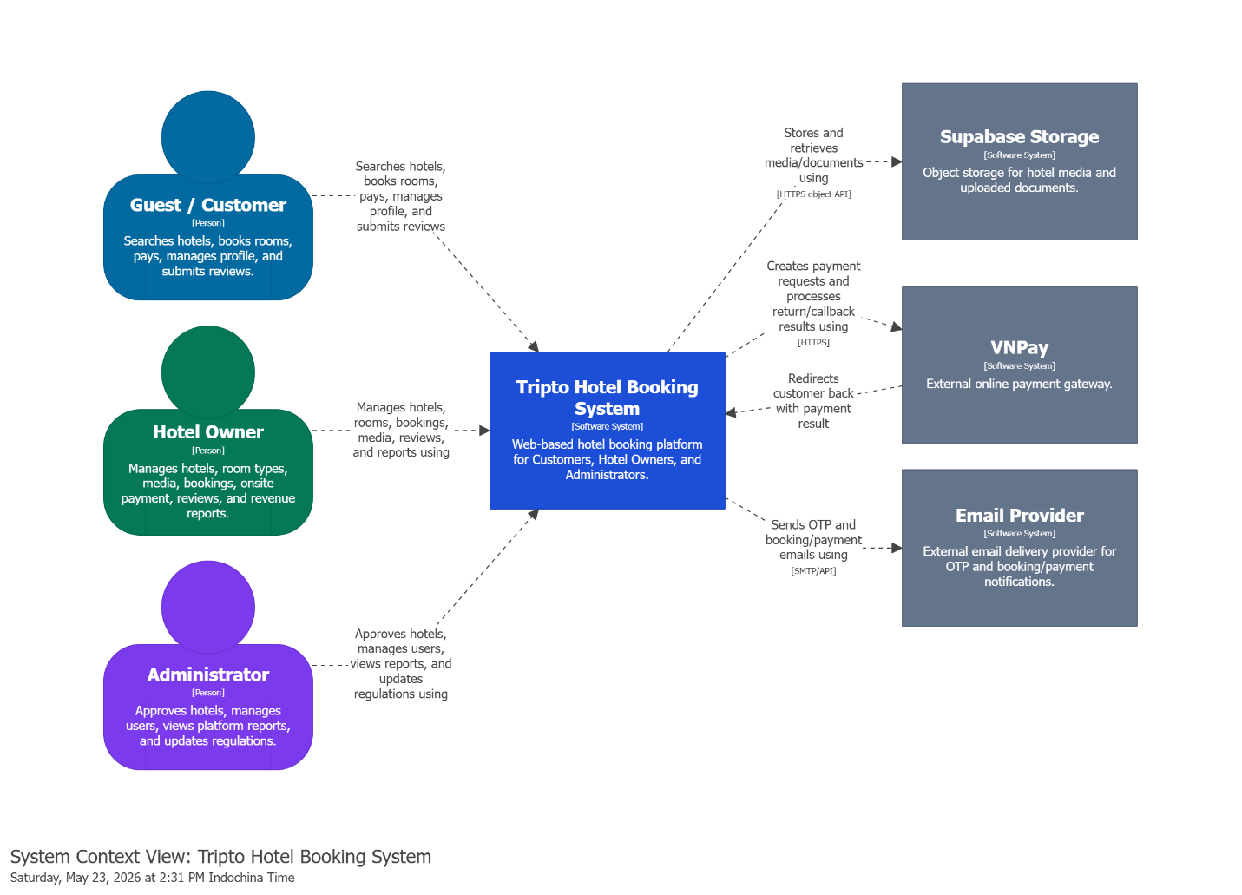

Note:
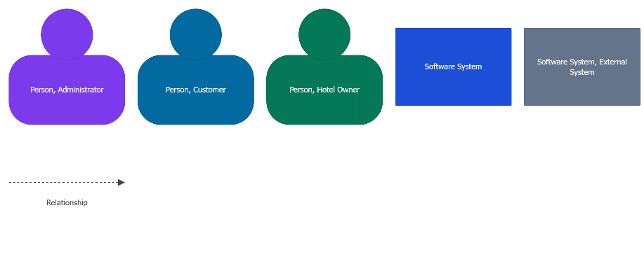

3.2. Technical Context
Contents
Channel | Used by | Purpose
HTTPS/REST | Frontend to API Gateway | Main browser-to-backend communication.
Spring Cloud Gateway routes | API Gateway to services | Route /api/auth, /api/user, /api/bookings, /api/payments, /api/reports, /api/regulations, /api/v1, /hotels, and /cities.
gRPC | Auth/User, Hotel/User, Hotel/Media, Revenue/Hotel, internal booking/payment APIs | Efficient service-to-service calls for internal operations.
RabbitMQ | User, Booking, Regulations, Revenue, Notification | Asynchronous OTP, payment, booking, and regulation events.
PostgreSQL/JPA | Service data layer | Transactional persistence.
Supabase Storage API | Media Service | Binary object upload/delete/retrieve.
VNPay HTTPS flow | Booking Payment Module | Payment URL creation and payment return/callback processing.
SMTP/API | Notification Service | Email delivery.

4. Solution Strategy
Quality goal | Scenario | Solution approach | Link to Details
Modifiability | New hotel, booking, payment, reporting, regulation, or notification features must be added without forcing one large monolithic change. | Decompose the backend into microservices by business capability: Auth, User, Hotel, Booking, Media, Revenue, Regulations, Notification, Gateway, Config, Eureka, and Admin Server. | Building Block View, Design Decisions
Security | Customers, Hotel Owners, and Admins access different features and data scopes. Hotel Owners must not access other owners' hotels, bookings, reviews, or revenue. | Use API Gateway routing, JWT-based identity, service-level validation, and RBAC/ownership checks at resource boundaries. | Cross-cutting Concepts - Security and Authorization, Quality Requirements
Reliability | Multiple customers may try to book the last available room, and VNPay may fail or return an unsuccessful payment result. | Create a room hold before payment, store booking/payment states explicitly, validate active holds before payment attempts, and confirm/release holds through Hotel Service availability APIs. | Runtime View, Booking Service and Payment Module
Modifiability | The business wants to add future payment methods beyond VNPay and pay-at-hotel. | Keep payment behavior inside a Payment Module and use a payment creation policy/factory so new payment methods can be added locally. | Booking Service and Payment Module, Design Decisions
Performance | Search should return results within 2 seconds, login should complete within 500ms, and the system should support 150 CCU. | Use API Gateway and stateless service instances with Eureka; keep search in Hotel Service today and allow a future Elasticsearch index and horizontal scaling through a load balancer/container platform. | System Scope and Context, Deployment View, Quality Requirements
Scalability | Hotel media and support documents grow independently from transactional business data. | Store binary files in object storage through Media Service and keep only metadata/URLs in PostgreSQL. | Cross-cutting Concepts - Media and File Handling, Deployment View
Interoperability | OTP email, payment notification, revenue ingestion, and regulation propagation should not block user-facing flows. | Use RabbitMQ events to decouple notification, reporting, and regulation update processing from synchronous API requests. | Cross-cutting Concepts - Messaging and Eventing, Runtime View
Availability | Secondary features such as reviews, notifications, or reporting may fail while search and booking should remain usable. | Apply graceful degradation in the frontend and plan Circuit Breaker support for service-to-service calls. Use scheduled maintenance and future Blue/Green deployment to reduce planned downtime. | Deployment View, Cross-cutting Concepts, Risks and Technical Debts
Auditability | Sensitive Admin actions and regulation changes must be traceable. | Store regulation snapshots, publish regulation events, and plan a consistent audit log for Admin account/hotel/regulation actions. | Cross-cutting Concepts - Data Ownership, Risks and Technical Debts

5. Building Block View

5.1. Whitebox Tripto Hotel Booking System
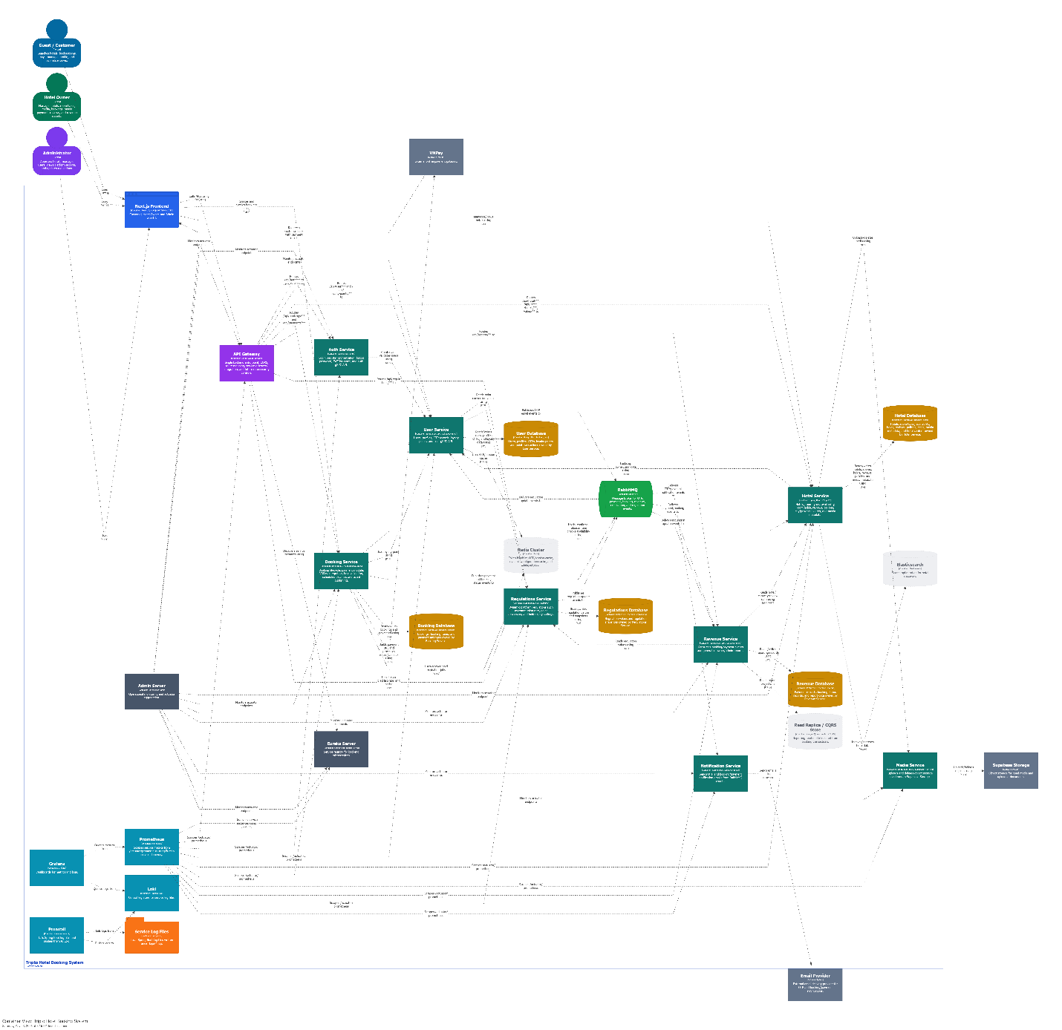

Note:
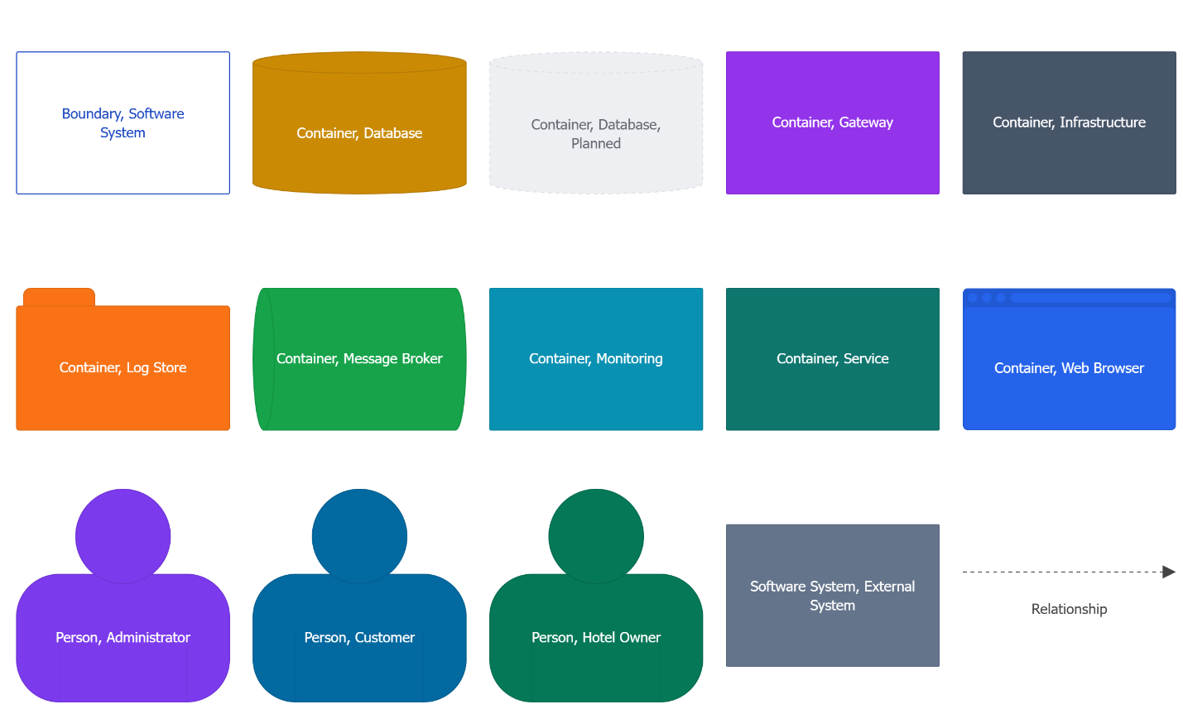

Contained Building Blocks:
Building block | Responsibility
Next.js Frontend | Customer, Hotel Owner, and Admin web interfaces.
API Gateway | Routes frontend/API traffic to backend services through Eureka.
Auth Service | Login/register orchestration, JWT issuance, auth gRPC API.
User Service | User accounts, profiles, OTP records, loyalty points, user gRPC API.
Hotel Service | Hotels, rooms, availability, room holds, policies, reviews, media metadata, city/province search.
Booking Service | Booking lifecycle, payment module, VNPay integration, hold validation, scheduled cleanup, events.
Media Service | Upload/delete objects in Supabase Storage through gRPC.
Revenue Service | Event ingestion and owner/admin reports.
Regulations Service | Dynamic regulation values and regulation update events.
Notification Service | OTP and booking/payment email delivery.
Eureka Server | Service registry.
Admin Server | Operational monitoring through Spring Boot Admin.
RabbitMQ | Asynchronous messaging.
Monitoring Stack | Prometheus metrics, Grafana dashboards, Loki log storage, and Promtail log shipping.
Elasticsearc | Internal search index for larger-scale hotel discovery and filtering.

5.2. Level 2: Important Service Responsibilities

5.2.1. Auth Service
Purpose: authenticate users, call User Service when needed, generate JWTs, and expose login/register/forgot-password endpoints.
Important interfaces:
Interface | Purpose
REST /api/auth/** via API Gateway | Public authentication workflows.
gRPC client to User Service | Create and validate user account data.
JWT service | Signed token creation and validation.
Quality notes: login latency target is 500ms under normal load; password data is stored as secure hashes in user-related persistence.

5.2.2 User Service
Purpose: manage users, profiles, OTPs, loyalty points, and user data exposed to other services.
Important interfaces:
Interface | Purpose
REST /api/user/**, /api/loyalty-points/** | Profile and loyalty operations.
gRPC user API | Internal user lookup and account operations.
RabbitMQ OTP events | Decouple OTP generation from email delivery.
Regulation cache/client | Use dynamic point conversion settings.

5.2.3. Hotel Service
Purpose: manage hotel content, room types, availability, room holds, reviews, policies, city/province discovery, and media metadata.
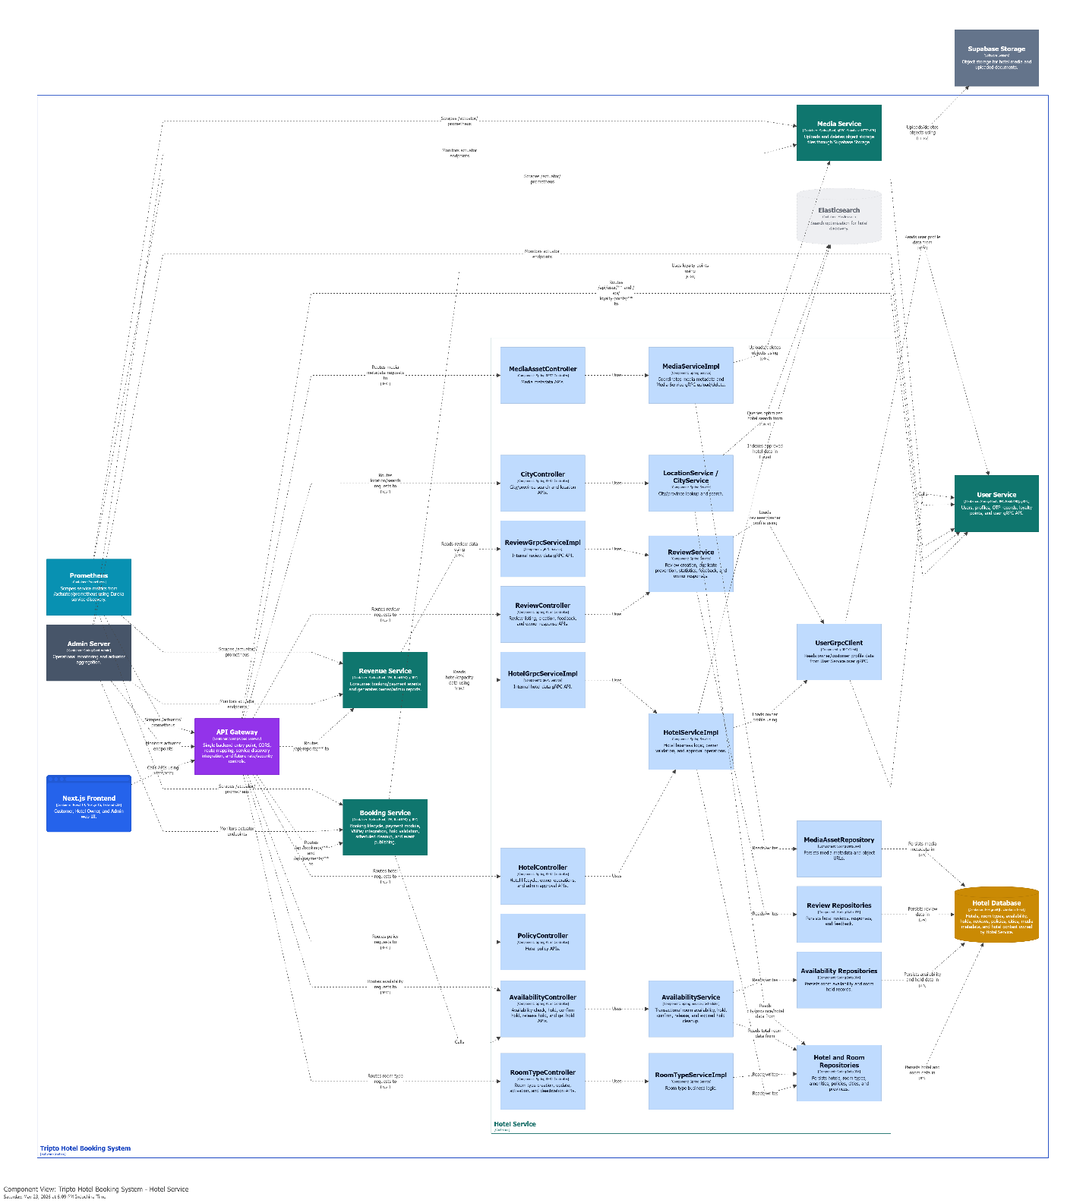

Note:
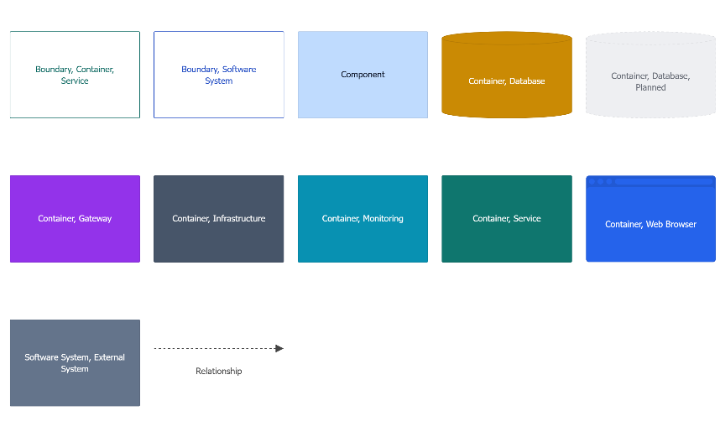
Key components:
Component | Responsibility
HotelController / HotelServiceImpl | Hotel CRUD, owner operations, admin approval.
RoomTypeController / RoomTypeServiceImpl | Room type creation, update, activation/deactivation.
AvailabilityController / AvailabilityService | Availability check, room hold, confirm hold, release hold, expired hold cleanup.
ReviewController / ReviewService | Customer reviews, duplicate prevention, owner responses, review statistics.
MediaAssetController / MediaServiceImpl | Media metadata and upload/delete coordination with Media Service.
CityController / LocationService | Destination search by city/province.
UserGrpcClient | Reads owner/customer profile data from User Service for hotel approval and review display.

External dependencies shown in this component view include API Gateway routing, Hotel Database ownership, Media Service/Supabase object storage, Booking Service availability calls, Revenue Service gRPC reads, Spring Boot Admin/Prometheus monitoring, and future Elasticsearch search indexing.

5.2.4. Booking Service and Payment Module
Purpose: create bookings, hold rooms, manage payment attempts, integrate VNPay, support pay-at-hotel, publish booking/payment events, and cleanup expired holds.
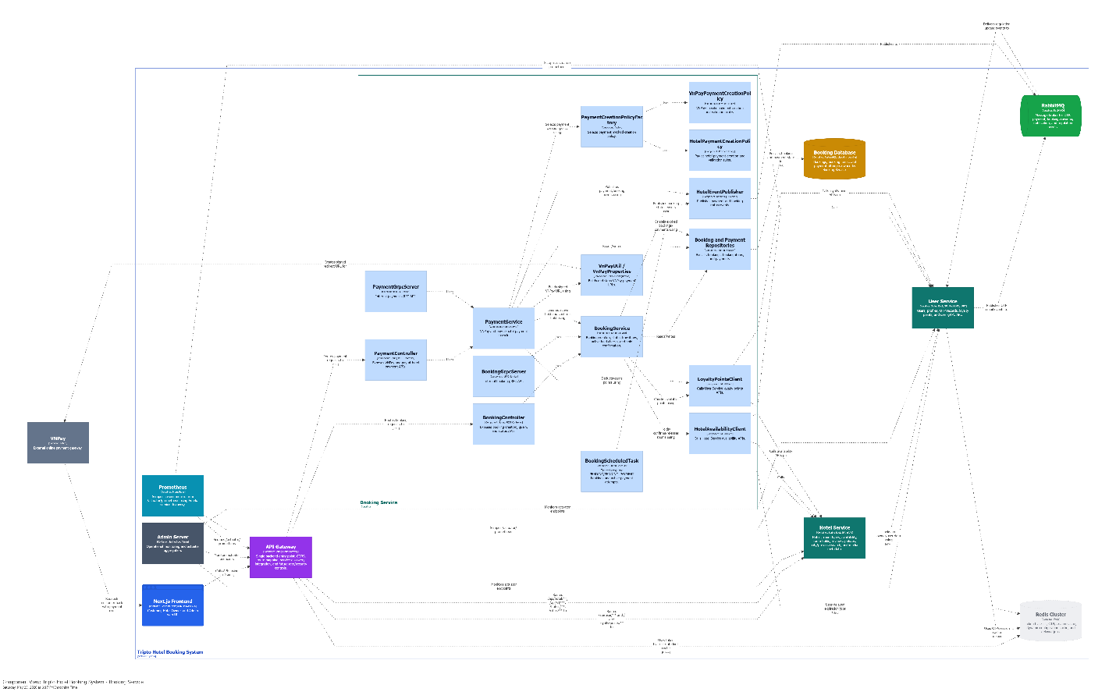

Note:
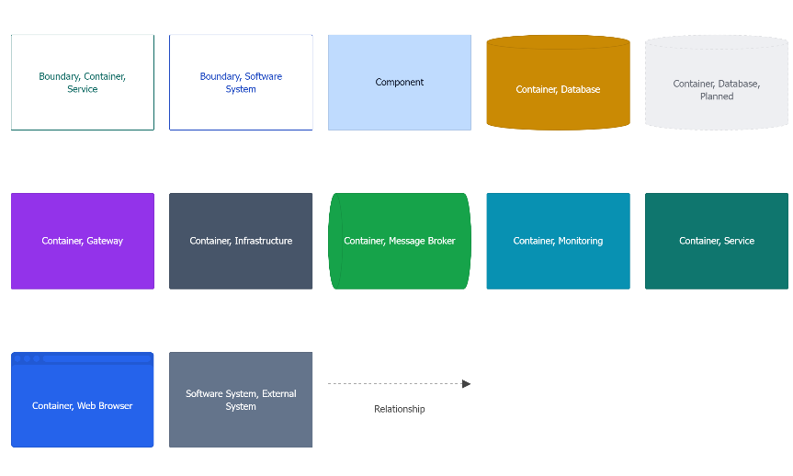

Key component:
Component | Responsibility
BookingController / BookingService | Booking creation, status updates, hold verification, booking queries.
PaymentController / PaymentService | VNPay creation/return, pay-at-hotel payment creation, payment confirmation.
PaymentCreationPolicyFactory | Extension point for new payment methods.
VnPayPaymentCreationPolicy / HotelPaymentCreationPolicy | Method-specific payment validation and creation.
BookingScheduledTask | Cancel expired PENDING/PENDING_PAYMENT bookings and active payments.
HotelAvailabilityClient | REST calls to Hotel Service availability APIs.
LoyaltyPointsClient | REST calls to User Service loyalty points APIs.
HotelEventPublisher | RabbitMQ payment and booking status events.

External dependencies shown in this component view include API Gateway routing, Hotel Service availability APIs, User Service loyalty APIs, Booking Database ownership, RabbitMQ event publishing, VNPay redirect/signature integration, Spring Boot Admin/Prometheus monitoring, and future Redis delayed expiration support.

5.2.5. Revenue Service
Purpose: consume booking/payment events, store reporting records, and provide admin/owner reporting APIs.
Important interfaces:
Interface | Purpose
REST /api/reports/** | Admin and hotel owner reports.
RabbitMQ listeners | Payment and booking status ingestion.
gRPC/REST clients to Hotel Service | Hotel and capacity context for reports.
Regulations client/cache | Commission and point-conversion data.

5.2.6. Regulations Service
Purpose: manage dynamic system regulations such as commission rate, point conversion, and hold expiry settings.
Important interfaces:
Interface | Purpose
REST /api/regulations/** | Admin updates and service reads.
RabbitMQ regulation events | Notify dependent services when regulation values change.
PostgreSQL snapshots | Preserve regulation history for audit and rollback.

5.2.7. Notification Service
Purpose: consume OTP and booking/payment events and send emails through an external provider.
Important interfaces:
Interface | Purpose
RabbitMQ listeners | notification.otp.queue, notification.payment.queue.
Email provider | Send OTP and payment/booking notifications.

6. Runtime View

6.1. Login
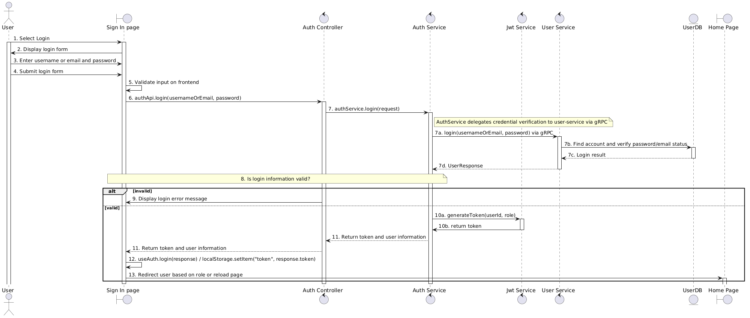

6.2. Search hotel
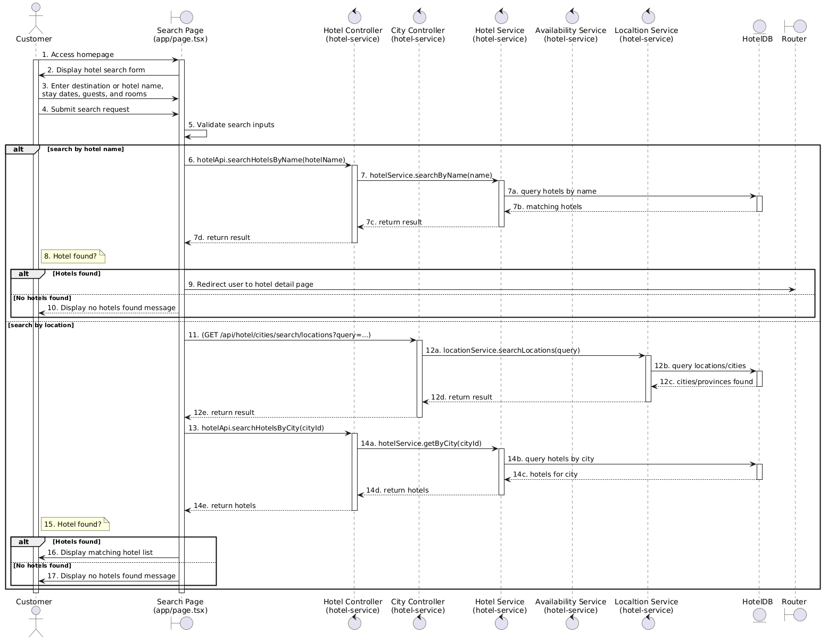

6.3. Book a room

6.4. Review hotel
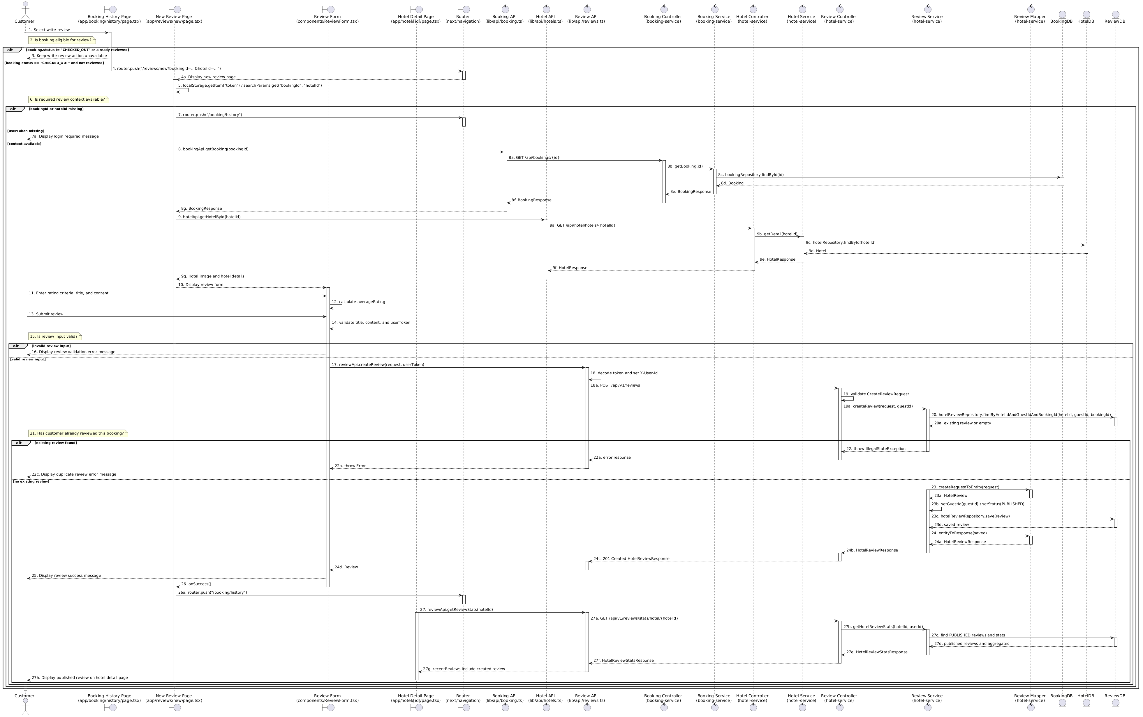

7. Deployment View

7.1. Development environment
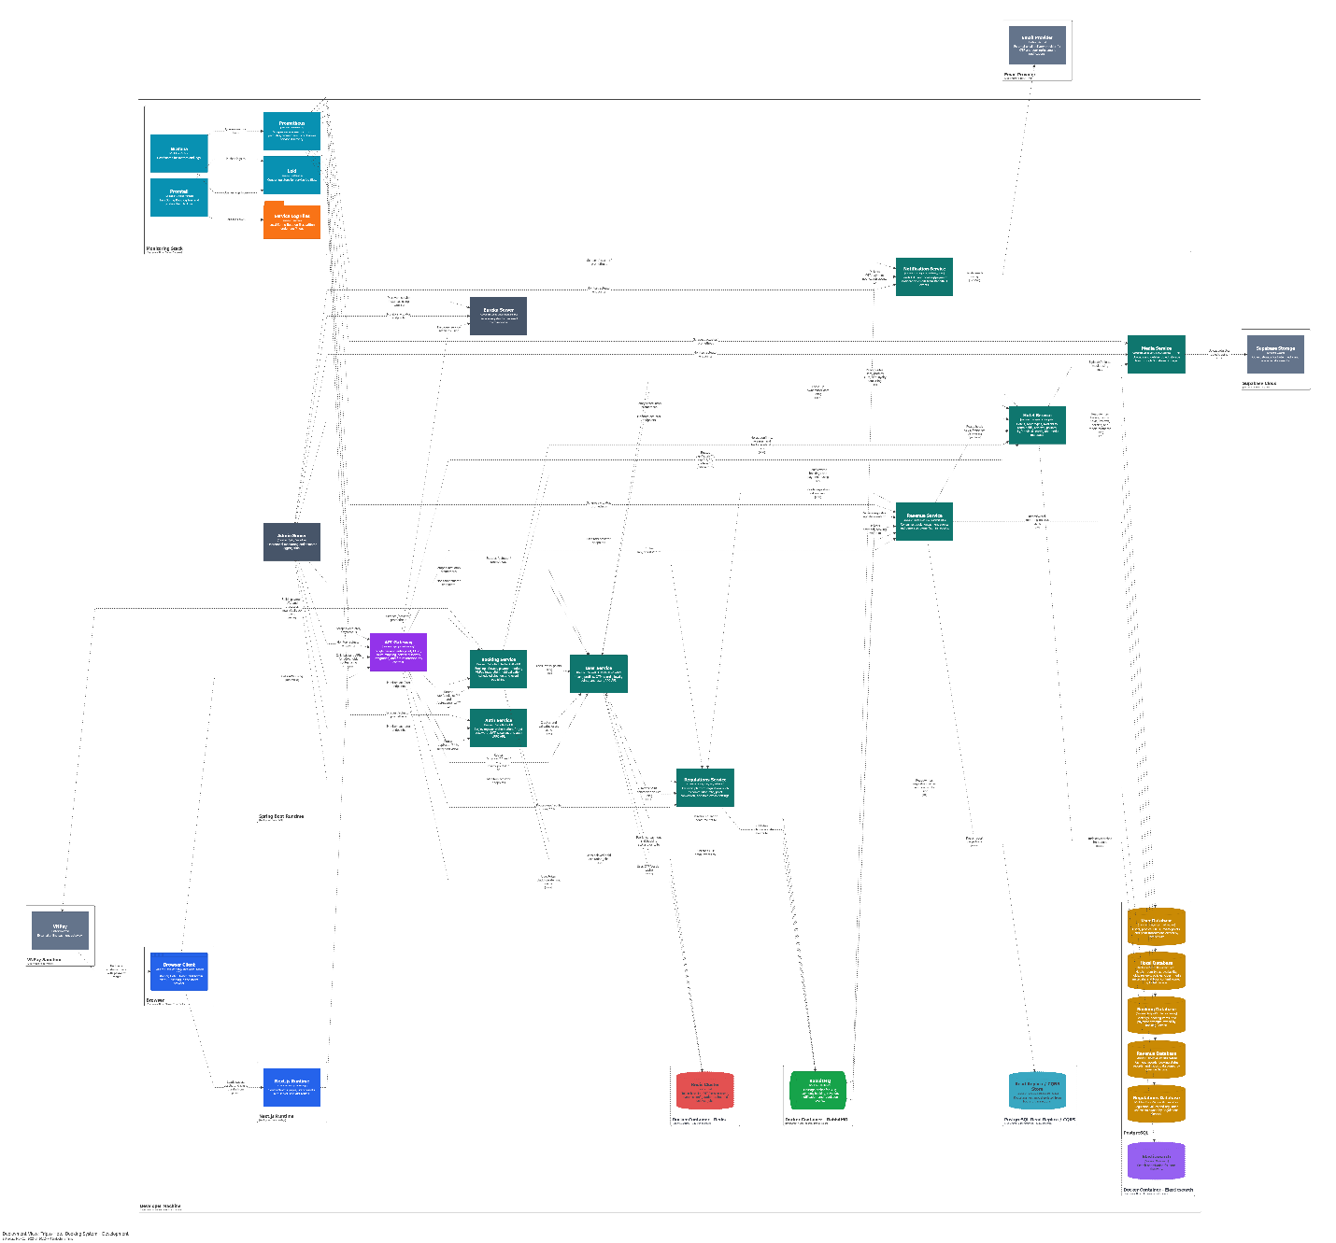

Note:
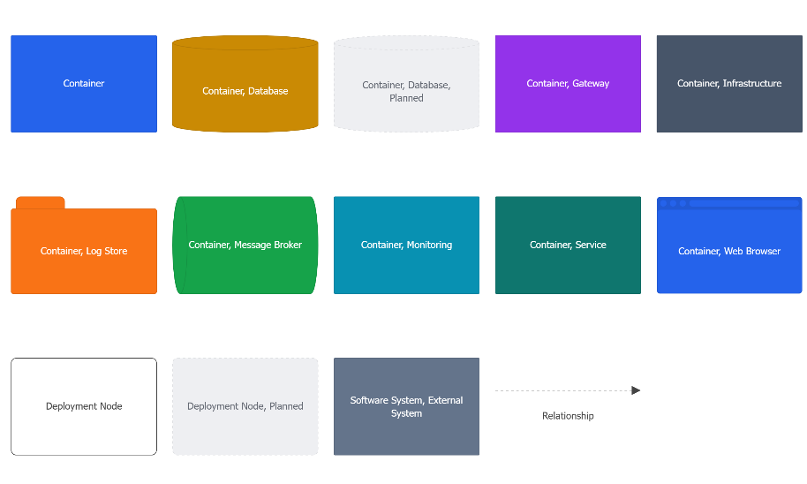

Node | Deployed artifacts
Browser | Runs the Browser Client downloaded from the Next.js runtime.
Next.js runtime | Hosts/deploys the Next.js Runtime for checkinn-frontend.
Spring Boot runtime | API Gateway, Auth, User, Hotel, Booking, Media, Revenue, Regulations, Notification, Eureka, Admin Server.
RabbitMQ Docker container | hotel.events, payment queues, notification queues.
Monitoring Docker Compose stack | Prometheus on 9090, Grafana on 3001, Loki on 3100, Promtail log shipper.
PostgreSQL | Service-owned databases: checkinn_user, checkinn_hotel, checkinn_booking, checkinn_revenue, and checkinn_regulations.
Supabase Cloud | Uploaded media and document objects.
VNPay sandbox/production | External payment gateway.
Email provider | OTP and notification delivery.
Redis, Elasticsearch, and reporting read model | Separate optional local deployment nodes for cache/delayed jobs, search indexing, and CQRS/read-replica reporting.

7.2. Production environment
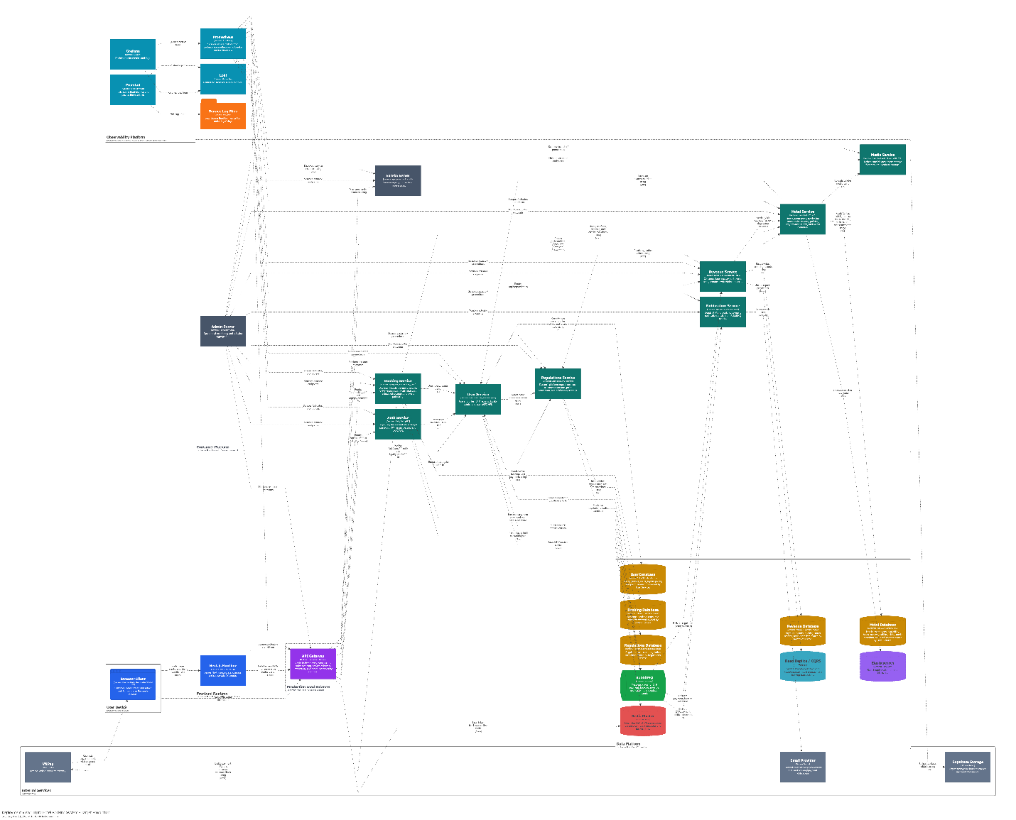

Note:
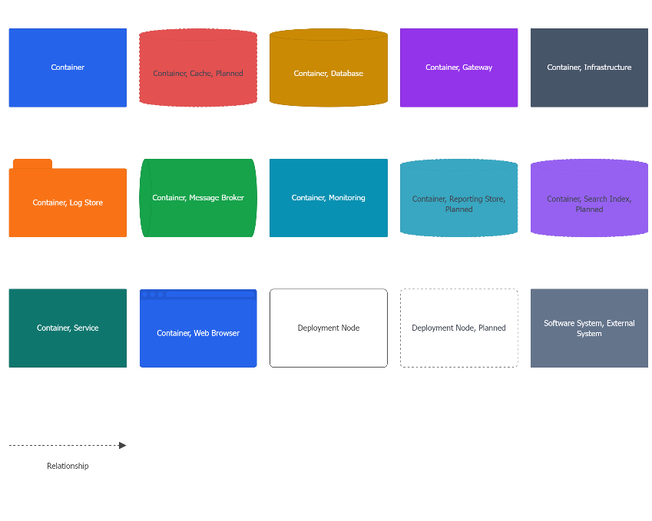

Planned element | Purpose
Nginx or Cloud Load Balancer | Route traffic to API Gateway replicas and support 150+ CCU.
Kubernetes / managed container platform | Run service replicas, health checks, rolling/Blue-Green deployment.
Redis Cluster | Token blacklist, OTP/session cache, dynamic config cache, delayed jobs.
Elasticsearch | Advanced hotel search and filtering.
Read replica / CQRS store | Isolate reporting reads from booking transactions.
Prometheus/Grafana/Loki/Promtail | Production-grade metrics dashboards and centralized log viewing.

8. Cross-cutting Concepts

8.1. Security and Authorization
- JWT is used to represent authenticated users and roles.
- API Gateway routes protected APIs to backend services; services also validate JWT or trusted identity context where needed.
- RBAC separates Customer, Hotel Owner, and Admin operations.
- Owner-scoped operations must validate hotel/resource ownership to prevent IDOR.
- Passwords are stored using a secure hash such as bcrypt.
- OTPs are 6-digit codes with a 10-minute validity period.
- Future improvements include token revocation/blacklist, rate limiting, and stronger password policy alignment.

8.2. Data Ownership
Service | Owned database/storage | Owned data
User Service | checkinn_user | Users, profiles, OTPs, loyalty points, point transactions.
Hotel Service | checkinn_hotel | Hotels, room types, availability, room holds, reviews, policies, amenities, cities/provinces, media metadata.
Booking Service | checkinn_booking | Bookings, booking items, payment attempts, VNPay fields.
Revenue Service | checkinn_revenue | Reporting records derived from payment and booking events.
Regulations Service | checkinn_regulations | Regulation values and snapshots.
Media Service | Supabase Storage | Object storage integration; binary data stored externally.

Auth Service does not own a separate database in the current implementation; it orchestrates authentication and uses User Service as the owner of account/profile data.

8.3. Consistency and Transaction Boundaries
- Room hold operations are transactional in Hotel Service.
- Booking creation stores hold information and booking state in Booking Service.
- VNPay success confirms both payment and booking, then finalizes the hold.
- VNPay failure keeps the booking unconfirmed and preserves the hold until expiration.
- Cross-service operations are coordinated through explicit service calls and events rather than distributed database transactions.

8.4. Messaging and Eventing
RabbitMQ decouples non-blocking work:
Publisher | Event examples | Consumers
User Service | OTP email events | Notification Service
Booking Service | payment.completed, booking status changes | Revenue Service, Notification Service
Regulations Service | Regulation changed events | Revenue Service, User Service, future services

8.5. Observability and Operations
- Spring Boot Actuator endpoints expose health and metrics.
- Spring Boot Admin Server is available for service monitoring.
- Eureka provides service registration and health-oriented discovery.
- Prometheus discovers services through Eureka and scrapes /actuator/prometheus.
- Grafana reads metrics from Prometheus and logs from Loki.
- Promtail tails Spring Boot log files from logs/*.log and pushes them to Loki.
- Future production operations should add alerting rules, dashboards, and distributed tracing.

8.6. Media and File Handling
- Binary files are stored in object storage, not in PostgreSQL.
- Hotel Service stores metadata and object URLs.
- Media Service is the integration boundary for Supabase/S3-compatible storage.
- File upload integrity requires MIME type, extension, and size validation.

8.7. Planned Extension Points
Extension | Reason
Elasticsearch | Improve complex hotel search at larger scale.
Redis | Token blacklist, OTP/session cache, delayed hold expiration, dynamic config cache.
Circuit Breaker | Graceful degradation when secondary services fail.
Read replica/CQRS | Keep reporting workloads from slowing booking transactions.
Blue/Green deployment | Support maintenance window and reduce user-visible deployment disruption.

9. Architecture Decisions

ID | Context | Decision | Reason | Consequence
ADR-01 | The platform has separate Customer, Hotel Owner, and Admin workflows across identity, hotel content, booking, payment, reporting, regulations, media, and notifications. | Use microservices by business capability. | Matches IAM, hotel, booking, reporting, regulation, media, and notification boundaries. | More deployment and integration complexity, but clearer ownership.
ADR-02 | Frontend clients need a stable backend entry point while backend service instances can change during development or deployment. | Use API Gateway and Eureka. | Provides one backend entry point and service discovery. | Gateway routing must stay synchronized with service APIs.
ADR-03 | Booking and payment state transitions are tightly coupled, especially for VNPay return handling and pay-at-hotel confirmation. | Keep payment logic inside Booking Service as a module. | Current code stores booking and payment lifecycle together and requires tight consistency. | Simpler current implementation; can be split later if payment complexity grows.
ADR-04 | Customers may compete for the last available room, and payment can be delayed, retried, or fail. | Use room holds before payment. | Prevents double-booking and supports VNPay retry. | Requires cleanup schedulers and cross-service hold checks.
ADR-05 | OTP email, payment notifications, reporting ingestion, and regulation propagation should not slow user-facing requests. | Use RabbitMQ for asynchronous notification / reporting / regulation events. | Prevents email/reporting work from blocking user-facing flows. | Requires event schemas, retry handling, and monitoring.
ADR-06 | Hotel media and supporting documents can grow faster than transactional data and should not bloat relational tables. | Store media in object storage. | Keeps PostgreSQL focused on transactional metadata and supports media growth. | Requires file validation and storage URL lifecycle management.

10. Quality Requirements

10.1. Quality Requirements Overview
Quality requirements are derived from utility tree and ADD
Quality attribute | Important scenarios
Performance | Search within 2 seconds, login within 500ms, 150 CCU, reporting without degrading booking.
Reliability | No double-booking, consistent booking/payment/hold states, automatic expired hold cleanup.
Security | Password hashing, OTP integrity, RBAC, token/session management, input/file validation.
Availability | 95% uptime, maintenance window, graceful degradation, recoverability.
Modifiability | Dynamic regulations, payment method extension, future data cascading.
Auditability | Trace sensitive admin actions and notify affected users when appropriate.
Scalability | 500,000 to 1,000,000 business records, 50,000 to 100,000 media/support files, 50MB to 200MB daily growth.
Interoperability | Email provider fault tolerance and VNPay failure handling.

10.2. Quality Scenarios
Scenario | Tactic in architecture
Search results within 2 seconds | Current relational search plus future Elasticsearch/search index.
Login within 500ms | Auth/User service separation, JWT issuance, indexed user lookup, future cache where needed.
150 CCU | API Gateway, Eureka, stateless service replicas, future load balancer/container platform.
Prevent double-booking | Transactional availability hold, database-level locking strategy, explicit hold status.
VNPay failure must not confirm booking | Payment state machine, callback validation, booking remains unconfirmed on failure.
Expired hold cleanup | Booking and Hotel scheduled tasks; future delayed queue/Redis enhancement.
New payment method | Payment policy/factory module inside Booking Service.
Regulation changes without restart | Regulations Service, events, local/distributed cache.
Review/file input protection | Content validation, MIME/extension/size validation, object storage boundary.
Secondary service failure | Graceful UI fallback and future Circuit Breaker.

11. Risks and Technical Debts
Risk / Debt | Impact | Mitigation
Search currently relies on relational queries | Complex search may not scale to target data volume. | Add Elasticsearch or equivalent search index when dataset grows.
Reporting may compete with transactional DB | Heavy reports can slow booking flow. | Add read replica/CQRS reporting store and event-driven projections.
Notification retry/dead-letter behavior needs hardening | OTP/payment emails may fail silently or be hard to recover. | Add retry policy, dead-letter queues, and monitoring.
Audit trail is incomplete for all admin actions | Accountability requirement may not be fully satisfied. | Add audit log model and enforce logging at admin service boundaries.

12. Glossary
Term | Definition
Tripto | Hotel booking platform documented in this SAD.
Customer | User who searches hotels, books rooms, pays, and reviews stays.
Hotel Owner | Business user who manages hotels, rooms, bookings, media, reviews, and revenue.
Admin | Platform administrator who manages approvals, accounts, reports, and regulations.
Room Hold | Temporary reservation of room inventory before payment confirmation.
VNPay | External online payment gateway used by Tripto.
Pay-at-hotel | Payment method where the customer pays onsite and the owner confirms payment.
OTP | One-time password used for email verification and password recovery.
JWT | Signed token used to authenticate API requests.
RBAC | Role-Based Access Control for Customer, Hotel Owner, and Admin permissions.
IDOR | Insecure Direct Object Reference, prevented by ownership validation.
RabbitMQ | Message broker used for asynchronous events.
Eureka | Service registry used by Spring Cloud services.
API Gateway | Spring Cloud Gateway service that routes public API traffic.
Supabase Storage | Current object storage provider for uploaded media/documents.
Elasticsearch | Planned search index for larger-scale hotel search.
Redis | Planned cache/delayed-job/token-blacklist infrastructure.
CQRS | Command Query Responsibility Segregation, planned for reporting scale-out.
C4 Model | Architecture diagram model using context, container, component, and dynamic/deployment views.
arc42 | Architecture documentation template used to structure this SAD.

