[Loai: NGHE – NGHE ĐỀ 4]

[Q]

**Part 4**

Directions: You will hear some talks given by a single speaker. You will be asked to answer three questions about what the speaker says in each talk. Select the best response to each question and mark the letter (A), (B), (C), or (D) on your answer sheet. The talks will not be printed in your test book and will be spoken only one time.

**Questions 29-31 refer to the following telephone message**

29-Why is the speaker calling?

0.To confirm an order

1.To describe a special offer

0.To advertise a new position

0.To request payment of a bill

[Q]

30-What can Mr. Marino get for $40?

1.Cable TV installation

0.Triple the number of movie channels

0.Cable TV for three months

0.Double the number of movie channels

[Q]

31-What does the caller request that Mr. Marino do?

1.Fill out an online form

0.Visit his workplace

0.Return his phone call

0.Complete a survey

**Questions 32-34 refer to the following talk**

[Q]

32-What is the purpose of the talk?

1.To go over some rules

0.To ask for assistance

0.To give an explanation

0.To request an apology

[Q]

33-What music the listeners do before installing software on their computers?

0.Make sure it is compatible with the computer

0.Purchase it properly

1.Receive permission

0.Prove its importance to their work

[Q]

34- What does the speaker indicate about the computers?

0.They must be turned off every night.

0.They are the most recently released models.

0.They should be scanned for viruses daily.

1.They must only be used for work.

**Questions 35-37 refer to the following talk**

[Q]

35-Who most likely is the speaker?

1.A tour guide

0.A chef

0.A taxi driver

0.A politician

[Q]

36-According to the speaker, what is special about Rosedale’s city hall?

0.Its age

0.Its location

0.Its architecture

1.Its size

[Q]

37-Why does the speaker say, “the bus leaves at 3:00 P.M”?

0.He is unhappy with an itinerary.

0.He cannot accept an invitation.

1.He wants the listeners to be on time.

0.He thinks the listeners should use other transportation.

**Questions 38-40 refer to the following talk and graph**

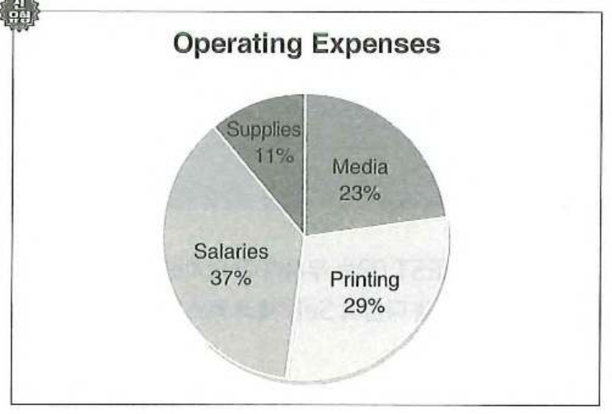

[Q]

38-Who most likely are the listeners?

0.Finacial advisors

1.Marketing professionals

0.Administrative staff

0.Company shareholders

[Q]

39- Look at the graphic. Which expense will most likely be reduced?

0.Media

1.Printing

0.Salaries

0.Supplies

[Q]

40-What will happen next?

1.A report will be distributed.

0.A presentation will be given.

0.A task will be explained.

0.A decision will be announced.