[Loai: NGHE – NGHE ĐỀ 5]

[Q]

**Part 4**

Directions: You will hear some talks given by a single speaker. You will be asked to answer three questions about what the speaker says in each talk. Select the best response to each question and mark the letter (A), (B), (C), or (D) on your answer sheet. The talks will not be printed in your test book and will be spoken only one time.

**Questions 29-31 refer to the following announcement**

29-Why is the train delayed?

0.It collided with a vehicle on the tracks.

1.There is an object on the tracks.

0.The train suffered a mechanical problem.

0.Bad weather is making it go slowly.

[Q]

30-When is the train expected to arrive?

0.In thirty minutes

1.In one hour

0.In one and a half hours

0.In two hours

[Q]

31-What can listeners receive in the departure lounge?

1.Refunds

0.Free upgrades

0.Complimentary snacks

0.New tickets

**Questions 32-34 refer to the following telephone message**

[Q]

32-What is the speaker’s problem?

0.She forgot about her appointment.

0.She has to cancel her daughter’s appointment.

0.She will be late for her appointment.

1.She cannot make it to her appointment.

[Q]

33-When does the speaker have time?

1.On Wednesday morning

0.On Wednesday afternoon

0.On Thursday morning

0.On Thursday afternoon

[Q]

34- How does the speaker want to change her appointment?

0.By getting only a haircut

0.By getting her hair dyed

1.By getting a perm

0.By getting her hair straightened

**Questions 35-37 refer to the following announcement**

[Q]

35-Where do the listeners work?

0.At a bank

1.At a restaurant

0.At a sports arena

0.At a construction company

[Q]

36-What does the speaker imply when she says, “our business is increasing”?

0.A marketing campaign has been successful.

0.The local population has grown.

0. An additional branch will be opened.

1.More employees will be hired.

[Q]

37- What does the speaker offer the listeners?

0.A higher salary

0.Reserved parking spaces

1.Free festival tickets

0.Discount meal coupons

**Questions 38-40 refer to the following talk and graph**

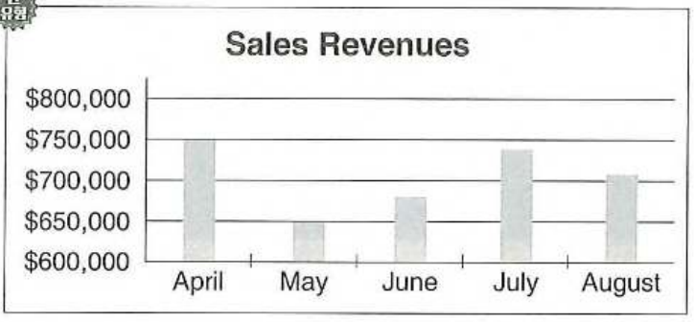

[Q]

38- Look at the graphic. When was the new refrigerator model released?

0.April

0.May

0.June

1.July

[Q]

39- What did the speaker do yesterday?

1.Talked with executives

0.Created a financial report

0.Examined a product

0.Reviewed consumer data

[Q]

40-What will most likely happen on Friday?

0.An advertising campaign will begin.

1.A team meeting will be held.

0.A salesperson will be promoted.

0.A board member will resign.