[Loai: NGHE – ĐỀ 1]
Activity 1
[Q]
Questions 1-5
What did each person do on the weekend? Listen and choose the correct answer.

Q
- He _____
0. watched an adventure movie on TV.
0. played video games.
1. went to a movie.
0. went to a theatre
[Q]
2. He _____
0. stayed at home.
1. went to the beach for the weekend.
0. went to the mountains.
0. went for a bike ride.
[Q]
3. He _____
0. read lots of interesting magazines.
0. used the computer.
0. read news on the computer.

1. read an interesting book.
[Q]
4. She _____
0. played in a band.
1. went to a concert.
0. played tennis.
0. played basketball.
[Q]
5. She _____
0. stayed home and watched TV.
0. went out to see a movie.
1. studied for an exam.
0. went out with friends.
Activity 2
[Q]
Listen carefully and choose the correct picture.
Q
6. How will they book their flights?

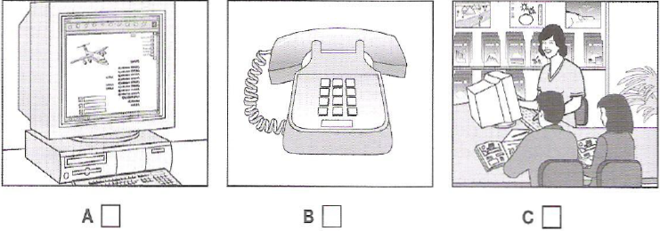
1. C
0. A
0. B
[Q]
7. What has the daughter forgotten to bring on holiday?
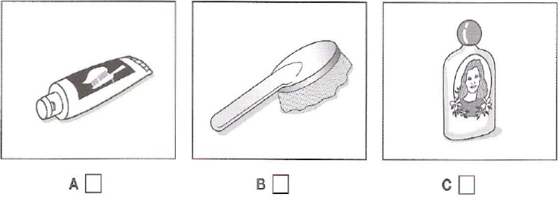
1. C
0. A
0. B
[Q]
8. What will the man and woman do on Sunday?
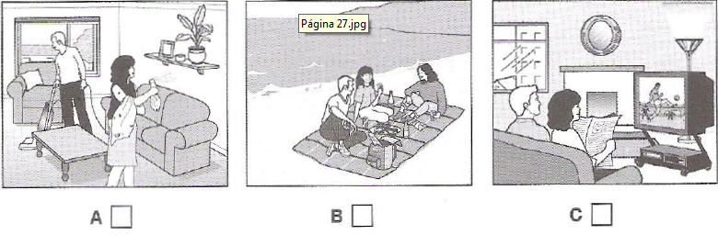
1. B
0. A
0. C
[Q]
9. Which blouse does the girl decide to buy?
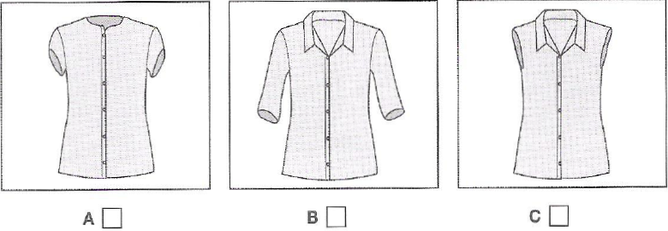
1. B
0. A
0. C
[Q]
10. When is the girl having a party?
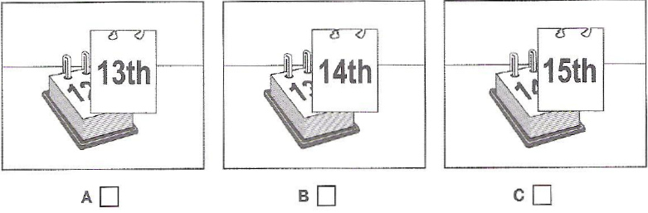
1. A
0. B
0. C
Activity 3
[Q]
Questions 11-20
Listen and choose the corect answer.
Conflict at work
Q
Over the years, (11) ____________ towards workers have changed considerably.
0. approaches
1. attitudes
0. positions
0. acceptance
[Q]
There was a time when workers laboured in (12) ________________ conditions.
0. prevailing
0. immaculate
1. appalling
0. favourable
[Q]
Conflict mostly consists of behavior in the general category of (13) ___________________
0. rights
0. behaviours
0. violence
1. bullying
[Q]
One or more people behave abusively or aggressively against another who is in a (14) _________________ position.
1. weaker
0. superior
0. preferable
0. unstable
[Q]
Often it’s caused by someone who feels the need to show their (15) ________________
1. superiority
0. aggressiveness
0. level
0. position
[Q]
Also caused by differences in (16) __________________ between people
0. hierarchy
0. believe
0. work
1. personality
[Q]
A general habit of (17) __________________ in one person can make them intolerant of a colleague who is constantly pessimistic.
0. pessimism
1. optimism
0. cynicism
0. idealism
[Q]
(18) _________________ conflicts: people more concerned about their own team than about company
0. Interest
0. Team
1. Structural
0. Administration
[Q]
Conflict-related stress can cause (19) ________________ that may last for months
0. impacts
0. stress
1. absence
0. breakdown
[Q]
For the company, if no effort is made to deal with conflict, it can spiral out of control, and even lead to the (20) _____________________ of the business.
0. impacts
0. stress
0. absence
1. breakdown

