[Loai: NGHE – ĐỀ 2 - 20 CÂU]
[Q]
Activity 1
Questions 1-5
People are talking about their jobs. Listen and choose the correct answer.
[Q]
1. He _____.
0. does not have a lot of experience.
1. has been working there awhile.
0. works at a theatre.
0. works far from the downtown.
[Q]
2. He _____.
0. works in the manager’s office.
0. likes his manager.
1. meets interesting people.
0. hates the work.
[Q]
3. He
1. sees the TV producer every day.
0. helps with movie productions.
0. doesn’t know how to drive.
0. works as a personal secretary.
[Q]
4. She _____.
0. thinks the salary is good.
0. is looking for another job.
0. finds her job interesting.
1. likes her co-workers.
[Q]
5. He _____.
0. works for a magazine.
1. writes about sports news.
0. isn’t famous.
0. is a short-story author.
[Q]
Activity 2
Questions 6-10
Listen carefully and choose the correct picture.
6. Where is the motorcycle race going to finish?
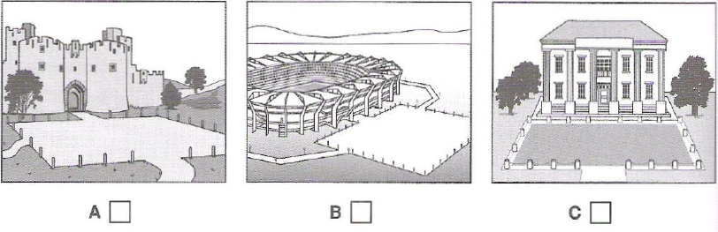
1. C
0. A
0. B
[Q]
7. What will the woman repair next?
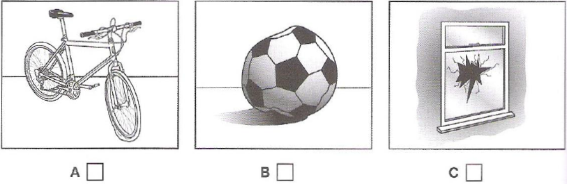
1. B
0. A
0. C
[Q]
8. What has the boy lost?
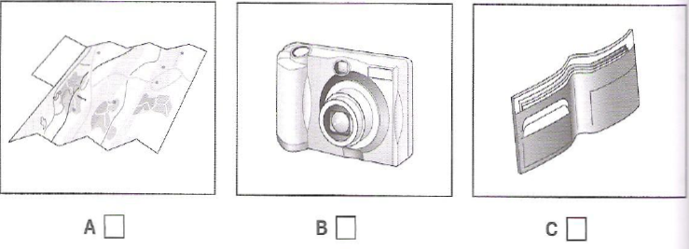
1. B
0. A
0. C
[Q]
9. What time does the race begin?
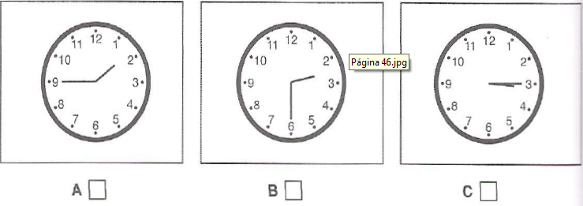
1. B
0. A
0. C
[Q]
10. Which musical instrument does the boy play now?
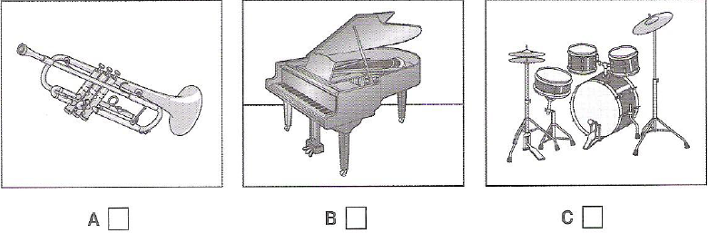
1. C
0. A
0. B
[Q]
Activity 3
Questions 11-20
Listen and choose the correct answer.

Effects of urban environments on animals
Introduction
[Q]
Recent urban developments represent massive (11) ______________ changes for over millions of years.
1. environmental
0. evolutionary
0. upheavals
0. affective
[Q]
It was previously thought that only a few animals were suitable for city life, e.g.
- the (12) ______________ because of its general adaptability
0. crowd
0. cow
0. crowded
1. crow
[Q]
- the pigeon – because walls of city buildings are similar to (13) ……………………… by the sea.
0. clips
0. ledges
1. cliffs
0. ships
[Q]
In fact, it is found that these early immigrants were just the start of more general (14) ____________________ of animals into cities.
0. immigrations
1. movements
0. development
0. adaptation
[Q]
One thing that researchers are finding especially interesting is the (15) ______________
1. speed
0. skills
0. changes
0. movement
[Q]
Recent research
- Emilie Snell-Rood studied small urbanized mammal specimens such as (16) _____________ and gophers from museums in Minnesota.
0. bats
0. cats
0. flies
1. mice
[Q]
- She undertook the research by examining (17) _____________ collected for over a hundred years.
0. rural mammals
1. specimens
0. urban mammals
0. small mammals
[Q]
- She found the size of their (18) _____________ had increased.
0. collection
0. specimens
0. body
1. brains
[Q]
- Researchers can’t be sure that small mammals are more (19) _____________ or not.
0. cognitive
1. intelligent
0. experienced
0. flexible
[Q]
- She suggests this may be due to the need locate new sources of (20) _______________ and to cope with a whole new set of dangers.
1. food
0. demands
0. places
0. city life

