[Loai: NGHE – ĐỀ 5 -20 CÂU]
[Q]
Activity 1
People are calling home while they are on vacation. Listen and choose the word that describes each person.
Q
1. Jill
0. worried
1. excited
0. upset
0. exhausted
[Q]
2. Sean
0. relaxed
0. worried
1. happy
0. frightened
[Q]
3. John
0. relaxed
0. pleased
0. happy
1. worried
[Q]
4. Rachel
0. happy
1. sick
0. excited
0. frightened
[Q]
5. Mary
1. upset
0. sick
0. relaxed
0. pleased
[Q]
Activity 2

Listen carefully and choose the correct picture.
Q
6. Which vehicle does Steve intend to buy?
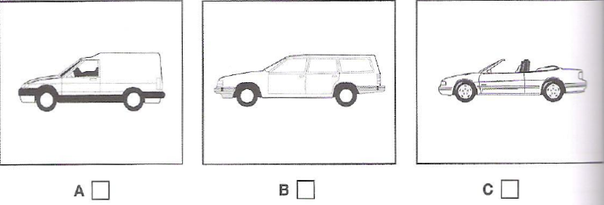
1. B
0. A
0. C
[Q]
7. Which prize has the man just won?
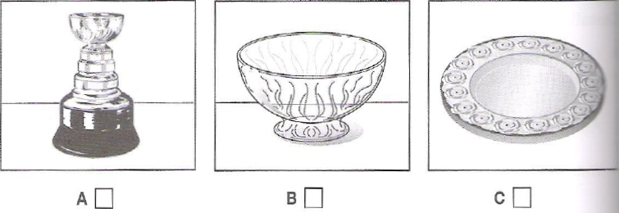
1. B
0. A
0. C

[Q]
8. What was the man’s first job?
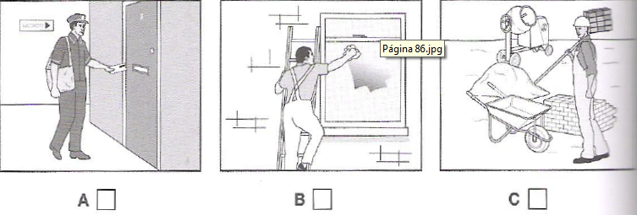
1. B
0. A
0. C
[Q]
9. Where will they have something to eat?
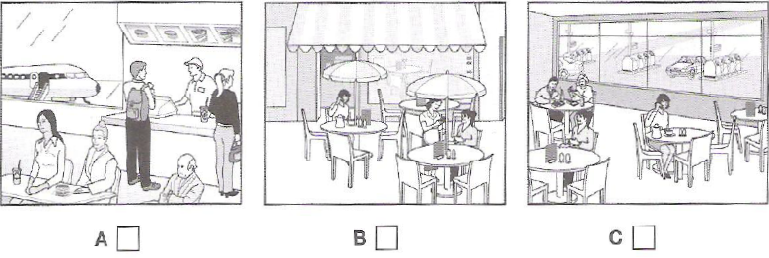
1. C
0. A
0. B

[Q]
10. What does the woman’s house look like now?
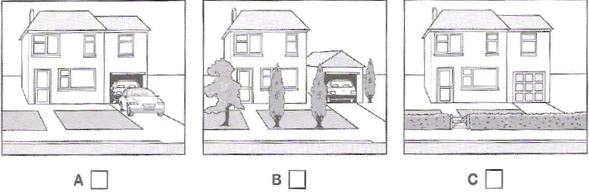
1. A
0. B
0. C

[Q]
Activity 3
Listen and choose the correct answer.
The history of coffee
Q
Coffee in the Arab world
- Coffee was originally gathered from bushes growing wild in (11) ______________
0. Middle East
1. Ethiopia
0. Turkey
0. Ottoman Empire
[Q]
- In 1522, coffee was approved in the Ottoman court as a type of (12) ______________
0. drink
0. refreshment
0. herbal
1. medicine
[Q]
- By (13) ______________, coffee bushes were being cultivated in the Yemen.
0. the early 1500s
1. the mid-1500s
0. the late 1500s
0. 1500
[Q]
- Coffee was rarely drunk (14) ______________
0. at coffee houses
0. at the party
1. at home
0. at the restaurant
[Q]
- In 1623, the ruler ordered the (15) ______________ of every coffee house in Constantinople.
0. center
1. destruction
0. share
0. consumption
[Q]
- In the 17th century, coffee arrives in Europe and coffee shops became places where (16) ______________ people could meet to exchange ideas.
0. middle-aged
0. the ruler
1. ordinary
0. high-status
[Q]
- Coffee shops were compared to (17) ______________
1. universities
0. homes
0. social movements
0. small society
[Q]
- They played an important part in social and (18) ______________ changes.
0. physical
0. industrial
1. political
0. original
[Q]
- In the late 1600s, the coffee production started to spread around the world because European powers established coffee plantations in (19) ______________
0. their countries
1. their colonies
0. mountainous areas
0. valleys
[Q]
- Types of coffee were often named according to the (20) ______________ they came from
0. countries
0. colonies
0. plantations
1. ports

