[Loai: NGHE – ĐỀ 6 -20 CÂU]

Activity 1
[Q]
People are calling home while they are on vacation. Why does each person call? Listen and choose the correct answer.
Q
1. Jill _____.
1. has some news.
0. was in a dangerous situation.
0. wants to ask a favor.
0. has a new job.
[Q]
2. Sean _____.
0. isn’t having a good time.
0. has met someone interesting.
0. has lots of free time.
1. needs money.
[Q]
3. John _____.
1. lost his wallet.
0. lost his ticket.
0. had his flight delayed.
0. will be coming back on time.
[Q]
4. Rachel _____.
0. has good news.
0. needs help.
1. to tell her friend about a health problem.
0. ate something delicious.
[Q]
5. Mary _____.
0. missed a bus tour.
1. lost her glasses.
0. was in an accident.
0. has good news.
Activity 2
[Q]
Listen carefully and choose the correct picture.
Q
6. Which sport will they do tomorrow?
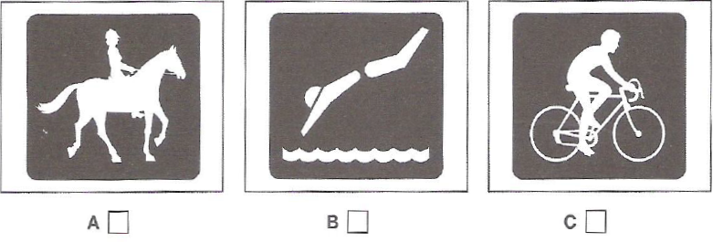
1. A
0. B
0. C
[Q]
7. What can you see on the television programme?
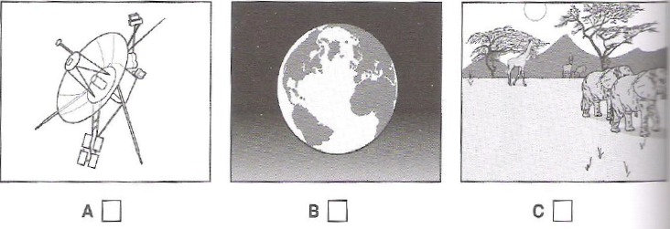
1. B
0. A
0. C
[Q]
8. Where will the man sit on the plane?
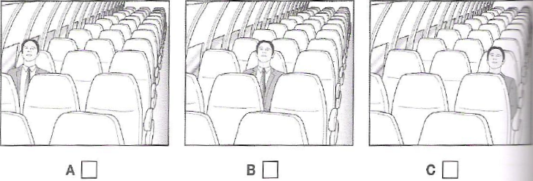
1. C
0. A
0. B
[Q]
9. What did the man buy?
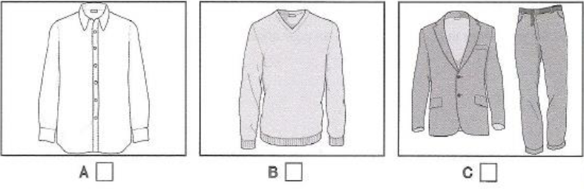
1. B
0. A
0. C
[Q]
10. How will the woman help the man?
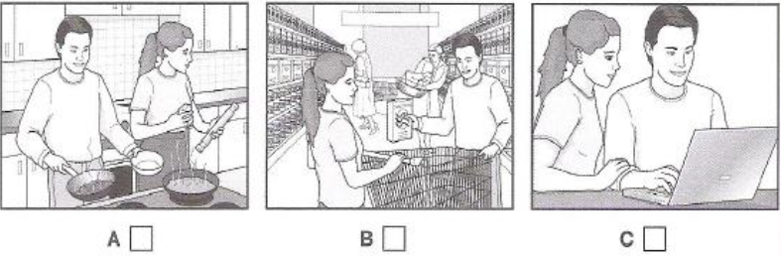
1. C
0. A
0. B

Activity 3
[Q]

Listen and choose the correct answer.
Ocean Biodiversity
Q
- Biodiversity hotspots are the areas which have the greatest mixture of (11) ________________
0. animals
0. plants
1. species
0. insects
[Q]
- Biodiversity hotspots are important for locating targets for focusing efforts at (12) ____________
0. hotspots
1. conservation
0. species
0. signifcant
[Q]
- At first, biologists could only identify hotspots (13) ______________
1. on land
0. in the ocean
0. under the rocks
0. in the river
[Q]
- In 2005, Boris Worm did some research on data on ocean species that he got from the (14) _________________
0. marine habitats
0. local hotspots
0. aquarium
1. fishing industry
[Q]
- He identified hotspots for (15) _________________
0. marine mammals
0. large land predators
1. large ocean predators
0. herbivores
[Q]
- Boris Worm found that ocean hotspots:
- were not always rich in (16) ______________
0. concentrations
0. common
0. surprise
1. food
[Q]
- had higher temperatures at the (17) _____________
1. surface
0. water
0. depths
0. factors
[Q]
- had enough (18) _______________ in the water
0. predators
0. factors
1. oxygen
0. metabolic
[Q]
- In 2007, Lisa Balance looked for hotspots for marine (19) _________________
0. animals
1. mammals
0. seals
0. boundaries
[Q]
- She found these hotpots were all located at boundaries between ocean (20) ________________
0. animals
0. mammals
0. streams
1. currents

