[Loai: NGHE – ĐỀ 7 -20 CÂU]

[Q]

Activity 1
Q
People are describing parties they gave recently. What happened at each party?
1. People _____.
0. ate lots of food.
1. listened to music.
0. played party games.
0. didn’t eat birthday cake.
[Q]
2. People _____.
0. ate lots of food.
0. danced.
0. ate indoors.
1. chatted.
[Q]
3. People _____.
1. sang.
0. ate pizza.
0. listened to music.
0. organized a party at the boss’ house.
[Q]
4. People _____.
0. played party games.
1. ate lots of food.
0. danced.
0. cooked a lot of dishes together.
[Q]
5. People _____.
0. ate lots of food.
0. talked too much.
1. danced.
0. chatted.
[Q]

Activity 2
[Q]
Listen carefully and choose the correct picture.
Q
6. Where will the friends meet?
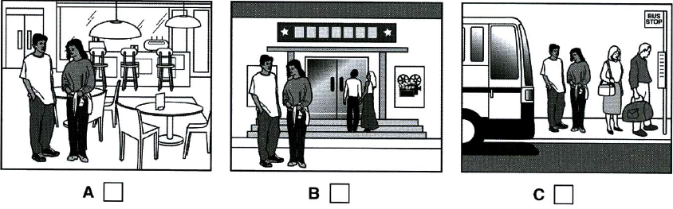
1. A
0. B
0. C
[Q]
7. What has the girl forgotten to bring?
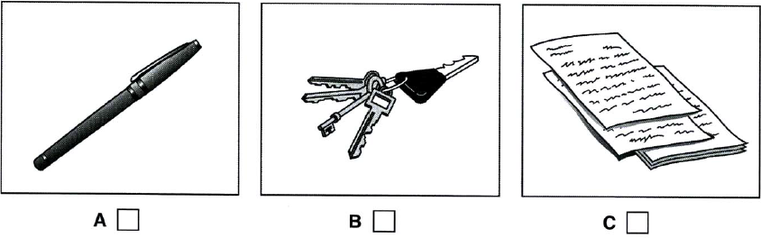
1. A
0. B
0. C

[Q]
8. Which TV programme is on at 9 o’clock tonight?
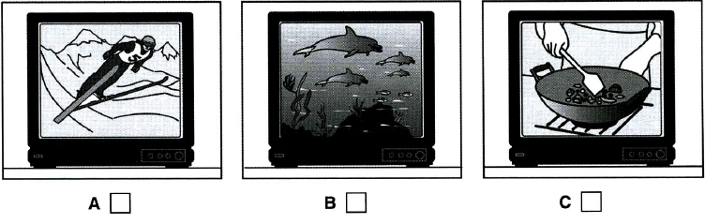
1. C
0. A
0. B

[Q]
9. How will the man book tickets for the show?
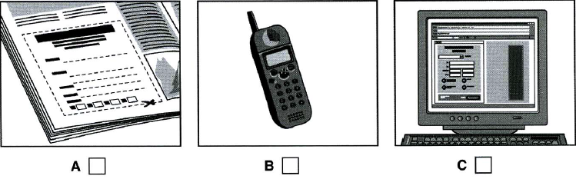
1. B
0. A
0. C

[Q]
10. What will the man do this winter?
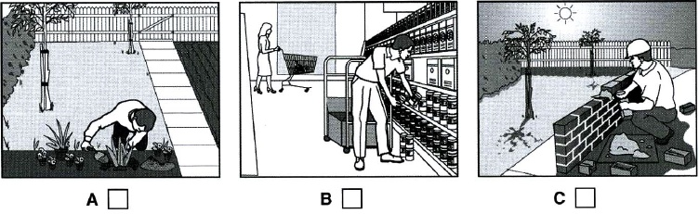
1. A
0. B
0. C
[Q]
Activity 3
[Q]
Listen and choose the correct answer.
Q
THE TAYLOR CONCERT HALL
This talk is about what (11) _______________ the architect has to consider when designing domestic buildings.
0. references
0. consideration
1. factors
0. design

[Q]
Introduction
The designer of a public building may need to consider the building’s
- (12) ___________________
0. construction costs
1. function
0. upkeep
0. surrounding
[Q]
- physical (13) _________________,
0. condition
1. location
0. world
0. exercise
[Q]
- (14) _______________ meaning
0. educational
0. administrational
0. public
1. social
[Q]
- and (15) ______________ meaning
0. hidden
0. spiritual
1. symbolic
0. original
[Q]
The Concert Hall
- The Concert Hall was a site in a run-down (16) ___________________
0. street
0. area
1. district
0. centre
[Q]
- Occupied by a (17) __________________
1. factory
0. company
0. building
0. park
[Q]
- It was one kilometre from the (18) _____________________
0. canal
0. boat
1. ring road
0. shopping centre
[Q]
- Tom Harrison, the project architect found the main design challenge was the (19) _______________ of the site.
0. view
1. location
0. ring road
0. office blocks
[Q]
- The design is based on the concept of a (20) ________________
0. story
0. festival
0. spiral
1. mystery

