[Loai: NGHE – ĐỀ 8 -20 CÂU]
[Q]
Activity 1
Q
People are talking about their interests. What hobby would NOT be suitable for each person? Listen and choose the correct answer.
1. John
1. gardening
0. playing music
0. singing
0. going to the church
[Q]
2. Mary
0. bird watching
0. reading books
1. hiking
0. reading the newspaper
[Q]
3. Wendy
0. watching videos
0. playing board games
0. playing computer games
1. gardening
[Q]
4. Russell
1. going shopping
0. reading books
0. surfing the Internet
0. staying at home
[Q]
5. Nancy
0. using camera
1. playing computer games
0. painting pictures
0. taking photos

Activity 2
[Q]
Listen carefully and choose the correct picture.
Q
6. How does the man want the woman help him?
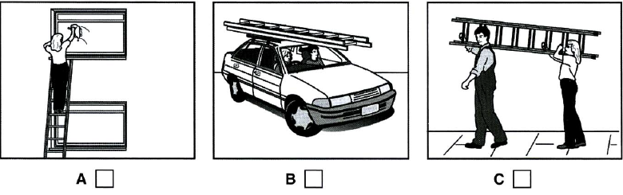
1. B
0. A
0. C
[Q]
7. Which house did the woman stay in?
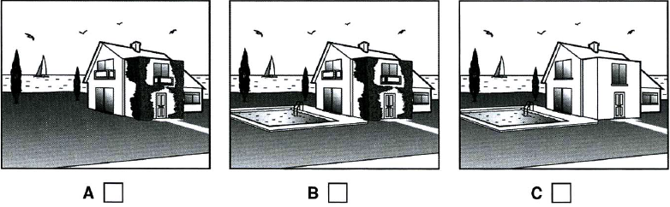
1. A
0. B
0. C
[Q]
8. Where are the dictionaries?
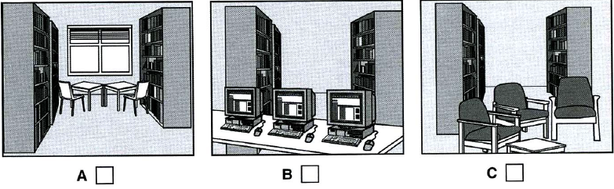
1. B
0. A
0. C
[Q]
9. Which evening dress does the woman decide to wear?
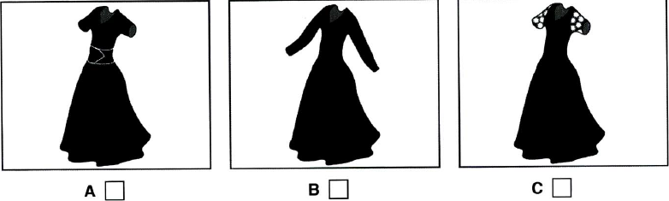
1. A
0. B
0. C
[Q]
10. What is the man’s job now?
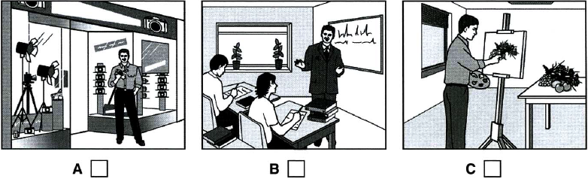
1. B
0. A
0. C
Activity

Listen and choose the correct answer.
Q
ETHNOGRAPHY IN BUSINESS
Ethnography: research which explores human (11) _____________
0. way
0. communication
1. cultures
0. psychology
[Q]
It can be used in business:
- to investigate customer need and (11) _________________
0. insight
1. attitude
0. value
0. information
[Q]
- to help companies develop new (13) _______________
0. needs
0. customers
0. demand
1. designs
Examples of ethnographic research in business
Kitchen equipment
- Researchers watched how cooks used measuring cups to measure out things like sugar and (14) ________________________
1. flour
0. salt
0. design
0. contents
[Q]
- Research found that cooks could not easily see the (15) _____________ in measuring cups.
0. cook
0. contents
0. design
1. numbers
[Q]
Cell phones
- In Uganda, customers paid to use the cell phones of (16) ________________
0. local government
1. entrepreneurs
0. other citizens
0. their relatives
[Q]
- These customers wanted to check the (17) ____________ used.
1. time
0. phone
0. feature
0. design
[Q]
(18) _______________ companies
0. phone
0. administration
1. computer
0. IT system
[Q]
- It was found that a large amount of work in these companies requires communication between system administrators and (19) _________________
0. colleges
0. managers
1. colleagues
0. spreadsheets
[Q]
- There was a need to develop (20) _____________ to improve this kind of communication
0. information
0. standard
0. amount
1. software

