[Loai: NGHE – ĐỀ 10 -20 CÂU]
Activity 1
[Q]
People are talking about their jobs. Listen and choose the correct answer.
Q
1. He _____.
0. has a lot of experience.
1. has been working there awhile.
0. works at a theatre.
0. works in the countryside.
[Q]
2. He _____.
0. works at home.
0. likes his manager.
1. meets interesting people.
0. hates the work.
[Q]
3. He _______________.
1. sees the TV producer every day.
0. can’t help his boss anything.
0. drives very badly.
0. works as a personal secretary.
[Q]
4. She _____.
0. thinks the salary is high.
0. wants to change her job.
0. finds her job interesting.
1. likes her co-workers.
[Q]
5. He _____.
0. works for a TV station.
1. writes about sports news.
0. isn’t well-known.
0. is a novelist.

Activity 2
[Q]
Listen carefully and choose the correct picture.
Q
6. Where is the motorcycle race going to finish?
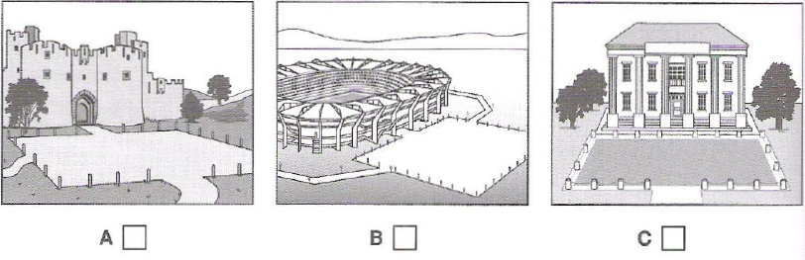
1. C
0. A
0. B

[Q]
7. What will the woman repair next?
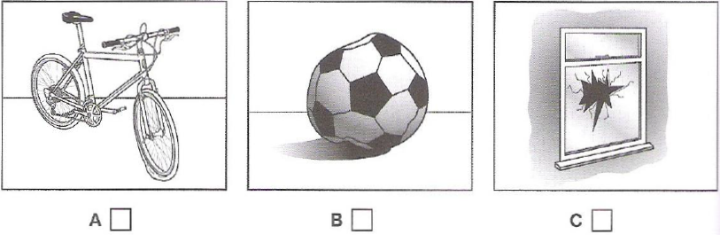
1. B
0. A
0. C

[Q]
8. What has the boy lost?
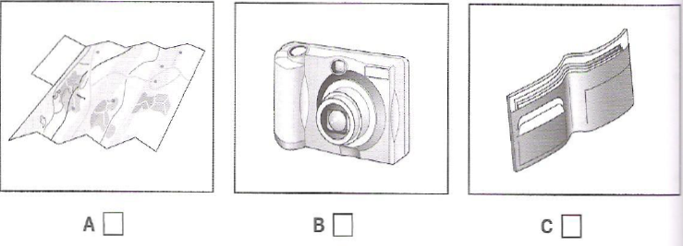
1. B
0. A
0. C

[Q]
9. What time does the race begin?
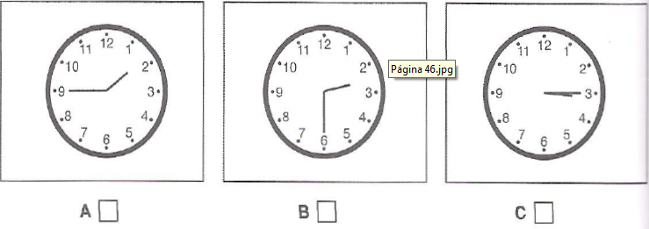
1. B
0. A
0. C

[Q]
10. Which musical instrument does the boy play now?
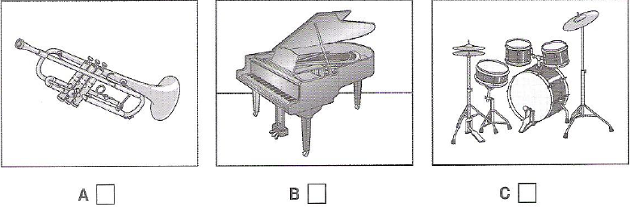
1. C
0. A
0. B
Activity 3
Questions 11-20
[Q]
Listen and choose the correct answer.

Q

Effects of urban environments on animals
Introduction
Recent urban developments represent massive (11) _______________ changes for over millions of years.
[Q]
1. environmental
0. urban
0. dramatical
0. affective
[Q]
It was previously thought that only a few animals were suitable for city life, e.g.
- the (12) _____________ - because of its general adaptability
0. crowd
0. cow
0. crowded
1. crow
[Q]
- the pigeon – because walls of city buildings are similar to (13) _____________by the sea.
0. nests
0. home
1. cliffs
0. ships
[Q]
In fact, it is found that these early immigrants were just the start of more general (14) _________________ of animals into cities.
0. immigrations
1. movements
0. migrations
0. lives
[Q]
One thing that researchers are finding especially interesting is the (15) ______________
1. speed
0. interests
0. changes
0. evolution
[Q]
Recent research
- Emilie Snell-Rood studied small urbanized mammal specimens such as (16) _____________and gophers from museums in Minnesota.
0. squirrels
0. fairies
0. flies
1. mice
[Q]
- She undertook the research by examining (17) _____________ collected for over a hundred years.
0. rural mammals
1. specimens
0. urban mammals
0. small mammals
[Q]
- She found the size of their (18) _____________ had increased.
0. group
0. body
0. heads
1. brains
[Q]
- Researchers can’t be sure that small mammals are more (19) ____________ or not.
0. cognitive
1. intelligent
0. experienced
0. flexible
[Q]
- She suggests this may be due to the need locate new sources of (20) _______________ and to cope with a whole new set of dangers.
1. food
0. demands
0. places
0. city life

