[Loai: NGHE – ĐỀ 11 -20 CÂU]
Activity 1
[Q]
Which activity does each person enjoy doing now? listen and choose the correct answer.
Q
1. Zachary
0. singing
1. playing in a band
0. playing the piano
0. joining in parties.
[Q]
2. Erica
0. collecting baseball cards
0. collecting comic books
0. reading gardening books
1. gardening
[Q]
3. Bradley
0. watching videos
0. using computers
1. hiking
0. playing video games
[Q]
4. Evan
1. collecting stamps
0. watching paintings
0. collecting baseball cards
0. visiting museums
[Q]
5. Danielle
1. painting
0. writing short stories
0. reading painting books
0. getting prizes
Activity 2
[Q]
Listen carefully and choose the correct picture.
Q
6. What will the weather be like tomorrow afternoon?
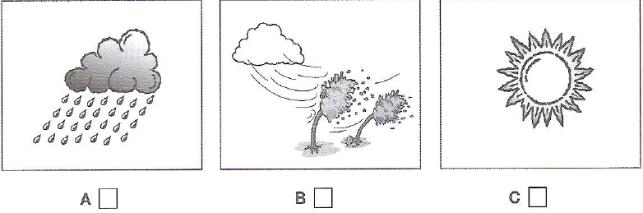
1. A
0. B
0. C
[Q]
7. What is the subject of James Wilson’s book?
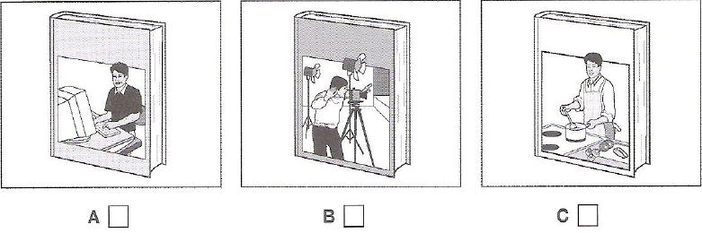
1. A
0. B
0. C

[Q]
8. Which part of the man’s body hurt at the moment?
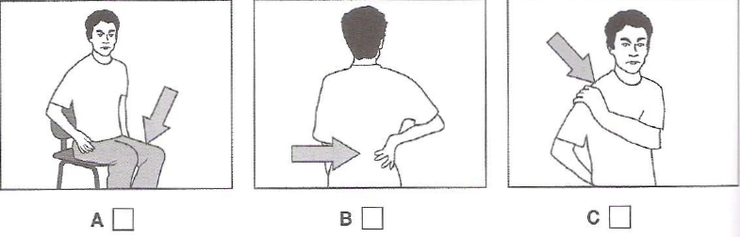
1. C
0. A
0. B
[Q]
9. Where was the man’s knowledge of Spanish useful?
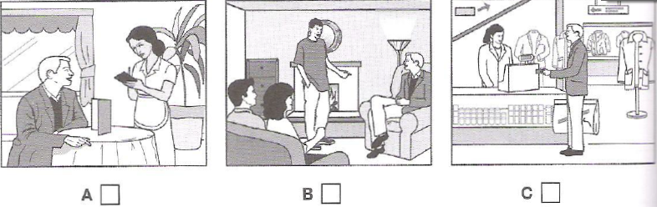
1. C
0. A
0. B
[Q]
10. Which present will the girl receive?
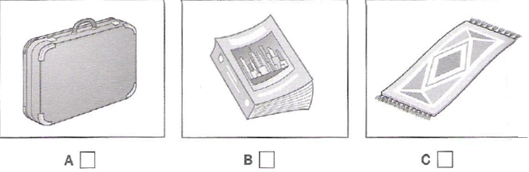
1. C
0. A
0. B

Activity 3
[Q]
Listen and choose the correct answer.
Q
Episodic memory
- Refers to the memory of and event or “(11) _____________”.
0. sequence
0. order
0. information
1. episode
[Q]
- the ability to recall details, e.g. the time and (12) ______________ of past events
1. location
0. contents
0. people
0. information
[Q]
For example, remember the last time you ate dinner at a restaurant, the ability to remember where you ate, who you were with and (13) ____________ are all features of an episodic memory.
0. how the dish looked like
0. where you sat
1. items you ordered
0. the order dishes were served
[Q]
- different to semantic memory – the ability to remember general information about the (14) ____________
0. another
0. generality
1. world
0. everyone
[Q]
Your understanding of what a car is and (15) _____________ are examples of semantic memory.
0. where you parked your car
1. how an engine works
0. the place you went to
0. what the car looked like
[Q]
- Semantic memory isn’t dependent on recalling (16) _____________ experiences

0. factual
1. personal
0. world
0. process
[Q]
Episodic memory can be thought of as process with several different steps of memory processing: (17) ______________, consolidation and retrieval.
1. encoding
0. storage
0. visualisation
0. rehearsing
[Q]
Episodic memories can help people connect with others by sharing (18) _______________details about their past.
0. individual
0. connecting
1. intimate
0. minor
[Q]
Episodic memory impairments
- children with autism may have difficulty forming episodic memories – possibly because their sense of the (19) ______________ may be absent.
1. self
0. impairments
0. reason
0. storage
[Q]
Memory training may help autistic children develop (20) ________________
0. impact
0. positivity
0. treatments
1. social skills

