[Loai: NGHE – ĐỀ 12 -20 CÂU]
Activity 1

[Q]
These people have to go somewhere. How will each person get there? Listen and choose the correct answer.
Q
1.
0. by bus
0. by train
1. by car
0. by bicycle
[Q]
2.
0. by car
0. by bus
0. by bike
1. by subway
[Q]
3.
1. by taxi
0. by car
0. by bus
0. by train
[Q]
4.
0. by subway
1. by car
0. by bus
0. by taxi
[Q]
5.
0. by car
0. by taxi and subway
1. by subway and on foot
0. by taxi and on foot

Activity 2
Listen carefully and choose the correct picture.
[Q]
6. Where will the tourists go last?
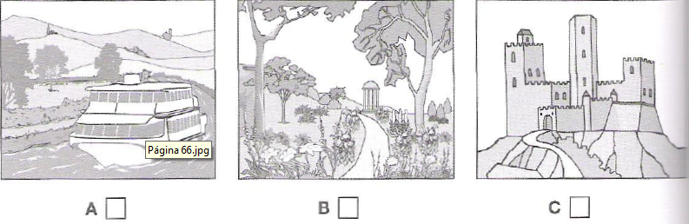
1. A
0. B
0. C
[Q]
7. How much does the man pay for the postage?

1. C
0. A
0. B
[Q]
8. Where in the theatre did the woman leave her gloves?
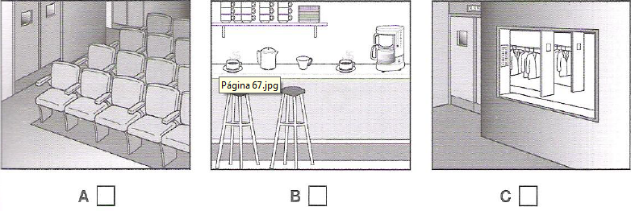
1. A
0. B
0. C
[Q]
9. Which dress does the woman like best?
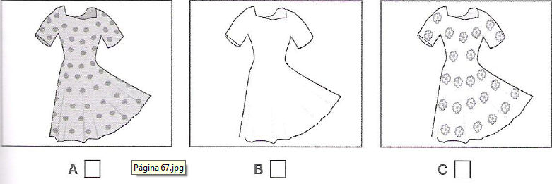
1. A
0. B
0. C
[Q]
10. What is the television programme about?
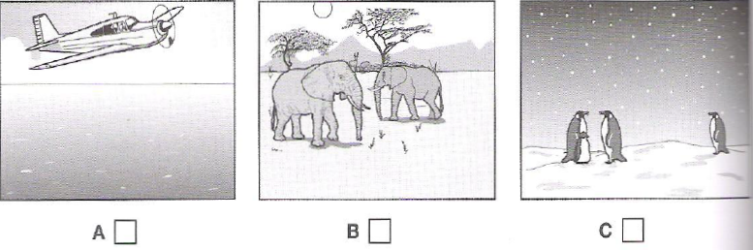
1. C
0. A
0. B

Activity 3
[Q]
Listen and choose the correct answer.
Q
The sleepy lizard
Tiliqua rugosa is commonly known as the sleepy lizard, because it’s quite slow in its movements and spends a lot of time dozing under (11) ___________ or lying in the sun
0. soil
1. rocks
0. water
0. sea
[Q]
Description
- They are common in (12) ________________
0. Western and Southern Austria
0. Southern Australia
0. Western Austria
1. Western and South Australia
[Q]
- Unlike European lizards, which are mostly small, (13) _____________ and fast-moving, sleepy lizards are brown.
0. white
1. green
0. yellow
0. colourful
[Q]

- They are brown, but recognizable by their dark blue (14) _______________
0. head
0. tail
0. lining
1. tongue
[Q]
- Their diet consists mainly of (15) ________________
0. insects
1. plants
0. small animals
0. other animals
[Q]
- They are relatively large and powerful, with strong (16) _______________ that can crush snail shells.
0. teeth
0. legs
1. jaws
0. body
[Q]
- Their main predators are large birds and (17) ________________
1. snakes
0. beetles
0. bees
0. crocodiles
[Q]
- Another threat to their survival is that quite a large number of sleepy lizards are killed by (18) _________________
0. tourists
0. trains
1. cars
0. thunder
[Q]
Navigation study
- Though sleepy lizards move slowly, they can travel quite long distances and they could usually find the way back even if they were taken some distance away from their (19) _______________
0. area
0. sky
1. territory
0. nest
[Q]
- One study found that lizards can use the (20) ______________ to help them find their way back home.
0. tail
0. head
1. sky
0. skin

