[Loai: NGHE – ĐỀ 13 -20 CÂU]
Activity 1
[Q]
People are calling home while they are on vacation. Listen and choose the word that describes each person.
Q
1. Jill
0. bored
1. excited
0. upset
0. tired
[Q]
2. Sean
0. terrified
0. free
1. happy
0. relaxed
[Q]
3. John
0. terrific
0. exciting
0. great
1. worried
[Q]
4. Rachel
0. bored
1. sick
0. worried
0. fine
[Q]
5. Mary
1. upset
0. happy
0. busy
0. pleased
Activity 2

[Q]
Listen carefully and choose the correct picture.
Q
6. Which vehicle does Steve intend to buy?
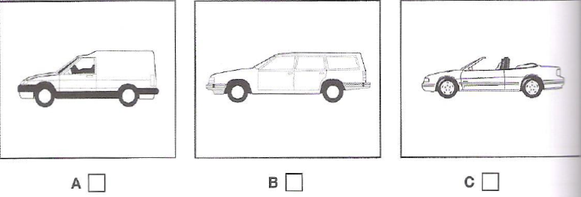
1. B
0. A
0. C

[Q]
7. Which prize has the man just won?
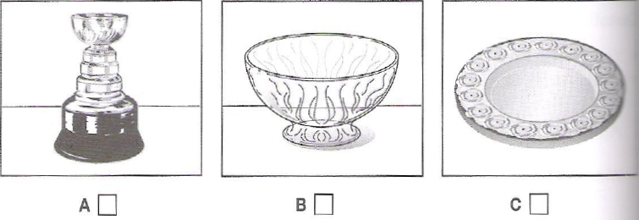
1. B
0. A
0. C

[Q]
8. What was the man’s first job?
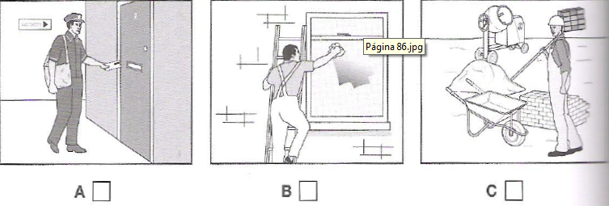
1. B
0. A
0. C

[Q]
9. Where will they have something to eat?
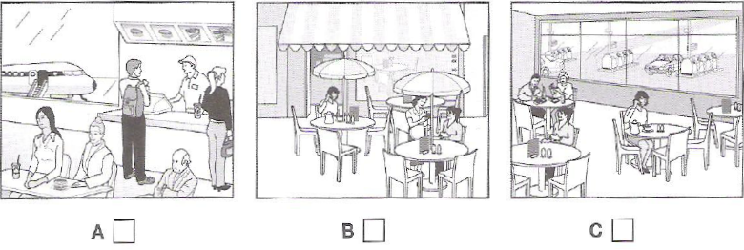
1. C
0. A
0. B

[Q]
10. What does the woman’s house look like now?
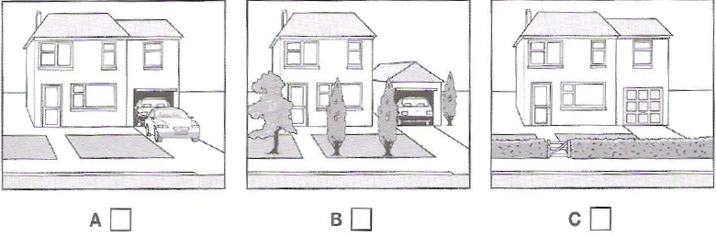
1. A
0. B
0. C

Activity 3
[Q]
Listen and choose the correct answer.
Q

The history of coffee
Coffee in the Arab world
- Coffee was originally gathered from bushes growing wild in (11) _______________
0. Arab
1. Ethiopia
0. Southeast Africa
0. Northwest Africa
[Q]
- In 1522, coffee was approved in the Ottoman court as a type of (12) ______________
0. trader
0. drink
0. wild bushes
1. medicine
[Q]
- By (13) ____________, coffee bushes were being cultivated in the Yemen.
0. before the 1500s
1. the mid-1500s
0. the late 1500s
0. after the 1500s
[Q]

- Coffee was rarely drunk (14) ______________
0. at coffee houses
0. at work
1. at home
0. on the street
[Q]

- In 1623, the ruler ordered the (15) ______________ of every coffee house in Constantinople.
0. replacement
1. destruction
0. destroy
0. consumption
[Q]
- In the 17th century, coffee arrives in Europe and coffee shops became places where (16) ______________ people could meet to exchange ideas.
0. young
0. upper-class
1. ordinary
0. noble
[Q]
- Coffee shops were compared to (17) ______________
1. universities
0. homes
0. small society
0. companies
[Q]
- They played an important part in social and (18) ______________ changes.
0. environmental
0. industrial
1. political
0. medical
[Q]
- In the late 1600s, the coffee production started to spread around the world because European powers established coffee plantations in (19) ________________
0. their lands
1. their colonies
0. mountains
0. hills and valleys
[Q]
- Types of coffee were often named according to the (20) ___________ they came from
0. lands
0. colonies
0. cities
1. ports

