[Loai: NGHE – ĐỀ 14 -20 CÂU]
Activity 1
[Q]
People are calling home while they are on vacation. Why does each person call? Listen and choose the correct answer.
Q
1. Jill _____.
1. has some news.
0. has a tiring time.
0. wants to ask for a ring.
0. meets a relative.
[Q]
2. Sean _____.
0. isn’t having a good time.
0. isn’t in a hotel.
0. wants to leave Hawaii.
1. needs money.
[Q]
3. John _____.
1. lost his wallet.
0. missed the flight.
0. had his credit cards left at home.
0. doesn’t sure when he will call.
[Q]
4. Rachel _____.
0. has got a terrible headache.
0. doesn’t want to see a doctor.
1. to tell her friend about a health problem.
0. is very worried.
[Q]
5. Mary _____.
0. missed Paris.
1. lost her glasses.
0. went on a bus tour this afternoon.
0. will call back later.

Activity 2
[Q]
Listen carefully and choose the correct picture.
Q
6. Which sport will they do tomorrow?
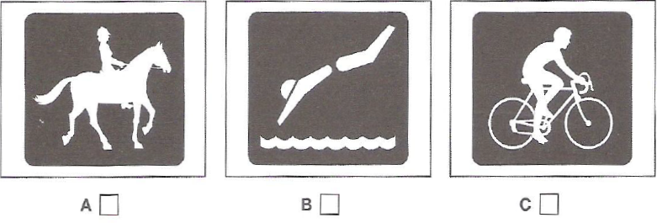
1. A
0. B
0. C

[Q]
7. What can you see on the television programme?
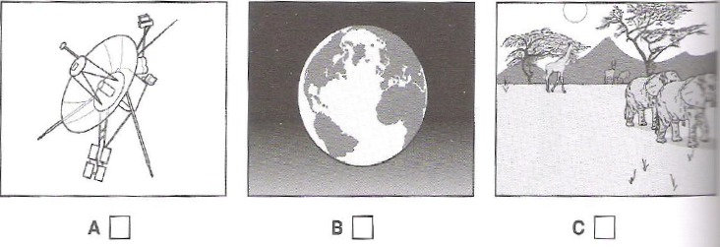
1. B
0. A
0. C

[Q]
8. Where will the man sit on the plane?
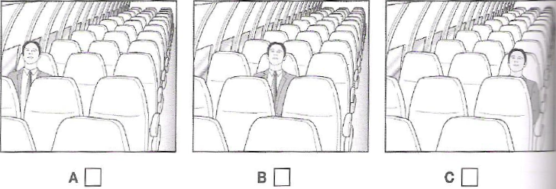
1. C
0. A
0. B

[Q]
9. What did the man buy?
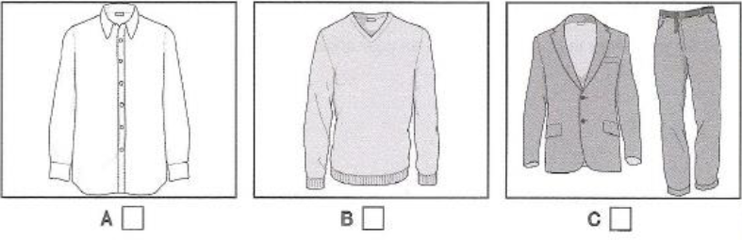
1. B
0. A
0. C

[Q]
10. How will the woman help the man?
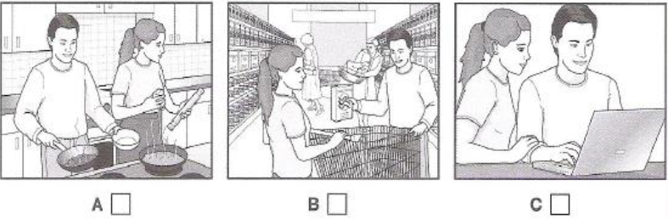
1. C
0. A
0. B
Activity 3

[Q]
Listen and choose the correct answer.
Ocean Biodiversity
- Biodiversity hotspots are the areas which have the greatest mixture of (11) ____________
0. mammals
0. diversity
1. species
0. fish
[Q]

- Biodiversity hotspots are important for locating targets for focusing efforts at (12) ______________
0. biologists
1. conservation
0. areas
0. efforts
[Q]
- At first, biologists could only identify hotspots (13) ____________
1. on land
0. existence
0. in the ocean
0. in the water
[Q]
- In 2005, Boris Worm did some research on data on ocean species that he got from the (14) ______________
0. ocean
0. local market
0. aquarium
1. fishing industry
[Q]
- He identified hotspots for (15) _____________
0. small ocean predators
0. large land predators
1. large ocean predators
0. small land predators
[Q]
- Boris Worm found that ocean hotspots:
- were not always rich in (16) ______________
0. highness
0. hotspots
0. remaining
1. food
[Q]
- had higher temperatures at the (17) _____________
1. surface
0. cases
0. greater depths
0. lower depths
[Q]
- had enough (18) _____________ in the water
0. factors
0. necessary
1. oxygen
0. rate
[Q]
- In 2007, Lisa Balance looked for hotspots for marine (19) ____________
0. fish
1. mammals
0. researchers
0. places
[Q]
- She found these hotpots were all located at boundaries between ocean (20) ______________
0. winds
0. boundaries
0. plankton
1. currents

