[Loai: NGHE – ĐỀ 4 -20 CÂU]
[Q]
Activity 1
Q

These people have to go somewhere. How will each person get there? Listen and choose the correct answer.
0. by bus
1. by car
0. by bicycle
0. by tram
[Q]
0. by car
0. by bus
0. by train
1. by subway
[Q]
1. by taxi
0. by car
0. by bus
0. by coach
[Q]
1. by car
0. by bus
0. by motorbike
0. by taxi
[Q]
0. by car
0. by taxi and subway
1. by subway and on foot
0. by taxi and on foot

[Q]
Activity 2
Q
Listen carefully and choose the correct picture.
Where will the tourists go last?
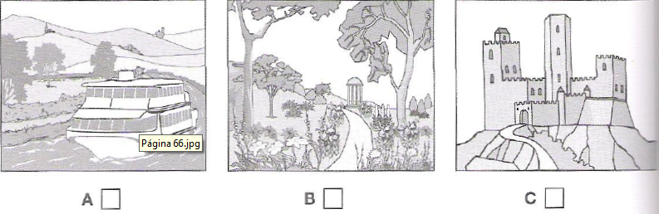
1. A
0. B
0. C
[Q]
How much does the man pay for the postage?

1. C
0. A
0. B
[Q]
Where in the theatre did the woman leave her gloves?
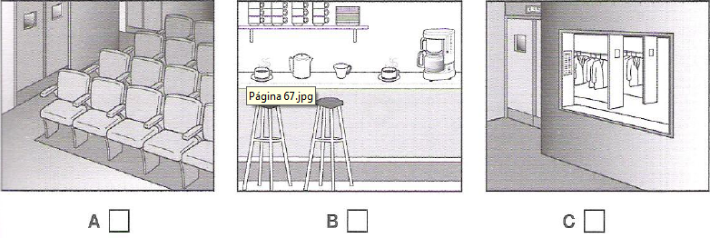
1. A
0. B
0. C

[Q]
Which dress does the woman like best?
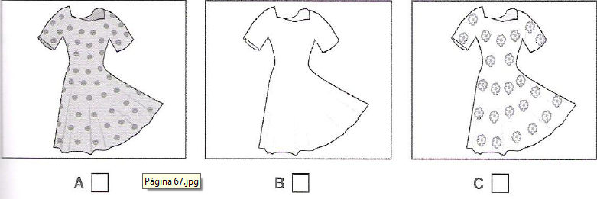
1. A
0. B
0. C
[Q]
What is the television programme about?
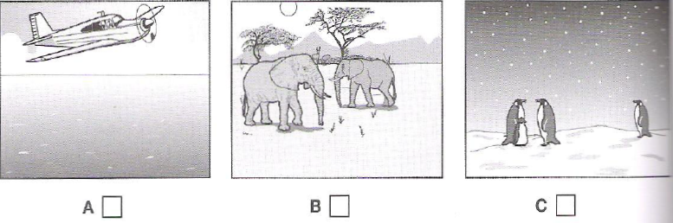
1. C
0. A
0. B

[Q]
Activity 3
Listen and choose the correct answer.
The sleepy lizard
Q
Tiliqua rugosa is commonly known as the sleepy lizard, because it’s quite slow in its movements and spends a lot of time dozing under (11) ____________ or lying in the sun
0. ground
1. rocks
0. water
0. cave
[Q]
Description
- They are common in (12) ________________
0. Western and South Austria
0. Southern Australia
0. Western Austria
1. Western and South Australia
[Q]
- Unlike European lizards, which are mostly small, (13) ________________ and fast-moving, sleepy lizards are brown.
0. grey
1. green
0. blue
0. colourful
[Q]
- They are brown, but recognizable by their dark blue (14) ________________
0. colour
0. mouth
0. lining
1. tongue
[Q]
- Their diet consists mainly of (15) ______________
0. insects
1. plants
0. small animals
0. other lizards
[Q]
- They are relatively large and powerful, with strong (16) ________________ that can crush snail shells.
0. tail
0. legs
1. jaws
0. tongue
[Q]
- Their main predators are large birds and (17) _______________
1. snakes
0. beetles
0. snail
0. cassowaries
[Q]
- Another threat to their survival is that quite a large number of sleepy lizards are killed by (18) _____________________
0. tourists
0. beetles
1. cars
0. cassowaries
[Q]
Navigation study
- Though sleepy lizards move slowly, they can travel quite long distances and they could usually find the way back even if they were taken some distance away from their (19) _______________
0. field
0. sky
1. territory
0. colony
[Q]
- One study found that lizards can use the (20) _____________ to help them find their way back home.
0. tail
0. distance
1. sky
0. territory

