[Loai: NGHE – ĐỀ 15 -20 CÂU]

Activity 1
[Q]
People are describing parties they gave recently. What happened at each party?
Q
1. People _____
0. were from work and family.
1. listened to music.
0. loved party games.
0. didn’t make birthday cake.
[Q]
2. People _____
0. had a terrible time.
0. danced a lot.
0. ate indoors.
1. didn’t feel hungry.
[Q]
3. People _____
1. sang.
0. ordered pizza.
0. didn’t eat snack.
0. organized a welcome party
[Q]
4. People _____
0. listened to music
1. ate lots of food.
0. danced.
0. didn’t cook any dishes.
[Q]
5. People _____
0. didn’t have good time.
0. ate too much.
1. danced.
0. didn’t listen to music.
Activity 2
[Q]
Listen carefully and choose the correct picture.
Q
6. Where will the friends meet?
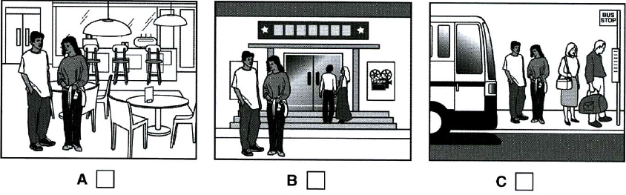
1. A
0. B
0. C

[Q]
7. What has the girl forgotten to bring?
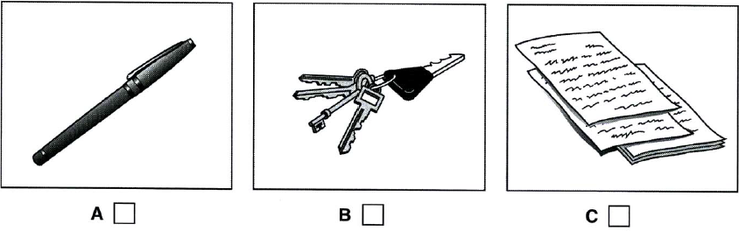
1. A
0. B
0. C

[Q]
8. Which TV programme is on at 9 o’clock tonight?
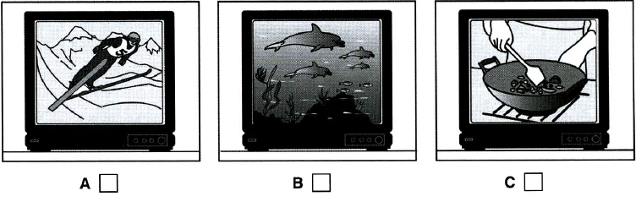
1. C
0. A
0. B

[Q]
9. How will the man book tickets for the show?
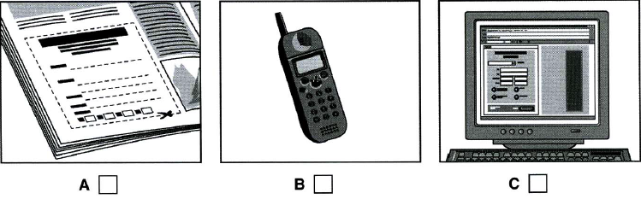
1. B
0. A
0. C

[Q]
10. What will the man do this winter?
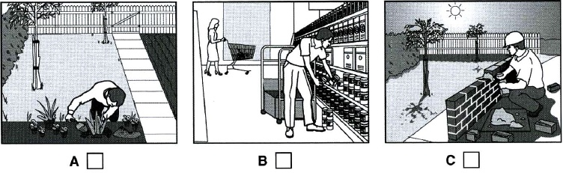
1. A
0. B
0. C
Activity 3
[Q]
Listen and choose the correct answer.
THE TAYLOR CONCERT HALL
Q
This talk is about what (11) _________ the architect has to consider when designing domestic buildings.
0. discussions
0. illustration
1. factors
0. referring
[Q]

Introduction
The designer of a public building may need to consider the building’s
- (12) _________________
0. building costs
1. function
0. entertainment
0. administration
[Q]

- physical (13) _________________,
0. education
0. strenth
1. location
0. necessity
[Q]

- (14) ______________ meaning
0. central
0. political
1. social
0. related
[Q]

and (15) ______________ meaning
0. public
0. spiritual
1. symbolic
0. intellectual
[Q]

The Concert Hall
- The Concert Hall was a site in a run-down (16) _________________
0. road
0. lane
1. district
0. centre
[Q]

- Occupied by a (17) ___________________
1. factory
0. school
0. theatre
0. museum
[Q]

- It was one kilometre from the (18) ________________
0. cinema
0. post office
1. ring road
0. tourist centre
[Q]

- Tom Harrison, the project architect found the main design challenge was the (18) _________________ of the site.
0. function
1. location
0. shape
0. construction
[Q]

- The design is based on the concept of a (20) _____________________
0. run-down location
0. discovery
0. story
1. mystery

