[Loai: NGHE – ĐỀ 3 -20 CÂU]
[Q]
Activity 1
Which activity does each person enjoy doing now? listen and choose the correct answer.
1. Zachary
0. playing the guitar
1. playing in a band
0. playing the piano
0. celebrating parties.
[Q]
2. Erica
0. collecting baseball cards
0. collecting comic books
0. reading comic books
1. gardening
[Q]
3. Bradley
0. watching videos
0. using computers
1. hiking
0. playing video games
[Q]
4. Evan
1. collecting stamps
0. collecting paintings
0. collecting baseball cards
0. going to the museums
[Q]
5. Danielle
1. painting
0. writing children’s books
0. reading
0. getting prizes
[Q]
Activity 2
Listen carefully and choose the correct picture.
6. What will the weather be like tomorrow afternoon?
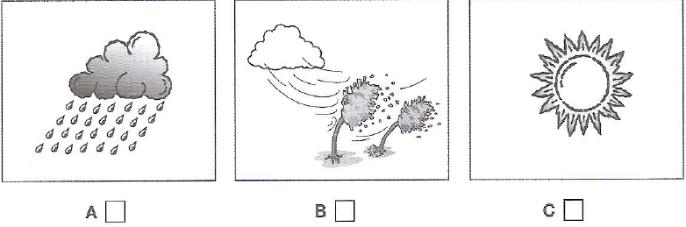
1. A
0. B
0. C
[Q]
7. What is the subject of James Wilson’s book?
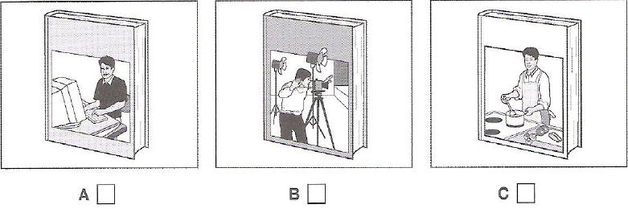
1. A
0. B
0. C
[Q]
8. Which part of the man’s body hurt at the moment?
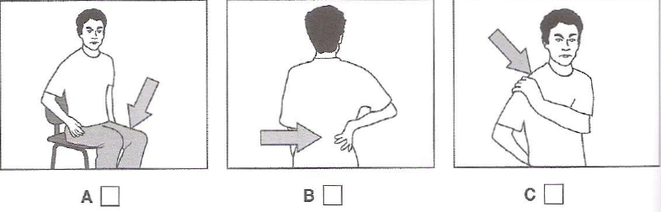
1. C
0. A
0. B
[Q]
9. Where was the man’s knowledge of Spanish useful?
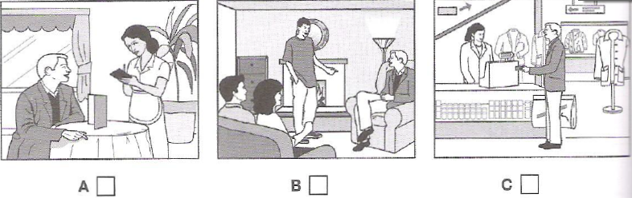
1. C
0. A
0. B
[Q]
10. Which present will the girl receive?
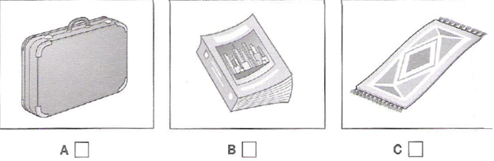
1. C
0. A
0. B
[Q]
Activity 3
Listen and choose the correct answer.
Episodic memory
- Refers to the memory of and event or “(11) ____________”.
0. things
0. period
0. information
1. episode
[Q]
- the ability to recall details, e.g. the time and (12) _____________ of past events
1. location
0. memory
0. information
0. concept
[Q]
For example, remember the last time you ate dinner at a restaurant, the ability to remember where you ate, who you were with and the (13) _____________ are all features of an episodic memory.
0. how the dish was cooked
0. the restaurant
1. items you ordered
0. the process of making a side dish
[Q]
- different to semantic memory – the ability to remember general information about the (14) __________________
0. fact
0. common
1. world
0. everyone
[Q]
Your understanding of what a car is and (15) ______________ are examples of semantic memory.
0. where you parked your car
1. how an engine works
0. the place you went to
0. what the car looked like
[Q]
- Semantic memory isn’t dependent on recalling (16) _____________ experiences
0. factual
1. personal
0. understandable
0. examples
[Q]
Episodic memory can be thought of as process with several different steps of memory processing: (17) ______________, consolidation and retrieval.
1. encoding
0. storage
0. visualisation
0. rehearsing
[Q]
Episodic memories can help people connect with others by sharing (18) _______________ details about their past.
0. general
0. specific
1. intimate
0. minor
[Q]
Episodic memory impairments
- children with autism may have difficulty forming episodic memories – possibly because their sense of (19) __________ may be absent.
1. self
0. individual
0. sense
0. storage
[Q]
Memory training may help autistic children develop (20) ______________
0. behaviours
0. flexibility
0. sense
1. social skills

