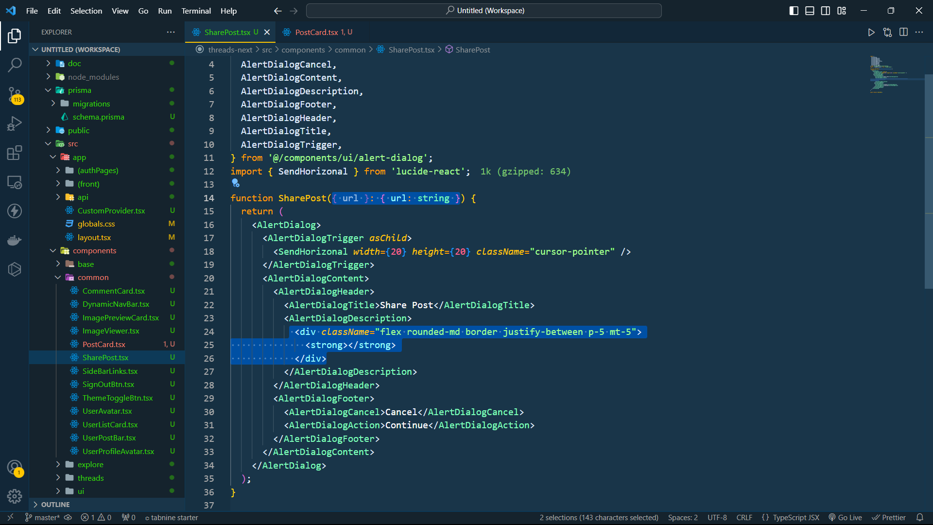

* Thêm use client

* Nhấn vào biểu tượng là nó tự copy và chỉ cần ctrl + c là được

