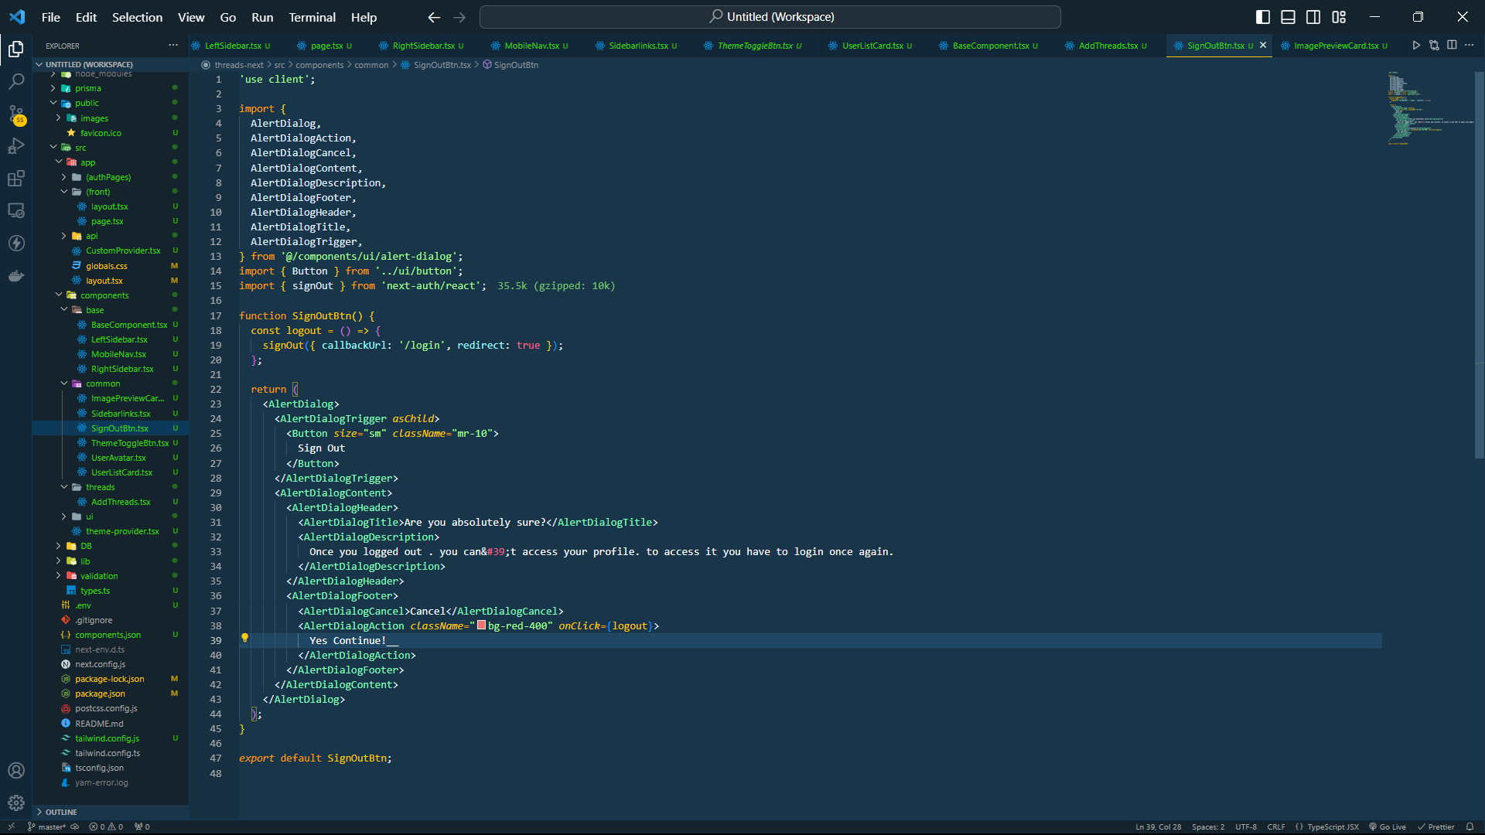

* Đăng nhập và thử quay lại trang login