Desktop Search over Local Files: Comparing Keyword, Semantic and Hybrid Retrieval, Evaluated on COVID-19 Papers

Abstract
Most of us keep a lot of files on our computer: PDFs, notes, downloaded papers. Normal keyword search misses a file if it uses different words from the ones we typed, for example "temperature" instead of "weather". In this project I built a desktop search system that scans a local folder, indexes text and PDF files, and compares three ways of ranking results: BM25 keyword search (the baseline), vector search using sentence embeddings, and a hybrid that joins both with Reciprocal Rank Fusion (RRF). Everything runs on my own machine with Elasticsearch, an all-MiniLM embedding model, a FastAPI back end and a simple web page that shows the three result lists next to each other. To measure quality, I tested it on a folder of 1,453 COVID-19 papers from TREC-COVID, which comes with relevance labels made by medical experts. After testing with more than 10 questions the hybrid carried the best Precision@10 that is 0.89, vector search has the best MRR 1.00 and BM25 has the lowest of 0.62 & 0.63 on both respectively. Introducing of meaning based search made desktop search better from plain language.

1. Introduction
Every person system contain thousands of files, including reports, lecture notes. However, the system search mainly relies on file names and matching keywords which means it can miss meaningful documents when they contain the right information but use similar wording. To explore & improve, I developed my own desktop search system and tested it using a collection of COVID-19 research papers.
I chose COVID-19 papers because the pandemic led to a huge increase in research publications. The Allen Institute for AI collected these papers in CORD-19, a publicly available dataset containing over a million research papers. I use this collection along with TREC-COVID, which provides expert judgements about which papers are relevant to particular search questions also keyword search is useful when the search terms match the words in a document. However, it struggles when the same idea is expressed differently. Vector search addresses this limitation by converting text into numerical representations of its meaning. For example, a search for "weather" may also find documents discussing temperature and humidity.
Problem. Which ranking method gives me the most relevant document when i search with normal question: keyword, vector, or both together?
Target users and information needs. Students, researchers and anyone who keeps many documents on their computer and needs the files that answer a question. In my test collection the questions are about COVID-19, for example "What are the initial symptoms of Covid-19?". People usually only look at the first page, so the top 10 is what matters.
Aim and objectives. My aim was to build a local desktop search system and test it properly, by:
- scanning a folder and pulling the text out of text and PDF files
- splitting the text into chunks, embedding them and indexing everything
- implementing a BM25 baseline, a vector alternative and a hybrid improvement
- building a simple local search page
- evaluating all three methods on a labelled COVID-19 test collection
Success criteria. The system answers any query through the page and the API. At least one alternative beats BM25 on Precision@10 and MRR, and anyone can re-run the code and get the same numbers.
Sections 2 to 6 cover related work, how I built it, the results, discussion and conclusion.

2. Related Work
BM25 is a common keyword-based ranking method (Robertson and Zaragoza, 2009). It ranks documents based on how often search terms appear and how rare those terms are across the collection. It also considers document length. I used BM25 because it is fast and does not require training like others. However, it struggles when users search with words that have similar meanings but are written differently through out the document.
Dense retrieval focuses on meaning rather than exact word matching. It converts text into vectors, where documents with similar meanings are placed closer together. Sentence-BERT (Reimers and Gurevych, 2019) made this approach practical for sentence-level search. In my project, I use all-MiniLM because it is lightweight and fast (Wang et al., 2020b). However, it can sometimes miss exact terms, such as specific drug names.
Hybrid search combines BM25 and vector search to benefit from both approaches. I use Reciprocal Rank Fusion (Cormack, Clarke and Büttcher, 2009) to merge their results based on ranking positions rather than comparing their raw scores. This is useful because neither method performs best in every situation, as also shown by the BEIR benchmark (Thakur et al., 2021).
Desktop search and test collections. Existing desktop search tools depend on file names and keyword matching which can lead to similar vocabulary problems. Since personal files do not have predefined relevance labels, I use TREC-COVID which is a standard dataset containing 50 search topics with relevance judgements made by medical experts to find which query is related to which document.
In this project, I want to explore whether combining keyword and semantic search can improve desktop search while keeping the system lightweight and local. I compare all three approaches using the same document collection.

3. Methodology and Implementation

3.1 Architecture
The system has five key parts: an extractor that scans a local folder with parameters like root path, file pattern & from, an indexer that chunks and index documents, Elasticsearch 8.15, a FastAPI search service and a web page. Elasticsearch and the embedding model (all-MiniLM, served through Ollama) run in Docker on the same machine, so no file leaves the computer.
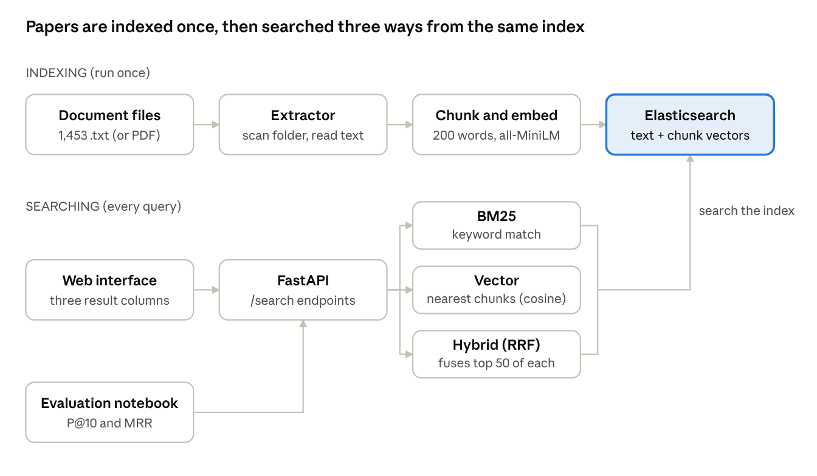
system architecture · indexing pipeline and three search modes
The top row runs once to build the index. After that every query goes through one of the three search modes on the same index.

3.2 Test collection
To evaluate a search system you need relevance labels, and personal files have none. The module recommends CORD-19, but it has no labels either. So I tested on TREC-COVID, which is built on CORD-19 and adds expert labels. I downloaded it from Hugging Face (BeIR/trec-covid and BeIR/trec-covid-qrels). The document gives parquet files that holds all data and also a csv that holds evaluation labels and then I saved each parquet as files in a local folder, the way most of user's documents sit on disk:
- I picked 10 of the 50 questions, covering different topics.
- For each one I randomly sampled 150 papers that experts had judged (random seed 42), skipping papers with fewer than 30 words.
- This gave 1,453 unique papers, each saved as a text file with its title and abstract.

3.3 Processing and indexing
The extractor traverse through a root folder and scan until the provided nested level is reached, keeps the files that match a pattern (for example *.txt) and reads plain text or PDF files. Each document is cut into 200 word chunks with a 50 word overlap, so a sentence on a boundary is still whole in at least one chunk. Each chunk becomes a vector of 384 numbers using a local embedding model.
Field | Type | Used for
content | text, English analyzer | BM25
chunks.text | text, English analyzer | chunk text
chunks.embedding | dense vector, 384, cosine | vector search
The English analyzer reduces words to their root, so "lungs" matches "lung". The file path is the document ID, so running the indexer again updates files instead of making duplicates.

3.4 Retrieval and ranking
- BM25 (baseline): a normal match query on the content field.
- Vector: the query is embedded, Elasticsearch finds the nearest chunks by cosine similarity, and each file is scored by its best chunk.
- Hybrid (RRF): I take the top 50 from each method where each paper points from each list it appears in.
points = 1 / (60 + rank)
A file in both lists gets two shares, so it moves up. Because RRF only uses ranks, I never compare a BM25 score with a cosine score.

3.5 Interface
FastAPI gives three endpoints, /search/bm25, /search/vector and /search/reranked, and serves one html page with a search box at top and three columns, one per method with rank, score, file name and short description

3.6 Evaluation
The experts scored each paper relevant from 0 to 2 where 2 is highly relevant and 0 is not relevant. For simplicity I marked 1 & 2 as relevant and 0 as not relevant. Each question goes through all three methods and I score the top 10 with:
- Precision@10 means relevant results in the top 10, divided by 10.
- MRR means 1 divided by the rank of the first relevant result, averaged over the questions.
Precision@10 tells me how good the first page is, and MRR tells me how fast the user gets to the first useful file.

4. Results and Analysis

4.1 Overall results
All 1,453 papers were indexed, with 2,072 expert labels for the 10 questions. The hybrid put the most relevant papers in the top 10, and vector search was best at putting a relevant paper in first place.
Method | Precision@10 | MRR | Best or joint best (of 10)
BM25 (baseline) | 0.62 | 0.63 | 2
Vector | 0.85 | 1.00 | 5
Hybrid (RRF) | 0.89 | 0.95 | 9
Against BM25, the hybrid raised Precision@10 by 0.27, so about 8.9 relevant papers on the first page instead of 6.2. Vector search put a relevant paper first for every question.

4.2 Results per question
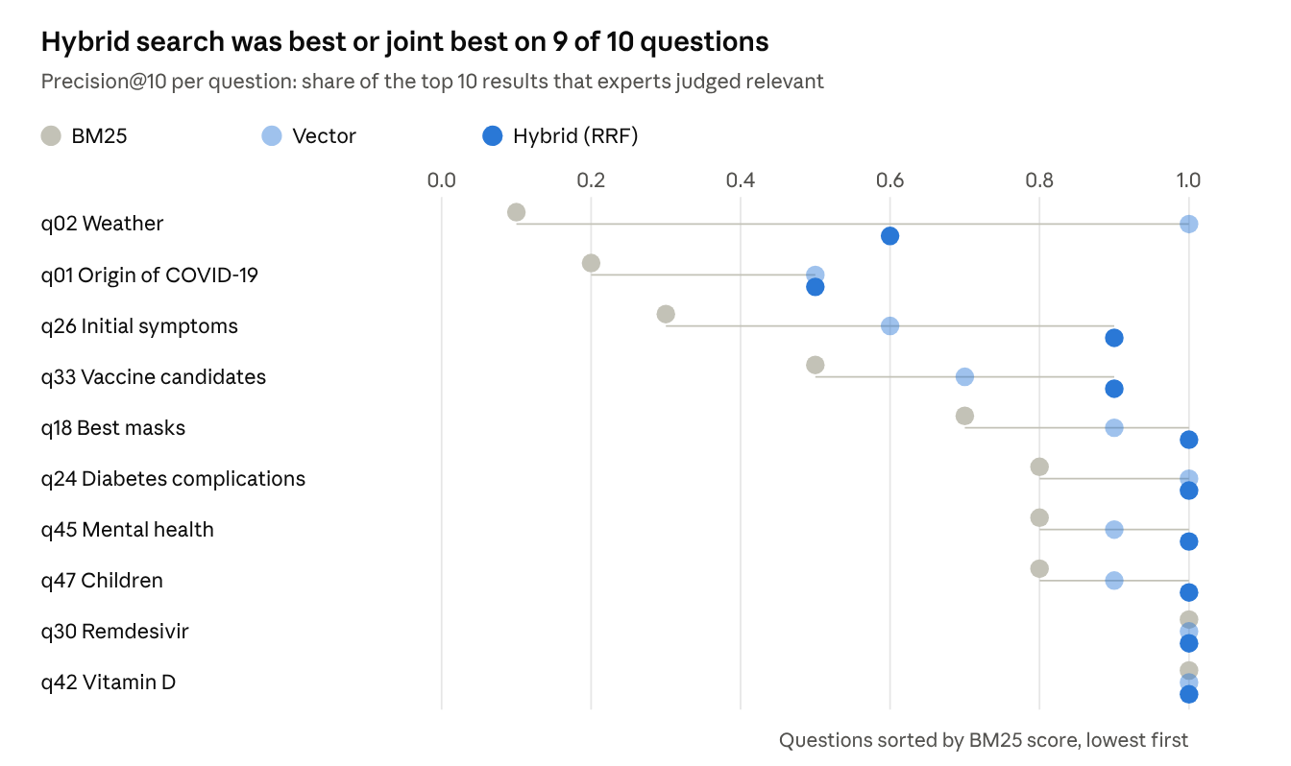
evaluation/evaluation.ipynb · 10 TREC-COVID questions, 1,453 papers
BM25 fell behind most when the relevant papers used different words from the question. On questions with a precise term, all three methods were perfect.

4.3 Example queries
Weather (q02). BM25 found only 1 relevant paper, vector search found 10. When I checked the 42 relevant papers, 32 say "temperature" and 25 say "humidity", but only 16 say "weather". BM25 matched common words like "coronavirus" and "changes" instead. Here the hybrid (0.6) was worse than vector alone, because the poor BM25 list dragged off-topic papers into the merged top 10.
Initial symptoms (q26). BM25 got 0.3, vector 0.6 and hybrid 0.9. Each method found some different relevant papers, and RRF pushed the ones both agreed on to the top. This is where combining helps most.
Remdesivir (q30). All three got 1.0. A rare, exact term like a drug name is easy for keyword search, and the embedding model handles it well too.

4.4 Data quality and suitability
- The documents are titles and abstracts only, so some details from the full papers are missing.
- Papers with fewer than 30 words were dropped, because there is almost nothing to search in them.
- The collection only has judged papers, so it holds more relevant papers than a real folder would. Scores are probably a bit optimistic.
- A paper can be relevant to a question it was never judged for, and then it counts as not relevant.
- CORD-19 also has older SARS and MERS papers that match COVID-19 questions on wording alone.
For plain-language questions, vector and hybrid search gave first pages with 8 to 9 relevant files out of 10. That is good enough for desktop search, where people rarely remember the exact words in a file. BM25 is still useful for exact terms like names or codes. The system ranks by relevance, not quality, so the user still has to judge what they find.

5. Conclusion and Future Directions
I built a local desktop search system with three ranking methods and a web page, and evaluated it on a folder of COVID-19 papers using TREC-COVID expert labels.
What the evidence shows. Based on 10 questions, vector and hybrid search clearly beat BM25 with Precision@10 of 0.85 and 0.89 against 0.62; MRR of 1.00 and 0.95 against 0.63. BM25 has failed worst when the words did not match (weather: 0.1). Precise terms were easy for every method.
Interpretation. My reading is that meaning-based search is the key improvement for plain-language desktop search, and the hybrid is the safest single choice, since it was best or joint best on 9 of 10 questions. This comes from a small sample and should be checked with more questions and with real personal folders.
Future work.
- I will add OCR for scanned PDFs.
- I will add document updated portion so that system can sync updated portion with relevant section from the document.

References
Cormack, G.V., Clarke, C.L.A. and Büttcher, S. (2009) 'Reciprocal rank fusion outperforms Condorcet and individual rank learning methods', Proceedings of the 32nd International ACM SIGIR Conference, pp. 758–759.
Reimers, N. and Gurevych, I. (2019) 'Sentence-BERT: Sentence embeddings using Siamese BERT-networks', Proceedings of EMNLP-IJCNLP 2019, pp. 3982–3992.
Robertson, S. and Zaragoza, H. (2009) 'The probabilistic relevance framework: BM25 and beyond', Foundations and Trends in Information Retrieval, 3(4), pp. 333–389.
Thakur, N., Reimers, N., Rücklé, A., Srivastava, A. and Gurevych, I. (2021) 'BEIR: A heterogeneous benchmark for zero-shot evaluation of information retrieval models', NeurIPS Datasets and Benchmarks Track. arXiv:2104.08663
Voorhees, E., Alam, T., Bedrick, S., Demner-Fushman, D., Hersh, W.R., Lo, K., Roberts, K., Soboroff, I. and Wang, L.L. (2020) 'TREC-COVID: Constructing a pandemic information retrieval test collection', ACM SIGIR Forum, 54(1). arXiv:2005.04474
Wang, L.L., Lo, K., Chandrasekhar, Y. et al. (2020a) 'CORD-19: The COVID-19 Open Research Dataset', Proceedings of the 1st Workshop on NLP for COVID-19 at ACL 2020. arXiv:2004.10706
Wang, W., Wei, F., Dong, L., Bao, H., Yang, N. and Zhou, M. (2020b) 'MiniLM: Deep self-attention distillation for task-agnostic compression of pre-trained transformers', Advances in Neural Information Processing Systems 33.

Datasets, tools and libraries
- CORD-19: huggingface.co/datasets/allenai/cord19
- TREC-COVID (BEIR): huggingface.co/datasets/BeIR/trec-covid and BeIR/trec-covid-qrels
- TREC-COVID official site: ir.nist.gov/trec-covid
- Elasticsearch 8.15: elastic.co
- Ollama and the all-minilm model: ollama.com/library/all-minilm
- FastAPI, Uvicorn, pypdf, pandas, matplotlib, Jupyter (open-source Python libraries)

