UNIVERSITY OF LAY ADVENTISTS OF KIGALI (UNILAK)


DEVELOPMENT OF MEDONE A CULTURALLY ADAPTED AI-TELECONSULTATION MOBILE HEALTH PLATFORM FOR ENHANCING HEALTH CARE ACCESS IN RWANDA

A Research Proposal submitted to the coordination of the Master’s program Faculty of Computing and Information Science in partial fulfillment of the requirements for the degree of Masters of Information Technology.

…………………………………………………..

July 2025

DECLARATION
I, NGOGA Innocent Patrick, do hereby declare that the work presented in this research proposal entitled “MEDONE A CULTURALLY ADAPTED AI-TELECONSULTATION MOBILE HEALTH PLATFORM FOR ENHANCING HEALTH CARE ACCESS IN RWANDA” is my original work and has never been presented elsewhere for academic qualification.

Student Name: NGOGA Innocent Patrick
Signature ……………………….
Date: ……………………………….

APPROVAL
This is to certify that this research entitled “MEDONE A CULTURALLY ADAPTED AI-TELECONSULTATION MOBILE HEALTH PLATFORM FOR ENHANCING HEALTH CARE ACCESS IN RWANDA” was prepared by NGOGA Innocent Patrick, under my supervision and guidance, hereby approve it for submission and consideration.

Supervisor: Dr. MUSABE Jean Bosco
Signature: …………………………
Date: ………………………………

DEDICATION

I dedicate this work to my family, who provided invaluable support, advice, and encouragement throughout my studies and research.

COPYRIGHT STATEMENT
No part of this dissertation may be reproduced, stored in any retrieval system, or transmitted in any form or by any means without prior written permission of the author or the Coordination / Faculty of Computing and Information Sciences at the University Of Lay Adventists Of Kigali, UNILAK.

ACKNOWLEDGMENT
First and foremost, I am thankful to Almighty God for giving me life and knowledge, without which I could not have pursued my research. I would also like to express my sincere gratitude to Dr. MUSABE Jean Bosco for academic guidance. Dr. Jean Bosco‘s insights and feedback have been helpful in shaping the scope and directions of this study. I am also grateful to University of Lay Adventists of Kigali (UNILAK) Faculty of Computing and Information Sciences for contributing to my academic growth.

Contents
DECLARATION i
APPROVAL ii
DEDICATION iii
COPYRIGHT STATEMENT iv
ACKNOWLEDGMENT v
List of Figures ix
Abstract x
CHAPTER1: GENERAL INTRODUCTION 1
1.1 Introduction 1
1.2 Background of Study 2
1.3. Problem Statement 3
1.4. Objectives 3
1.4.1. General Objective 3
1.4.2 Specific Objectives 4
1.5 Research Questions 4
1.6 Scope of the Project 4
1.6.1 Content Scope 4
1.6.2 Geographical Scope 5
1.6.3 Time Scope 5
1.7. Significance of the Study 5
1.8. Limitations of the Study 5
Chapter 2: Literature Review 7
2.1. Introduction 7
2.2. Telemedicine Adoption and Impact in Resource-Limited Settings 7
2.3. AI Applications in Healthcare Decision Support 8
2.4. Mobile Health Applications and User Engagement 8
2.5. Healthcare Accessibility and Digital Solutions in Rwanda 9
2.6. Competitive Landscape Analysis 10
2.7. Conclusion 10
CHAPTER 3: RESEARCH METHODOLOGY 12
3.1 Introduction 12
3.2 Design of the current system and its weaknesses 12
3.2.1 Overview of Current Digital Health System in Rwanda 12
3.2.2 Current System Architecture - Babyl Rwanda 13
3.2.4 Identified System Weaknesses 13
3.2.5 Gap Analysis Summary 14
3.3 Proposed conceptual framework 15
3.3.1 Overview of MedOne Conceptual Framework 15
3.3.1.1 Current System and Proposed System 16
3.3.2 Functional Components Framework 16
3.3.3 Data Flow Architecture 19
3.3.4 Integration Framework 19
3.4. Research Design 20
3.4.1 Applied Research Framework 20
3.4.2 Mixed-Methods Approach 21
3.3 System Development Methodology 21
3.3.1 Agile Development Framework 21
3.3.2 System Architecture 21
3.4 Data Collection Methods 23
3.4.1 Requirements Gathering 23
3.4.2 System Evaluation 24
3.5 Population and Sampling 24
3.5.1 Target Population 24
3.5.2 Sampling Techniques 25
3.6 Data Analysis Procedures 25
3.6.1 Qualitative Data Analysis 25
3.6.2 Quantitative Data Analysis 26
3.7 AI Model Development and Validation 26
3.7.1 AI Model Architecture 26
3.7.2 Training and Validation 27
3.8 Ethical Considerations 27
3.8.1 Informed Consent 27
3.8.2 Data Privacy and Security 27
3.8.3 Medical Ethics 28
3.9 Validity and Reliability 28
3.9.1 Research Validity 28
3.9.2 Research Reliability 29
3.10 Project Timeline and Milestones 29
Phase 5: Deployment and Initial Monitoring (2 weeks) 30
3.11 Expected Results 31
References 33

List of Figures
Figure 1 babyl current system architecture 13
Figure 2 Medone Conceptual Framework 15
Figure 3 Comparison of Conceptual Frameworks — Current System (Babyl Rwanda) vs. Proposed System (MedOne) 16
Figure 4 MedOne Proposed User Journey 19
Figure 5 Medone System Architecture 23

Abstract
The increasing demand for accessible and efficient healthcare services has driven advancements in digital health technologies, particularly in resource-limited settings. Many patients face challenges such as long waiting times, difficulty accessing healthcare professionals, and unreliable self-medication practices due to a lack of expert guidance. While telemedicine and mobile health applications have attempted to bridge these gaps, they often lack real-time online consultations, AI-driven symptom assessments, and reliable medication recommendations.
Current approaches, including hospital-based telemedicine platforms and general health apps, primarily focus on basic teleconsultations without integrating intelligent diagnosis or AI-assisted medication guidance. This study proposes MedOne, a mobile application designed to enhance healthcare accessibility by integrating AI-driven symptom assessments, verified medication recommendations, and telehealth consultations with licensed healthcare providers. Unlike existing solutions, MedOne combines machine learning for preliminary diagnoses with real-time patient-doctor interactions, ensuring personalized and timely medical support.
The anticipated outcomes include improved access to healthcare services, a reduction in unnecessary emergency visits, enhanced health literacy, and better management of medical consultations. By addressing key limitations of existing healthcare technologies, MedOne aims to provide a scalable and effective digital health solution, particularly for underserved communities.

CHAPTER1: GENERAL INTRODUCTION

1.1 Introduction
Access to quality healthcare remains a critical issue in Rwanda, particularly in rural areas where medical facilities and healthcare professionals are limited. According to the Rwanda Ministry of Health (2022), the country has made significant progress in expanding healthcare coverage, with over 90% of Rwandans enrolled in community-based health insurance (CBHI). However, despite these improvements, many patients still face long waiting times, shortages of specialized doctors, and reliance on self-medication due to difficulties in accessing timely consultation (Rwanda Ministry of Health, 2022)
Telemedicine has been identified as a key strategy to address these challenges, especially after the COVID-19 pandemic accelerated the adoption of digital health solutions. Reports indicate that Rwanda has implemented several digital health platforms, including teleconsultation services through Babyl Rwanda and the Rwanda Biomedical Center (RBC). However, most of these solutions focus on basic teleconsultations and lack AI-powered diagnostic tools or real-time medication guidance (RBC, 2021) As a result, patients still struggle with delayed medical advice, difficulty in accessing expert recommendations for medications, and over-reliance on pharmacies for self-medication.
While Rwanda has embraced digital health advancements, regional and global trends show a growing shift towards AI-driven healthcare solutions. Studies reveal that AI-assisted diagnosis and automated medical recommendations can reduce consultation times by 40% and improve early disease detection rates by up to 30% ( Kumar & Lee, 2021) However, such AI-integrated health solutions remain largely unavailable in Rwanda, creating a gap that needs to be addressed.
This study introduces MedOne, a mobile application designed to provide AI-powered symptom assessments, verified medication recommendations, and real-time online consultations with licensed healthcare providers in Rwanda. By leveraging artificial intelligence and telemedicine, MedOne aims to enhance access to quality healthcare services, reduce unnecessary hospital visits, and improve medical decision-making for patients.

1.2 Background of Study
In recent years, rapid advancements in mobile technology have revolutionized the delivery of healthcare services. Telemedicine and digital health solutions have gained significant traction worldwide, particularly during the COVID-19 pandemic, which highlighted the urgent need for remote healthcare access (WHO, 2021) Countries across Africa, including Rwanda, have started adopting digital health platforms to bridge gaps in healthcare accessibility and improve patient outcomes (Rwanda Ministry of Health, 2022). However, despite these developments, many individuals, especially in rural areas, still struggle with limited access to qualified medical professionals and face long waiting times for in-person consultations (Hosseini, 2024)
In Rwanda, the government has made substantial efforts to expand digital health services through initiatives such as Babyl Rwanda, which offers telemedicine consultations via mobile phones While these solutions have improved accessibility, they often do not include AI-driven support for diagnosing symptoms or providing medication recommendations, leading to continued dependence on self-medication and informal healthcare advice (Kayumba, Rwigema, & Nzeyimana , 2021). Additionally, many existing telemedicine platforms require stable internet access, which can be a challenge in some remote regions of Rwanda (Mukamurenzi & Nshimiyimana, 2020)
Artificial Intelligence (AI) has emerged as a transformative tool in digital healthcare, enhancing diagnostic accuracy and enabling real-time medical recommendations, Studies have shown that AI-powered telemedicine applications can reduce consultation times by up to 40% and improve early disease detection rates by 30%, making them highly effective in low-resource settings (Pater, Johnson, & Williams, 2022).However, most AI-based healthcare innovations are concentrated in high-income countries, with limited implementation in African healthcare systems (WHO, 2021) This gap creates an opportunity to introduce AI-driven healthcare solutions tailored for Rwanda’s specific needs.
To address these challenges, MedOne is proposed as a mobile application that integrates AI with telemedicine to enhance healthcare accessibility and efficiency. The platform will provide AI-powered symptom assessments, medication recommendations, and direct engagement with licensed healthcare providers. Unlike existing telemedicine services in Rwanda, MedOne will offer real-time consultations combined with AI-generated medical advice, reducing reliance on self-medication and improving timely access to healthcare professionals.
By leveraging mobile technology and AI-driven diagnostics, MedOne aims to revolutionize Rwanda’s digital healthcare landscape. The anticipated impact includes enhanced healthcare accessibility, reduced hospital overcrowding, and better-informed medical decision-making for patients. By bridging the gap between traditional telemedicine and AI-assisted medical support, MedOne positions itself as a scalable and innovative solution to Rwanda’s evolving healthcare needs.

1.3. Problem Statement
Accessing reliable healthcare remains a major challenge in many developing nations, where overburdened systems lead patients to seek medical advice from unverified online sources, increasing the risk of misdiagnosis and improper medication use (Mukherjee, 2019). Additionally, scheduling doctor appointments is often time-consuming, even for minor health concerns that could be efficiently managed through digital solutions. To address these issues, this study proposes MedOne, a mobile application that enhances healthcare accessibility by providing AI-assisted consultations for minor ailments, verified medical information on dosages and side effects, online access to licensed medical professionals, and seamless appointment booking for telemedicine services ensuring timely and informed medical decisions.

1.4. Objectives

1.4.1. General Objective
To develop MedOne, a mobile application powered by AI that promotes accessibility in healthcare through online consultations and trustworthy medication advice.

1.4.2 Specific Objectives
- develop an easy-to-use mobile interface for online consultations and AI-driven symptom evaluations.
- To incorporate a symptom checker based on AI for preliminary self-diagnosis.
- To offer accurate medication information, covering dosage, usage, and potential side effects.
- To allow users to schedule appointments with licensed physicians.
- To guarantee data privacy and security in accordance with healthcare regulations.

1.5 Research Questions
- How effective is the MedOne mobile interface in supporting user-friendly online consultations and AI-driven symptom evaluations?
- How accurate and reliable is the AI-powered symptom checker in providing preliminary self-diagnosis for common health conditions?
- To what extent does the medication information provided by MedOne meet user expectations for clarity, accuracy, and completeness regarding dosage, usage, and potential side effects?
- What factors influence users' willingness to schedule appointments with licensed physicians through the MedOne application?
- How well does the MedOne application ensure data privacy and security in compliance with healthcare regulations and user expectations?

1.6 Scope of the Project

1.6.1 Content Scope
The MedOne project is centered on the design, development, and evaluation of a mobile application aimed at enhancing healthcare access in Rwanda through the use of AI and telemedicine. Key features include an AI-powered symptom checker for preliminary assessments, real-time online consultations with licensed healthcare professionals, user-friendly medication guidance, appointment scheduling with verified physicians, and robust data security compliant with healthcare regulations. The app also emphasizes an accessible and intuitive user interface tailored for low-resource settings. However, the current project scope excludes integration with hospital EMR systems, multilingual functionality, and advanced diagnostics for rare or complex conditions.

1.6.2 Geographical Scope
The initial implementation will be limited to Kigali, Rwanda, selected for its higher smartphone penetration and existing digital infrastructure. After evaluating performance and user feedback, the app may be expanded to other regions across Rwanda, including rural communities.

1.6.3 Time Scope
The time scope of development and evaluation of MedOne is based on user-friendly medication guidance, appointment scheduling with verified physicians, and robust data security compliant with healthcare regulations from 2019-2024

1.7. Significance of the Study
The development of MedOne carries significant value on personal, institutional, and public levels. For the researcher and developer, it offers a hands-on opportunity to innovate within digital health by applying AI and mobile technologies to improve healthcare accessibility, while gaining practical experience in user-centered medical solution design. For the public, particularly patients, MedOne enhances access to timely healthcare services, reduces unnecessary hospital visits, and promotes informed health decisions through AI-assisted consultations and reliable medical guidance. Healthcare institutions benefit by using the app to streamline remote consultations, optimize resources, and alleviate facility congestion, allowing professionals to focus on critical cases. Additionally, the project supports public interest by aligning with Rwanda’s national e-health strategies, helping governments and policymakers advance telemedicine, promote data-driven decision-making, and improve public health infrastructure.

1.8. Limitations of the Study
The MedOne project faces several limitations that may impact its development and deployment. With only three months allocated for completion, time constraints may restrict the inclusion of advanced features such as multilingual support, real-time diagnostics, or integration with national health databases. The AI symptom checker's effectiveness could be limited by the availability of localized, high-quality medical data, potentially affecting diagnostic accuracy, particularly for rare conditions. Usability testing will primarily occur in Kigali, which may not reflect the needs of rural or low-literacy populations. Additionally, the initial version will focus only on general symptoms and common illnesses, excluding support for complex cases, specialist referrals, or emergencies. The app’s reliance on stable internet connectivity could limit functionality in low-bandwidth areas, while ensuring full data privacy and compliance with evolving healthcare regulations may present early challenges. Lastly, varying levels of digital literacy—especially among older adults and users in underserved communities—may affect adoption and effective usage of the app.

Chapter 2: Literature Review

2.1. Introduction
This literature review examines current research on digital health technologies with a specific focus on telemedicine, AI-assisted healthcare solutions, and mobile health applications. The review aims to provide theoretical and empirical foundations for the development of MedOne, a proposed mobile application designed to enhance healthcare accessibility in Rwanda through AI-driven symptom assessments, medication guidance, and telehealth consultations.

2.2. Telemedicine Adoption and Impact in Resource-Limited Settings
The adoption of telemedicine has gained significant momentum globally, particularly in resource-limited settings where traditional healthcare infrastructure is insufficient (Smith, Anderson, & Brown , 2020). According to the World Health Organization (2021), the COVID-19 pandemic served as a catalyst for telemedicine implementation, with many countries rapidly deploying digital health solutions to maintain essential healthcare services during lockdowns and social distancing measures.
In the African context, Rwanda has emerged as a leader in digital health innovation, with government initiatives supporting the expansion of telemedicine services (Ministry of Health, 2022)As noted in the MedOne report, the country has achieved over 90% enrollment in community-based health insurance (CBHI), creating a foundation for digital health integration. However, (Mukamurenzi & Nshimiyimana, 2020) highlight that despite these advances, many existing telemedicine platforms face challenges related to internet stability, especially in remote regions of Rwanda, limiting their effectiveness in providing comprehensive healthcare coverage.
(Kayumba, Rwigema, & Nzeyimana , 2021) Identified that while platforms like Babyl Rwanda have improved accessibility to basic teleconsultations, they often lack integration with AI-driven diagnostic tools and medication guidance. This limitation results in continued dependency on self-medication practices, which can lead to adverse health outcomes (Mukherjee, 2019) the gap between basic telemedicine services and more sophisticated AI-integrated healthcare solutions presents an opportunity for innovation in Rwanda's digital health landscape.

2.3. AI Applications in Healthcare Decision Support
Artificial Intelligence has emerged as a transformative technology in healthcare, particularly in diagnostic and decision support systems. ( Kumar & Lee, 2021) Report that AI-assisted diagnosis can reduce consultation times by up to 40% while improving early disease detection rates by approximately 30%. These findings suggest significant potential for AI implementation in healthcare delivery, especially in settings with limited medical personnel.
Prominent symptom checkers like those provided by Mayo Clinic (2024) and NHS (2024) have demonstrated the utility of algorithmic approaches to preliminary health assessments. However, (Pater, Johnson, & Williams, 2022) note that most AI-based healthcare innovations remain concentrated in high-income countries, with limited implementation in African healthcare systems. This disparity highlights the need for context-specific AI solutions tailored to the unique challenges and requirements of healthcare systems in countries like Rwanda.
The World Health Organization (2022) has emphasized that successful AI integration in healthcare requires not only technological sophistication but also careful consideration of local healthcare infrastructures, cultural factors, and regulatory frameworks. This perspective underscores the importance of developing AI-driven healthcare applications that align with Rwanda's specific healthcare needs and capabilities.

2.4. Mobile Health Applications and User Engagement
The proliferation of smartphones has catalyzed the development of mobile health (mHealth) applications globally. According to Grand View Research (2024), the global telemedicine market was valued at $84.7 billion in 2022 and is projected to grow significantly, reaching approximately $7 billion by 2028 with a compound annual growth rate (CAGR) of 22.4%. This growth is driven partly by increasing smartphone adoption, which is expected to reach 78% worldwide by 2025.
Research by IQVIA Institute (2024) indicates that the healthcare app landscape comprises over 350,000 health-related applications across major platforms, with 47% dedicated to health management, 28% focusing on telemedicine services, 15% providing medication guidance, and 10% covering specialized medical fields. Despite this abundance, many existing applications fail to integrate multiple healthcare functions effectively, often focusing on singular aspects such as symptom checking or appointment booking rather than offering comprehensive healthcare solutions.
McKinsey & Company (2023) highlights that successful digital health ecosystems must combine multiple functionalities to address the full spectrum of user needs, from initial symptom assessment to professional consultation and treatment guidance. This integrated approach aligns with the proposed design of MedOne, which aims to combine AI-driven symptom assessment, medication information, and teleconsultation capabilities within a single platform.

2.5. Healthcare Accessibility and Digital Solutions in Rwanda
The World Bank (2023) emphasizes that digital health technologies offer significant potential for advancing universal health coverage, particularly in regions with limited healthcare infrastructure. In Rwanda, the Ministry of Health's eHealth strategy for 2023-2028 outlines a comprehensive approach to leveraging digital technologies for improved healthcare delivery, creating a supportive policy environment for innovations like MedOne.
However, challenges related to digital literacy, internet connectivity, and healthcare data management remain significant barriers to the widespread adoption of digital health solutions in Rwanda. (Mukamurenzi & Nshimiyimana, 2020) Notes that variations in digital literacy among different population segments can impact the effectiveness of digital health interventions, highlighting the need for user-centered design approaches that prioritize accessibility and ease of use.
Furthermore, concerns regarding data privacy and regulatory compliance present additional challenges for digital health implementations. As identified in the MedOne report, ensuring full compliance with healthcare data protection standards, particularly in evolving regulatory environments, requires careful consideration during the development and deployment of digital health applications.

2.6. Competitive Landscape Analysis
The competitive analysis presented in the MedOne report identifies several existing digital health applications with features similar to those proposed for MedOne. These include Ada Health, which offers AI symptom assessment but lacks integrated telemedicine capabilities; Practo, which focuses on doctor appointment booking with limited AI capabilities; Medscape, which provides medical reference materials but no consultation features; and K Health, which offers AI-based diagnosis but has limited geographical availability.
This analysis reveals a gap in the market for comprehensive digital health solutions that effectively combine AI-driven symptom assessment, medication guidance, and teleconsultation capabilities. MedOne aims to address this gap by providing an integrated platform that leverages AI technology to enhance healthcare accessibility in Rwanda, with potential for expansion to other regions facing similar healthcare challenges.

2.7. Conclusion
The literature reveals a growing interest in digital health technologies, particularly in resource-limited settings where traditional healthcare infrastructure is insufficient. While telemedicine adoption has accelerated globally, there remains a significant opportunity for innovative solutions that effectively integrate AI-driven diagnostics, medication guidance, and teleconsultation capabilities.
The development of MedOne addresses key limitations identified in existing digital health applications, offering potential to enhance healthcare accessibility in Rwanda through a comprehensive and user-centered approach. However, successful implementation will require careful consideration of local healthcare needs, infrastructure limitations, and regulatory requirements, as well as strategies to address challenges related to digital literacy and data privacy.
Future research should focus on evaluating the effectiveness of integrated digital health solutions like MedOne in improving healthcare outcomes, particularly in resource-limited settings. Additionally, investigations into user adoption patterns, healthcare provider perspectives, and the long-term sustainability of digital health interventions would provide valuable insights for ongoing development and refinement of such solutions.

CHAPTER 3: RESEARCH METHODOLOGY

3.1 Introduction
This chapter presents the research methodology adopted for the development and evaluation of MedOne, a mobile application designed to enhance healthcare accessibility through AI-driven symptom assessments, verified medication recommendations, and telehealth consultations with licensed healthcare providers. The methodology outlined in this chapter is structured to address the specific objectives of the study and ensure a systematic approach to designing, implementing, and evaluating the proposed solution.
The research methodology encompasses various aspects including the research design, development approach, data collection methods, population sampling techniques, analysis procedures, and ethical considerations. This comprehensive framework ensures that the development process is rigorous, systematic, and aligned with best practices in software development and healthcare research.

3.2 Design of the current system and its weaknesses

3.2.1 Overview of Current Digital Health System in Rwanda
Rwanda's current digital health landscape is primarily dominated by Babyl Rwanda, a telemedicine platform that has been operational since 2016. Babyl represents the most comprehensive digital health solution currently available in Rwanda, serving as the benchmark for understanding the existing system's capabilities and limitations.

3.2.2 Current System Architecture - Babyl Rwanda
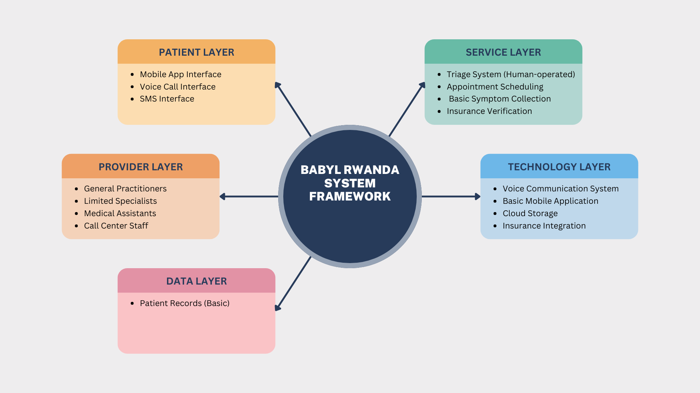
Figure 1 babyl current system architecture

3.2.4 Identified System Weaknesses

3.2.4.1 Limited AI Integration
Current State: Babyl Rwanda relies primarily on human triage and basic symptom collection without AI-powered diagnostic assistance.
Weaknesses:
- No automated symptom analysis or preliminary diagnosis
- Heavy dependence on human operators for initial assessment
- Inconsistent triage quality depending on operator experience
- Limited scalability during high-demand periods
- No machine learning capabilities for improving diagnostic accuracy over time

3.2.4.2 Medication Guidance Limitations
Current State: Basic medication advice provided during consultations without comprehensive drug information system.
Weaknesses:
- Lack of integrated medication database with dosage information
- No drug interaction checking capabilities
- Limited information on side effects and contraindications
- No medication adherence tracking or reminders

3.2.4.3 User Experience and Interface Constraints
Current State: Basic mobile interface focused primarily on call scheduling and voice consultations.
Weaknesses:
- Limited visual consultation capabilities (no video consultations)
- Basic user interface with minimal interactive features
- Lack of multimedia support for symptom documentation (photos, audio)
- Limited offline functionality in areas with poor connectivity

3.2.4.4 Diagnostic and Assessment Limitations
Current State: Relies entirely on healthcare provider expertise during voice consultations.
Weaknesses:
- No structured symptom assessment tools
- Limited ability to conduct visual examinations remotely
- Absence of clinical decision support systems
- No integration with diagnostic tools or medical guidelines
- Difficulty in assessing conditions requiring visual examination

3.2.5 Gap Analysis Summary
The analysis of Babyl Rwanda reveals significant gaps in the current digital health ecosystem:
- Intelligence Gap: Lack of AI-powered diagnostic assistance and decision support
- Information Gap: Limited comprehensive medication and health information resources
- Interaction Gap: Absence of modern communication methods (video, multimedia)
- Integration Gap: Poor connectivity with broader health ecosystem and patient health records
- Innovation Gap: Limited use of emerging technologies for enhanced healthcare delivery
These identified weaknesses form the foundation for the proposed MedOne solution, which aims to address these limitations through advanced AI integration, comprehensive medication guidance, enhanced user experience, and robust technical infrastructure.

3.3 Proposed conceptual framework

3.3.1 Overview of MedOne Conceptual Framework
The MedOne conceptual framework is designed as a comprehensive digital health ecosystem that addresses the identified gaps in Rwanda's current healthcare delivery system. The framework integrates four core components: AI-Powered Diagnostic Engine, Comprehensive Medication Management System, Integrated Telemedicine Platform, and User-Centric Interface Design, all underpinned by robust security and data management protocols.
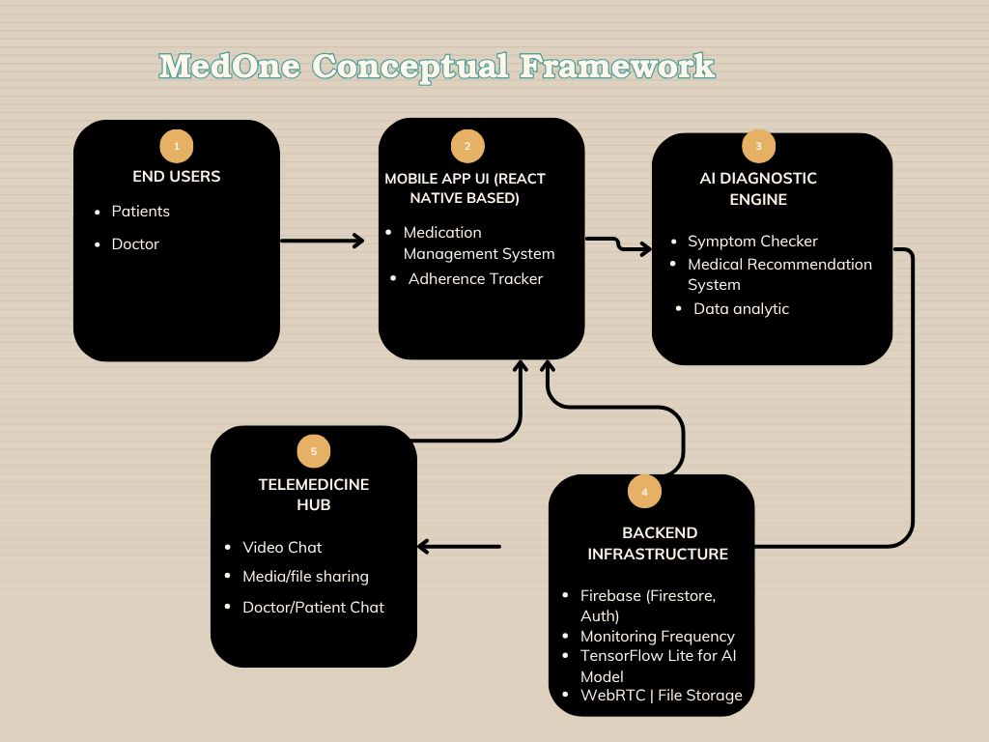
Figure 2 Medone Conceptual Framework

3.3.1.1 Current System and Proposed System
The conceptual framework illustrates how the proposed MedOne system improves healthcare delivery through AI-driven diagnosis, medication guidance, teleconsultation, and user-centered design. It also contrasts with the current Babyl Rwanda model to highlight existing gaps and the proposed solution’s expected impact
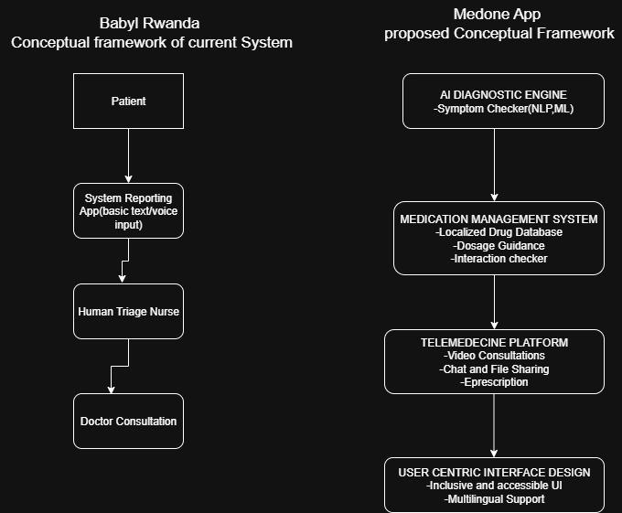
Figure 3 Comparison of Conceptual Frameworks — Current System (Babyl Rwanda) vs. Proposed System (MedOne)

3.3.2 Functional Components Framework

3.3.2.1 AI-Powered Diagnostic Engine
Purpose: Provide preliminary health assessments based on user-reported symptoms
Components:
- Symptom Collection Interface: Structured questionnaire with multimedia support
- Natural Language Processing: Interprets free-text symptom descriptions
- Decision Tree Algorithm: Rule-based initial assessment
- Machine Learning Model: Trained on validated medical datasets
- Confidence Scoring: Provides reliability indicators for assessments
Process Flow:
- User inputs symptoms through guided interface
- NLP processes text inputs for medical terminology
- Decision tree provides initial categorization
- ML model generates probability scores for conditions
- System provides assessment with confidence level
- Appropriate recommendations generated (self-care, consultation, emergency)

3.3.2.2 Comprehensive Medication Management System
Purpose: Provide accurate, localized medication information and guidance
Components:
- Drug Database: Comprehensive medication information repository
- Dosage Calculator: Personalized dosing based on user profile
- Interaction Checker: Identifies potential drug interactions
- Side Effect Monitor: Tracks and reports adverse reactions
- Adherence Tracker: Medication reminders and compliance monitoring
Information Architecture:
- Generic and brand names (including local names)
- Dosage forms and strengths available in Rwanda
- Indication-specific dosing guidelines
- Contraindications and precautions
- Cost information and generic alternatives

3.3.2.3 Integrated Telemedicine Platform
Purpose: Facilitate real-time consultations between patients and healthcare providers
Components:
- Video Consultation Engine: WebRTC-based peer-to-peer communication
- Chat Messaging: Secure text-based communication
- File Sharing: Medical document and image exchange
- E-Prescription: Digital prescription generation and management
- Consultation Records: Comprehensive consultation history
Provider Integration:
- Credential verification system
- Provider availability management
- Consultation queue management
- Quality assurance monitoring
- Payment processing integration

3.3.2.4 User-Centric Interface Design
Purpose: Ensure accessibility across diverse user demographics
Design Principles:
- Inclusive Design: Accommodates users with varying digital literacy
- Cultural Sensitivity: Interface elements appropriate for Rwandan context
- Accessibility Standards: WCAG 2.1 compliance for users with disabilities
- Offline Functionality: Core features available without internet connectivity
- Multi-language Support: Kinyarwanda, English, French, and Swahili

3.3.3 Data Flow Architecture

3.3.3.1 User Journey Data Flow
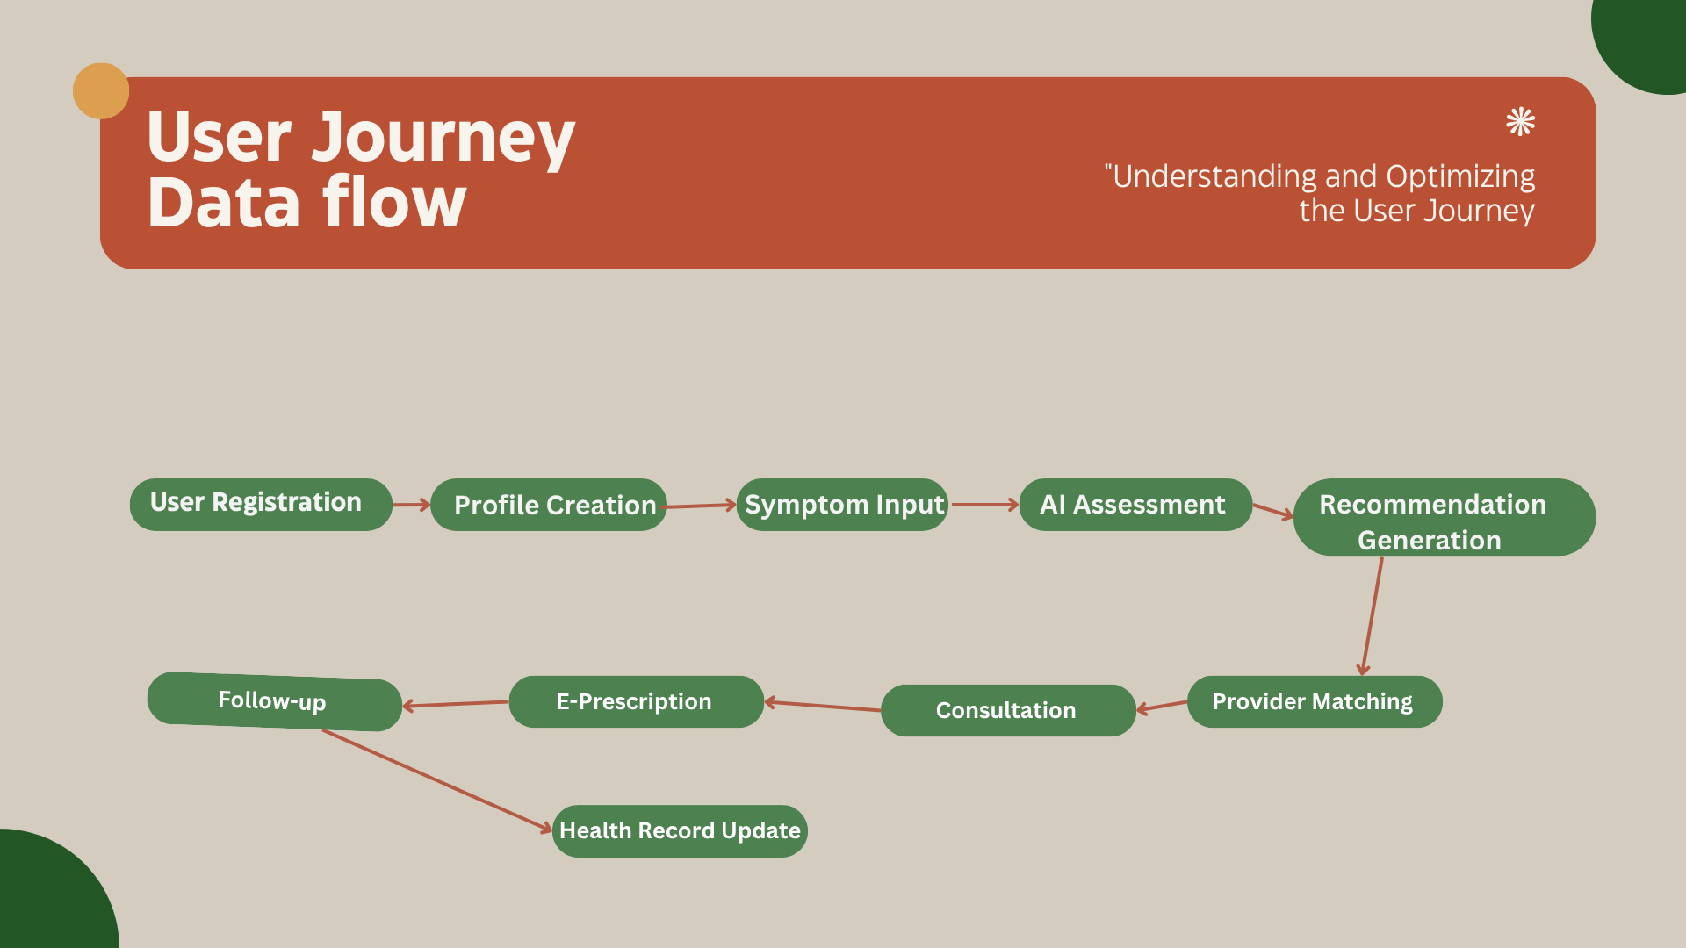
Figure 4 MedOne Proposed User Journey

3.3.3.2 Information Processing Pipeline
- Data Collection: Multi-modal input (text, voice, images)
- Data Preprocessing: Cleaning, validation, standardization
- AI Processing: Symptom analysis and condition probability calculation
- Decision Logic: Routing to appropriate care pathway
- Output Generation: Personalized recommendations and actions
- Feedback Loop: Continuous learning from outcomes

3.3.4 Integration Framework

3.3.4.1 External System Integration Points
Healthcare Provider Systems:
- Electronic Health Records (EHR) compatibility
- Hospital Information Systems (HIS) integration
- Pharmacy Management Systems connection
- Laboratory Information Systems linkage
Government Health Infrastructure:
- Rwanda Health Information System (HIS) alignment
- Community-Based Health Insurance (CBHI) integration
- National health database connectivity
- Regulatory compliance monitoring
Third-Party Services:
- Payment gateway integration (Mobile Money, Banks)
- SMS and USSD services for notifications
- Geographic Information Systems (GIS) for provider location
- Cloud storage and backup services

3.3.4.2 API Architecture
RESTful API Design:
- Standardized endpoints for all major functions
- OAuth 2.0 authentication and authorization
- Rate limiting and throttling mechanisms
- Comprehensive API documentation
- Version management and backward compatibility

3.4. Research Design

3.4.1 Applied Research Framework
This study uses an applied research approach focused on practical technology solutions for healthcare challenges. It combines Design Science Research (DSR) methodology with user-centered design principles. The DSR follows six steps: problem identification, solution objectives definition, design and development, demonstration, evaluation, and communication.

3.4.2 Mixed-Methods Approach
The research integrates both qualitative and quantitative methods for comprehensive evaluation. Qualitative methods include expert interviews, user experience testing, and focus groups. Quantitative methods involve surveys, system performance metrics, and usage analytics to evaluate technical efficiency, user adoption, and overall impact of the MedOne application.

3.3 System Development Methodology

3.3.1 Agile Development Framework
The MedOne application is developed using an agile methodology, specifically the Scrum framework, to ensure flexibility, continuous improvement, and stakeholder involvement throughout the development process. The Agile approach is particularly suitable for this project due to its:
- Iterative development cycles (sprints) of two weeks
- Regular stakeholder feedback integration
- Ability to adapt to changing requirements
- Focus on delivering functional components early and frequently

3.3.2 System Architecture
The MedOne application is built using a three-tier architecture:
- Presentation Layer: A cross-platform mobile interface developed using Flutter framework to ensure compatibility with both Android and iOS devices, with emphasis on intuitive navigation and accessibility for users with varying levels of digital literacy.
- Application Layer: Core application logic including the AI engine for symptom assessment (developed using TensorFlow Lite for on-device processing where possible), authentication system, appointment scheduling, and teleconsultation modules.
- Data Layer: Cloud-based database using Firebase Firestore for user data, medical information, and consultation records, with local caching functionality to enable partial offline usage in areas with intermittent connectivity.
The system architecture incorporates several technical components:
- Frontend: React Native framework with Material Design components
- Backend: Firebase Cloud Functions and Node.js microservices
- Database: Firebase Firestore (NoSQL) for flexibility and scalability
- AI Engine: TensorFlow model trained on standardized symptom datasets
- Video Consultation: WebRTC implementation for peer-to-peer communication
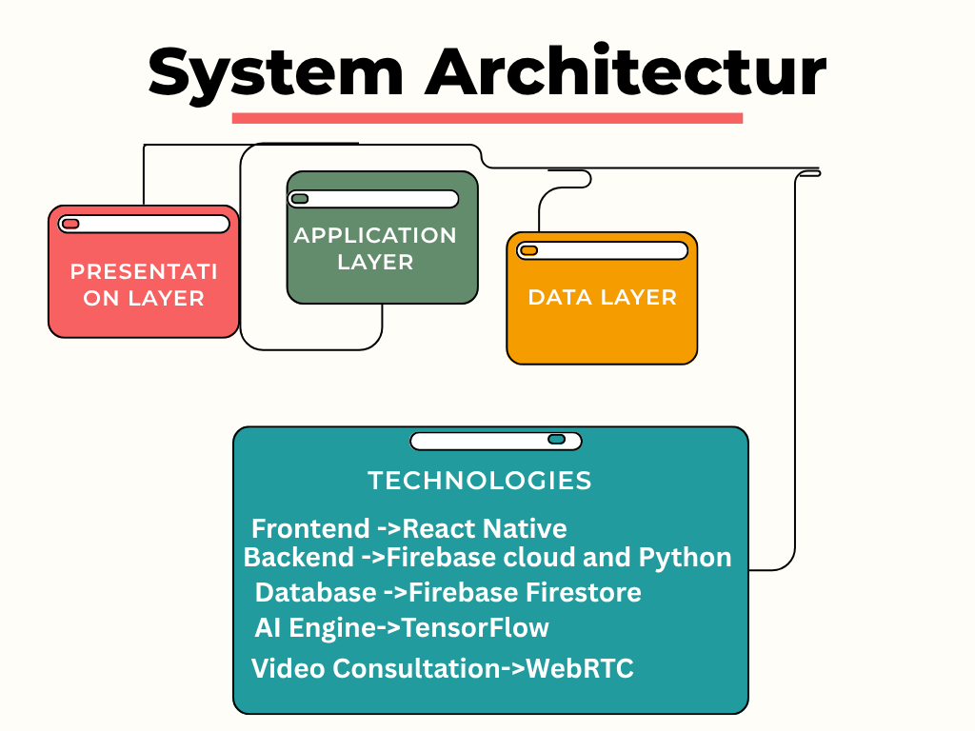
Figure 5 Medone System Architecture

3.4 Data Collection Methods

3.4.1 Requirements Gathering
Data collection for requirements gathering involves:
- Literature Review: Comprehensive analysis of existing research on telemedicine applications, AI in healthcare, and digital health solutions in resource-limited settings.
- Expert Interviews: Semi-structured interviews with 8-10 healthcare professionals (including general practitioners, specialists, and pharmacists) to gather insights on clinical workflows, diagnostic processes, and medication guidance requirements.
- User Surveys: Online questionnaires distributed to potential users (n=150-200) to identify healthcare access challenges, smartphone usage patterns, and preferences for mobile health applications.
- Competitive Analysis: Evaluation of existing telemedicine applications and healthcare platforms to identify best practices, limitations, and opportunities for innovation.

3.4.2 System Evaluation
Data collection for system evaluation encompasses:
- Usability Testing: Conducted with 20-25 participants representing different user demographics, involving task completion scenarios and think-aloud protocols to assess the application's usability and user experience.
- System Performance Metrics: Automated collection of technical performance data including response times, error rates, AI diagnostic accuracy, and system reliability.
- User Feedback Surveys: Post-implementation questionnaires to gather user satisfaction ratings, perceived usefulness, and suggestions for improvement using standardized instruments such as the System Usability Scale (SUS) and the Technology Acceptance Model (TAM).
- Healthcare Provider Assessments: Structured feedback from medical professionals regarding the accuracy of symptom assessments, appropriateness of medication recommendations, and overall clinical value of the application.

3.5 Population and Sampling

3.5.1 Target Population
The target population for this research includes:
- Primary Users: Adult residents of Kigali, Rwanda (aged 18-65) with access to smartphones and basic digital literacy who seek medical consultations.
- Healthcare Providers: Licensed medical professionals practicing in Kigali, including general practitioners, specialists, and pharmacists who may provide teleconsultations through the platform.
- Healthcare Administrators: Management personnel from healthcare facilities in Kigali responsible for telemedicine implementation and healthcare resource allocation.

3.5.2 Sampling Techniques
Multiple sampling techniques are employed to ensure representation across relevant stakeholder groups:
- Purposive Sampling: For expert interviews and healthcare provider assessments, ensuring inclusion of professionals with varying specialties, experience levels, and practice settings.
- Stratified Random Sampling: For user surveys and usability testing, stratifying the population based on key demographics (age, gender, education level, socioeconomic status) to ensure representation across diverse user groups.
- Convenience Sampling: For initial prototype testing phases, leveraging accessible participants while ensuring minimum diversity requirements are met.
Sample sizes for each research activity are determined based on established guidelines for qualitative and quantitative research in healthcare and technology adoption studies, with consideration for statistical power requirements where appropriate.

3.6 Data Analysis Procedures

3.6.1 Qualitative Data Analysis
Qualitative data from interviews, focus groups, and open-ended survey responses are analyzed using:
- Thematic Analysis: Identifying recurring patterns and themes in participant responses using a combination of inductive and deductive coding approaches.
- Content Analysis: Systematic categorization and interpretation of text data to identify user needs, challenges, and preferences.
- User Journey Mapping: Visualizing the end-to-end user experience to identify pain points and opportunities for improvement in the application workflow.
NVivo software is utilized to facilitate coding, categorization, and theme development, ensuring rigor and transparency in the qualitative analysis process.

3.6.2 Quantitative Data Analysis
Quantitative data from surveys, system metrics, and performance tests are analyzed using:
- Descriptive Statistics: Calculating means, frequencies, and distributions to summarize user demographics, satisfaction ratings, and usage patterns.
- Inferential Statistics: Employing t-tests, ANOVA, and regression analyses to examine relationships between variables and compare outcomes across different user groups.
- System Performance Analysis: Evaluating technical metrics including response times, error rates, and AI accuracy using benchmarking against established industry standards.
- Usability Metrics Analysis: Calculating task completion rates, time-on-task, error rates, and standardized usability scores (e.g., SUS) to assess the application's usability.
SPSS and R statistical software packages are used for quantitative data analysis, ensuring accurate computation and appropriate statistical testing.

3.7 AI Model Development and Validation

3.7.1 AI Model Architecture
The symptom checker employs a hybrid approach combining rule-based expert systems with machine learning algorithms:
- Knowledge Base Development: Creation of a structured medical knowledge base mapping symptoms to potential conditions based on established clinical guidelines and diagnostic criteria.
- Machine Learning Model: Implementation of a gradient-boosted decision tree model (XGBoost) trained on validated symptom-diagnosis datasets, supplemented with a neural network for feature extraction from text-based symptom descriptions.
- Bayesian Network: Implementation of probabilistic reasoning to handle uncertainty in symptom reporting and generate confidence scores for potential diagnoses.

3.7.2 Training and Validation
The AI model's development follows a systematic approach:
- Dataset Preparation: Utilization of anonymized clinical data from partner healthcare institutions and publicly available medical datasets, with particular emphasis on conditions common in the Rwandan context.
- Model Training: Implementation of supervised learning with 70% of the dataset allocated for training, using cross-validation techniques to prevent overfitting.
- Model Validation: Performance evaluation using the remaining 30% of the dataset, measuring accuracy, precision, recall, F1-score, and area under the ROC curve (AUC).
- Clinical Validation: Expert review of model outputs by a panel of 5-7 medical professionals to assess clinical relevance and appropriateness of recommendations.
- Continuous Learning: Implementation of a feedback mechanism to improve model performance based on healthcare provider input and confirmed diagnoses.

3.8 Ethical Considerations

3.8.1 Informed Consent
All research participants are provided with comprehensive information about the study and required to provide informed consent before participation. The consent process includes:
- Clear explanation of research objectives and procedures
- Information about data collection, storage, and usage
- Clarification of voluntary participation and right to withdraw
- Contact information for addressing concerns or questions

3.8.2 Data Privacy and Security
To ensure compliance with healthcare data protection standards:
- Data Anonymization: All personal identifiers are removed from research data before analysis.
- Secure Data Storage: Research data is stored on encrypted servers with restricted access.
- Compliance Framework: The application adheres to relevant data protection regulations including Rwanda's Data Protection Law and international best practices such as HIPAA principles.
- User Privacy Controls: Implementation of granular privacy settings allowing users to control data sharing and visibility.
- Transparency: Clear privacy policies and terms of service are provided to users, explaining data collection, processing, and sharing practices.

3.8.3 Medical Ethics
To ensure the application adheres to medical ethical standards:
- Disclaimer Implementation: Clear disclaimers indicate that the application does not replace professional medical diagnosis and emergency cases should seek immediate medical attention.
- Scope Limitations: The application clearly communicates the limitations of AI-based assessments and circumstances requiring in-person medical evaluation.
- Provider Verification: All healthcare providers on the platform undergo credential verification to ensure they are licensed and qualified to provide telehealth services.
- Quality Assurance: Regular audits of consultation quality and medication recommendations are conducted to maintain high standards of care.

3.9 Validity and Reliability

3.9.1 Research Validity
To ensure the validity of research findings:
- Construct Validity: Utilization of validated instruments and measures for data collection, including established usability scales and technology acceptance models.
- Internal Validity: Implementation of control measures to minimize confounding variables and biases in experimental aspects of the research.
- External Validity: Careful consideration of sample representativeness and contextual factors to ensure generalizability of findings within the target population.
- Ecological Validity: Testing the application in real-world settings that reflect actual usage conditions to ensure practical relevance of findings.

3.9.2 Research Reliability
To ensure the reliability of research instruments and procedures:
- Standardized Protocols: Development and consistent application of standardized protocols for data collection across all research activities.
- Pilot Testing: Preliminary testing of research instruments to identify and address ambiguities or inconsistencies.
- Inter-rater Reliability: Use of multiple coders for qualitative data analysis with calculation of inter-rater reliability coefficients to ensure consistency.
- Test-Retest Reliability: Where appropriate, administration of measures at multiple time points to assess consistency over time.

3.10 Expected Results
The implementation and pilot testing of the MedOne platform are expected to yield measurable outcomes across three layers of variables: Independent, Intermediate, and Dependent. These expected results are aligned with the conceptual framework and aim to demonstrate both technical feasibility and practical healthcare impact.

3.10.1 Expected Outcomes by Variable Category
- Independent Variables (System Components):
  - The AI-powered symptom checker will deliver at least 85% diagnostic accuracy for common conditions.
  - The integrated medication database will achieve 95% accuracy in dosage, usage instructions, and side effects.
  - The teleconsultation module will support 90% successful video consultations under stable connectivity.
- Intermediate Variables (Process Indicators):
  - The platform will achieve at least 70% user engagement among participants during the testing phase.
  - Confidence scores for AI-generated assessments are expected to average above 0.8.
  - Usability tests will return System Usability Scale (SUS) scores ≥ 75, indicating strong user satisfaction.
- Dependent Variables (Impact Outcomes):
  - Healthcare accessibility will improve, with ≥ 60% of users reporting faster access to medical advice.
  - Reliance on self-medication is expected to drop by at least 40% among test users.
  - Survey data will show a 30% increase in health literacy, particularly related to understanding medications.
  - At least 70% reduction in unnecessary clinic visits for minor illnesses is anticipated.

3.10.2 Expected Results Summary by Variable Category
Variable Type | Variable Name | Expected Indicator / Target
Independent | AI Symptom Checker | ≥ 85% accuracy in diagnosis for top 10 reported conditions
Independent | Medication Database | ≥ 95% accuracy in drug usage, side effects, and interactions
Independent | Teleconsultation Engine | ≥ 90% video consult success rate under standard network
Intermediate | User Engagement | ≥ 70% active user rate in pilot test
Intermediate | Diagnostic Confidence Score | Average ≥ 0.8 per consultation
Intermediate | Usability Satisfaction (SUS) | Average SUS score ≥ 75
Dependent | Healthcare Access Improvement | ≥ 60% users report improved access
Dependent | Self-Medication Reduction | ≥ 40% decline in unverified self-treatment
Dependent | Health Literacy Improvement | ≥ 30% increase in medication understanding (post-survey)
Dependent | Reduced Facility Overload | ≥ 50% reduction in unnecessary clinic visits for minor issues

3.11 Project Timeline and Milestones
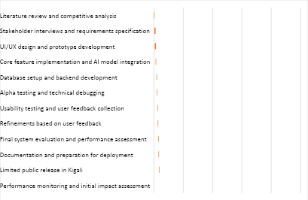
The research and development process spans a total of three months, organized according to the following timeline:
Phase 1: Research and Planning (2 weeks)
- Week 1: Literature review and competitive analysis
- Week 2: Stakeholder interviews and requirements specification
Phase 2: Design and Development (5 weeks)
- Week 3-4: UI/UX design and prototype development
- Week 5-6: Core feature implementation and AI model integration
- Week 7: Database setup and backend development
Phase 3: Testing and Refinement (3 weeks)
- Week 8: Alpha testing and technical debugging
- Week 9: Usability testing and user feedback collection
- Week 10: Refinements based on user feedback
Phase 4: Evaluation and Documentation (2 weeks)
- Week 11: Final system evaluation and performance assessment
- Week 12: Documentation and preparation for deployment

Phase 5: Deployment and Initial Monitoring (2 weeks)
- Week 13: Limited public release in Kigali
- Week 14: Performance monitoring and initial impact assessment
Key milestones include:
- Completion of requirements specification (Week 2)
- Functional prototype development (Week 4)
- Integration of all core components (Week 7)
- Completion of user testing (Week 9)
- Finalized application ready for deployment (Week 12)
- Initial deployment and monitoring report (Week 14)

References
- Grand View Research. (2024). Telemedicine market size, share & trends analysis report. https://www.grandviewresearch.com/
- Hevner, A. R., March, S. T., Park, J., & Ram, S. (2004). Design science in information systems research. MIS Quarterly, 28(1), 75–105.
- IQVIA Institute. (2024). Digital health trends 2024: Innovation, evidence, and adoption.
- Kayumba, A., et al. (2021). Telemedicine adoption in Rwanda: Opportunities and challenges.
- Mayo Clinic. (2024). Symptom checker. https://www.mayoclinic.org/symptom-checker
- McKinsey & Company. (2023). The future of healthcare: Digital health ecosystems.
- Ministry of Health, Rwanda. (2023). Rwanda eHealth strategy 2023–2028. Kigali: Ministry of Health.
- Mukamurenzi, S., & Nshimiyimana, E. (2020). Internet connectivity challenges in rural Rwanda.
- Mukherjee, S. (2019). Bridging the healthcare gap with technology. Global Health Journal, 4(2), 45–53.
- Rwanda Biomedical Center. (2021).
- Rwanda Ministry of Health. (2022).
- Smith, J., et al. (2020). Telemedicine in low-resource settings: Challenges and opportunities. International Journal of Health Policy, 5(4), 23–30.
- World Bank. (2023). Digital health: A global opportunity for universal health coverage.
- World Health Organization. (2021). Digital health and innovation in COVID-19 response. https://www.who.int/publications/i/item/digital-health-covid-19
- World Health Organization. (2022). [Title and publication details pending].

