3. Application-view architecture diagram
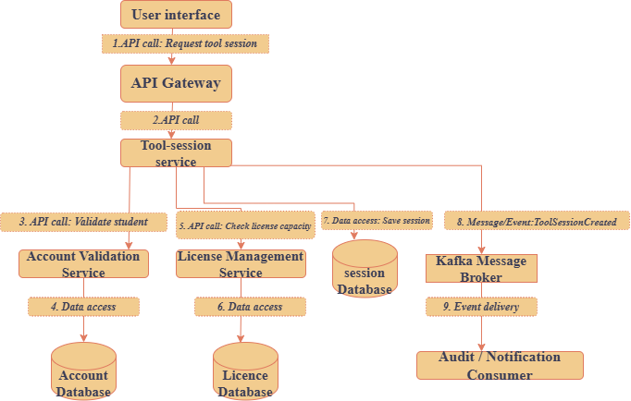

Figure 1:Architecture diagram(source: draw.io)

