**HAI NAM NGO**

**STUDENT ID: 103488515**

**LAB01**

**From Q1 to Q7:**

|  |  |  |
| --- | --- | --- |
| Pin1 | Pin2 | Output |
| 0 | 0 | 0 |
| 0 | 1 | 0 |
| 1 | 0 | 1 |
| 1 | 1 | 1 |

|  |  |
| --- | --- |
| Pin | Output |
| 0 | 1 |
| 1 | 0 |

**From Q8 to Q9:**

**From Q10 to Q11:**

|  |  |  |
| --- | --- | --- |
| Pin1 | Pin2 | Output |
| 0 | 0 | 0 |
| 0 | 1 | 1 |
| 1 | 0 | 1 |
| 1 | 1 | 0 |

**From Q12 to Q14:**

|  |  |  |  |
| --- | --- | --- | --- |
| Pin1 | Pin2 | NOT (Pin2) | Pin1 XOR (NOT Pin2) |
| 0 | 0 | 1 | 0 |
| 0 | 1 | 0 | 1 |
| 1 | 0 | 1 | 1 |
| 1 | 1 | 0 | 0 |

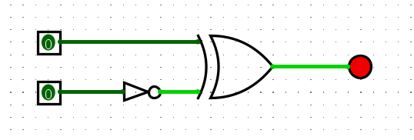

**Q15:**

