|  |  |  |  |
| --- | --- | --- | --- |
| Input 1 | Input 2 | Sum Output | Carry Output |
| 0 | 0 | 0 | 0 |
| 0 | 1 | 1 | 0 |
| 1 | 0 | 1 | 0 |
| 1 | 1 | 0 | 1 |

|  |  |  |  |  |
| --- | --- | --- | --- | --- |
| Input 1 | Input 2 | Carry in | Sum Output | Carry Output |
| 0 | 0 | 0 | 0 | 0 |
| 0 | 1 | 0 | 1 | 0 |
| 1 | 0 | 0 | 1 | 0 |
| 1 | 1 | 0 | 0 | 1 |
| 0 | 0 | 1 | 1 | 0 |
| 0 | 1 | 1 | 0 | 1 |
| 1 | 0 | 1 | 0 | 1 |
| 1 | 1 | 1 | 1 | 1 |

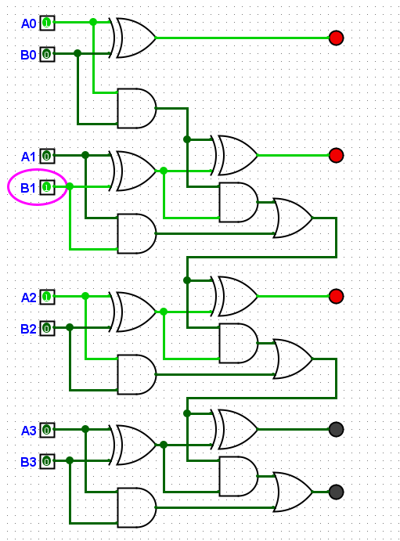

|  |  |  |
| --- | --- | --- |
| Input A | Input B | Output |
| 0101 | 0000 | 0101 |
| 0101 | 0001 | 0110 |
| 0101 | 0010 | 0111 |
| 0101 | 0011 | 1000 |
| 0101 | 0100 | 1001 |
| 0101 | 0101 | 1010 |
| 0101 | 0110 | 1011 |
| 0101 | 0111 | 1100 |
| 0101 | 1000 | 1101 |
| 0101 | 1001 | 1110 |
| 0101 | 1010 | 1111 |
| 0101 | 1011 | 0000 (carry 1) |
| 0101 | 1100 | 0001 (carry 1) |
| 0101 | 1101 | 0010 (carry 1) |
| 0101 | 1110 | 0011 (carry 1) |
| 0101 | 1111 | 0100 (carry 1) |