**PART 1**

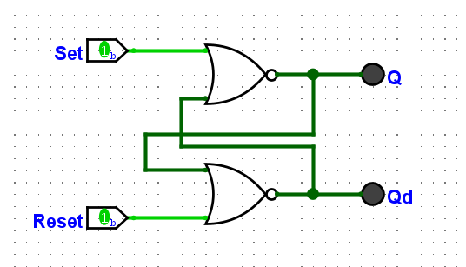

|  |  |  |  |
| --- | --- | --- | --- |
| Set | Reset | Q | Q’ |
| 1 | 0 | 0 | 1 |
| 1 | 1 | 0 | 0 |
| 0 | 1 | 1 | 0 |
| 1 | 1 | 0 | 0 |

7. If one input is 1, the output will also have 1 on and 1 off, like a switching function.

This is useful when we want to store a single bit of binary data.

8. If both are on, none of the output will be turned off, in this case, we won’t know which state of the flip flop it is.

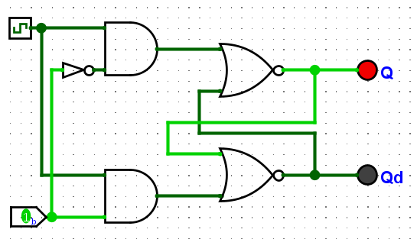

|  |  |  |  |
| --- | --- | --- | --- |
| Clock | Pin | Q | Q’ |
| 0 | 0 | 0 | 1 |
| 0 | 1 | 0 | 1 |
| 1 | 1 | 1 | 0 |
| 1 | 0 | 0 | 1 |

11. The D flip flop store the data of the input in the Q when the clock is on, otherwise, it will remain the current state when the clock is off.

It is useful when we can store data and control the time of state changes.

12. The clock in the flip flop can control the time and the moment when we want the input data is transmitted to the output Q. The clock ensures that all changes happen precisely, avoiding the issue of metastability.

13. D Flip Flops are generally preferred over R-S Flip Flops due to their synchronous behavior with a clock signal.

|  |  |  |  |
| --- | --- | --- | --- |
| J | K | Q (when clocked) | Q’ (when clocked) |
| 0 | 0 | Q | Q’ |
| 1 | 0 | 1 | 0 |
| 0 | 1 | 0 | 1 |
| 1 | 1 | (Q) | (Q’) |

16. J-K flip flop acts like a D flip flop when either J or K is on.

17. J-K flip flop acts like a T flip flop when both of J and K is on.

**PART 2**

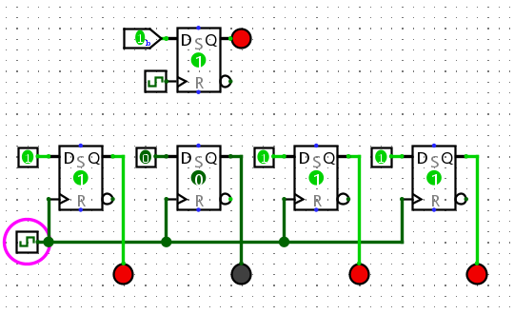

|  |  |  |
| --- | --- | --- |
| Ox | Input Binary | Output Binary |
| 0 | 0000 | 0000 |
| 1 | 0001 | 0001 |
| 2 | 0010 | 0010 |
| 3 | 0011 | 0011 |
| 5 | 0101 | 0101 |
| A | 1010 | 1010 |
| B | 1011 | 1011 |
| C | 1100 | 1100 |
| D | 1101 | 1101 |
| E | 1110 | 1110 |
| F | 1111 | 1111 |