1.

"Big-endian" refers to an ordering of bits in which the most significant bit comes first.

Bit order will be: Bit2 – Bit1 – Bit0.

2-3.

4-6.

7-8.

9.

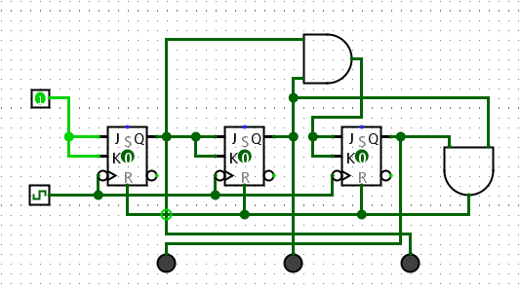

10.

10.2.

Managing issues like momentary illegal states is essential because it ensures circuit reliability, data integrity, predictability, compatibility with other systems, consistency, and prevents glitches.

11.

