**Week3_Qn1**

/*

Unit Code: COS10007

Unit Name: Developing Techinical Software

Student ID: 103488515

Name: Hai Nam Ngo

Date Created: 3/24/2023

Date Modified: 3/24/2023

Problem: Week 3 Question 1

Problem Description: inserts 10 random integers between 0 and 50 in order in a

linked list.

*/

#include <stdio.h>

#include <stdlib.h>

#include <time.h>

typedef struct node {

int data;

struct node* next;

} Node;

void insert(Node** head, int data)

{

// Allocate memory for a new node and set its data value

Node* new_node = (Node*) malloc(sizeof(Node));

new_node->data = data;

new_node->next = NULL;

// If the list is empty or the new node's data is less than the head's data, insert at the beginning

if (*head == NULL || data < (*head)->data)

{

new_node->next = *head;

*head = new_node;

}

else

{ // Otherwise, find the correct position to insert the new node and update pointers accordingly

Node* current = *head;

while (current->next != NULL && current->next->data < data)

{

current = current->next;

}

new_node->next = current->next;

current->next = new_node;

}

}

float average(Node* head)

{

// Traverse the list, keeping track of the sum and count of elements

int sum = 0, count = 0;

while (head != NULL)

{

sum += head->data;

count++;

head = head->next;

}

// Calculate and return the average as a float

return (float) sum / count;

}

int main()

{

srand(time(NULL)); // Seed the random number generator with the current time

Node* head = NULL; // Initialize the head pointer to NULL

for (int i = 0; i < 10; i++)

{

int data = rand() % 51; // Generate a random integer between 0 and 50

insert(&head, data); // Insert the new value in order into the linked list

}

printf("List elements: ");

Node* current = head;

while (current != NULL)

{ // Traverse the list and print each element

printf("%d ", current->data);

current = current->next;

}

printf("\n");

printf("Average: %.2f\n", average(head)); // Calculate and print the average of the list

return 0;

}

OUTPUT FOR Qn1

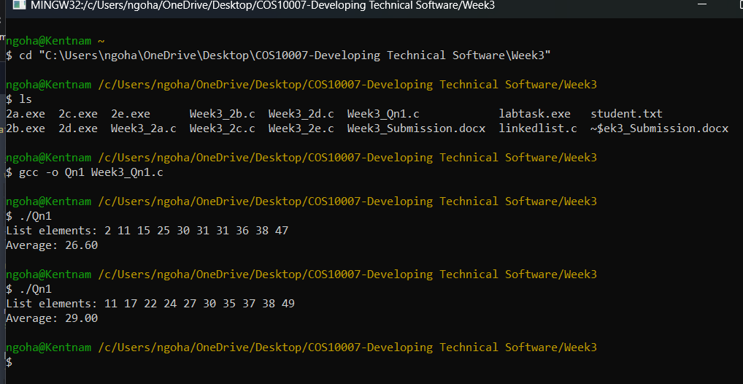

**WEEK3_2a.c**

/*

Unit Code: COS10007

Unit Name: Developing Techinical Software

Student ID: 103488515

Name: Hai Nam Ngo

Date Created: 3/14/2023

Date Modified: 3/14/2023

Problem: Week 3 Question 2

Problem Description: Reading grade details of five students from a file and displaying it on screen

*/

#include <stdio.h>

#include <stdlib.h>

struct personal

{

char studentName[20];

int studentId;

};

struct course

{

char courseName[20];

int courseId;

};

struct student

{

struct personal studentInfo;

struct course courseInfo;

struct student *nextPtr;

};

typedef struct student Student;

typedef Student *StudentPtr;

void printList(StudentPtr currentPtr)

{

puts("The list is \n");

while(currentPtr!=NULL)

{

printf("Student Name: %s \n",currentPtr->studentInfo.studentName);

printf("Course Name: %s \n", currentPtr->courseInfo.courseName);

printf("Student ID: %d \n",currentPtr->studentInfo.studentId);

printf("Course ID: %d \n",currentPtr->courseInfo.courseId);

currentPtr=currentPtr->nextPtr;

}

}

int main()

{

FILE *fp=fopen("student.txt","r");

if(fp==NULL)

{

printf("Error opening the file \n");

return -1;

}

StudentPtr startPtr=NULL;

startPtr=(Student*)malloc(sizeof(Student));

fscanf(fp,"%s",startPtr->studentInfo.studentName);

fscanf(fp,"%s",startPtr->courseInfo.courseName);

fscanf(fp,"%d",&startPtr->studentInfo.studentId);

fscanf(fp,"%d",&startPtr->courseInfo.courseId);

startPtr->nextPtr=NULL;

printList(startPtr);

}

**OUTPUT FOR 2a**

**WEEK3_2b.c**

/*

Unit Code: COS10007

Unit Name: Developing Techinical Software

Student ID: 103488515

Name: Hai Nam Ngo

Date Created: 3/14/2023

Date Modified: 3/14/2023

Problem: Week 3 Question 2b

*/

#include <stdio.h>

#include <stdlib.h>

#include <string.h>

struct personal

{

char studentName[20];

int studentId;

};

struct course

{

char courseName[20];

int courseId;

};

struct student

{

struct personal studentInfo;

struct course courseInfo;

struct student *nextPtr;

};

typedef struct student Student;

typedef Student *StudentPtr;

void printList(StudentPtr currentPtr)

{

puts("The list is \n");

while(currentPtr!=NULL)

{

printf("Student Name: %s \n",currentPtr->studentInfo.studentName);

printf("Course Name: %s \n", currentPtr->courseInfo.courseName);

printf("Student ID: %d \n",currentPtr->studentInfo.studentId);

printf("Course ID: %d \n",currentPtr->courseInfo.courseId);

currentPtr=currentPtr->nextPtr;

}

}

void insert(StudentPtr *sPtr, char sName [], char cName[], int sID, int cID)

{

StudentPtr newPtr; /* pointer to new node*/

StudentPtr previousPtr; /* pointer to previous node in list*/

StudentPtr currentPtr; /* pointer to current node in list*/

newPtr = malloc( sizeof( Student )); /* create node*/

if ( newPtr != NULL ) /* is space available*/

{

strcpy(newPtr->studentInfo.studentName,sName);

strcpy(newPtr->courseInfo.courseName, cName);

newPtr->studentInfo.studentId=sID;

newPtr->courseInfo.courseId=cID;

newPtr->nextPtr = NULL; /* node does not link to another node*/

previousPtr = NULL;

currentPtr = *sPtr;

/* loop to find the correct location in the list*/

while ( currentPtr != NULL && sID > currentPtr ->studentInfo.studentId)

{

previousPtr = currentPtr; /* walk to ...*/

currentPtr = currentPtr->nextPtr; /* ... next node*/

} /* end while*/

/* insert new node at beginning of list*/

if ( previousPtr == NULL )

{

newPtr->nextPtr = *sPtr;

*sPtr = newPtr;

} /* end if*/

else /* insert new node between previousPtr and currentPtr*/

{

previousPtr->nextPtr = newPtr;

newPtr->nextPtr = currentPtr;

} /* end else*/

} /* end if*/

else

{

printf( "No memory available.\n");

} /* end else*/

} /* end function insert*/

int main()

{

char sName[20], cName[20];

int sID, cID;

FILE *fp=fopen("student.txt","r");

if(fp==NULL)

{

printf("Error opening the file \n");

return -1;

}

StudentPtr startPtr=NULL;

while(!feof(fp))

{

fscanf(fp,"%s",sName);

fscanf(fp,"%s",cName);

fscanf(fp,"%d",&sID);

fscanf(fp,"%d",&cID);

insert(&startPtr, sName,cName,sID,cID);

}

printList(startPtr);

}

**OUTPUT FOR 2b**

**WEEK3_2c.c**

/*

Unit Code: COS10007

Unit Name: Developing Techinical Software

Student ID: 103488515

Name: Hai Nam Ngo

Date Created: 3/14/2023

Date Modified: 3/14/2023

Problem: Week 3 Question 2b

*/

#include <stdio.h>

#include <stdlib.h>

#include <string.h>

struct personal

{

char studentName[20];

int studentId;

};

struct course

{

char courseName[20];

int courseId;

};

struct student

{

struct personal studentInfo;

struct course courseInfo;

struct student *nextPtr;

};

typedef struct student Student;

typedef Student *StudentPtr;

void printList(StudentPtr currentPtr)

{

puts("The list is \n");

while(currentPtr!=NULL)

{

printf("Student Name: %s \n",currentPtr->studentInfo.studentName);

printf("Course Name: %s \n", currentPtr->courseInfo.courseName);

printf("Student ID: %d \n",currentPtr->studentInfo.studentId);

printf("Course ID: %d \n",currentPtr->courseInfo.courseId);

currentPtr=currentPtr->nextPtr;

}

}

void insert(StudentPtr *sPtr, char sName [], char cName[], int sID, int cID)

{

StudentPtr newPtr; /* pointer to new node*/

StudentPtr previousPtr; /* pointer to previous node in list*/

StudentPtr currentPtr; /* pointer to current node in list*/

newPtr = malloc( sizeof( Student )); /* create node*/

if ( newPtr != NULL ) /* is space available*/

{

strcpy(newPtr->studentInfo.studentName,sName);

strcpy(newPtr->courseInfo.courseName, cName);

newPtr->studentInfo.studentId=sID;

newPtr->courseInfo.courseId=cID;

newPtr->nextPtr = NULL; /* node does not link to another node*/

previousPtr = NULL;

currentPtr = *sPtr;

/* loop to find the correct location in the list*/

while ( currentPtr != NULL && sID > currentPtr ->studentInfo.studentId)

{

previousPtr = currentPtr; /* walk to ...*/

currentPtr = currentPtr->nextPtr; /* ... next node*/

} /* end while*/

/* insert new node at beginning of list*/

if ( previousPtr == NULL )

{

newPtr->nextPtr = *sPtr;

*sPtr = newPtr;

} /* end if*/

else /* insert new node between previousPtr and currentPtr*/

{

previousPtr->nextPtr = newPtr;

newPtr->nextPtr = currentPtr;

} /* end else*/

} /* end if*/

else

{

printf( "No memory available.\n");

} /* end else*/

} /* end function insert*/

void printfFile(StudentPtr currentPtr)

{

FILE *fp=fopen("Output.txt","w+");

while(currentPtr!=NULL)

{

fprintf(fp,"Student Name: %s \n",currentPtr->studentInfo.studentName);

fprintf(fp,"Course Name: %s \n", currentPtr->courseInfo.courseName);

fprintf(fp,"Student ID: %d \n",currentPtr->studentInfo.studentId);

fprintf(fp,"Course ID: %d \n",currentPtr->courseInfo.courseId);

currentPtr=currentPtr->nextPtr;

}

}

int main()

{

char sName[20], cName[20];

int sID, cID;

FILE *fp=fopen("student.txt","r");

if(fp==NULL)

{

printf("Error opening the file \n");

return -1;

}

StudentPtr startPtr=NULL;

while(!feof(fp))

{

fscanf(fp,"%s",sName);

fscanf(fp,"%s",cName);

fscanf(fp,"%d",&sID);

fscanf(fp,"%d",&cID);

insert(&startPtr, sName,cName,sID,cID);

}

printList(startPtr);

}

**OUTPUT FOR 2c**

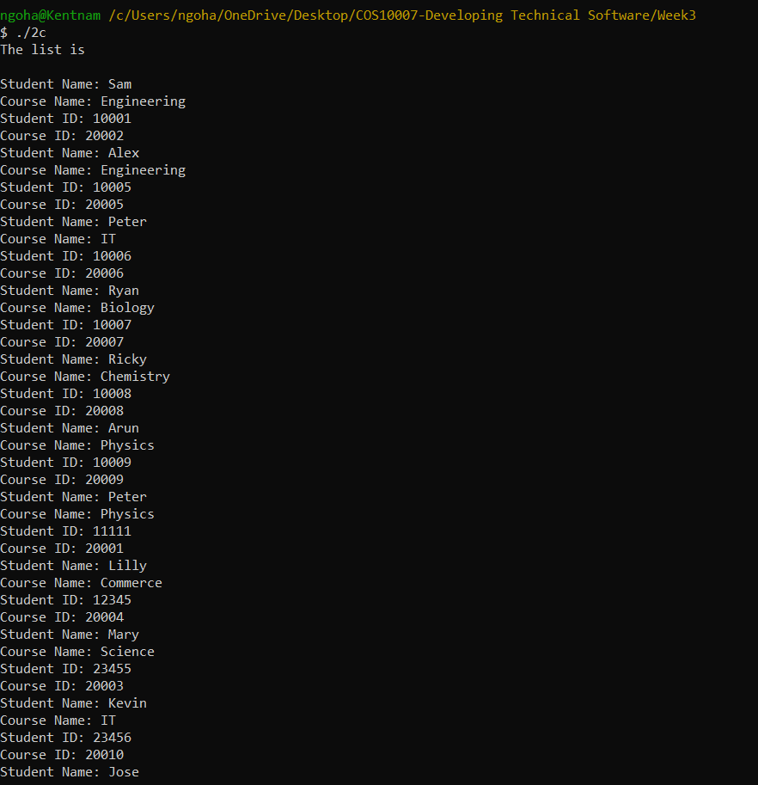

**WEEK3_2d.c**

/*

Unit Code: COS10007

Unit Name: Developing Techinical Software

Student ID: 103488515

Name: Hai Nam Ngo

Date Created: 3/14/2023

Date Modified: 3/14/2023

Problem: Week 3 Question 2d

*/

#include <stdio.h>

#include <stdlib.h>

#include <string.h>

struct personal

{

char studentName[20];

int studentId;

};

struct course

{

char courseName[20];

int courseId;

};

struct student

{

struct personal studentInfo;

struct course courseInfo;

struct student *nextPtr;

};

typedef struct student Student;

typedef Student *StudentPtr;

void printList(StudentPtr currentPtr)

{

puts("The list is \n");

while(currentPtr!=NULL)

{

printf("Student Name: %s \n",currentPtr->studentInfo.studentName);

printf("Course Name: %s \n", currentPtr->courseInfo.courseName);

printf("Student ID: %d \n",currentPtr->studentInfo.studentId);

printf("Course ID: %d \n",currentPtr->courseInfo.courseId);

currentPtr=currentPtr->nextPtr;

}

}

void printfFile(StudentPtr currentPtr)

{

FILE *fp=fopen("Output.txt","w+");

while(currentPtr!=NULL)

{

fprintf(fp,"Student Name: %s \n",currentPtr->studentInfo.studentName);

fprintf(fp,"Course Name: %s \n", currentPtr->courseInfo.courseName);

fprintf(fp,"Student ID: %d \n",currentPtr->studentInfo.studentId);

fprintf(fp,"Course ID: %d \n",currentPtr->courseInfo.courseId);

currentPtr=currentPtr->nextPtr;

}

}

void insert(StudentPtr *sPtr, char sName [], char cName[], int sID, int cID)

{

StudentPtr newPtr; /* pointer to new node*/

StudentPtr previousPtr; /* pointer to previous node in list*/

StudentPtr currentPtr; /* pointer to current node in list*/

newPtr = malloc( sizeof( Student )); /* create node*/

if ( newPtr != NULL ) /* is space available*/

{

strcpy(newPtr->studentInfo.studentName,sName);

strcpy(newPtr->courseInfo.courseName, cName);

newPtr->studentInfo.studentId=sID;

newPtr->courseInfo.courseId=cID;

newPtr->nextPtr = NULL; /* node does not link to another node*/

previousPtr = NULL;

currentPtr = *sPtr;

/* loop to find the correct location in the list*/

while ( currentPtr != NULL && sID > currentPtr ->studentInfo.studentId)

{

previousPtr = currentPtr; /* walk to ...*/

currentPtr = currentPtr->nextPtr; /* ... next node*/

} /* end while*/

/* insert new node at beginning of list*/

if ( previousPtr == NULL )

{

newPtr->nextPtr = *sPtr;

*sPtr = newPtr;

} /* end if*/

else /* insert new node between previousPtr and currentPtr*/

{

previousPtr->nextPtr = newPtr;

newPtr->nextPtr = currentPtr;

} /* end else*/

} /* end if*/

else

{

printf( "No memory available.\n");

} /* end else*/

} /* end function insert*/

void delete(StudentPtr *sPtr, char sName[])

{

StudentPtr previousPtr; /* pointer to previous node in list*/

StudentPtr currentPtr; /* pointer to current node in list*/

//StudentPtr tempPtr=*sPtr; /* temporary node pointer*/

/* delete first node*/

StudentPtr tempPtr=*sPtr;

if ( strcmp(sName,(*sPtr )-> studentInfo.studentName)==0)

{

*sPtr = ( *sPtr )->nextPtr; /* de-thread the node*/

free( tempPtr ); /* free the de-threaded node*/

} /* end if*/

else

{

previousPtr = *sPtr;

currentPtr = ( *sPtr )->nextPtr;

/* loop to find the correct location in the list*/

while ( currentPtr != NULL && strcmp(currentPtr -> studentInfo.studentName,sName)!=0)

{

previousPtr = currentPtr; /* walk to ...*/

currentPtr = currentPtr -> nextPtr; /*... next node*/

} /* end while*/

/* delete node at currentPtr*/

if ( currentPtr != NULL )

{

tempPtr = currentPtr;

previousPtr->nextPtr = currentPtr->nextPtr;

free( tempPtr );

} /* end if*/

} /* end else*/

} /* end function delete*/

int main()

{

char sName[20], cName[20];

int sID, cID;

FILE *fp=fopen("student.txt","r");

if(fp==NULL)

{

printf("Error opening the file \n");

return -1;

}

StudentPtr startPtr=NULL;

while(!feof(fp))

{

fscanf(fp,"%s",sName);

fscanf(fp,"%s",cName);

fscanf(fp,"%d",&sID);

fscanf(fp,"%d",&cID);

insert(&startPtr,sName,cName,sID,cID);

}

printList(startPtr);

//part d below

printf("Enter a name to delete \n");

scanf("%s", sName);

delete(&startPtr, sName);

printf("The list after deleting %s \n", sName);

printList(startPtr);

}

**OUTPUT FOR 2d**

**WEEK3_2e**

/*

Unit Code: COS10007

Unit Name: Developing Techinical Software

Student ID: 103488515

Name: Hai Nam Ngo

Date Created: 3/14/2023

Date Modified: 3/14/2023

Problem: Week 3 Question 2d

*/

#include <stdio.h>

#include <stdlib.h>

#include <string.h>

struct personal

{

char studentName[20];

int studentId;

};

struct course

{

char courseName[20];

int courseId;

};

struct student

{

struct personal studentInfo;

struct course courseInfo;

struct student *nextPtr;

};

typedef struct student Student;

typedef Student *StudentPtr;

void printList(StudentPtr currentPtr)

{

puts("The list is \n");

while(currentPtr!=NULL)

{

printf("Student Name: %s \n",currentPtr->studentInfo.studentName);

printf("Course Name: %s \n", currentPtr->courseInfo.courseName);

printf("Student ID: %d \n",currentPtr->studentInfo.studentId);

printf("Course ID: %d \n",currentPtr->courseInfo.courseId);

currentPtr=currentPtr->nextPtr;

}

}

void printfFile(StudentPtr currentPtr)

{

FILE *fp=fopen("Output.txt","w+");

while(currentPtr!=NULL)

{

fprintf(fp,"Student Name: %s \n",currentPtr->studentInfo.studentName);

fprintf(fp,"Course Name: %s \n", currentPtr->courseInfo.courseName);

fprintf(fp,"Student ID: %d \n",currentPtr->studentInfo.studentId);

fprintf(fp,"Course ID: %d \n",currentPtr->courseInfo.courseId);

currentPtr=currentPtr->nextPtr;

}

}

void insert(StudentPtr *sPtr, char sName [], char cName[], int sID, int cID)

{

StudentPtr newPtr; /* pointer to new node*/

StudentPtr previousPtr; /* pointer to previous node in list*/

StudentPtr currentPtr; /* pointer to current node in list*/

newPtr = malloc( sizeof( Student )); /* create node*/

if ( newPtr != NULL ) /* is space available*/

{

strcpy(newPtr->studentInfo.studentName,sName);

strcpy(newPtr->courseInfo.courseName, cName);

newPtr->studentInfo.studentId=sID;

newPtr->courseInfo.courseId=cID;

newPtr->nextPtr = NULL; /* node does not link to another node*/

previousPtr = NULL;

currentPtr = *sPtr;

/* loop to find the correct location in the list*/

while ( currentPtr != NULL && sID > currentPtr ->studentInfo.studentId)

{

previousPtr = currentPtr; /* walk to ...*/

currentPtr = currentPtr->nextPtr; /* ... next node*/

} /* end while*/

/* insert new node at beginning of list*/

if ( previousPtr == NULL )

{

newPtr->nextPtr = *sPtr;

*sPtr = newPtr;

} /* end if*/

else /* insert new node between previousPtr and currentPtr*/

{

previousPtr->nextPtr = newPtr;

newPtr->nextPtr = currentPtr;

} /* end else*/

} /* end if*/

else

{

printf( "No memory available.\n");

} /* end else*/

} /* end function insert*/

void delete(StudentPtr *sPtr, char sName[])

{

StudentPtr previousPtr; /* pointer to previous node in list*/

StudentPtr currentPtr; /* pointer to current node in list*/

//StudentPtr tempPtr=*sPtr; /* temporary node pointer*/

/* delete first node*/

StudentPtr tempPtr=*sPtr;

if ( strcmp(sName,(*sPtr )-> studentInfo.studentName)==0)

{

*sPtr = ( *sPtr )->nextPtr; /* de-thread the node*/

free( tempPtr ); /* free the de-threaded node*/

} /* end if*/

else

{

previousPtr = *sPtr;

currentPtr = ( *sPtr )->nextPtr;

/* loop to find the correct location in the list*/

while ( currentPtr != NULL && strcmp(currentPtr -> studentInfo.studentName,sName)!=0)

{

previousPtr = currentPtr; /* walk to ...*/

currentPtr = currentPtr -> nextPtr; /*... next node*/

} /* end while*/

/* delete node at currentPtr*/

if ( currentPtr != NULL )

{

tempPtr = currentPtr;

previousPtr->nextPtr = currentPtr->nextPtr;

free( tempPtr );

} /* end if*/

} /* end else*/

} /* end function delete*/

void update(StudentPtr *sPtr, char sName[])

{

StudentPtr previousPtr; /* pointer to previous node in list*/

StudentPtr currentPtr; /* pointer to current node in list*/

char cName[20];

int cID, newSID;

/* delete first node*/

StudentPtr tempPtr=*sPtr;

if ( strcmp(sName,(*sPtr )-> studentInfo.studentName)==0)

{

*sPtr = ( *sPtr )->nextPtr; /* de-thread the node*/

strcpy(cName, (*sPtr )->courseInfo.courseName);

cID=(*sPtr)->courseInfo.courseId;

free( tempPtr ); /* free the de-threaded node*/

} /* end if*/

else

{

previousPtr = *sPtr;

currentPtr = ( *sPtr )->nextPtr;

/* loop to find the correct location in the list*/

while ( currentPtr != NULL && strcmp(currentPtr -> studentInfo.studentName,sName)!=0)

{

previousPtr = currentPtr; /* walk to ...*/

currentPtr = currentPtr -> nextPtr; /*... next node*/

} /* end while*/

/* delete node at currentPtr*/

if ( currentPtr != NULL )

{

tempPtr = currentPtr;

previousPtr->nextPtr = currentPtr->nextPtr;

strcpy(cName, currentPtr->courseInfo.courseName);

cID=currentPtr->courseInfo.courseId;

free( tempPtr );

} /* end if*/

} /* end else*/

printf("Enter a new student ID for %s\n",sName);

scanf("%d",&newSID);

insert(sPtr, sName, cName, newSID, cID);

}

int main()

{

char sName[20], cName[20];

int sID, cID;

FILE *fp=fopen("student.txt","r");

if(fp==NULL)

{

printf("Error opening the file \n");

return -1;

}

StudentPtr startPtr=NULL;

while(!feof(fp))

{

fscanf(fp,"%s",sName);

fscanf(fp,"%s",cName);

fscanf(fp,"%d",&sID);

fscanf(fp,"%d",&cID);

insert(&startPtr,sName,cName,sID,cID);

}

printList(startPtr);

//part d below

printf("Enter a name to delete \n");

scanf("%s", sName);

delete(&startPtr, sName);

printf("The list after deleting %s \n", sName);

printList(startPtr);

//part e below

printf("Enter a name to update student's ID \n");

scanf("%s", sName);

update(&startPtr, sName);

printf("The list after modifying student ID of %c\n", sName);

printList(startPtr);

}

**OUTPUT FOR 2e**

