W9_Qn1

Looking into programs you developed in previous weeks (Week 1 to Week 8), which programs should be written in multiple modules? Name three and explain why they need to be rewritten into multiple source files

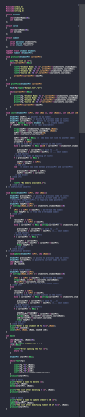1st Program: Week 3

Reason:

* It has many tasks and if one is not correct, it will be difficult to fix the error. I had the same problem before and it took me a lot of time and effort to find and fix the error.
* We can reuse the code because most of the question has the same logic, just add a little bit more function.

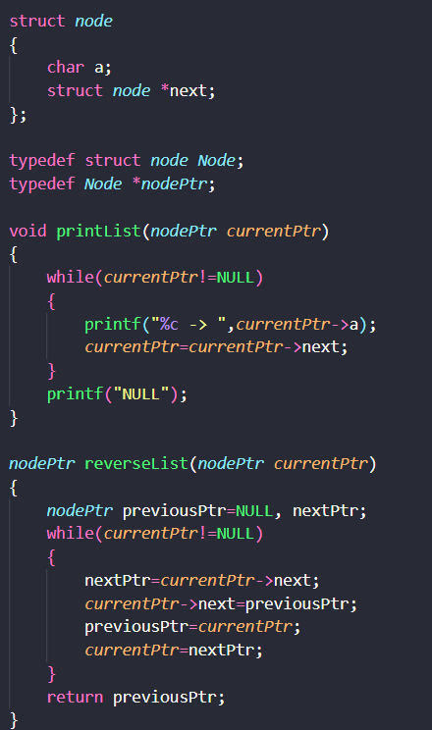2nd Program: Week 5

Reason:

* Both question 1 and 2 can be written in multiple files. One can includes the main function and the other file can include structures
* This will make the files easier to fix and read the code if there is any error occurs.

3rd Program: Week 4

* As we can see in the W9_Qn2, we have separate the Week4_Qn2 in multiple files and it’s easier to understand .
* Better code organization.

W9_Qn2.c

1st part: The main

/*

Unit Code: COS10007

Unit Name: Developing Techinical Software

Student ID: 103488515

Name: Hai Nam Ngo

Date Created: 5/9/2023

Date Modified: 5/9/2023

Problem: Week 9 Question 2

Problem Description: Try to rewrite your program in Week 4 Question 2 into multiple files, e.g. more than one

.c file and .h header.

*/

#include <stdio.h>

#include <stdlib.h>

#include <string.h>

#include "W9_Qn2_header.h"

int main()

{

reversePtr topPtr=NULL;

char str1[20], str2[20]={0};

int len;

printf("Enter a string \n");

gets(str1);

len=strlen(str1);

pushPop(topPtr, str1, str2, len);

printf("The string in reverse order is %s \n", str2);

}

2nd part: W9_Qn2_header.h

struct reverse

{

char letter;

struct reverse *next;

};

typedef struct reverse Reverse;

typedef Reverse *reversePtr;

void pushPop(reversePtr topPtr, char str1[], char str2[], int len);

3rd part: W9_Qn2_Pushpop.c

#include <stdio.h>

#include <stdlib.h>

#include <string.h>

#include "W9_Qn2_header.h"

void pushPop(reversePtr topPtr, char str1[], char str2[], int len)

{

reversePtr newPtr, temPtr;

char popValue;

int i=0;

while(len>0)

{

newPtr=(Reverse*)malloc(sizeof(Reverse));

newPtr->letter=str1[i];

newPtr->next=topPtr;

topPtr=newPtr;

len--;

i++;

}

i=0;

while(topPtr!=NULL)

{

temPtr=topPtr;

popValue=topPtr->letter;

str2[i]=popValue;

topPtr=topPtr->next;

free(temPtr);

i++;

}

}

OUTPUT FOR Qn2

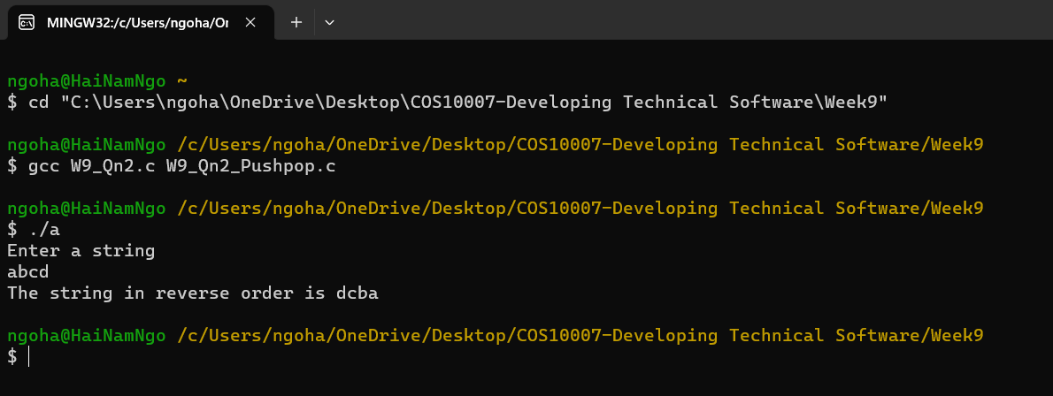

W9_Qn3.cpp

/*

Unit Code: COS10007

Unit Name: Developing Techinical Software

Student ID: 103488515

Name: Hai Nam Ngo

Date Created: 5/9/2023

Date Modified: 5/9/2023

Problem: Week 9 Question 3

Problem Description: Write a complete program that prompt the user for the radius of a sphere and calculates and prints its volume. Use an inline function sphereVolume that returns the result of the volume

*/

#include <iostream>

#include <cmath>

using namespace std;

inline double sphereVolume(double radius)

{

return (4.0 / 3.0) * M_PI * pow(radius, 3);

}

int main()

{

double radius, volume;

cout<< "Enter the radius of the sphere: ";

cin>> radius;

volume = sphereVolume(radius);

cout<<"The volume of the sphere is: "<<volume<<endl;

return 0;

}

OUTPUT FOR Qn3

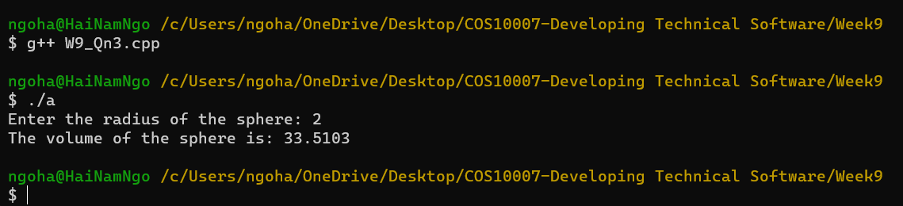

W9_Qn4.c

/*

Unit Code: COS10007

Unit Name: Developing Techinical Software

Student ID: 103488515

Name: Hai Nam Ngo

Date Created: 5/9/2023

Date Modified: 5/9/2023

Problem: Week 9 Question 4

Problem: Write a complete C++ program with the two alternate functions specified below.

These functions will double the variable count defined in main.

a. Function doubleByValue that passes a copy of count by value, double the copy

and returns the new value.

b. Function doubleByReference that passes count by reference via a reference

parameter, double the original value of count through its alias, i.e. the reference

parameter.

*/

#include <iostream>

using namespace std;

// function prototype (value pass)

int doubleByValue(int);

// function prototype (reference pass)

void doubleByReference(int&);

int doubleByValue(int number)

{

return number * 2;

}

void doubleByReference(int& numberRef)

{

numberRef *= 2;

}

int main()

{

int x, y;

// part a

cout << "Enter value of x before double: ";

cin >> x;

cout << "Value returned by doubleByValue: " << doubleByValue(x) << endl;

cout << "x = " << doubleByValue(x) << " after doubleByValue\n" << endl;

// part b

cout << "Enter value of y before double: ";

cin >> y;

doubleByReference(y);

cout << "Value returned by doubleByReference: " << y << endl;

cout << "y = " << y << " after doubleByReference\n" << endl;

return 0;

}

OUTPUT FOR Qn4

