TMDB Movie Data Analysis Report

A Spark/PySpark batch pipeline: extraction, cleaning, KPI ranking,
franchise & director analysis, and visualization

Prepared by: ngoh.amah@amalitechtraining.org
Date: 19 August 2026

Executive Summary
This report analyzes a batch of 18 released movies fetched from The Movie Database (TMDB) API. The dataset was cleaned and transformed with PySpark, then used to rank movies on financial and audience-engagement metrics, compare franchise vs. standalone performance, and identify the most successful franchises and directors.
Key findings:
- Avatar (2009) is both the most profitable film in the set ($2,687M profit) and the highest-ROI film (12.3x) among movies with a budget of at least $10M.
- Avatar (2009) leads on revenue ($2,924M) with a budget of $237M and 34,471 votes.
- Avengers: Infinity War holds the highest audience rating in the set (8.24 / 10, among movies with at least 10 votes).
- Compared to standalone movies, franchise movies in this set show: -5% mean revenue; +21% mean budget; +28% mean popularity; -1% mean rating — see the Franchise vs. Standalone Movie Performance section for the full breakdown.
- The Avengers Collection is the most successful franchise by total revenue ($7,776M across 4 film(s)), with a mean rating of 7.96.
- James Cameron leads all directors by total revenue generated ($5,188M across 2 film(s) in this set), with a mean rating of 7.75.
- Star Wars: The Last Jedi posts both the lowest profit ($1,034M) and the lowest ROI (4.4x) among movies with a budget of at least $10M — it still carries an audience rating of 6.7.
Note: neither of the two required search queries (Bruce Willis sci-fi/action films, Tarantino films starring Uma Thurman) match any movie in this particular batch of TMDB IDs — see the Advanced Movie Filtering & Search Queries section for the query definitions and confirmation of zero matches.

Methodology
The analysis follows the four-stage pipeline defined in the project spec (Data-Analysis-using-SparknPyspark-I.md), implemented as a modular PySpark application (src/tmdb_pipeline/).
1. API Data Extraction: Fetched the 19 specified TMDB movie IDs via the TMDB API (append_to_response=credits for cast/crew in a single call per movie), with raw responses cached locally and a bundled sample-data fallback for offline runs.
2. Data Cleaning & Transformation: Dropped irrelevant columns; flattened JSON-like fields (genres, production companies/countries, spoken languages, collection name) using Spark's native array functions; fixed data types; treated zero budget/revenue/runtime and placeholder text as missing; converted budget/revenue to million-USD units; derived profit and ROI; removed duplicates and sparse rows; kept only 'Released' movies. 18 of the 19 requested movie IDs survived fetching and cleaning to form the analysis dataset.
3. KPI Implementation & Analysis: Built a single reusable ranking routine (Spark Window + UDF) to power all ten headline rankings, ran the two required filtered searches, and computed franchise-vs-standalone, franchise, director, and yearly-trend summaries via groupBy aggregations.
4. Visualization: Rendered five Matplotlib charts (via toPandas()) with plain-language titles and axis labels aimed at non-technical stakeholders.

Best & Worst Performing Movies
Movies are ranked below on ten headline metrics. ROI rankings are restricted to movies with a budget of at least $10M; rating rankings are restricted to movies with at least 10 votes, per the project spec.

Highest Revenue
Title | Release Date | Director | Budget ($M) | Revenue ($M) | Profit ($M) | ROI | Votes | Rating | Popularity
Avatar | 2009-12-16 | James Cameron | 237.0 | 2,923.7 | 2,686.7 | 12.34 | 34,471 | 7.6 | 28
Avengers: Endgame | 2019-04-24 | Anthony Russo | 356.0 | 2,799.4 | 2,443.4 | 7.86 | 28,359 | 8.2 | 64
Titanic | 1997-12-18 | James Cameron | 200.0 | 2,264.2 | 2,064.2 | 11.32 | 27,556 | 7.9 | 35
Star Wars: The Force Awakens | 2015-12-15 | J.J. Abrams | 245.0 | 2,068.2 | 1,823.2 | 8.44 | 20,788 | 7.2 | 21
Avengers: Infinity War | 2018-04-25 | Joe Russo | 300.0 | 2,052.4 | 1,752.4 | 6.84 | 32,611 | 8.2 | 88

Highest Budget
Title | Release Date | Director | Budget ($M) | Revenue ($M) | Profit ($M) | ROI | Votes | Rating | Popularity
Avengers: Endgame | 2019-04-24 | Anthony Russo | 356.0 | 2,799.4 | 2,443.4 | 7.86 | 28,359 | 8.2 | 64
Avengers: Infinity War | 2018-04-25 | Joe Russo | 300.0 | 2,052.4 | 1,752.4 | 6.84 | 32,611 | 8.2 | 88
Star Wars: The Last Jedi | 2017-12-13 | Rian Johnson | 300.0 | 1,334.4 | 1,034.4 | 4.45 | 16,562 | 6.7 | 22
The Lion King | 2019-07-12 | Jon Favreau | 260.0 | 1,662.0 | 1,402.0 | 6.39 | 10,856 | 7.1 | 17
Star Wars: The Force Awakens | 2015-12-15 | J.J. Abrams | 245.0 | 2,068.2 | 1,823.2 | 8.44 | 20,788 | 7.2 | 21

Highest Profit
Title | Release Date | Director | Budget ($M) | Revenue ($M) | Profit ($M) | ROI | Votes | Rating | Popularity
Avatar | 2009-12-16 | James Cameron | 237.0 | 2,923.7 | 2,686.7 | 12.34 | 34,471 | 7.6 | 28
Avengers: Endgame | 2019-04-24 | Anthony Russo | 356.0 | 2,799.4 | 2,443.4 | 7.86 | 28,359 | 8.2 | 64
Titanic | 1997-12-18 | James Cameron | 200.0 | 2,264.2 | 2,064.2 | 11.32 | 27,556 | 7.9 | 35
Star Wars: The Force Awakens | 2015-12-15 | J.J. Abrams | 245.0 | 2,068.2 | 1,823.2 | 8.44 | 20,788 | 7.2 | 21
Avengers: Infinity War | 2018-04-25 | Joe Russo | 300.0 | 2,052.4 | 1,752.4 | 6.84 | 32,611 | 8.2 | 88

Lowest Profit
Title | Release Date | Director | Budget ($M) | Revenue ($M) | Profit ($M) | ROI | Votes | Rating | Popularity
Star Wars: The Last Jedi | 2017-12-13 | Rian Johnson | 300.0 | 1,334.4 | 1,034.4 | 4.45 | 16,562 | 6.7 | 22
Incredibles 2 | 2018-06-14 | Brad Bird | 200.0 | 1,243.2 | 1,043.2 | 6.22 | 13,862 | 7.5 | 19
Beauty and the Beast | 2017-03-16 | Bill Condon | 160.0 | 1,266.1 | 1,106.1 | 7.91 | 16,121 | 7.0 | 20
Frozen | 2013-11-20 | Chris Buck | 150.0 | 1,274.2 | 1,124.2 | 8.49 | 17,792 | 7.2 | 27
Jurassic World: Fallen Kingdom | 2018-06-06 | J. A. Bayona | 170.0 | 1,310.5 | 1,140.5 | 7.71 | 12,935 | 6.5 | 14

Highest ROI (Budget ≥ $10M)
Title | Release Date | Director | Budget ($M) | Revenue ($M) | Profit ($M) | ROI | Votes | Rating | Popularity
Avatar | 2009-12-16 | James Cameron | 237.0 | 2,923.7 | 2,686.7 | 12.34 | 34,471 | 7.6 | 28
Titanic | 1997-12-18 | James Cameron | 200.0 | 2,264.2 | 2,064.2 | 11.32 | 27,556 | 7.9 | 35
Jurassic World | 2015-06-06 | Colin Trevorrow | 150.0 | 1,671.5 | 1,521.5 | 11.14 | 21,819 | 6.7 | 21
Harry Potter and the Deathly Hallows: Part 2 | 2011-07-12 | David Yates | 125.0 | 1,341.5 | 1,216.5 | 10.73 | 22,304 | 8.1 | 33
Frozen II | 2019-11-20 | Jennifer Lee | 150.0 | 1,453.7 | 1,303.7 | 9.69 | 10,410 | 7.2 | 26

Lowest ROI (Budget ≥ $10M)
Title | Release Date | Director | Budget ($M) | Revenue ($M) | Profit ($M) | ROI | Votes | Rating | Popularity
Star Wars: The Last Jedi | 2017-12-13 | Rian Johnson | 300.0 | 1,334.4 | 1,034.4 | 4.45 | 16,562 | 6.7 | 22
Avengers: Age of Ultron | 2015-04-22 | Joss Whedon | 235.0 | 1,405.4 | 1,170.4 | 5.98 | 24,831 | 7.3 | 49
Incredibles 2 | 2018-06-14 | Brad Bird | 200.0 | 1,243.2 | 1,043.2 | 6.22 | 13,862 | 7.5 | 19
The Lion King | 2019-07-12 | Jon Favreau | 260.0 | 1,662.0 | 1,402.0 | 6.39 | 10,856 | 7.1 | 17
Black Panther | 2018-02-13 | Ryan Coogler | 200.0 | 1,349.9 | 1,149.9 | 6.75 | 23,805 | 7.4 | 32

Most Voted
Title | Release Date | Director | Budget ($M) | Revenue ($M) | Profit ($M) | ROI | Votes | Rating | Popularity
The Avengers | 2012-04-25 | Joss Whedon | 220.0 | 1,518.8 | 1,298.8 | 6.90 | 39,285 | 8.1 | 77
Avatar | 2009-12-16 | James Cameron | 237.0 | 2,923.7 | 2,686.7 | 12.34 | 34,471 | 7.6 | 28
Avengers: Infinity War | 2018-04-25 | Joe Russo | 300.0 | 2,052.4 | 1,752.4 | 6.84 | 32,611 | 8.2 | 88
Avengers: Endgame | 2019-04-24 | Anthony Russo | 356.0 | 2,799.4 | 2,443.4 | 7.86 | 28,359 | 8.2 | 64
Titanic | 1997-12-18 | James Cameron | 200.0 | 2,264.2 | 2,064.2 | 11.32 | 27,556 | 7.9 | 35

Highest Rated (≥ 10 votes)
Title | Release Date | Director | Budget ($M) | Revenue ($M) | Profit ($M) | ROI | Votes | Rating | Popularity
Avengers: Infinity War | 2018-04-25 | Joe Russo | 300.0 | 2,052.4 | 1,752.4 | 6.84 | 32,611 | 8.2 | 88
Avengers: Endgame | 2019-04-24 | Anthony Russo | 356.0 | 2,799.4 | 2,443.4 | 7.86 | 28,359 | 8.2 | 64
Harry Potter and the Deathly Hallows: Part 2 | 2011-07-12 | David Yates | 125.0 | 1,341.5 | 1,216.5 | 10.73 | 22,304 | 8.1 | 33
The Avengers | 2012-04-25 | Joss Whedon | 220.0 | 1,518.8 | 1,298.8 | 6.90 | 39,285 | 8.1 | 77
Titanic | 1997-12-18 | James Cameron | 200.0 | 2,264.2 | 2,064.2 | 11.32 | 27,556 | 7.9 | 35

Lowest Rated (≥ 10 votes)
Title | Release Date | Director | Budget ($M) | Revenue ($M) | Profit ($M) | ROI | Votes | Rating | Popularity
Jurassic World: Fallen Kingdom | 2018-06-06 | J. A. Bayona | 170.0 | 1,310.5 | 1,140.5 | 7.71 | 12,935 | 6.5 | 14
Jurassic World | 2015-06-06 | Colin Trevorrow | 150.0 | 1,671.5 | 1,521.5 | 11.14 | 21,819 | 6.7 | 21
Star Wars: The Last Jedi | 2017-12-13 | Rian Johnson | 300.0 | 1,334.4 | 1,034.4 | 4.45 | 16,562 | 6.7 | 22
Beauty and the Beast | 2017-03-16 | Bill Condon | 160.0 | 1,266.1 | 1,106.1 | 7.91 | 16,121 | 7.0 | 20
The Lion King | 2019-07-12 | Jon Favreau | 260.0 | 1,662.0 | 1,402.0 | 6.39 | 10,856 | 7.1 | 17

Most Popular
Title | Release Date | Director | Budget ($M) | Revenue ($M) | Profit ($M) | ROI | Votes | Rating | Popularity
Avengers: Infinity War | 2018-04-25 | Joe Russo | 300.0 | 2,052.4 | 1,752.4 | 6.84 | 32,611 | 8.2 | 88
The Avengers | 2012-04-25 | Joss Whedon | 220.0 | 1,518.8 | 1,298.8 | 6.90 | 39,285 | 8.1 | 77
Avengers: Endgame | 2019-04-24 | Anthony Russo | 356.0 | 2,799.4 | 2,443.4 | 7.86 | 28,359 | 8.2 | 64
Avengers: Age of Ultron | 2015-04-22 | Joss Whedon | 235.0 | 1,405.4 | 1,170.4 | 5.98 | 24,831 | 7.3 | 49
Titanic | 1997-12-18 | James Cameron | 200.0 | 2,264.2 | 2,064.2 | 11.32 | 27,556 | 7.9 | 35

Advanced Movie Filtering & Search Queries

Best-Rated Sci-Fi Action Movies Starring Bruce Willis
No matching movies found in this dataset.

Uma Thurman Movies Directed by Quentin Tarantino (by runtime)
No matching movies found in this dataset.

Franchise vs. Standalone Movie Performance
Is Franchise | Mean Revenue ($M) | Median Roi | Mean Budget ($M) | Mean Popularity | Mean Rating
Franchise | 1,682.8 | 7.79 | 218.0 | 34.6 | 7.40
Standalone | 1,765.1 | 9.62 | 180.0 | 27.0 | 7.43

Franchise entries post mean revenue lower than standalone films ($1,682.8M vs. $1,765.1M), median ROI lower than standalone (7.79x vs. 9.62x), mean budget higher than standalone ($218.0M vs. $180.0M), mean popularity higher than standalone (34.6 vs. 27.0), and mean rating lower than standalone (7.40 vs. 7.43).

Most Successful Franchises
Belongs To Collection | Movie Count | Total Budget ($M) | Mean Budget ($M) | Total Revenue ($M) | Mean Revenue ($M) | Mean Rating
The Avengers Collection | 4 | 1,111.0 | 277.8 | 7,776.1 | 1,944.0 | 7.96
Star Wars Collection | 2 | 545.0 | 272.5 | 3,402.6 | 1,701.3 | 6.99
Jurassic Park Collection | 2 | 320.0 | 160.0 | 2,982.0 | 1,491.0 | 6.61
Avatar Collection | 1 | 237.0 | 237.0 | 2,923.7 | 2,923.7 | 7.61
Frozen Collection | 2 | 300.0 | 150.0 | 2,727.9 | 1,364.0 | 7.24
The Lion King (Reboot) Collection | 1 | 260.0 | 260.0 | 1,662.0 | 1,662.0 | 7.09
The Fast and the Furious Collection | 1 | 190.0 | 190.0 | 1,515.4 | 1,515.4 | 7.21
Black Panther Collection | 1 | 200.0 | 200.0 | 1,349.9 | 1,349.9 | 7.36
Harry Potter Collection | 1 | 125.0 | 125.0 | 1,341.5 | 1,341.5 | 8.08
The Incredibles Collection | 1 | 200.0 | 200.0 | 1,243.2 | 1,243.2 | 7.45

The Avengers Collection dominates on scale (4 film(s), $7,776M total revenue). The Harry Potter Collection holds the highest mean rating (8.08) among all franchises in this set.

Most Successful Directors
Director | Movie Count | Total Revenue ($M) | Mean Rating
James Cameron | 2 | 5,187.9 | 7.75
Joss Whedon | 2 | 2,924.2 | 7.67
Anthony Russo | 1 | 2,799.4 | 8.24
J.J. Abrams | 1 | 2,068.2 | 7.25
Joe Russo | 1 | 2,052.4 | 8.24
Colin Trevorrow | 1 | 1,671.5 | 6.70
Jon Favreau | 1 | 1,662.0 | 7.09
James Wan | 1 | 1,515.4 | 7.21
Jennifer Lee | 1 | 1,453.7 | 7.23
Ryan Coogler | 1 | 1,349.9 | 7.36
David Yates | 1 | 1,341.5 | 8.08
Rian Johnson | 1 | 1,334.4 | 6.74
J. A. Bayona | 1 | 1,310.5 | 6.53
Chris Buck | 1 | 1,274.2 | 7.25
Bill Condon | 1 | 1,266.1 | 6.97
Brad Bird | 1 | 1,243.2 | 7.45

James Cameron leads total revenue ($5,188M across 2 film(s) in this set). Joe Russo holds the highest mean rating (8.24) of any director represented.

Yearly Box Office Trends
Release Year | Movie Count | Mean Budget ($M) | Mean Revenue ($M)
1997 | 1.00 | 200.0 | 2,264.2
2009 | 1.00 | 237.0 | 2,923.7
2011 | 1.00 | 125.0 | 1,341.5
2012 | 1.00 | 220.0 | 1,518.8
2013 | 1.00 | 150.0 | 1,274.2
2015 | 4.00 | 205.0 | 1,665.1
2017 | 2.00 | 230.0 | 1,300.3
2018 | 4.00 | 217.5 | 1,489.0
2019 | 3.00 | 255.3 | 1,971.7

Box-office activity in this dataset spans 1997 to 2019, with mean budgets moving from $200M to $255M per release over that period.

Visualizations
The following charts summarize the same KPIs in visual form, with plain-language titles and labels for non-technical stakeholders. Refer to the tables above for the exact figures behind each chart.
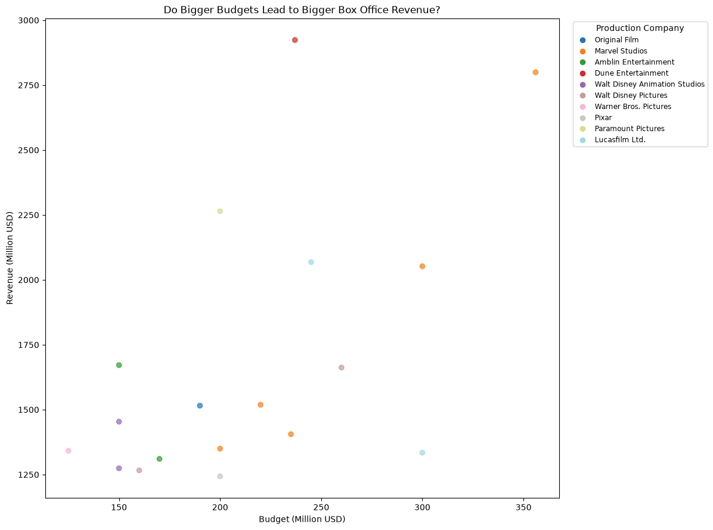
Figure 1. Revenue vs. Budget
Insight: Avatar shows that a strong box-office draw can outperform its budget class, driving the outsized ROI seen in the rankings above, while higher budgets generally still track with higher revenue overall.

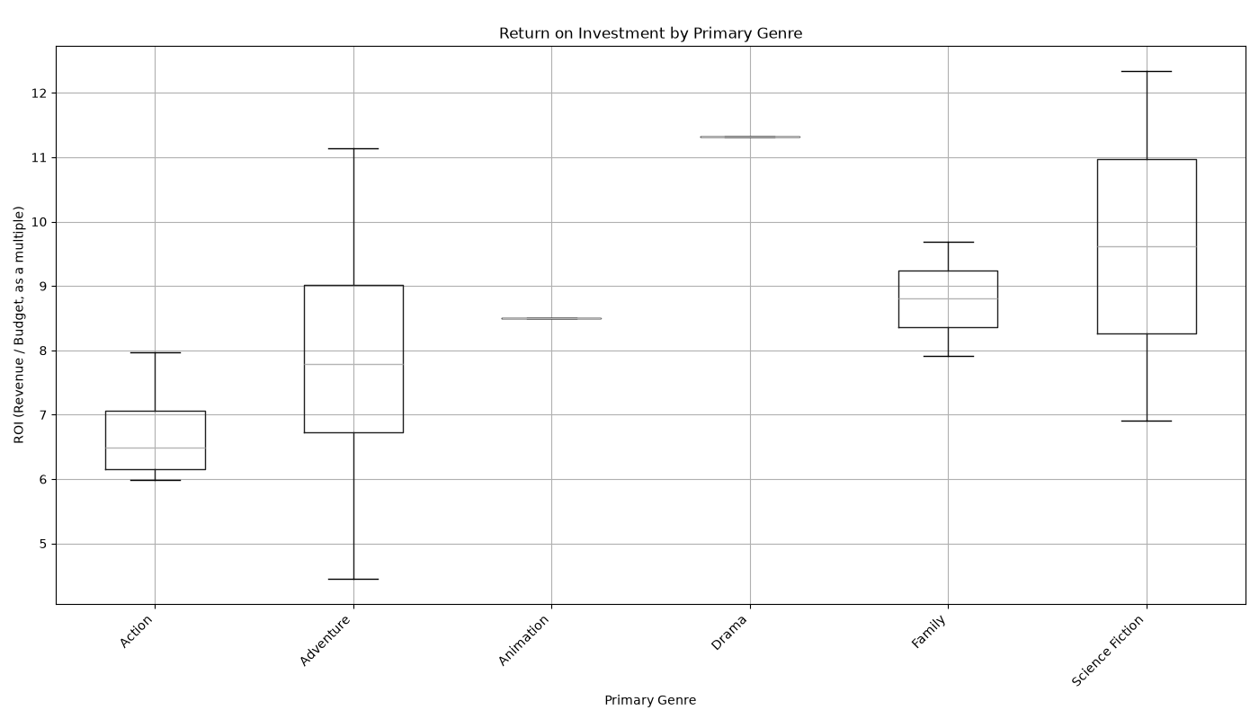
Figure 2. ROI Distribution by Genre
Insight: Genres with the widest ROI spread mix high-ROI blockbusters with lower-ROI entries carrying the same genre tags — see the Highest/Lowest ROI rankings above for the specific titles driving each end of the spread.

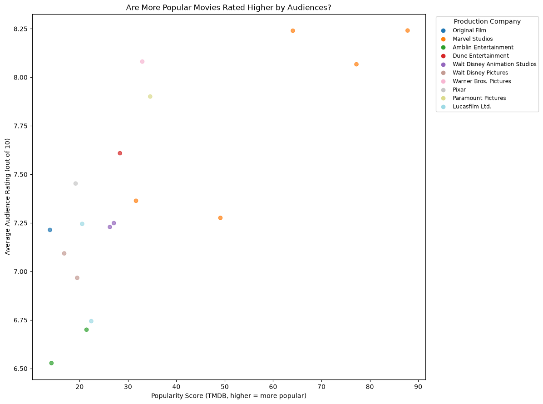
Figure 3. Popularity vs. Rating
Insight: Popularity and audience rating broadly move together for the top franchise films, while smaller or standalone films can hold solid ratings without matching mainstream popularity.

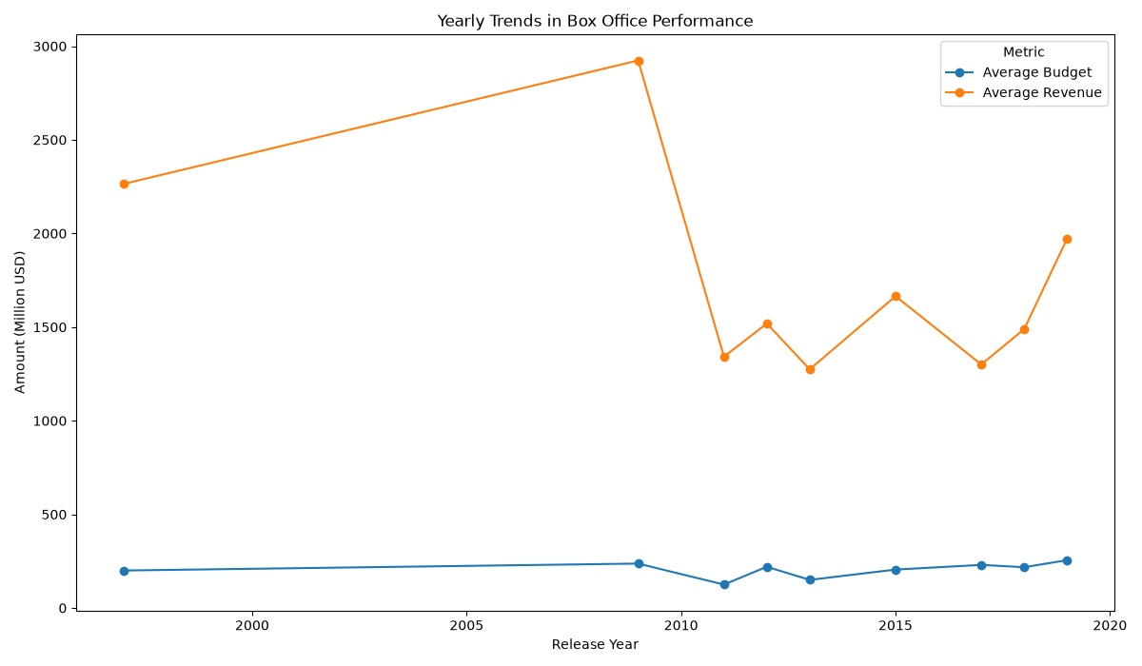
Figure 4. Yearly Box Office Trends
Insight: Mean budgets and revenues move unevenly across release years, consistent with the industry's shift toward fewer, larger tentpole releases over time.

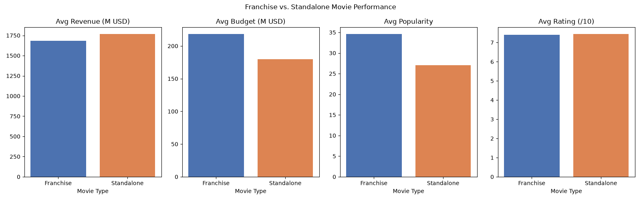
Figure 5. Franchise vs. Standalone Performance
Insight: This chart visualizes the same franchise-vs-standalone comparison tabulated above, making the gap (or its absence) across metrics easy to scan at a glance.

Conclusions
Across financial, audience, and franchise/director dimensions, Avatar and The Avengers Collection represent the strongest combination of scale and reception in this dataset. Avatar stands out as an efficient investment, pairing its budget with the highest ROI in the set, while lower-ROI entries in the same rankings still carry respectable audience ratings — a reminder that financial return and critical reception are related but distinct measures of success.

