Triceratops
Trend Following Trading System



Risk Disclaimer

If you cannot abide by these disclaimers and are unwilling to accept full responsibility for your actions, please do not trade.

Your possession of this document is bound by your signed non-disclosure agreement with Marylebone Holdings, LTD. Marylebone is the parent company of both Trend Following and TurtleTrader®. Michael Covel serves as President.

All questions for the Triceratops trading system: info@trendfollowing.com.

Additional disclaimer:

FUTURES AND OR STOCK TRADING CAN INVOLVE HIGH RISKS WITH THE POTENTIAL FOR SUBSTANTIAL LOSSES. HOWEVER, YOU CAN ALSO GAIN LARGE WINNINGS AS WELL.

HYPOTHETICAL OR SIMULATED PERFORMANCE RESULTS HAVE CERTAIN INHERENT LIMITATIONS. UNLIKE AN ACTUAL PERFORMANCE RECORD, SIMULATED RESULTS DO NOT REPRESENT ACTUAL TRADING. ALSO, SINCE THE TRADES HAVE NOT ACTUALLY BEEN EXECUTED, THE RESULTS MAY HAVE UNDER OR OVER-COMPENSATED FOR THE IMPACT, IF ANY, OF CERTAIN MARKET FACTORS, SUCH AS LACK OF LIQUIDITY. SIMULATED TRADING PROGRAMS IN GENERAL ARE ALSO SUBJECT TO THE FACT THAT THEY ARE DESIGNED WITH THE BENEFIT OF HINDSIGHT. NO REPRESENTATION IS BEING MADE THAT ANY ACCOUNT WILL OR IS LIKELY TO ACHIEVE THE PROFITS OR LOSSES SIMILAR TO THOSE SHOWN.
TradeStation Installation

Importing TradeStation code is straightforward:
- Click on file and select Import/Export Easy Language.
- Click on Import Easy Language File (ELD, ELS or ELA).
- Browse to the location of the file.
- Click import.

Once the code is imported you need to change one setting:
- Open a chart and select insert strategy.
- Select Trend System One and ok.
- Then click properties for all and select the General Tab.
- On bottom left change Maximum number of bars the study will reference to 126.

Stock Selection
The universe of stocks is vast. Symbols used will vary from user to user. Here are a few suggestions for selecting a portfolio to review.

- Issues mentioned on TV or in the newspaper will most likely be large cap stocks. These typically mirror the economy and can trade in a range for extended periods of time. Try to select names you don’t hear every day. This will add diversity and more trades to the portfolio.
- ETFs have provided great exposure to commodity-based products. These issues can trend more frequently and should be considered.

Goals of the Method
The system is designed for two primary reasons: to isolate weekly breakouts and to keep capital out of the market during periods of turmoil. The market declines of October 2008, the flash crash of May 2010 and EU troubles during the fall of 2011 are just some of the pitfalls that have occurred in the last few years. This system is designed to issue sell signals around periods of long term trend reversal. Why? It is easier to come back and profit when you have capital to trade! For this reason when comparing trade results keep in mind what a buy and hold return would have been for the same period. This makes an apples to apples comparison.

Initial Trade Signals
The core trading system is a weekly channel breakout. By default the system is set to look for 50-week channel breakouts. You can also modify the breakout length on the input screen in TradeStation. The input ‘primaryma’ identifies the number of weeks the system will consider for a trade signal.

On the input screen you will also see the input named ‘channel’. By default it is set to 1.5. The ‘channel’ is calculated by taking a 50-week moving average and adding and subtracting 1.5 weekly ATRs from it. This sets a band on the chart that identifies entry and exit points. A long set up will happen with the price pierces through the band completely. For long trades the low of the bar must be higher than the upper band and for a short trade the high of the bar must be lower than the lower band.

Date | 50-Day MA | ATR | Channel | Upper Band | Lower Band
3/3/2000 | 42.37 | 1.73 | 2.6 | 44.97 | 39.77
3/10/2000 | 42.41 | 1.92 | 2.89 | 45.3 | 39.52
3/17/2000 | 42.36 | 2.27 | 3.41 | 45.77 | 38.95
3/24/2000 | 42.43 | 2.42 | 3.62 | 46.05 | 38.81
3/31/2000 | 42.45 | 2.56 | 3.84 | 46.29 | 38.61
4/7/2000 | 42.41 | 2.71 | 4.06 | 46.47 | 38.35
4/14/2000 | 42.32 | 2.89 | 4.33 | 46.65 | 37.99
4/21/2000 | 42.21 | 3.2 | 4.8 | 47.01 | 37.41
4/28/2000 | 42.1 | 3.38 | 5.08 | 47.18 | 37.02

Trade Setups

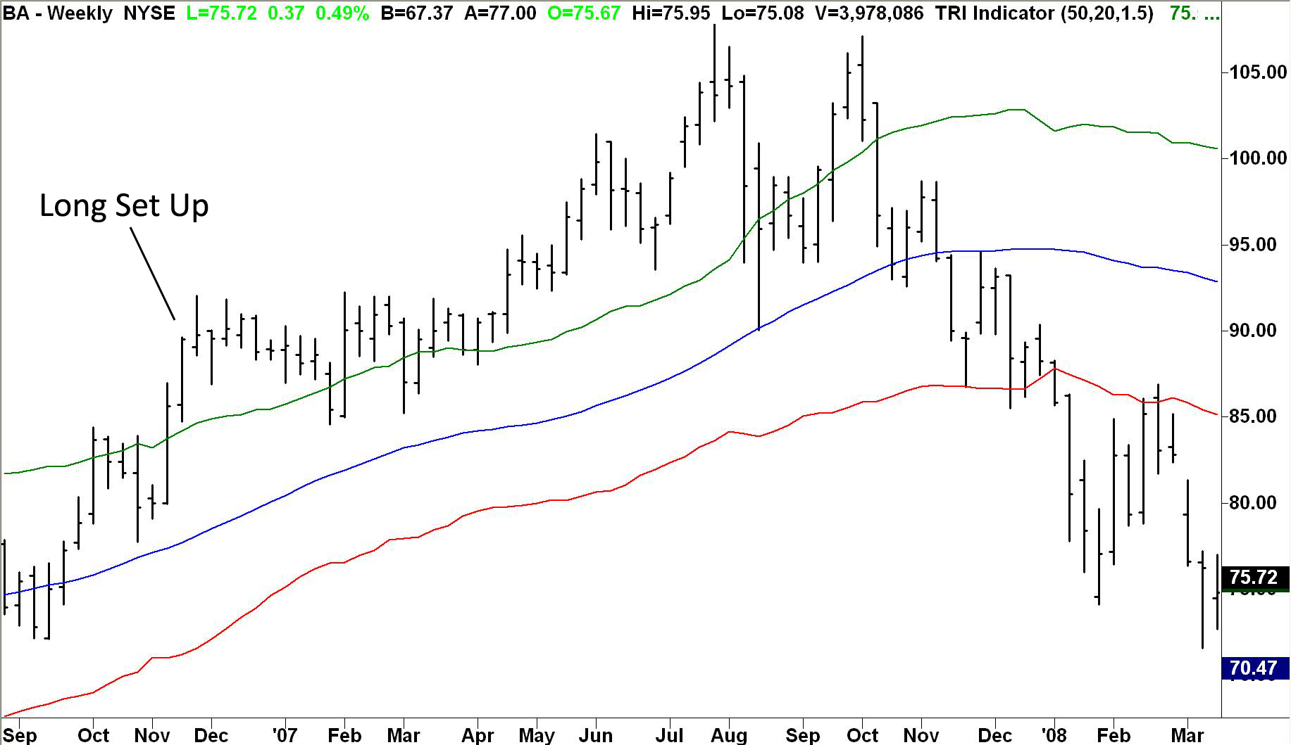
Chart 1: Demonstrating Long Setup

As you can see the low of the highlighted bar is completely above the upper band--this signals a long setup.

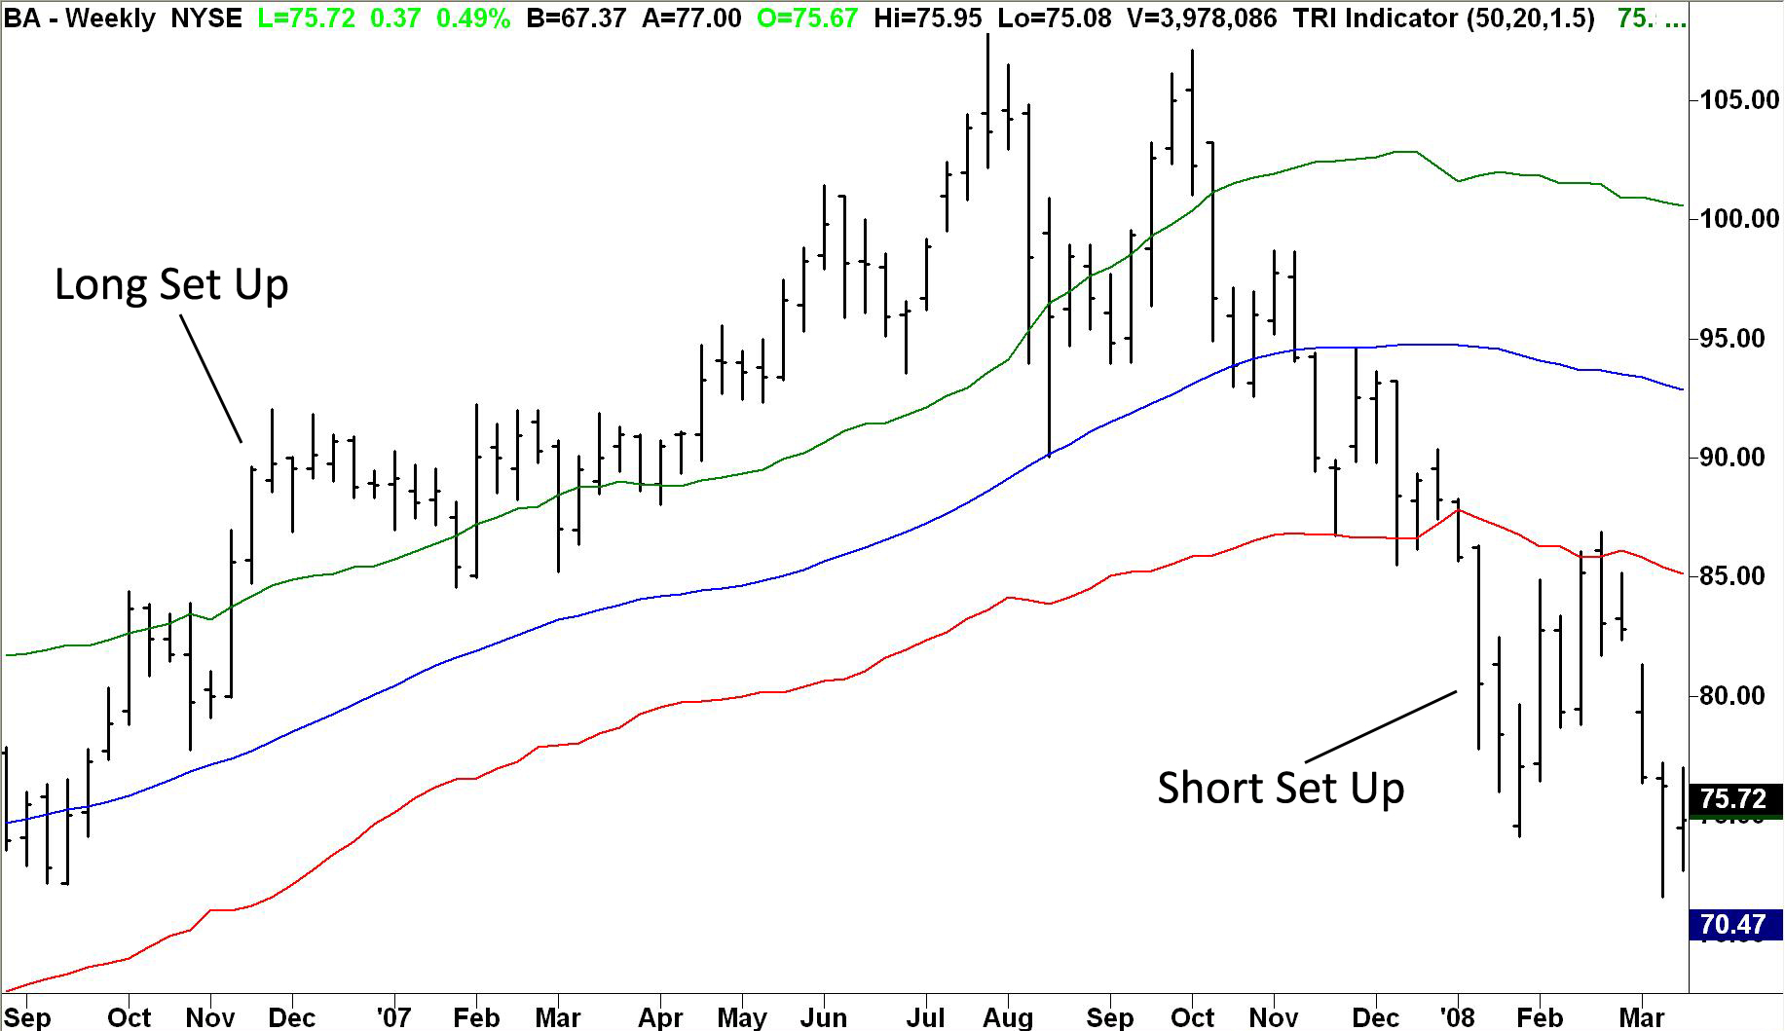
Chart 2: Demonstrating Short Setup

The chart above shows both a long and short setup for this issue. The trade will be made on the week following the trade setup. For example, you will not know if the trade setup has occurred until Friday afternoon, as these are weekly bars. You will enter the market on Monday morning. Believe it or not some of the great traders today trade weekly bars.
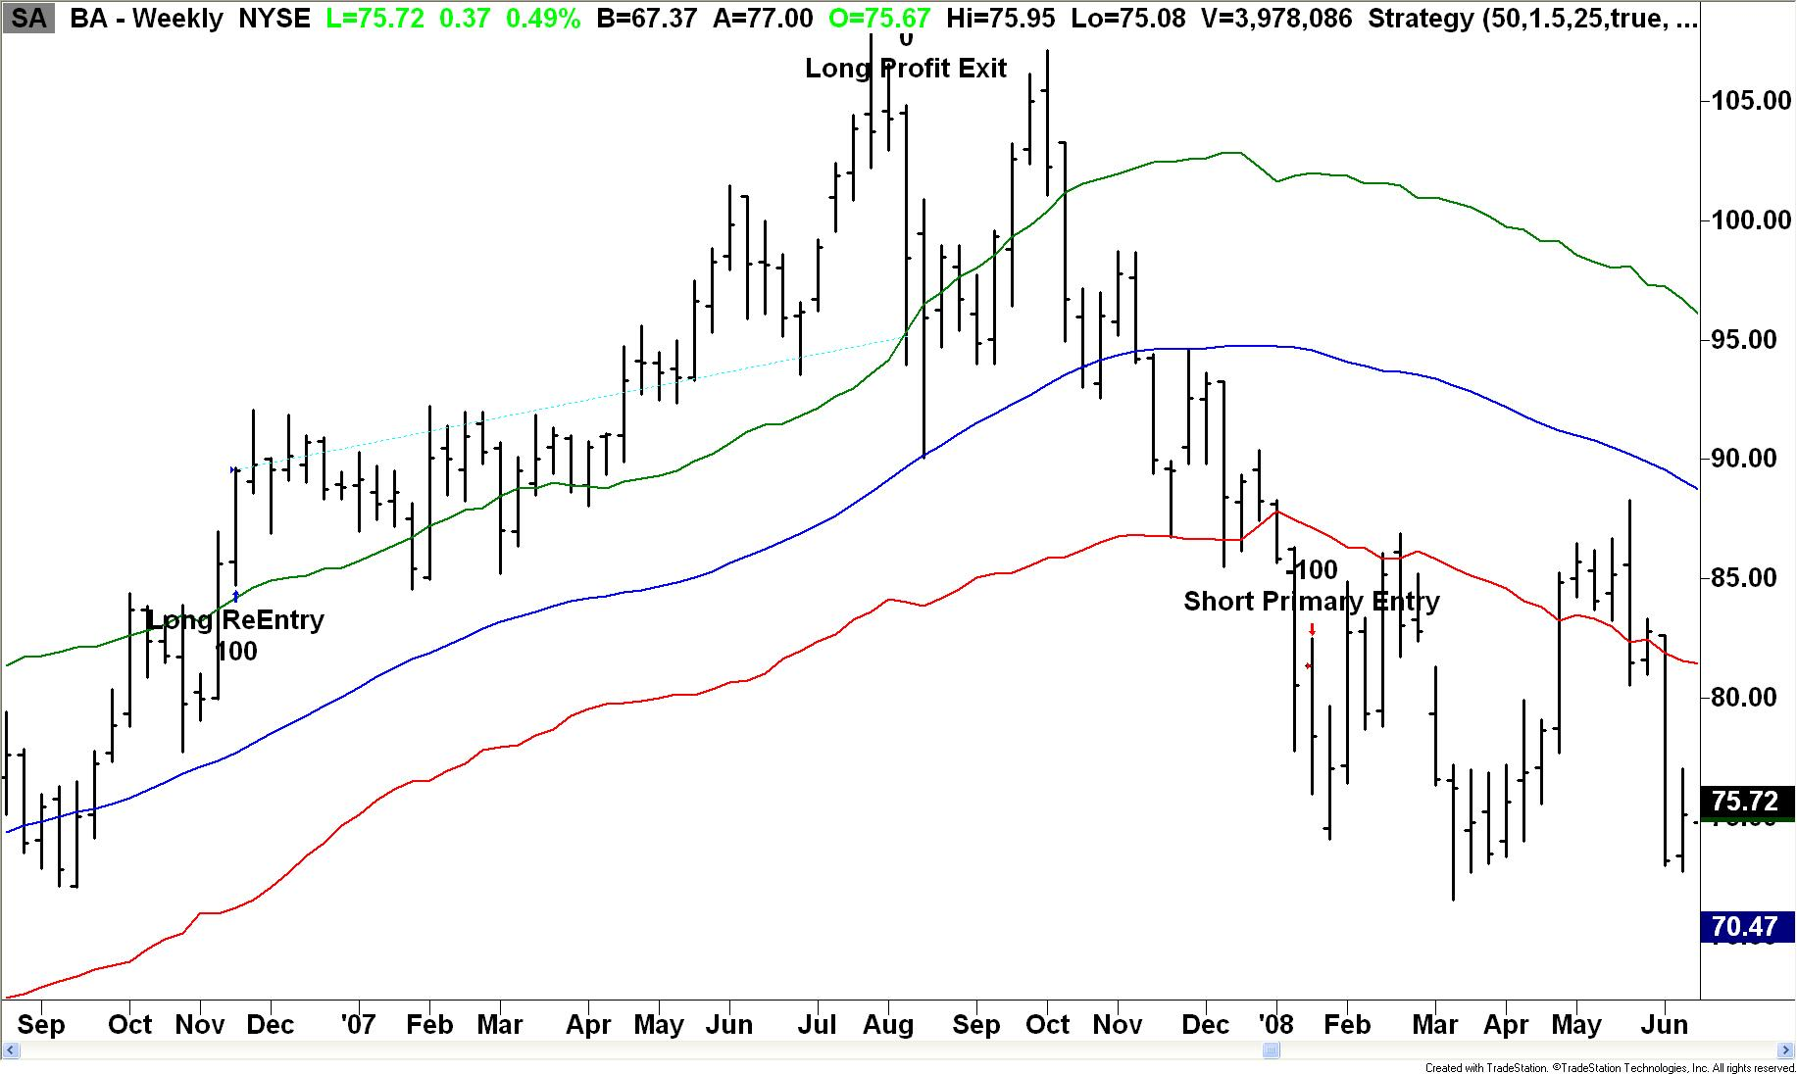
Chart 3: Demonstrating Long and Short Trade Setups with TradeStation.

There are two types of entries for both long and short trades. The first is the ‘Initial Setup’ as outlined above. Those will show up on a TradeStation chart as a ‘Long Primary Entry’ or ‘Short Primary Entry’. A full break of the bar will trigger this entry. There will be times, however, when you exit a long trade and then the market begins another trend without reversing, i.e. two long trades back to back or two short trades back to back.

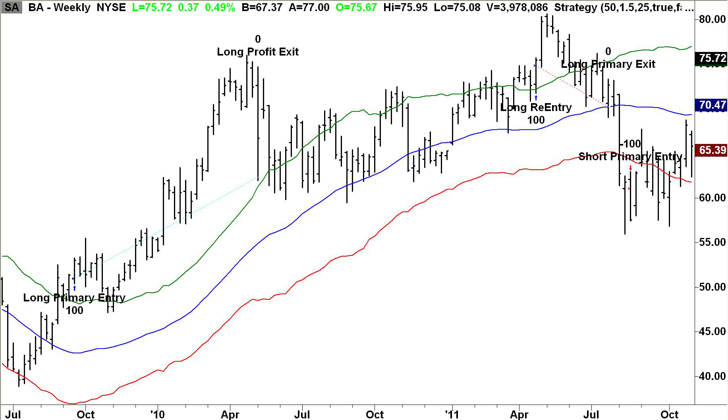
Chart 4: Demonstrating Long Primary Entry and Long Re-entry

On the chart above you can see an initial long trade to the left that is stopped out in April 2010. A re-entry trade is generated in April 2011. Re-entries result from the market making a fresh high or low without reversing. This type of trade is shown on the chart as ‘Long ReEntry’ or ‘Short ReEntry’.

In this example notice that the market stayed in a long bias-- although the position was stopped out it did not take a short. When the market makes a fresh high another long is generated. The look back period for longs is tied to the ‘primaryma’ as defined earlier. The system defaults to 50. The middle line is a 50-week moving average (blue in color) and the system will generate a re-entry signal at a fresh 50-week high. The same logic applies to short positions, just in reverse. A short trade that is stopped out can re-enter if (a.) a long trade is not generated and (b.) a fresh low is triggered.

You can customize the ‘primaryma’ and ‘channel’ by selecting different values on the input screen in TradeStation. Longer lengths of the ‘primaryma’ and channel will typically produce fewer trades.

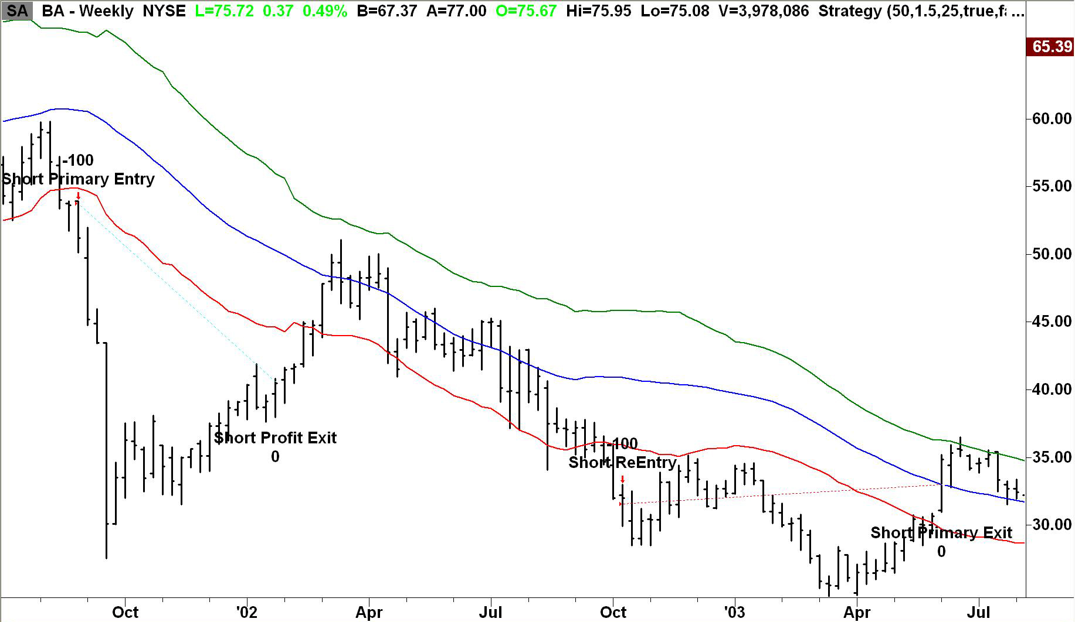
Chart 5: Demonstrating Short Primary Entry and Subsequent Short Re-Entry

Trade Exits

Trade exits are set by two methods. The first is the middle band, the 50-week moving average (default setting) or blue line in chart above. Notice on the re-entry trade starting in October the exit occurred on the right side of the chart and is named ‘Short Primary Exit.’ Long and Short Primary Exits are set to the X week moving average defined by the ‘primaryma’ variable on the input screen.

Profit Exits are defined by the ‘secondaryma’ on the TradeStation input screen. The system will switch from the primaryma to the secondaryma when 0.75 of trade risk is generated in profits (See below for trade risk calculations).

In the system code 0.75 is referred to as the profit multiple. Once a profit multiple triggers a change in the exit parameters, it will not change. Once the profit multiple trades above 0.75 the exit criteria will set itself to the ‘secondaryma’ and will not move back to the ‘primaryma’.
Example of Exit Criteria

Date | Market Direction | Entry Price | Close | Profit Multiple | Exit MA
8/4/2000 | Short | 48.5 | 49 | 0.16 | 50
8/11/2000 | Short | 48.5 | 49.56 | 0.16 | 50
8/18/2000 | Short | 48.5 | 45.69 | 0.16 | 50
8/25/2000 | Short | 48.5 | 54.13 | 0.68 | 50
9/1/2000 | Short | 48.5 | 54.81 | 0.88 | 25
9/8/2000 | Short | 48.5 | 58.13 | 1.3 | 25
9/15/2000 | Short | 48.5 | 56.88 | 1.32 | 25
9/22/2000 | Short | 48.5 | 63.5 | 1.8 | 25
9/29/2000 | Short | 48.5 | 64.5 | 2.1 | 25
10/6/2000 | Short | 48.5 | 61 | 1.65 | 25
10/13/2000 | Short | 48.5 | 58.75 | 1.45 | 25
1020/2000 | Short | 48.5 | 60 | 1.48 | 25
10/27/2000 | Short | 48.5 | 63.75 | 1.75 | 25
11/3/2000 | Short | 48.5 | 66.06 | 2.2 | 25
11/10/2000 | Short | 48.5 | 63.5 | 2.03 | 25
11/17/2000 | Short | 48.5 | 65.38 | 2.08 | 25
11/24/2000 | Short | 48.5 | 65.69 | 2.39 | 25
12/1/2000 | Short | 48.5 | 65.81 | 2.44 | 25
12/8/2000 | Short | 48.5 | 69.94 | 2.55 | 25
12/15/2000 | Short | 48.5 | 64.88 | 2.51 | 25
12/22/2000 | Short | 48.5 | 63.44 | 2.44 | 25
12/29/2000 | Short | 48.5 | 66 | 2.1 | 25

Notice on 9/1/2000 the profit multiple went above 0.75 and the Exit MA dropped from 50 down to 25. The Exit MA never moved back down through the trade. The chart below backs the trade detail shown above. You can see the switch to the shorter exit length saved over $5.00 per share. The trade would have exited at roughly 54.50 per share as opposed to $60.00 per share.

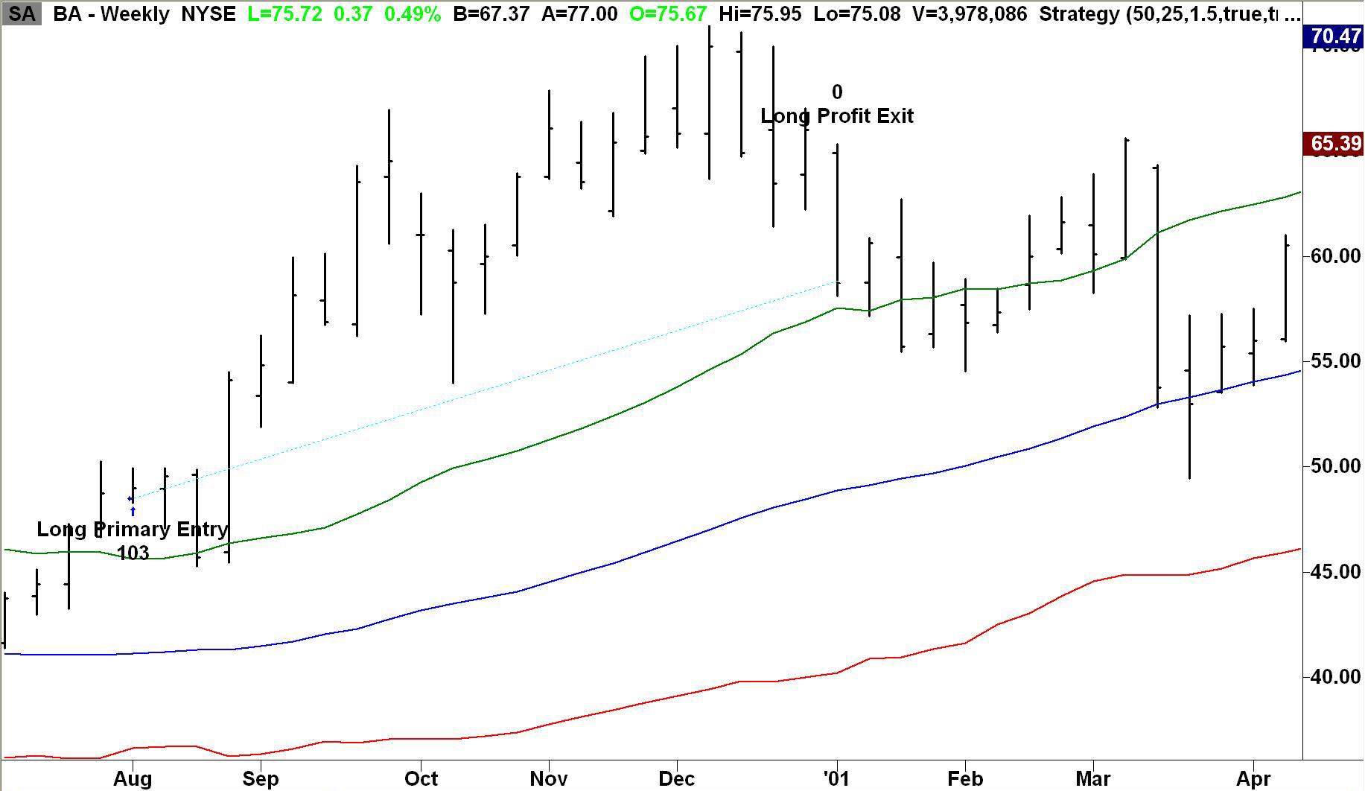
Chart 6: Example Exit Chart

Trade Risk
Initial trade risk is defined as the high – Middle Band (Long Trades) or the Middle Band - high (Short Trades). For example, in the chart above the system initially went short at 53.75 while the Middle Band was at 60.65. This results in a trade risk of 6.90 points (60.65 – 53.75 = 6.90).

When the market declines by 5.175 the system will switch from the ‘primaryma’ to the ‘secondaryma’ for trade exits. At this point the market generated 5.175 points of profit and the system seeks to protect those profits by tightening up the exit.

Notice the Re-Entry trade exited on the Primary Exit. The risk on this position was 10.94 (Entry of 29.95 and Middle Band of 40.89). The market needed to decline by 8.205 in order to trigger the ‘secondaryma’.

Short Trade Options
Some traders will not be able to sell short an issue, which is to profit from the decline in price of a stock. If this is the case you can change the input ‘oktoshort’ to false on the TradeStation input screen. This will ignore any short trades generated by the system. Valid inputs for this variable are ‘true’ or ‘false’.

Money Management

The system will set the appropriate number of shares to trade based on the trade risk. There are two software inputs to help you control risk. These are explained below:

‘Mmgment’
The first variable in the code is mmgment. This allows you to turn on and off the money management components of the TradeStation Triceratops code. Appropriate choices for this field are true or false. When set to false the code will execute 100 shares to each trade signal. It will not size trades according to risk. Furthermore, the risk on each trade can be more than you are willing to trade. The variables discussed below allow the user to control their risk.

‘Risk_dollars’
Inside the TradeStation code you will see a user defined input titled ‘risk_dollars’, which defaults to $5,000. The code will calculate the number of shares to trade based on the entry placed in this field. You can set the trade risk to a level that works for your account equity.

The number of shares is calculated as follows. The trade risk is identified per the instructions on the previous page. The last example had a trade risk of 8.205 points and the share price was 29.95. Using $5,000 for risk dollars produces the following result:

Shares = risk dollars / share price
Shares = 5000 / 29.95
Shares = 166.94, rounded down to 166

Resulting cost of the trade is $4,971.70
Shares x Share price
166 x 29.95

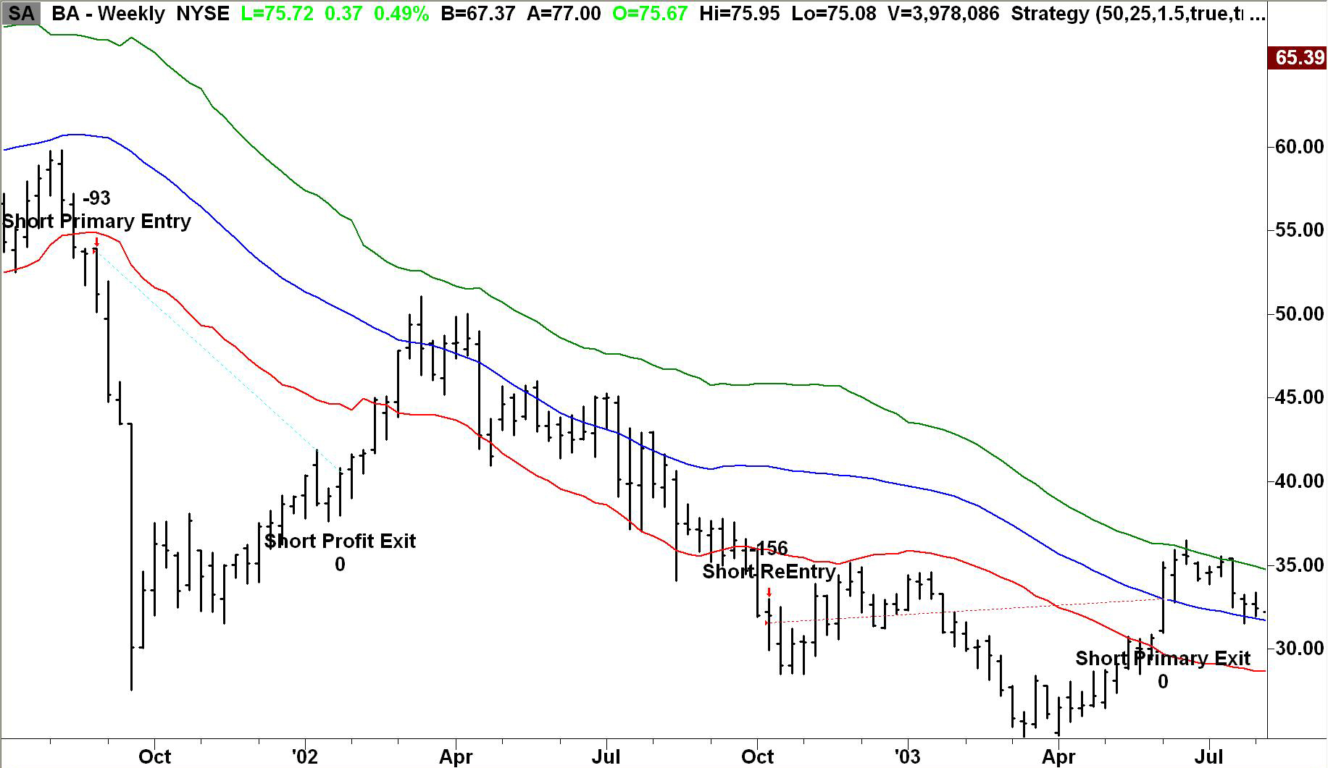
Chart 7: Showing TradeStation Sized Positions

Notice the number of shares for the Primary Entry is now 93 and the Re-Entry is 156. There is a tendency for smaller share prices to be rewarded with more shares since they are less costly. At first this might seem frustrating, as more expensive issues will ‘cost more.’ However, remember that more expensive shares will have larger daily ranges – so the unit fluctuation of one group versus another can be roughly the same.

Risk to Account Equity
TradeStation will not dynamically position size for you based upon your entire trading equity. It looks at markets individually, not in terms of your entire portfolio. It is recommended that you risk a fixed percent of your total trading equity on each position. You can enter that number in the Max_risk field. You can change your entry in max_risk as trading equity increases or decreases. For example, today you have a $100,000 account risking 3%, so you would enter $3,000 in the max risk field. If tomorrow you have $99,000 you would enter 3% of that amount or $2,970.

What to Expect
Your success or failure with any trading method involves the ability to withstand pressures from the market. It is good to know what to expect from the system and how it behaves during periods of volatility. This lets you mentally prepare yourself for live trading. Additionally, since the system is based on a weekly bar method it is highly advised that you find as many different issues to screen as possible. You might find that one issue may sit on the sidelines for a year or more. Trading just one stock or a few stocks will mean lost opportunity.

We recommend selecting a diverse tracking portfolio. There will be times when entire sectors will move and trade in unison. The banking sector, for example, traded together from 2005 until 2009. First was up from 2005 until 2007 and then down as the banking crisis unfolded. The goal is to spread your capital over different and non-correlated issues to maximize opportunities.

It is also possible to have a string of losers before a profitable trade takes off. Once again that is why it is critical that you select a basket of markets to track and trade. Bottom line, in trend following winners offset losers. Clearly, becoming married or emotionally attached to one market, or sector, will create an unstable return profile.

One more issue to keep in mind?

Good luck and good trading!

If you have any questions drop us an email: info@trendfollowing.com.

