Triceratops

Trend Following Trading System Tests


Risk Disclaimers
If you cannot abide by the following disclaimers and are unwilling to accept full responsibility for your actions, please do not trade.

This document is designed as a big picture analysis of the TREX trading system. Please be advised that there is no one perfect portfolio or set of parameters. This is a robust methodology designed to give traders another tool in their trading toolbox. It is not a guarantee of performance.

Data presented was generated with TradeStation’s Portfolio Maestro software using default settings. Users can customize parameters including risk controls to their own tolerances.

All questions: info@trendfollowing.com.

Additional Risk Disclaimers

FUTURES AND OR STOCK TRADING CAN INVOLVE HIGH RISKS WITH THE POTENTIAL FOR SUBSTANTIAL LOSSES. HOWEVER, YOU CAN ALSO PRODUCE LARGE WINNINGS AS WELL.

HYPOTHETICAL OR SIMULATED PERFORMANCE RESULTS HAVE CERTAIN INHERENT LIMITATIONS. UNLIKE AN ACTUAL PERFORMANCE RECORD, SIMULATED RESULTS DO NOT REPRESENT ACTUAL TRADING. ALSO, SINCE THE TRADES HAVE NOT ACTUALLY BEEN EXECUTED, THE RESULTS MAY HAVE UNDER OR OVER-COMPENSATED FOR THE IMPACT, IF ANY, OF CERTAIN MARKET FACTORS, SUCH AS LACK OF LIQUIDITY. SIMULATED TRADING PROGRAMS IN GENERAL ARE ALSO SUBJECT TO THE FACT THAT THEY ARE DESIGNED WITH THE BENEFIT OF HINDSIGHT. NO REPRESENTATION IS BEING MADE THAT ANY ACCOUNT WILL OR IS LIKELY TO ACHIEVE THE PROFITS OR LOSSES SIMILAR TO THOSE SHOWN.

Our firm cannot promise you will earn like returns of traders, charts or examples (real or hypothetical) mentioned. All past performance is not necessarily an indication of future results. Data presented is for educational purposes. This information is not an invitation for investment. We assume all data to be accurate, but assume no responsibility for errors, omissions or clerical errors made.

Table of Contents

TRI-Top Trading Method (ETF) with Money Management

Summary

Strategy Analysis

Trade Analysis

Statistical Analysis

Return Analysis

Annual Returns

Monthly Returns

Weekly Returns

Equity Analysis

Equity Drawdown

Equity Runup

Program Settings

Equity Curve

TRI-Top Trading Method (Stocks) with Money Management

Summary

Strategy Analysis

Trade Analysis

Statistical Analysis

Return Analysis

Annual Returns

Monthly Returns

Weekly Returns

Daily Returns

Equity Analysis

Equity Drawdown

Equity Runup

Program Settings

Equity Curve

TRI-Top Trading Method (ETF) with Money Management
Fixed fractional allocation by market value; 20% per trade.

Summary
Total Return | $191,388.40
Total Realized Return | $174,272.24
Gross Profit | $363,083.55
Gross Loss | ($188,811.31)
Open Trade P/L | $17,116.16
Number of Trades | 174
Number of Winning Trades | 81
Number of Losing Trades | 93
% Profitable | 46.55%
Average Trade | $1,001.56
Average Trade (%) | 3.30%
Standard Deviation Trade | $4,708.11
Standard Deviation Trade (%) | 13.44%
Largest Winning Trade | $19,169.08
Largest Losing Trade | ($10,693.30)
Profit Factor | 1.92
Average Win / Average Loss | 2.21
Sharpe Ratio | 0.0743
K-Ratio | 0.1295
Return Retracement Ratio | 0.9592
Compounded Annual Return | 9.02%
Compounded Monthly Return | 0.71%
Average Annual Return | $13,670.60
Average Annual Return (%) | 8.57%
Average Monthly Return | $1,275.92
Average Monthly Return (%) | 0.80%
Percent Days Profitable | 47.58%
Percent Months Profitable | 52.00%
Percent Years Profitable | 71.43%
Commissions on Futures | $0.00
Commissions on Currencies | $0.00
Commissions on Equities | $3,530.00
Total Commissions | $3,530.00

Strategy Analysis
Total Return | $191,388.40
Total Realized Return | $174,272.24
Gross Profit | $363,083.55
Gross Loss | ($188,811.31)
Open Trade P/L | $17,116.16
Number of Trades | 174
Number of Symbols Traded | 5 out of 5
Average Trade | $1,001.56
Standard Deviation | $4,708.11
Average Trade (%) | 3.30%
Standard Deviation | 13.44%
Average Trade Length | 76.28 days
Winning Trades | $363,083.55
Number of Winning Trades | 81
Average Win | $4,482.51
Percent of Winning Trades | 46.55%
Maximum Consecutive Wins | 8
Largest Winning Trade | $19,169.08
Largest Winning Trade (%) | 52.67%
Average Winning Trade Length | 124.52 days
Losing Trades | ($188,811.31)
Number of Losing Trades | 93
Average Loss | ($2,030.23)
Percent of Losing Trades | 53.45%
Maximum Consecutive Losses | 10
Largest Losing Trade | ($10,693.30)
Largest Losing Trade (%) | -21.17%
Average Losing Trade Length | 34.27 days
Commissions on Futures | $0.00
Commissions on Currencies | $0.00
Commissions on Equities | $3,530.00
Total Commissions | $3,530.00

Trade Analysis
Runups
(by Amount)
Maximum | $26,745.12
Date | 10/19/2009
Average | $4,953.45
Standard Deviation | $5,464.37
(by Percent)
Maximum | 85.38%
Date | 3/24/2000
Average | 14.20%
Standard Deviation | 15.97%
Drawdowns
(by Amount)
Maximum | ($10,673.30)
Date | 3/23/2009
Average | ($1,504.67)
Standard Deviation | $1,596.38
(by Percent)
Maximum | -21.13%
Date | 3/23/2009
Average | -4.11%
Standard Deviation | 3.74%
Efficiency Analysis
Efficiency
Total
Average | -11.22%
Standard Deviation | 53.86%
Entry
Average | 64.23%
Standard Deviation | 31.75%
Exit
Average | 24.55%
Standard Deviation | 27.33%
Profit Factor | 1.92
Average Win/Average Loss | 2.21
Net Profit/Largest Loss | -16.3
Net Profit/Max Drawdown | 16.33

Statistical Analysis
t-Test | 73.17
Significance | Yes

Return Analysis
Annual Returns | Amount | Amount (%) | Percent of Fixed Capital
Average | $13,670.60 | 8.57% | 13.67%
Standard Deviation | $25,246.73 | 12.37% | 25.25%
Annualized Sharpe Ratio | 0.5415

Monthly Returns
Average | $1,275.92 | 0.80% | 1.28%
Standard Deviation | $8,234.57 | 4.28% | 8.23%

Weekly Returns
Average | $295.81 | 0.19% | 0.30%
Standard Deviation | $4,279.17 | 2.10% | 4.28%
Sharpe Ratio | 0.0743
K-Ratio | 0.1295
Return Retracement Ratio | 0.9592
Daily Returns
Average | $61.44 | 0.04% | 0.06%
Standard Deviation | $2,188.39 | 1.04% | 2.19%
Best 12-month period | $95,729.96 | 47.55% | 95.73%
 | starting 10/1/2008 | starting 8/1/2008 | starting 10/1/2008
Worst 12-month period | ($44,312.69) | -14.14% | -44.31%
 | starting 10/1/2009 | starting 10/1/2009 | starting 10/1/2009

Equity Analysis

Equity Drawdown
Maximum | $71,519.33 | 21.55% | 71.52%
Maximum Drawdown Date | 9/17/2010 | 9/17/2010 | 9/17/2010
Average | $7,638.41 | 3.85% | 7.64%
Standard Deviation | $11,286.69 | 4.81% | 11.29%

Equity Runup
Maximum | $235,705.22 | 245.00% | 235.71%
Maximum Runup Date | 10/19/2009 | 10/19/2009 | 10/19/2009
Average | $37,365.88 | 38.80% | 37.37%
Standard Deviation | $87,776.53 | 91.25% | 87.78%
Average Time to Recovery | 23 days
Average Time Between Equity Peaks | 47 days
Longest Time Between Equity Peaks | 539 days
Percent Years Profitable | 71.43%
Percent Months Profitable | 52.00%
Percent Weeks Profitable | 50.39%
Percent Days Profitable | 47.58%
Compounded Annual Return | 9.02%
Compounded Monthly Return | 0.71%

Program Settings

Portfolio Name | Sample Portfolio 2
Created using | Portfolio Maestro 3.0.48.0
Base Currency | USD
Initial Capital | $100,000.00
Risk Free Rate | 0.50%
Sharpe Period | Weekly
Commissions | Stock - 10 per Trade
Slippage
Start Date | 10/1/1999 12:00:00 AM
End Date | 2/15/2012 11:59:59 PM
Strategy Group | New Strategy Group
Trading Symbols | [NEW ETF]
 | EEM, EWZ, QQQ, XLK, MDY, EWC, FXI, PFF
Ranking | None
Strategy | TRI System
Money Management | Fixed Fractional by Market Value
Inputs | Maximum Contracts=5000
 | Percent Risk=0.2

Equity Curve
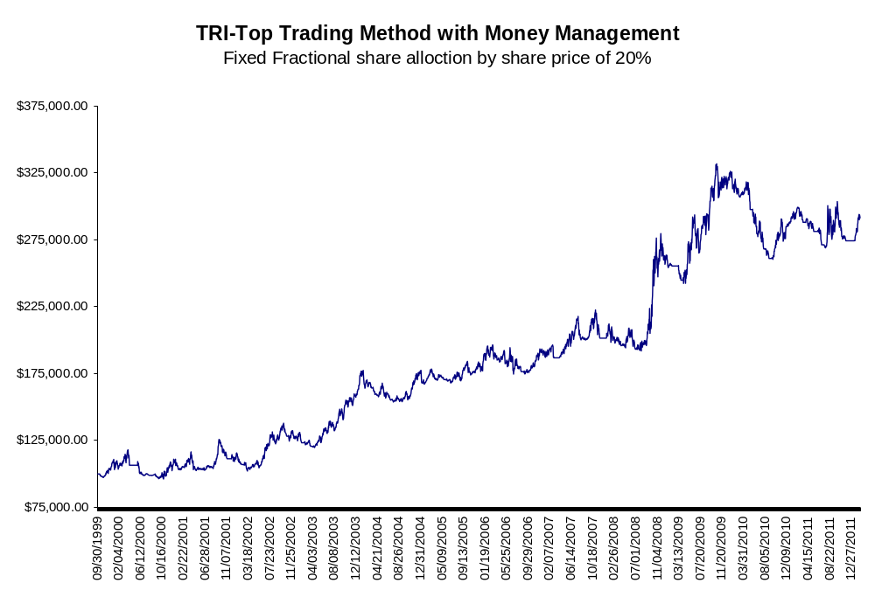

TRI-Top Trading Method (Stocks) with Money Management
Fixed fractional allocation by market value; 5% of portfolio per signal.

Summary
Total Return | $364,617.98
Total Realized Return | $321,060.71
Gross Profit | $932,010.12
Gross Loss | ($610,949.41)
Open Trade P/L | $43,557.27
Number of Trades | 942
Number of Winning Trades | 347
Number of Losing Trades | 595
% Profitable | 36.84%
Average Trade | $340.83
Average Trade (%) | 3.64%
Standard Deviation Trade | $2,891.53
Standard Deviation Trade (%) | 31.25%
Largest Winning Trade | $33,380.00
Largest Losing Trade | ($14,972.89)
Profit Factor | 1.53
Average Win / Average Loss | 2.62
Sharpe Ratio | 0.0933
K-Ratio | 0.1301
Return Retracement Ratio | 1.3864
Compounded Annual Return | 13.20%
Compounded Monthly Return | 1.02%
Average Annual Return | $26,044.14
Average Annual Return (%) | 12.55%
Average Monthly Return | $2,430.79
Average Monthly Return (%) | 1.13%
Percent Days Profitable | 52.94%
Percent Months Profitable | 59.33%
Percent Years Profitable | 85.71%
Commissions on Futures | $0.00
Commissions on Currencies | $0.00
Commissions on Equities | $18,980.00
Total Commissions | $18,980.00

Strategy Analysis
Total Return | $364,617.98
Total Realized Return | $321,060.71
Gross Profit | $932,010.12
Gross Loss | ($610,949.41)
Open Trade P/L | $43,557.27
Number of Trades | 942
Number of Symbols Traded | 24 out of 24
Average Trade | $340.83
Standard Deviation | $2,891.53
Average Trade (%) | 3.64%
Standard Deviation | 31.25%
Average Trade Length | 65.84 days
Winning Trades | $932,010.12
Number of Winning Trades | 347
Average Win | $2,685.91
Percent of Winning Trades | 36.84%
Maximum Consecutive Wins | 9
Largest Winning Trade | $33,380.00
Largest Winning Trade (%) | 419.35%
Average Winning Trade Length | 119.33 days
Losing Trades | ($610,949.41)
Number of Losing Trades | 595
Average Loss | ($1,026.81)
Percent of Losing Trades | 63.16%
Maximum Consecutive Losses | 15
Largest Losing Trade | ($14,972.89)
Largest Losing Trade (%) | -95.34%
Average Losing Trade Length | 34.65 days
Commissions on Futures | $0.00
Commissions on Currencies | $0.00
Commissions on Equities | $18,980.00
Total Commissions | $18,980.00

Trade Analysis
Runups
(by Amount)
Maximum | $39,000.00
Date | 11/11/2009
Average | $2,550.28
Standard Deviation | $3,873.26
(by Percent)
Maximum | 490.57%
Date | 11/11/2009
Average | 25.05%
Standard Deviation | 41.13%
Drawdowns
(by Amount)
Maximum | ($14,952.89)
Date | 4/2/2009
Average | ($941.18)
Standard Deviation | $1,056.30
(by Percent)
Maximum | -100.00%
Date | 2/12/2001
Average | -9.09%
Standard Deviation | 8.94%
Efficiency Analysis
Efficiency
Total
Average | -20.38%
Standard Deviation | 52.70%
Entry
Average | 57.92%
Standard Deviation | 31.51%
Exit
Average | 21.70%
Standard Deviation | 26.87%
Profit Factor | 1.53
Average Win/Average Loss | 2.62
Net Profit/Largest Loss | -21.44
Net Profit/Max Drawdown | 21.47

Statistical Analysis
t-Test | 112.838
Significance | Yes

Return Analysis
Annual Returns | Amount | Amount (%) | Percent of Fixed Capital
Average | $26,044.14 | 12.55% | 26.04%
Standard Deviation | $29,361.25 | 15.53% | 29.36%
Annualized Sharpe Ratio | 0.887

Monthly Returns
Average | $2,430.79 | 1.13% | 2.43%
Standard Deviation | $12,394.01 | 4.45% | 12.39%

Weekly Returns
Average | $563.55 | 0.27% | 0.56%
Standard Deviation | $7,454.40 | 2.45% | 7.45%
Sharpe Ratio | 0.0933
K-Ratio | 0.1301
Return Retracement Ratio | 1.3864

Daily Returns
Average | $117.05 | 0.06% | 0.12%
Standard Deviation | $3,355.03 | 1.11% | 3.36%
Best 12-month period | $166,957.44 | 64.01% | 166.96%
 | starting 10/1/2008 | starting 10/1/2008 | starting 10/1/2008
Worst 12-month period | ($45,411.77) | -22.53% | -45.41%
 | starting 10/1/2009 | starting 5/1/2000 | starting 10/1/2009

Equity Analysis

Equity Drawdown
Maximum | $78,895.43 | 31.79% | 78.90%
Maximum Drawdown Date | 6/17/2010 | 4/20/2001 | 6/17/2010
Average | $11,045.93 | 4.26% | 11.05%
Standard Deviation | $17,149.77 | 5.18% | 17.15%

Equity Runup
Maximum | $426,806.22 | 516.31% | 426.81%
Maximum Runup Date | 10/3/2011 | 10/3/2011 | 10/3/2011
Average | $47,738.59 | 57.07% | 47.74%
Standard Deviation | $133,422.37 | 161.57% | 133.42%
Average Time to Recovery | 24 days
Average Time Between Equity Peaks | 51 days
Longest Time Between Equity Peaks | 795 days
Percent Years Profitable | 85.71%
Percent Months Profitable | 59.33%
Percent Weeks Profitable | 56.72%
Percent Days Profitable | 52.94%
Compounded Annual Return | 13.20%
Compounded Monthly Return | 1.02%

Program Settings

Portfolio Name | Sample Portfolio 2
Created using | Portfolio Maestro 3.0.48.0
Base Currency | USD
Initial Capital | $100,000.00
Risk Free Rate | 0.50%
Sharpe Period | Weekly
Commissions | Stock - 10 per Trade
Slippage
Start Date | 10/1/1999 12:00:00 AM
End Date | 2/15/2012 11:59:59 PM
Strategy Group | New Strategy Group
Trading Symbols | [stocks]
 | AEG, ATPG, AMD, ACAS, AINV, BFR, BAC, BLC, BSX, BYD, CELL, CX, COT, DX, EXFO, CETV, HHS, INAP, KEM, KKD, MIL, MRGE, SONC
Ranking | None
Strategy | TRI System
Money Management | Fixed Fractional by Market Value
Inputs | Maximum Contracts=5000
 | Percent Risk=0.05

Equity Curve
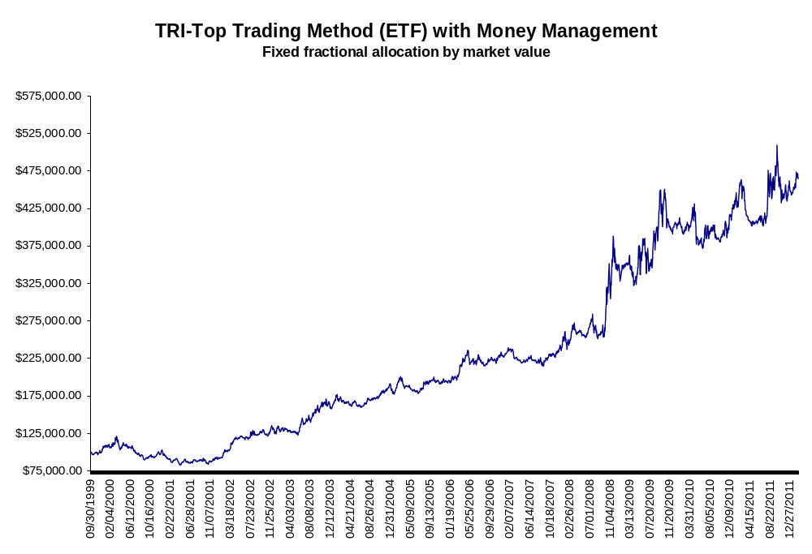

Risk Disclaimers
If you cannot abide by the following disclaimers and are unwilling to accept full responsibility for your actions, please do not trade.

This document is designed as a big picture analysis of the TREX trading system. Please be advised that there is no one perfect portfolio or set of parameters. This is a robust methodology designed to give traders another tool in their trading toolbox. It is not a guarantee of performance.

Data presented was generated with TradeStation’s Portfolio Maestro software using default settings. Users can customize parameters including risk controls to their own tolerances.

All questions: info@trendfollowing.com.

Additional Risk Disclaimers

FUTURES AND OR STOCK TRADING CAN INVOLVE HIGH RISKS WITH THE POTENTIAL FOR SUBSTANTIAL LOSSES. HOWEVER, YOU CAN ALSO PRODUCE LARGE WINNINGS AS WELL.

HYPOTHETICAL OR SIMULATED PERFORMANCE RESULTS HAVE CERTAIN INHERENT LIMITATIONS. UNLIKE AN ACTUAL PERFORMANCE RECORD, SIMULATED RESULTS DO NOT REPRESENT ACTUAL TRADING. ALSO, SINCE THE TRADES HAVE NOT ACTUALLY BEEN EXECUTED, THE RESULTS MAY HAVE UNDER OR OVER-COMPENSATED FOR THE IMPACT, IF ANY, OF CERTAIN MARKET FACTORS, SUCH AS LACK OF LIQUIDITY. SIMULATED TRADING PROGRAMS IN GENERAL ARE ALSO SUBJECT TO THE FACT THAT THEY ARE DESIGNED WITH THE BENEFIT OF HINDSIGHT. NO REPRESENTATION IS BEING MADE THAT ANY ACCOUNT WILL OR IS LIKELY TO ACHIEVE THE PROFITS OR LOSSES SIMILAR TO THOSE SHOWN.

Our firm cannot promise you will earn like returns of traders, charts or examples (real or hypothetical) mentioned. All past performance is not necessarily an indication of future results. Data presented is for educational purposes. This information is not an invitation for investment. We assume all data to be accurate, but assume no responsibility for errors, omissions or clerical errors made.

