Tyrannosaurus

Trend Following Trading System Tests
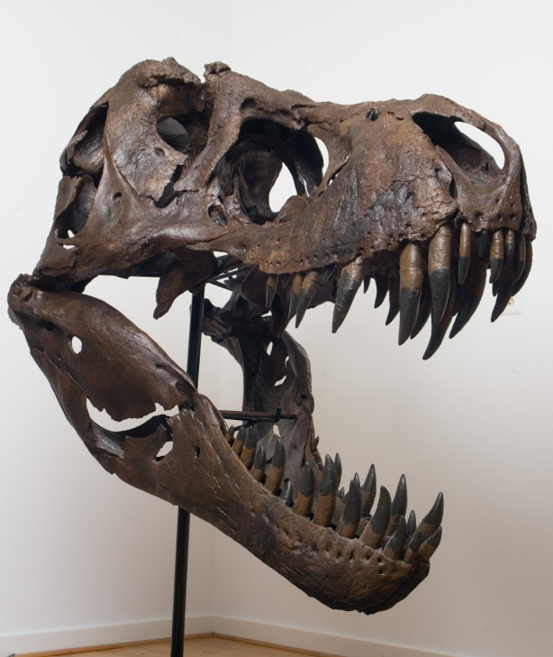

Risk Disclaimers
If you cannot abide by the following disclaimers and are unwilling to accept full responsibility for your actions, please do not trade.

This document is designed as a big picture analysis of the TREX trading system. Please be advised that there is no one perfect portfolio or set of parameters. This is a robust methodology designed to give traders another tool in their trading toolbox. It is not a guarantee of performance.

Data presented was generated with TradeStation’s Portfolio Maestro software using default settings. Users can customize parameters including risk controls to their own tolerances.

All questions: info@trendfollowing.com.

Additional Risk Disclaimers

FUTURES AND OR STOCK TRADING CAN INVOLVE HIGH RISKS WITH THE POTENTIAL FOR SUBSTANTIAL LOSSES. HOWEVER, YOU CAN ALSO PRODUCE LARGE WINNINGS AS WELL.

HYPOTHETICAL OR SIMULATED PERFORMANCE RESULTS HAVE CERTAIN INHERENT LIMITATIONS. UNLIKE AN ACTUAL PERFORMANCE RECORD, SIMULATED RESULTS DO NOT REPRESENT ACTUAL TRADING. ALSO, SINCE THE TRADES HAVE NOT ACTUALLY BEEN EXECUTED, THE RESULTS MAY HAVE UNDER OR OVER-COMPENSATED FOR THE IMPACT, IF ANY, OF CERTAIN MARKET FACTORS, SUCH AS LACK OF LIQUIDITY. SIMULATED TRADING PROGRAMS IN GENERAL ARE ALSO SUBJECT TO THE FACT THAT THEY ARE DESIGNED WITH THE BENEFIT OF HINDSIGHT. NO REPRESENTATION IS BEING MADE THAT ANY ACCOUNT WILL OR IS LIKELY TO ACHIEVE THE PROFITS OR LOSSES SIMILAR TO THOSE SHOWN.

Our firm cannot promise you will earn like returns of traders, charts or examples (real or hypothetical) mentioned. All past performance is not necessarily an indication of future results. Data presented is for educational purposes. This information is not an invitation for investment. We assume all data to be accurate, but assume no responsibility for errors, omissions or clerical errors made.

Example #1 TREX Trading Method with No Money Management 5
Summary 5
Strategy Analysis 6
Trade Analysis 7
Statistical Analysis 7
Return Analysis 8
Annual Returns 8
Monthly Returns 8
Daily Returns 8
Equity Analysis 8
Equity Drawdown 8
Equity Run-up 8
Program Settings 9
Equity Curve 10
Example #2 TREX Trading System with Money Management 11
Summary 11
Strategy Analysis 13
Trade Analysis 14
Statistical Analysis 14
Return Analysis 15
Annual Returns 15
Monthly Returns 15
Weekly Returns 15
Equity Analysis 15
Equity Drawdown 15
Equity Run-up 15
Program Settings 16
Equity Curve 17
Example #3 TREX Trading Method with Money Management 18
Summary 18
Strategy Analysis 20
Trade Analysis 21
Statistical Analysis 21
Return Analysis 22
Annual Returns 22
Monthly Returns 22
Weekly Returns 22
Daily Returns 22
Equity Analysis 22
Equity Drawdown 22
Equity Run-up 22
Program Settings 23
Equity Curve 24
Risk Disclaimer 24

Example #1 TREX Trading Method with No Money Management
One contract per trading signal.

Summary
Total Return | $790,095.40
Total Realized Return | $773,129.78
Gross Profit | $2,245,907.54
Gross Loss | ($1,472,777.76)
Open Trade P/L | $16,965.63
Number of Trades | 1648
Number of Winning Trades | 714
Number of Losing Trades | 930
% Profitable | 43.33%
Average Trade | $469.13
Average Trade (%) | 1.19%
Standard Deviation Trade | $3,772.73
Standard Deviation Trade (%) | 18.62%
Largest Winning Trade | $47,070.00
Largest Losing Trade | ($13,720.00)
Profit Factor | 1.52
Average Win / Average Loss | 1.99
Sharpe Ratio | 0.0911
K-Ratio | 0.1076
Return Retracement Ratio | 2.1983
Compounded Annual Return | 10.25%
Compounded Monthly Return | 0.81%
Average Annual Return | $32,920.64
Average Annual Return (%) | 10.35%
Average Monthly Return | $2,926.28
Average Monthly Return (%) | 0.87%
Percent Days Profitable | 52.92%
Percent Months Profitable | 56.67%
Percent Years Profitable | 79.17%
Commissions on Futures | $82,550.00
Commissions on Currencies | $0.00
Commissions on Equities | $0.00
Total Commissions | $82,550.00

Strategy Analysis
Total Return | $790,095.40
Total Realized Return | $773,129.78
Gross Profit | $2,245,907.54
Gross Loss | ($1,472,777.76)
Open Trade P/L | $16,965.63
Number of Trades | 1648
Number of Symbols Traded | 19 out of 19
Average Trade | $469.13
Standard Deviation | $3,772.73
Average Trade (%) | 1.19%
Standard Deviation | 18.62%
Average Trade Length | 36.92 days
Winning Trades | $2,245,907.54
Number of Winning Trades | 714
Average Win | $3,145.53
Percent of Winning Trades | 43.33%
Maximum Consecutive Wins | 10
Largest Winning Trade | $47,070.00
Largest Winning Trade (%) | 540.06%
Average Winning Trade Length | 55.93 days
Losing Trades | ($1,472,777.76)
Number of Losing Trades | 930
Average Loss | ($1,583.63)
Percent of Losing Trades | 56.43%
Maximum Consecutive Losses | 12
Largest Losing Trade | ($13,720.00)
Largest Losing Trade (%) | -212.02%
Average Losing Trade Length | 22.48 days
Commissions on Futures | $82,550.00
Commissions on Currencies | $0.00
Commissions on Equities | $0.00
Total Commissions | $82,550.00

Trade Analysis
Run-ups
(by Amount)
Maximum | $72,300.00
Date | 2/25/2003
Average | $3,249.03
Standard Deviation | $4,957.33
(by Percent)
Maximum | 617.24%
Date | 8/2/1991
Average | 5.68%
Standard Deviation | 26.60%
Drawdowns
(by Amount)
Maximum | ($13,670.00)
Date | 9/22/2011
Average | ($1,253.99)
Standard Deviation | $1,409.94
(by Percent)
Maximum | -76.47%
Date | 2/18/1992
Average | -1.79%
Standard Deviation | 15.17%
Efficiency Analysis
Efficiency
Total
Average | -15.30%
Standard Deviation | 56.88%
Entry
Average | 58.64%
Standard Deviation | 33.53%
Exit
Average | 26.06%
Standard Deviation | 27.96%
Profit Factor | 1.52
Average Win/Average Loss | 1.99
Net Profit/Largest Loss | -56.35
Net Profit/Max Drawdown | 56.56

Statistical Analysis
t-Test | 69.867
Significance | Yes

Return Analysis
Annual Returns | Amount | Amount (%) | Percent of Fixed Capital
Average | $32,920.64 | 10.35% | 32.92%
Standard Deviation | $54,948.61 | 14.68% | 54.95%
Annualized Sharpe Ratio | 0.5991

Monthly Returns
Average | $2,926.28 | 0.87% | 2.93%
Standard Deviation | $13,442.52 | 3.46% | 13.44%
Weekly Returns
Average | $675.87 | 0.20% | 0.68%
Standard Deviation | $6,983.07 | 1.63% | 6.98%
Sharpe Ratio | 0.0911
K-Ratio | 0.1076
Return Retracement Ratio | 2.1983

Daily Returns
Average | $138.59 | 0.04% | 0.14%
Standard Deviation | $3,105.00 | 0.74% | 3.11%
Best 12-month period | $247,324.55 | 67.64% | 247.32%
 | starting 1/2/2008 | starting 11/1/1989 | starting 1/2/2008
Worst 12-month period | ($62,314.03) | -6.48% | -62.31%
 | starting 11/1/2010 | starting 11/1/2010 | starting 11/1/2010

Equity Analysis

Equity Drawdown
Maximum | $96,740.21 | 18.83% | 96.74%
Maximum Drawdown Date | 2/10/2012 | 5/28/1992 | 2/10/2012
Average | $5,692.38 | 1.46% | 5.69%
Standard Deviation | $11,372.36 | 2.54% | 11.37%

Equity Run-up
Maximum | $887,785.14 | 925.54% | 887.79%
Maximum Run-up Date | 11/9/2010 | 11/9/2010 | 11/9/2010
Average | $99,013.07 | 103.21% | 99.01%
Standard Deviation | $295,790.22 | 308.37% | 295.79%
Average Time to Recovery | 11 days
Average Time Between Equity Peaks | 22 days
Longest Time Between Equity Peaks | 570 days
Percent Years Profitable | 79.17%
Percent Months Profitable | 56.67%
Percent Weeks Profitable | 53.29%
Percent Days Profitable | 52.92%
Compounded Annual Return | 10.25%
Compounded Monthly Return | 0.81%

Program Settings

Portfolio Name | Sample Portfolio 2
Created using | Portfolio Maestro 3.0.48.0
Base Currency | USD
Initial Capital | $100,000.00
Risk Free Rate | 2.00%
Sharpe Period | Weekly
Commissions | Future - 25 per Contract
Slippage
Start Date | 10/1/1989 12:00:00 AM
End Date | 2/15/2012 11:59:59 PM
Strategy Group | TREX
Trading Symbols | [Futures]
@C.C,@CL.C,@CT,@DX,@FC.P,@FV.P,@GC.C,@JY.C,@NG.C,@S.C
@SB, @TY.P, @EC.C, @SF.C, @W.C, @US.P, @BP.C, @KW, @LH.C
Ranking | None
Strategy | TREX
Max Bars Study References | 50

Equity Curve
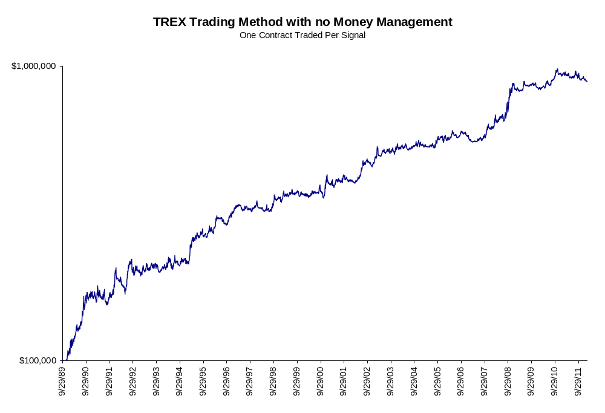

Example #2 TREX Trading System with Money Management
Fixed fractional contract allocation set to 1% risk per trade based on 20 day ATR value.

Summary
Total Return | $14,815,764.00
Total Realized Return | $13,570,014.03
Gross Profit | $48,581,407.33
Gross Loss | ($35,011,393.29)
Open Trade P/L | $1,245,749.97
Number of Trades | 1648
Number of Winning Trades | 714
Number of Losing Trades | 930
% Profitable | 43.33%
Average Trade | $8,234.23
Average Trade (%) | 1.19%
Standard Deviation Trade | $116,117.51
Standard Deviation Trade (%) | 18.62%
Largest Winning Trade | $1,979,751.13
Largest Losing Trade | ($1,268,930.45)
Profit Factor | 1.39
Average Win / Average Loss | 1.81
Sharpe Ratio | 0.1101
K-Ratio | 0.0458
Return Retracement Ratio | 2.0962
Compounded Annual Return | 25.04%
Compounded Monthly Return | 1.85%
Average Annual Return | $617,323.50
Average Annual Return (%) | 26.32%
Average Monthly Return | $54,873.20
Average Monthly Return (%) | 2.13%
Percent Days Profitable | 53.53%
Percent Months Profitable | 54.44%
Percent Years Profitable | 79.17%
Commissions on Futures | $2,113,654.87
Commissions on Currencies | $0.00
Commissions on Equities | $0.00
Total Commissions | $2,113,654.87

Strategy Analysis
Total Return | $14,815,764.00
Total Realized Return | $13,570,014.03
Gross Profit | $48,581,407.33
Gross Loss | ($35,011,393.29)
Open Trade P/L | $1,245,749.97
Number of Trades | 1648
Number of Symbols Traded | 19 out of 19
Average Trade | $8,234.23
Standard Deviation | $116,117.51
Average Trade (%) | 1.19%
Standard Deviation | 18.62%
Average Trade Length | 36.92 days
Winning Trades | $48,581,407.33
Number of Winning Trades | 714
Average Win | $68,041.19
Percent of Winning Trades | 43.33%
Maximum Consecutive Wins | 10
Largest Winning Trade | $1,979,751.13
Largest Winning Trade (%) | 540.06%
Average Winning Trade Length | 55.93 days
Losing Trades | ($35,011,393.29)
Number of Losing Trades | 930
Average Loss | ($37,646.66)
Percent of Losing Trades | 56.43%
Maximum Consecutive Losses | 12
Largest Losing Trade | ($1,268,930.45)
Largest Losing Trade (%) | -212.02%
Average Losing Trade Length | 22.48 days
Commissions on Futures | $2,113,654.87
Commissions on Currencies | $0.00
Commissions on Equities | $0.00
Total Commissions | $2,113,654.87

Trade Analysis
Run-ups
(by Amount)
Maximum | $3,170,390.00
Date | 11/10/2010
Average | $72,427.92
Standard Deviation | $158,231.88
(by Percent)
Maximum | 617.24%
Date | 8/2/1991
Average | 5.68%
Standard Deviation | 26.60%
Drawdowns
(by Amount)
Maximum | ($1,249,218.75)
Date | 11/15/2010
Average | ($28,575.86)
Standard Deviation | $54,120.88
(by Percent)
Maximum | -76.47%
Date | 2/18/1992
Average | -1.79%
Standard Deviation | 15.17%
Efficiency Analysis
Efficiency
Total
Average | -15.30%
Standard Deviation | 56.88%
Entry
Average | 58.64%
Standard Deviation | 33.53%
Exit
Average | 26.06%
Standard Deviation | 27.96%
Profit Factor | 1.39
Average Win/Average Loss | 1.81
Net Profit/Largest Loss | -10.69
Net Profit/Max Drawdown | 10.86

Statistical Analysis
t-Test | 599.573
Significance | Yes

Return Analysis
Annual Returns | Amount | Amount (%) | Percent of Fixed Capital
Average | $617,323.50 | 26.32% | 617.32%
Standard Deviation | $1,530,950.74 | 30.40% | 1,530.95%
Annualized Sharpe Ratio | 0.4032

Monthly Returns
Average | $54,873.20 | 2.13% | 54.87%
Standard Deviation | $418,589.86 | 7.43% | 418.59%

Weekly Returns
Average | $12,673.88 | 0.49% | 12.67%
Standard Deviation | $220,628.18 | 3.55% | 220.63%
Sharpe Ratio | 0.1101
K-Ratio | 0.0458
Return Retracement Ratio | 2.0962
Daily Returns
Average | $2,598.80 | 0.10% | 2.60%
Standard Deviation | $97,882.17 | 1.59% | 97.88%
Best 12-month period | $7,744,236.55 | 109.64% | 7,744.24%
 | starting 11/2/2009 | starting 3/1/2002 | starting 11/2/2009
Worst 12-month period | ($3,007,624.86) | -20.33% | -3,007.62%
 | starting 11/1/2010 | starting 9/1/2006 | starting 11/1/2010

Equity Analysis

Equity Drawdown
Maximum | $5,834,736.56 | 30.60% | 5,834.74%
Maximum Drawdown Date | 4/20/2011 | 8/16/2007 | 4/20/2011
Average | $104,114.77 | 2.94% | 104.11%
Standard Deviation | $373,871.56 | 5.02% | 373.87%

Equity Run-up
Maximum | $19,235,517.13 | 20,171.80% | 19,235.52%
Maximum Run-up Date | 11/9/2010 | 11/9/2010 | 11/9/2010
Average | $2,137,829.13 | 2,241.87% | 2,137.83%
Standard Deviation | $6,411,633.05 | 6,723.72% | 6,411.63%
Average Time to Recovery | 8 days
Average Time Between Equity Peaks | 18 days
Longest Time Between Equity Peaks | 528 days
Percent Years Profitable | 79.17%
Percent Months Profitable | 54.44%
Percent Weeks Profitable | 55.86%
Percent Days Profitable | 53.53%
Compounded Annual Return | 25.04%
Compounded Monthly Return | 1.85%

Program Settings

Portfolio Name | Sample Portfolio 2
Created using | Portfolio Maestro 3.0.48.0
Base Currency | USD
Initial Capital | $100,000.00
Risk Free Rate | 2.00%
Sharpe Period | Weekly
Commissions | Future - 25 per Contract
Slippage
Start Date | 10/1/1989 12:00:00 AM
End Date | 2/15/2012 11:59:59 PM
Strategy Group | TREX
Trading Symbols | [Futures]
@C.C,@CL.C,@CT,@DX,@FC.P,@FV.P,@GC.C,@JY.C,@NG.C,@S.C
@SB, @TY.P, @EC.C, @SF.C, @W.C, @US.P, @BP.C, @KW, @LH.C
Ranking | None
Strategy | TREX
Max Bars Study References | 50
Money Management | Fixed Fractional with ATR Risk
Inputs | ATR Lookback=20
 | ATR Multiplier=2
 | Maximum Contracts=50000
 | Percent Risk=0.01

Equity Curve
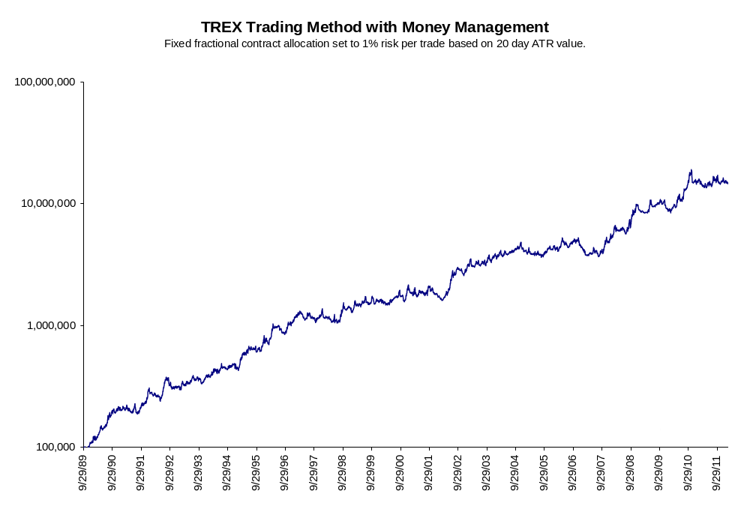

Example #3 TREX Trading Method with Money Management
Fixed fractional contract allocation set to 2% risk per trade based on 20 day ATR value.

Summary | Value
Total Return | $609,231,011.12
Total Realized Return | $507,399,290.53
Gross Profit | $2,488,142,253.21
Gross Loss | ($1,980,742,962.68)
Open Trade P/L | $101,831,720.60
Number of Trades | 1648
Number of Winning Trades | 714
Number of Losing Trades | 930
% Profitable | 43.33%
Average Trade | $307,887.92
Average Trade (%) | 1.19%
Standard Deviation Trade | $8,727,408.12
Standard Deviation Trade (%) | 18.62%
Largest Winning Trade | $162,694,459.56
Largest Losing Trade | ($134,348,015.80)
Profit Factor | 1.26
Average Win / Average Loss | 1.64
Sharpe Ratio | 0.1042
K-Ratio | 0.0288
Return Retracement Ratio | 2.0692
Compounded Annual Return | 47.57%
Compounded Monthly Return | 3.25%
Average Annual Return | $25,384,625.46
Average Annual Return (%) | 57.41%
Average Monthly Return | $2,256,411.15
Average Monthly Return (%) | 4.26%
Percent Days Profitable | 53.52%
Percent Months Profitable | 54.07%
Percent Years Profitable | 75.00%
Commissions on Futures | $97,789,716.95
Commissions on Currencies | $0.00
Commissions on Equities | $0.00
Total Commissions | $97,789,716.95

Strategy Analysis
Total Return | $609,231,011.12
Total Realized Return | $507,399,290.53
Gross Profit | $2,488,142,253.21
Gross Loss | ($1,980,742,962.68)
Open Trade P/L | $101,831,720.60
Number of Trades | 1648
Number of Symbols Traded | 19 out of 19
Average Trade | $307,887.92
Standard Deviation | $8,727,408.12
Average Trade (%) | 1.19%
Standard Deviation | 18.62%
Average Trade Length | 36.92 days
Winning Trades | $2,488,142,253.21
Number of Winning Trades | 714
Average Win | $3,484,793.07
Percent of Winning Trades | 43.33%
Maximum Consecutive Wins | 10
Largest Winning Trade | $162,694,459.56
Largest Winning Trade (%) | 540.06%
Average Winning Trade Length | 55.93 days
Losing Trades | ($1,980,742,962.68)
Number of Losing Trades | 930
Average Loss | ($2,129,831.14)
Percent of Losing Trades | 56.43%
Maximum Consecutive Losses | 12
Largest Losing Trade | ($134,348,015.80)
Largest Losing Trade (%) | -212.02%
Average Losing Trade Length | 22.48 days
Commissions on Futures | $97,789,716.95
Commissions on Currencies | $0.00
Commissions on Equities | $0.00
Total Commissions | $97,789,716.95

Trade Analysis
Run-ups
(by Amount)
Maximum | $261,335,985.00
Date | 11/10/2010
Average | $3,799,358.16
Standard Deviation | $11,930,158.41
(by Percent)
Maximum | 617.24%
Date | 8/2/1991
Average | 5.68%
Standard Deviation | 26.60%
Drawdowns
(by Amount)
Maximum | ($132,179,531.25)
Date | 11/15/2010
Average | ($1,587,763.52)
Standard Deviation | $4,942,517.62
(by Percent)
Maximum | -76.47%
Date | 2/18/1992
Average | -1.79%
Standard Deviation | 15.17%
Efficiency Analysis
Efficiency
Total
Average | -15.30%
Standard Deviation | 56.88%
Entry
Average | 58.64%
Standard Deviation | 33.53%
Exit
Average | 26.06%
Standard Deviation | 27.96%
Profit Factor | 1.26
Average Win/Average Loss | 1.64
Net Profit/Largest Loss | -3.78
Net Profit/Max Drawdown | 3.84

Statistical Analysis
t-Test | 2985.954
Significance | Yes

Return Analysis
Annual Returns | Amount | Amount (%) | Percent of Fixed Capital
Average | $25,384,625.46 | 57.41% | 25,384.63%
Standard Deviation | $88,700,593.37 | 75.64% | 88,700.59%
Annualized Sharpe Ratio | 0.2862

Monthly Returns
Average | $2,256,411.15 | 4.26% | 2,256.41%
Standard Deviation | $32,206,771.00 | 14.63% | 32,206.77%

Weekly Returns
Average | $521,155.70 | 0.98% | 521.16%
Standard Deviation | $16,774,110.35 | 6.82% | 16,774.11%
Sharpe Ratio | 0.1042
K-Ratio | 0.0288
Return Retracement Ratio | 2.0692

Daily Returns
Average | $106,863.89 | 0.20% | 106.86%
Standard Deviation | $7,290,305.82 | 3.04% | 7,290.31%
Best 12-month period | $576,334,420.47 | 264.37% | 576,334.42%
 | starting 11/2/2009 | starting 1/2/2008 | starting 11/2/2009
Worst 12-month period | ($328,852,373.07) | -39.60% | -328,852.37%
 | starting 11/1/2010 | starting 9/1/2006 | starting 11/1/2010

Equity Analysis

Equity Drawdown
Maximum | $548,702,475.30 | 54.66% | 548,702.48%
Maximum Drawdown Date | 4/20/2011 | 8/16/2007 | 4/20/2011
Average | $5,585,825.53 | 5.32% | 5,585.83%
Standard Deviation | $30,626,342.52 | 8.93% | 30,626.34%

Equity Run-up
Maximum | $1,055,410,651.47 | 1,134,125.23% | 1,055,410.65%
Maximum Run-up Date | 11/5/2010 | 11/5/2010 | 11/5/2010
Average | $117,268,948.11 | 126,015.05% | 117,268.95%
Standard Deviation | $351,803,138.76 | 378,041.32% | 351,803.14%
Average Time to Recovery | 8 days
Average Time Between Equity Peaks | 18 days
Longest Time Between Equity Peaks | 528 days
Percent Years Profitable | 75.00%
Percent Months Profitable | 54.07%
Percent Weeks Profitable | 56.03%
Percent Days Profitable | 53.52%
Compounded Annual Return | 47.57%
Compounded Monthly Return | 3.25%

Program Settings

Portfolio Name | Sample Portfolio 2
Created using | Portfolio Maestro 3.0.48.0
Base Currency | USD
Initial Capital | $100,000.00
Risk Free Rate | 2.00%
Sharpe Period | Weekly
Commissions | Future - 25 per Contract
Slippage
Start Date | 10/1/1989 12:00:00 AM
End Date | 2/15/2012 11:59:59 PM
Strategy Group | TREX
Trading Symbols | [Futures]
@C.C,@CL.C,@CT,@DX,@FC.P,@FV.P,@GC.C,@JY.C,@NG.C,@S.C
@SB, @TY.P, @EC.C, @SF.C, @W.C, @US.P, @BP.C, @KW, @LH.C
Ranking | None
Strategy | TREX
Max Bars Study References | 50
Money Management | Fixed Fractional with ATR Risk
Inputs | ATR Lookback=20
 | ATR Multiplier=2
 | Maximum Contracts=50000
 | Percent Risk=0.02

Equity Curve
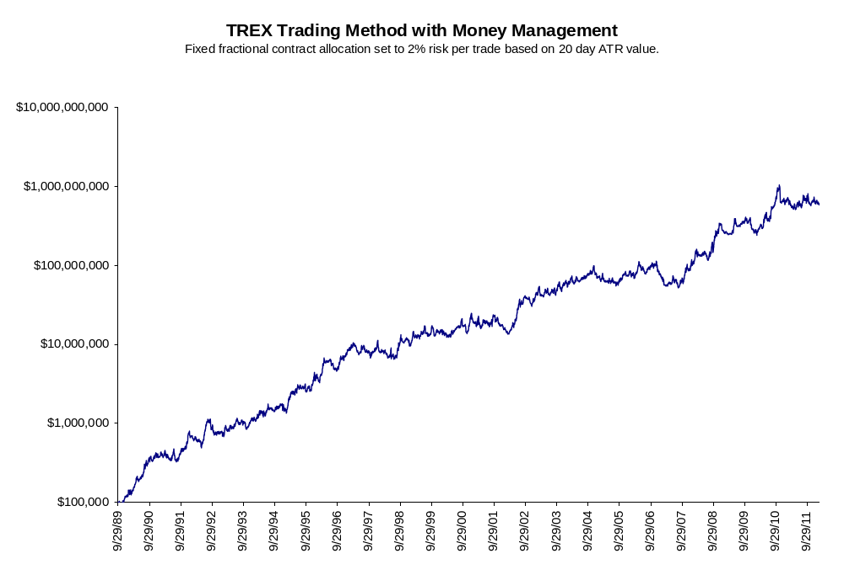

Risk Disclaimers
If you cannot abide by the following disclaimers and are unwilling to accept full responsibility for your actions, please do not trade.

This document is designed as a big picture analysis of the TREX trading system. Please be advised that there is no one perfect portfolio or set of parameters. This is a robust methodology designed to give traders another tool in their trading toolbox. It is not a guarantee of performance.

Data presented was generated with TradeStation’s Portfolio Maestro software using default settings. Users can customize parameters including risk controls to their own tolerances.

All questions: info@trendfollowing.com.

Additional Risk Disclaimers

FUTURES AND OR STOCK TRADING CAN INVOLVE HIGH RISKS WITH THE POTENTIAL FOR SUBSTANTIAL LOSSES. HOWEVER, YOU CAN ALSO PRODUCE LARGE WINNINGS AS WELL.

HYPOTHETICAL OR SIMULATED PERFORMANCE RESULTS HAVE CERTAIN INHERENT LIMITATIONS. UNLIKE AN ACTUAL PERFORMANCE RECORD, SIMULATED RESULTS DO NOT REPRESENT ACTUAL TRADING. ALSO, SINCE THE TRADES HAVE NOT ACTUALLY BEEN EXECUTED, THE RESULTS MAY HAVE UNDER OR OVER-COMPENSATED FOR THE IMPACT, IF ANY, OF CERTAIN MARKET FACTORS, SUCH AS LACK OF LIQUIDITY. SIMULATED TRADING PROGRAMS IN GENERAL ARE ALSO SUBJECT TO THE FACT THAT THEY ARE DESIGNED WITH THE BENEFIT OF HINDSIGHT. NO REPRESENTATION IS BEING MADE THAT ANY ACCOUNT WILL OR IS LIKELY TO ACHIEVE THE PROFITS OR LOSSES SIMILAR TO THOSE SHOWN.

Our firm cannot promise you will earn like returns of traders, charts or examples (real or hypothetical) mentioned. All past performance is not necessarily an indication of future results. Data presented is for educational purposes. This information is not an invitation for investment. We assume all data to be accurate, but assume no responsibility for errors, omissions or clerical errors made.

