Triceratops
Trend Following Trading System


The Triceratops Trend Following Trading System is designed to help traders quickly spot and identify changes in trend direction—in a unique and proprietary manner. It is useful for traders who need to quickly screen multiple instruments to determine trend direction in the context of a trend following system. All logic is fully disclosed.

Operationally, the system will change to either blue or red to signal trend direction. Blue bars indicate the likelihood of an uptrend, while red bars indicate the likelihood of a downtrend. Each user can change bar color to colors more suited for their eye.

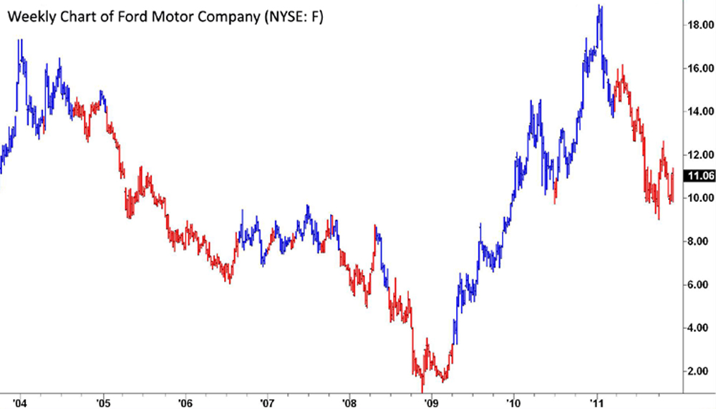
Weekly chart of Ford Motor Company

Blue bars indicate a potential up trend & red bars indicate a potential down trend.

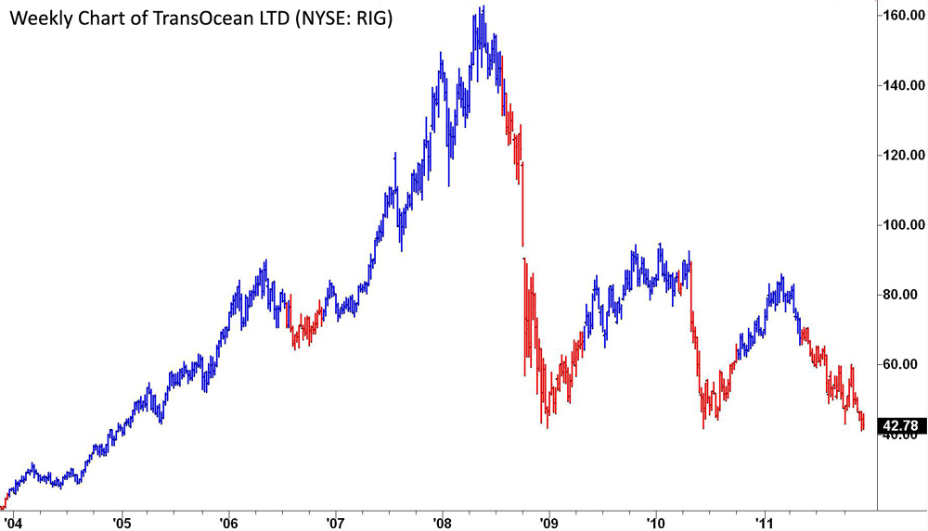
Weekly Chart of TransOcean LTD

Traders with limited investment options, or those who need to trade in a long only environment (401K plans, retirement plans, etc.) will see a major benefit as the system indicates exits for long term holdings. Instead of being forced into buy and hold, you can identify potential change in trends of ETFs, mutual funds and long only equity positions.

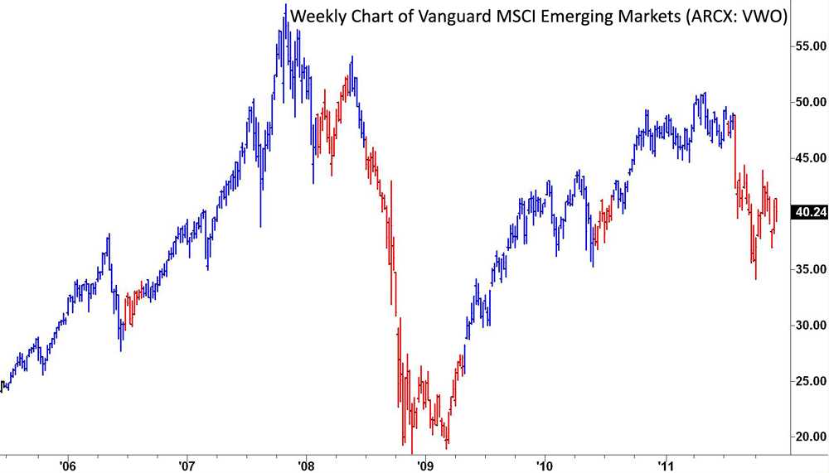
Weekly chart of Vanguard MSCI Emerging Markets mutual fund

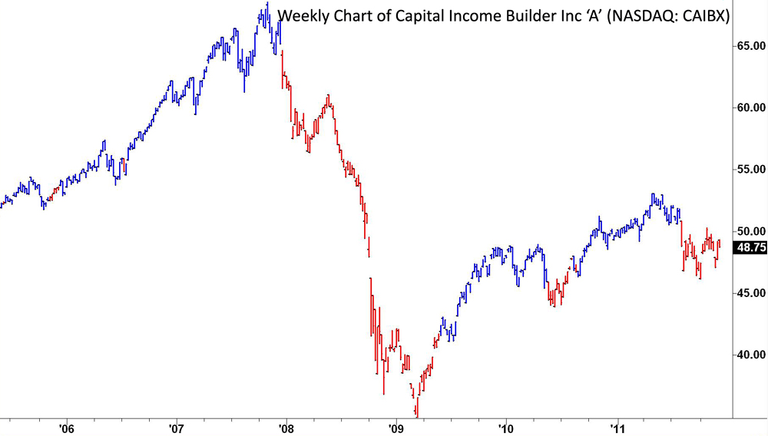
Weekly chart of Capital Income Builder ‘A’ mutual fund

The system utilizes a weekly bar giving a long-term trend change indication for each market tracked. You will receive TradeStation® code and all logic. Each trader can customize and adjust all system parameters to their individual preferences.

Equity examples:

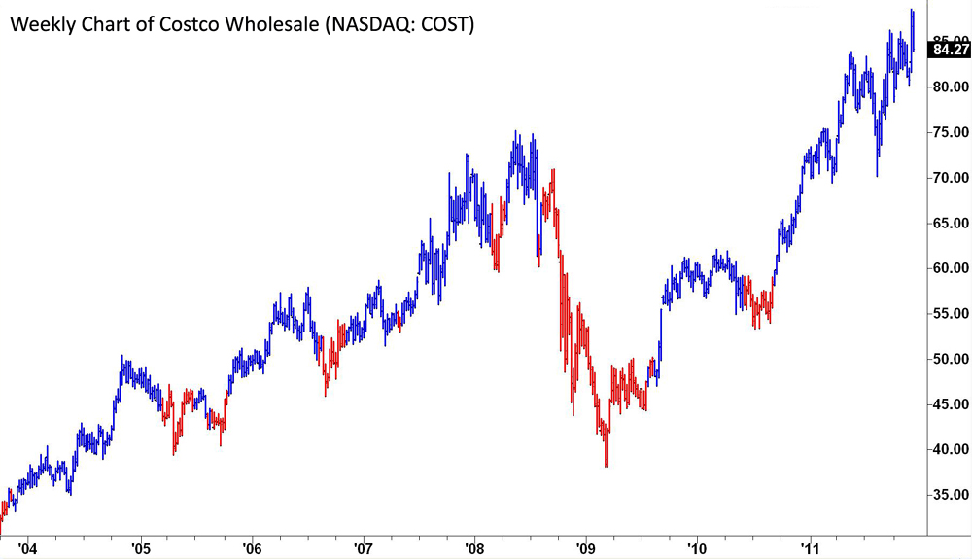

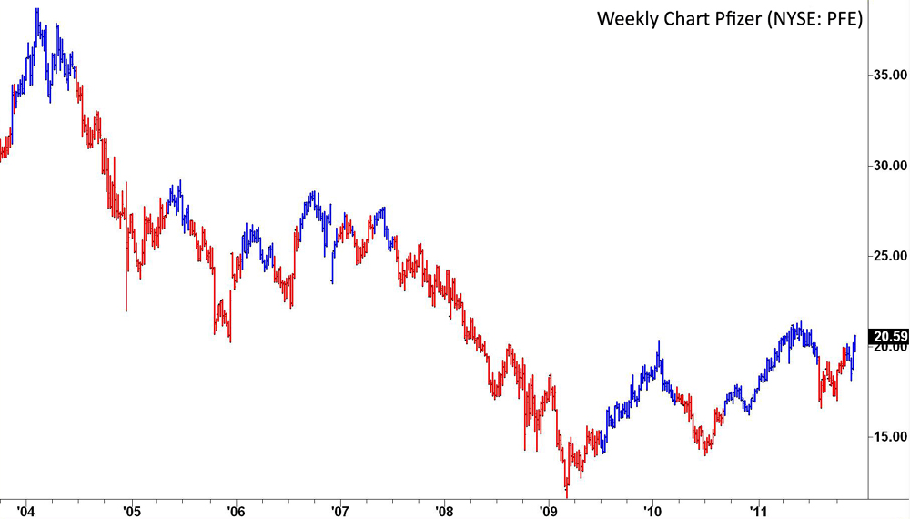

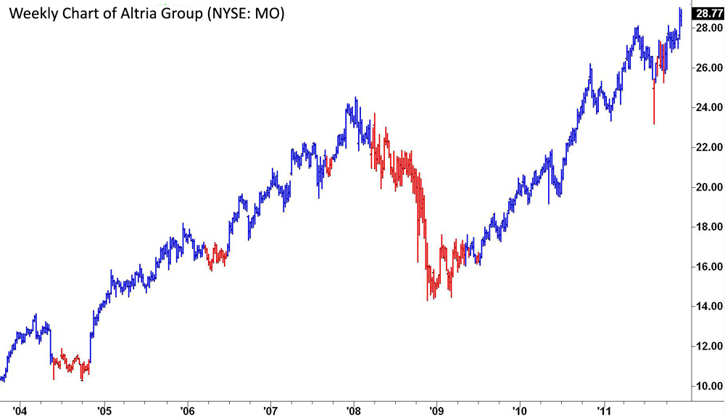

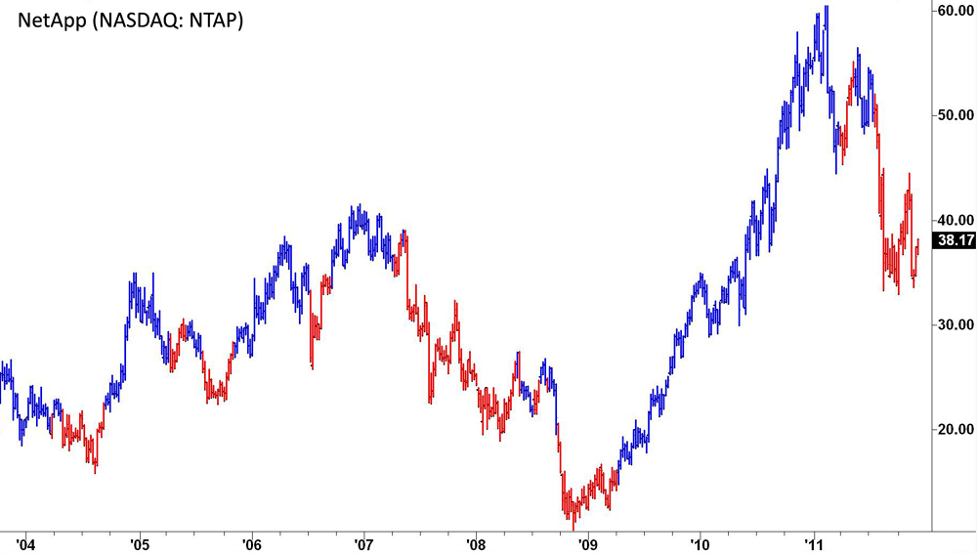

ETF examples:
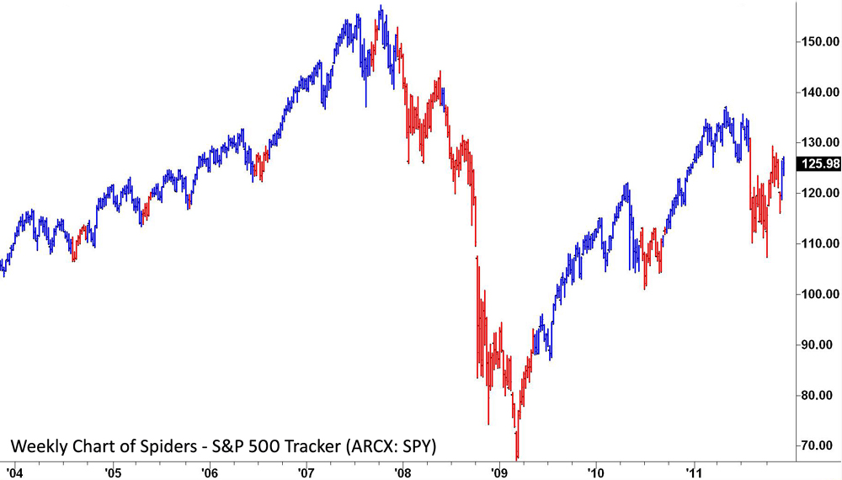

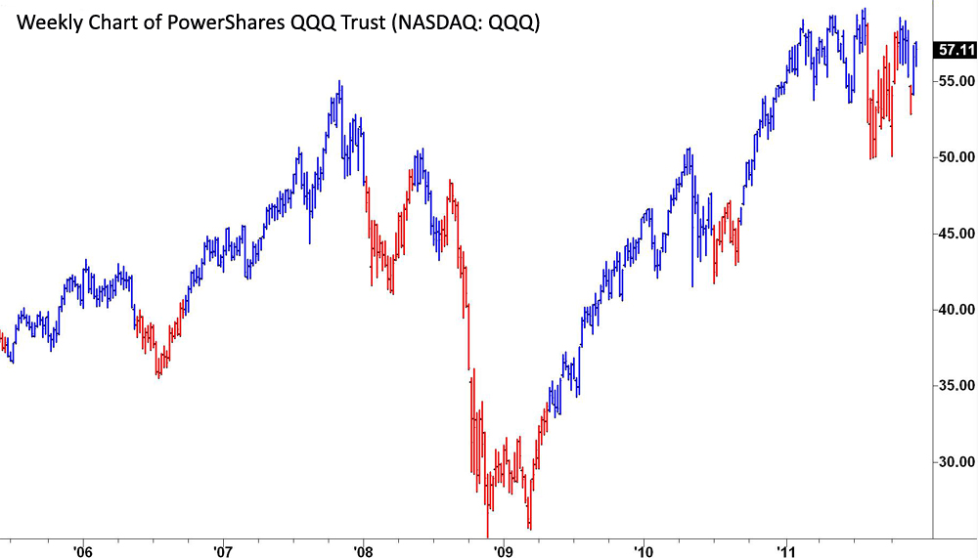

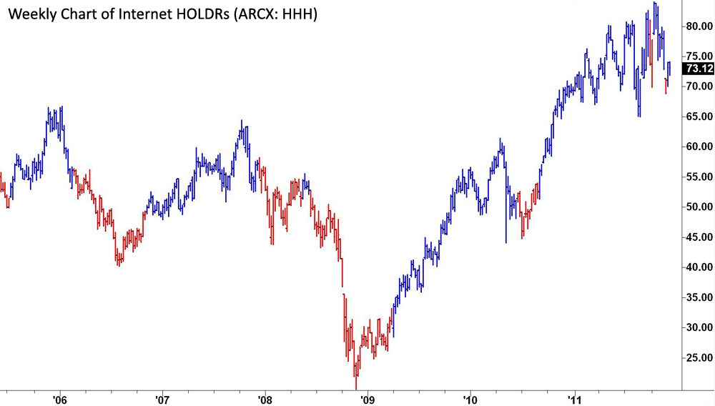

If you have additional questions do not hesitate to reach out:

info@trendfollowing.com

