HANOI UNIVERSITY OF SCIENCE AND TECHNOLOGY
SCHOOL OF INFORMATION AND COMMUNICATION TECHNOLOGY

GRADUATION RESEARCH REPORT (GR1)
Topic: Design and Development of a Web-Based Fitness Platform for Beginner Gym Users
Project Code Name: FiFB (Fitness for Beginners)

NGÔ ĐỨC HUY
Huy.nd235946@sis.hust.edu.vn
Program: Global ICT

Supervisor: Professor Cao Tuan Dung
Department:
School: School of Information and Communications Technology

HANOI, 07/2026
ACKNOWLEDGMENTS
[CẦN BỔ SUNG: The student should write personal acknowledgments to supervisor, family, friends, and the university.]

Table of Contents
Chapter 1 – Introduction 4
1.1 Scientific and Technological Context 4
1.2 Problem Significance and Motivation 5
1.3 Objectives and Scope 5
1.4 Research Tasks 6
1.5 Planned Roadmap: GR1 → GR2 → Thesis 7
Chapter 2 – Related Work and Practical Survey 7
2.1 Overview of Existing Fitness Platforms 7
2.2 Comparative Analysis 8
2.3 Derived Requirements for a Complete Product 9
2.4 GR1 Feature Scope 9
Chapter 3 – Theoretical Foundations and Technology Stack 10
3.1 Client–Server Architecture and RESTful APIs 10
3.2 Authentication and Authorization 10
3.3 Real-Time Communication with WebSocket 11
3.4 Relational Database Design 12
3.5 In-Memory Caching and Rate Limiting 12
3.6 Technology and Framework Selection 13
Chapter 4 – FiFB Product 14
4.1 Functional Requirements 14
4.2 Non-Functional Requirements 17
4.3 System Architecture 18
4.4 Database Design 19
4.5 Backend Implementation 21
4.5.1 API Endpoints 21
4.5.2 Middleware Pipeline 21
4.5.3 Data Import 22
4.5.4 Workout Statistics and Progression 22
4.6 Frontend Implementation 22
4.6.1 Application Structure 22
4.6.2 Routing and Access Control 23
4.6.3 HTTP Client and Token Management 23
4.6.4 State Management 24
4.6.5 Shared Components 24
4.7 Real-Time Features 24
4.7.1 Socket.IO Architecture 24
4.7.2 Chat Implementation 25
4.8 DevOps and Deployment 25
4.8.1 Docker Containerization 25
4.8.2 CI/CD Pipeline 25
4.8.3 Render Deployment 26
Chapter 5 – Results and Evaluation 26
5.1 Completion Status 26
5.2 Demonstration and Outputs 27
5.3 Functional Evaluation 30
5.3.1 Authentication and Security 30
5.3.2 Exercise Library 30
5.3.3 Workout Tracking 30
5.3.4 Trainer Ecosystem 31
5.3.5 Code Quality 31
5.4 Limitations 31
5.5 Development Plan for GR2 31
References 32
Appendices 33

LIST OF ABBREVIATIONS
Abbreviation | Full Term
API | Application Programming Interface
CORS | Cross-Origin Resource Sharing
CRUD | Create, Read, Update, Delete
CI/CD | Continuous Integration / Continuous Deployment
CSS | Cascading Style Sheets
DOM | Document Object Model
ER | Entity–Relationship
GR1 | Graduation Research 1
GR2 | Graduation Research 2
HTML | HyperText Markup Language
HTTP | HyperText Transfer Protocol
JWT | JSON Web Token
MVP | Minimum Viable Product
ORM | Object-Relational Mapping
OTP | One-Time Password
REST | Representational State Transfer
RLS | Row-Level Security
SPA | Single-Page Application
SQL | Structured Query Language
UI/UX | User Interface / User Experience
UUID | Universally Unique Identifier
WebSocket | Full-duplex communication protocol

Chapter 1 – Introduction

1.1 Scientific and Technological Context
The global fitness industry has experienced significant growth over the past decade, with the digital fitness and well-being market projected to continue expanding. As more individuals seek convenient, technology-enabled ways to manage their health routines, web-based fitness platforms have emerged as valuable tools. These platforms bridge the gap between professional training knowledge and the general public by providing structured exercise libraries, training plans, and trainer discovery mechanisms.
From a technological perspective, the modern web development ecosystem offers mature tools for building full-stack applications. Frameworks such as React for the frontend and Express.js (Node.js) for the backend enable rapid development of responsive, real-time web applications. PostgreSQL provides robust relational data management, while Redis offers in-memory caching for performance optimization. Socket.IO facilitates bidirectional real-time communication between clients and servers. Together, these technologies form a solid foundation for building scalable and maintainable fitness platforms.
In the academic context, building a full-stack web application that addresses a practical domain problem serves as an excellent vehicle for applying knowledge in software engineering, database design, system architecture, and web development — all of which are core competencies within the Information Technology curriculum at HUST.

1.2 Problem Significance and Motivation
Beginner gym users face several significant challenges when starting their fitness journeys:
- Information fragmentation: Exercise instructions, demonstration videos, and training guidance are scattered across numerous websites, YouTube channels, and social media accounts, making it difficult for beginners to find reliable, consistent information.
- Lack of structured guidance: Without a personal trainer, beginners struggle to identify appropriate exercises for their target muscle groups, understand proper form, and organize exercises into coherent workout plans.
- Difficulty finding qualified trainers: There is no centralized, transparent platform where beginners can browse certified trainers, read verified reviews, and establish formal training connections.
- No integrated tracking: Most free resources do not offer workout logging, progress tracking, or streak-based motivation mechanisms integrated with the exercise library itself.
These problems are particularly acute in the Vietnamese market, where dedicated fitness platforms for beginners remain underdeveloped compared to international counterparts. FiFB (Fitness for Beginners) was conceived to address this gap by providing a unified, centralized platform that combines an exercise library, trainer discovery, workout planning, workout tracking, and real-time communication within a single web application.

1.3 Objectives and Scope
Objectives
The primary objective of this graduation research is to design and implement a web-based fitness platform (FiFB) that enables beginner gym users to:
- Browse a standardized exercise library with GIF demonstrations, step-by-step instructions, and taxonomy-based filtering (by body part, target muscle, equipment).
- Create and manage personal workout plans composed of selected exercises.
- Log workout sessions with actual set, rep, weight, and duration data.
- Discover and connect with certified trainers.
- Communicate with connected trainers via persistent real-time chat.
- Receive in-app and real-time notifications for important events.
The secondary objective is to build a system with a clean, extensible architecture that supports future integration of AI-powered features such as chatbot assistance, exercise recommendation, equipment recognition, and posture analysis.
Scope
The scope of GR1 encompasses the complete development of the MVP (Minimum Viable Product), which includes:
- Full authentication and authorization system (JWT-based).
- Exercise library with taxonomy management (body parts, equipment, muscles).
- User profile management and role-based access control (User, Trainer, Admin).
- Trainer profiles, certificate verification, and review systems.
- User–Trainer connection workflow.
- Favorite exercises and workout plan management.
- Workout session tracking with set/rep/weight logs, statistics, streaks, and exercise progression.
- Persistent real-time chat between connected trainers and users.
- Real-time notifications via Socket.IO.
- Admin panel for user management, exercise moderation, certificate review, and audit logging.
- Redis-based caching and distributed rate limiting.
- Docker containerization and CI/CD pipeline.
Explicitly excluded from GR1 scope: AI-powered chatbot, exercise recommendation engine, posture analysis, equipment recognition, online payment, and marketplace features.

1.4 Research Tasks
The following research tasks were defined for GR1:
- Literature review: Survey existing fitness platforms and related academic work on web-based health/fitness systems.
- Requirements analysis: Define functional and non-functional requirements based on the problem statement and stakeholder analysis.
- System design: Design the overall system architecture, database schema, API specification, and UI/UX wireframes.
- Backend development: Implement the Express.js backend with modular architecture, RESTful APIs, JWT authentication, Socket.IO real-time layer, Redis caching, and PostgreSQL integration.
- Frontend development: Build a React-based SPA with role-based routing, responsive layouts, and real-time features.
- Testing and quality assurance: Write unit tests, set up ESLint and Prettier for code quality, and configure GitHub Actions CI pipeline.
- Deployment: Containerize the application with Docker and configure deployment on Render.

1.5 Planned Roadmap: GR1 → GR2
[Hình 1.1: Projected Roadmap from GR1 to Thesis — a Gantt chart or timeline diagram showing the three phases]
Phase | Period | Key Deliverables
GR1 | 2025.2 | MVP with full-stack implementation: exercise library, workout plans, trainer connections, chat, notifications, workout tracking, admin panel.
GR2 | 2026.1 | AI service integration (Flask/FastAPI): chatbot, exercise recommendation, equipment recognition. Enhanced UI/UX. Performance optimization.
The system architecture has been intentionally designed to support this incremental roadmap. The data model captures structured exercise taxonomy that can be consumed by AI recommendation engines. The modular backend allows an independent AI microservice (e.g., Flask/FastAPI) to be added without modifying existing business logic.

Chapter 2 – Related Work and Practical Survey

2.1 Overview of Existing Fitness Platforms
To understand the competitive landscape and derive requirements for FiFB, five representative fitness platforms were surveyed:
- Jefit (jefit.com): A mobile-first workout planning and tracking application with a large exercise database. Users can create workout plans, log progress, and access community-shared routines. Limited trainer discovery features.
- JEFIT / Hevy (hevy.com): A workout tracking app focused on logging sets, reps, and weights with social features. Lacks an integrated trainer marketplace.
- Trainerize (trainerize.com): A platform connecting personal trainers with clients. Trainers can deliver workout programs, track client progress, and communicate via in-app messaging. However, it is primarily B2B (trainer-centric) and not designed for beginner self-discovery.
- ExerciseDB (exercisedb.io): An open API providing over 1,300 exercises with GIF animations, target muscles, body parts, and equipment data. It serves as a data source rather than a consumer-facing platform.
- Stronglifts 5×5 (stronglifts.com): A structured beginner strength program app. Effective for a single program but lacks flexibility in exercise browsing, trainer discovery, and custom workout plan creation.

2.2 Comparative Analysis
[Bảng 2.1: Comparison of Existing Fitness Platforms]
Feature | Jefit | Hevy | Trainerize | ExerciseDB API | FiFB (GR1)
Exercise Library with GIF | ✓ | Partial | ✓ | ✓ (API only) | ✓
Taxonomy-based Filtering | Partial | ✗ | Partial | ✓ | ✓
Custom Workout Plans | ✓ | ✓ | ✓ | ✗ | ✓
Workout Session Logging | ✓ | ✓ | ✓ | ✗ | ✓
Streak and Progression | Partial | ✓ | Partial | ✗ | ✓
Trainer Discovery | ✗ | ✗ | ✓ | ✗ | ✓
Trainer Verification | ✗ | ✗ | Partial | ✗ | ✓
Real-Time Chat | ✗ | ✗ | ✓ | ✗ | ✓
Review System | ✗ | ✗ | ✗ | ✗ | ✓
Admin Moderation | ✗ | ✗ | ✓ | ✗ | ✓
Open / Web-based | Partial | Partial | ✓ | API only | ✓
Beginner-focused | Partial | ✗ | ✗ | ✗ | ✓

Key findings from the comparison:
- No single platform combines a comprehensive exercise library, trainer discovery with verification, workout tracking, and real-time chat in a beginner-friendly web application.
- Trainerize is the closest in terms of trainer–client interaction, but it is designed for existing trainers to manage existing clients, not for beginners to discover trainers.
- ExerciseDB provides an excellent data source for exercise information but is only an API without a consumer-facing application.

2.3 Derived Requirements for a Complete Product
Based on the survey, the following requirements were identified for a complete fitness platform:
Core functional requirements:
- Standardized exercise library with rich metadata (GIF, instructions, muscle targets, equipment).
- Taxonomy-based search and filtering.
- User-managed favorite exercises and workout plans.
- Workout session tracking with set/rep/weight logging.
- Trainer profile system with certificate-based verification.
- User–Trainer connection workflow with request management.
- Rating and review system for trainers.
- Real-time chat between connected users and trainers.
- Notification system for important events.
- Admin panel for content moderation and user management.
Quality requirements:
- Response time under 1000ms for standard CRUD operations.
- Role-based access control ensuring data isolation.
- Audit logging for sensitive administrative operations.
- Soft-delete strategy for data integrity.
- Secure authentication with password hashing and token management.

2.4 GR1 Feature Scope
For the GR1 phase, all core functional requirements listed above have been targeted for implementation. The system is designed as a complete MVP that can be used independently while also serving as the foundation for future AI integration in GR2 and the thesis.
Features explicitly deferred to later phases include: AI-powered chatbot, automatic exercise recommendation, equipment recognition via image analysis, posture analysis via computer vision, online payment processing, and a gym product marketplace.

Chapter 3 – Theoretical Foundations and Technology Stack

3.1 Client–Server Architecture and RESTful APIs
FiFB follows the client–server architectural pattern, where the frontend (client) and backend (server) are developed as separate applications communicating over HTTP.
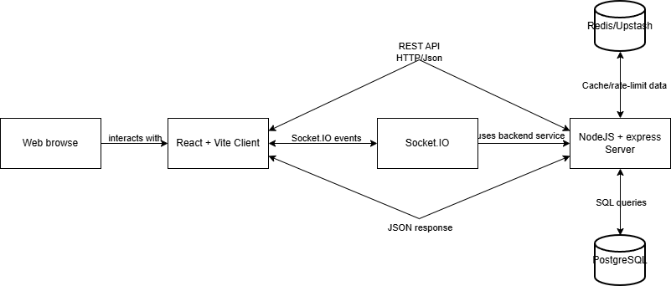
[Figure 3.1: Client–Server Architecture Overvie]
The backend exposes a RESTful API following standard HTTP semantics:
- Resource-based URLs: e.g., `/api/exercises`, `/api/workout-plans/:id`.
- Standard HTTP methods: `GET` for retrieval, `POST` for creation, `PATCH` for partial updates, `DELETE` for removal.
- Consistent response format: All responses follow a standardized JSON envelope: `{ "success": true/false, "data": {...}, "message": "..." }`.
- Pagination: List endpoints return paginated results with `items`, `page`, `limit`, `total`, and `totalPages` fields.
- Error format: Errors include machine-readable `code`, human-readable `message`, and optional `details` for validation errors.
The separation of concerns between client and server allows independent scaling, testing, and potential replacement of either tier.

3.2 Authentication and Authorization
FiFB implements a custom JWT-based authentication system rather than relying on third-party authentication services:
Key design decisions:
- Access tokens are short-lived JWTs (default 15 minutes) containing the user's `sub` (ID), `role`, and `status` claims. They are stored in-memory on the client and sent via the `Authorization: Bearer` header.
- Refresh tokens are opaque, long-lived tokens (default 30 days) stored as HTTP-only cookies. Their hashes are stored server-side in Redis (or in-memory in development mode).

Token rotation: Each refresh operation invalidates the old refresh token and issues a new pair, mitigating token theft.
- Password hashing: bcrypt with a configurable number of rounds (default 12) is used for password storage.
- Email verification: A 6-digit OTP is sent via SendGrid on registration. Accounts remain in `pending_verification` status until verified.
- Password reset: Time-limited reset tokens are sent via email, and their hashes are stored server-side.
Authorization is enforced at multiple levels:
- Middleware layer: The `authenticate` middleware verifies the JWT and attaches the user's identity to the request. Additional middleware functions enforce role-based (`requireRoles`) and status-based (`requireActiveUser`, `requireVerifiedEmail`) access control.
- Service layer: Business logic validates ownership and permissions (e.g., only the workout plan owner can view or modify their plans).
- Database layer: Foreign key constraints and check constraints enforce data integrity.

3.3 Real-Time Communication with WebSocket
FiFB uses Socket.IO (built on top of the WebSocket protocol) for real-time features:
- Notifications: When the backend creates a database notification (e.g., connection request approved, exercise submission reviewed), it simultaneously emits a `notification:new` event to the recipient's Socket.IO room. The client displays a toast notification and updates the unread badge count.
- Chat: Trainer–user chat supports real-time message delivery (`chat:send` / `chat:receive`), typing indicators (`chat:typing`), and read receipts (`chat:read`). Messages are persisted in the database and can be retrieved via REST API as a fallback.
Socket.IO connections are authenticated using the same JWT access token, verified during the handshake phase. Each connected user joins a personal room (user:{userId}) for targeted event delivery.

3.4 Relational Database Design
PostgreSQL was chosen as the primary database for its robustness, support for complex queries, JSONB data types, and advanced constraint mechanisms.
Key database design principles applied in FiFB:
- Normalization: Exercise taxonomy data (body parts, equipment, muscles) is normalized into separate tables linked via many-to-many junction tables, avoiding data duplication and enabling consistent filtering.
- Soft delete: Critical entities use status fields (`active`/`inactive`/`archived`) or `deleted_at` timestamps instead of hard deletion, preserving data integrity and audit trails.
- UUID primary keys: All tables use `uuid` primary keys generated by `gen_random_uuid()`, providing collision-resistant identifiers suitable for distributed systems.
- Check constraints: Business rules are enforced at the database level (e.g., ratings between 1–5, positive set/rep counts, valid status enums).
- JSONB columns: Used for semi-structured data such as exercise instructions (ordered array of steps), raw imported data, and notification metadata.
- Indexing: Indexes are applied to frequently filtered columns including exercise status, notification read status, connection status, and workout session dates.

3.5 In-Memory Caching and Rate Limiting
Redis is used for two primary purposes in FiFB:
- Response caching: The `cacheResponse` middleware caches GET responses in Redis with a configurable TTL (default 300 seconds). Cache hits are indicated by an `X-Cache: HIT` response header. This reduces database load for frequently accessed, infrequently changing data such as the exercise library and taxonomy lists.
- Distributed rate limiting: Two rate limiters protect the API:
- Auth rate limiter: 20 requests per 15-minute window on authentication endpoints, preventing brute-force attacks.
- API rate limiter: 60 requests per minute on general API endpoints, preventing abuse.
When Redis is available, rate limiting state is stored in Redis via rate-limit-redis, enabling distributed rate limiting across multiple server instances. When Redis is unavailable, rate limiting falls back to in-memory storage.
Additionally, Redis stores:
- Refresh token hashes for session management.
- Password reset token hashes.
- Email verification OTP hashes.
- Workout statistics cache for individual users.
FiFB supports two Redis connection modes: standard TCP Redis (for local development with Docker) and Upstash Redis REST API (for serverless production environments). A unified adapter abstracts the differences.

3.6 Technology and Framework Selection
[Bảng 3.1: Technology Stack Summary]
Layer | Technology | Purpose
Frontend | React | UI component library
 | Vite | Build tool and dev server
 | React Router DOM | Client-side routing
 | Axios | HTTP client
 | Socket.IO Client | Real-time WebSocket communication
 | Tailwind CSS | Utility-first CSS framework
 | Lucide React | Icon library
 | React Hook Form | Form state management
 | Sonner | Toast notifications
Backend | Node.js | JavaScript runtime
 | Express.js | HTTP framework
 | Socket.IO | Real-time server
 | PostgreSQL | Relational database
 | Redis / Upstash | In-memory cache and rate limiting
 | jsonwebtoken | JWT creation and verification
 | bcryptjs | Password hashing
 | Zod | Schema validation
 | Helmet | HTTP security headers
 | Compression | Response compression
 | Morgan | HTTP request logging
 | SendGrid Mail | Transactional email delivery
 | pg (node-postgres) | PostgreSQL driver
DevOps | Docker | Containerization
 | Docker Compose | Multi-container orchestration
 | GitHub Actions | CI pipeline
 | Render | Cloud deployment platform
 | ESLint | Code linting
 | Prettier | Code formatting
 | Jest | Unit testing
 | Supertest | HTTP integration testing
 | Nodemon | Development auto-restart

Rationale for key choices:
- React + Vite was chosen for the frontend due to React's mature ecosystem, component reusability, and Vite's superior hot module replacement performance compared to Webpack.
- Express.js was selected for its minimalist, un-opinionated design, allowing full control over middleware composition and request handling.
- PostgreSQL was preferred over NoSQL alternatives because the domain model is inherently relational (many-to-many exercise–taxonomy mappings, user–trainer connections, referential integrity requirements).
- Zod was chosen for runtime schema validation on the backend because it provides type-safe schema definitions with excellent error messages, replacing the need for manual validation logic.
- Socket.IO was selected over plain WebSocket for its automatic reconnection, room management, and fallback to HTTP long-polling, which simplifies the real-time implementation.

Chapter 4 – FiFB Product

4.1 Functional Requirements
The system supports three primary actors (User, Trainer, Admin) and one secondary actor (Guest). Requirements are organized by actor.
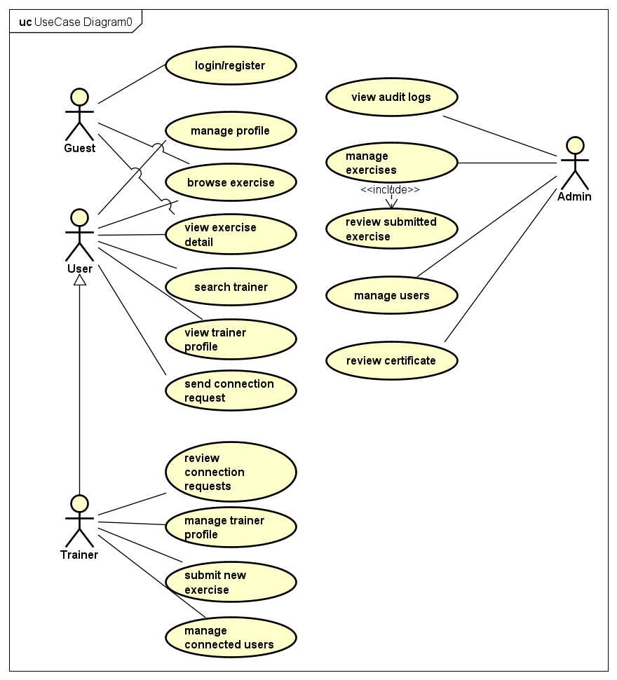

[Figure 4.1: Use Case Diagram]
[Bảng 4.1: Functional Requirements by Actor]
Guest
ID | Requirement | Description
G-01 | Browse exercises | View active exercises with GIF, instructions, and taxonomy.
G-02 | Filter exercises | Filter by body part, equipment, target muscle, secondary muscle, and keyword.
G-03 | View exercise detail | View full exercise detail including all taxonomy associations.
G-04 | Browse trainers | View active trainer profiles with specialization and verification status.
G-05 | View trainer detail | View trainer profile, average rating, and reviews.
G-06 | Register account | Register as User or Trainer with email verification.
G-07 | Login / Logout | Authenticate with email and password; obtain JWT tokens.
G-08 | Password recovery | Request password reset via email; reset with token.

User (Authenticated, role = `user` or `trainer`)
ID | Requirement | Description
U-01 | Manage profile | View and update personal profile fields.
U-02 | Manage favorites | Add and remove favorite exercises.
U-03 | Manage workout plans | Create, view, update, and archive workout plans with ordered exercise items.
U-04 | Log workout sessions | Start workout sessions, log set/rep/weight data, and complete sessions.
U-05 | View workout statistics | View total sessions, weekly volume, streaks, and top exercises.
U-06 | View exercise progression | View historical weight/rep trends for a specific exercise.
U-07 | Send connection request | Request connection to a trainer with optional goal snapshot and message.
U-08 | Cancel connection request | Cancel a pending outgoing connection request.
U-09 | View connections | View current and historical trainer connections.
U-10 | Review trainer | Submit a rating (1–5) and comment for a connected trainer.
U-11 | Chat with trainer | Send and receive real-time messages within an active connection.
U-12 | View notifications | View, mark as read, and mark all notifications as read.

Trainer (Authenticated, role = `trainer`)
ID | Requirement | Description
T-01 | Manage trainer profile | Create/update bio, specialization, and years of experience.
T-02 | Submit certificates | Upload certification metadata for admin verification.
T-03 | View certificate status | Track the verification status of submitted certificates.
T-04 | Handle connection requests | View, approve, or reject incoming connection requests.
T-05 | Submit exercises | Submit new exercises for admin review (status = `pending`).
T-06 | View reviews | View ratings and comments from connected users.

Admin (Authenticated, role = `admin`)
ID | Requirement | Description
A-01 | Manage users | List, filter, and change user status (active, locked, disabled).
A-02 | Moderate exercises | List all exercises; approve, reject, or deactivate submissions.
A-03 | Moderate certificates | List, approve, or reject trainer certificates.
A-04 | CRUD exercises | Create and update exercises directly.
A-05 | Manage taxonomy | Create body parts, equipment, and muscle taxonomy items.
A-06 | View audit logs | Browse audit logs filtered by action, entity type, and actor.
A-07 | View email deliveries | Monitor runtime SMTP delivery attempts.

4.2 Non-Functional Requirements
Category | Requirement
Performance | API response time < 500ms for standard operations; Redis caching for frequently read data with 5-minute default TTL; Gzip/Brotli response compression.
Security | bcrypt password hashing (12 rounds); JWT with separate access/refresh secrets (≥32 chars); HTTP-only refresh cookies; Helmet security headers; CORS origin validation; rate limiting on auth (20/15min) and API (60/min) endpoints.
Data integrity | UUID primary keys; foreign key constraints; check constraints on enums; soft-delete via status fields; audit logging for sensitive operations.
Reliability | Graceful shutdown with connection cleanup; error boundary on frontend; centralized error handling on backend.
Maintainability | ESLint + Prettier enforced in CI; modular backend (controller → service → repository); consistent response format; Zod schema validation.
Deployability | Docker containerization; Docker Compose for local development; Render Blueprint for production; GitHub Actions CI.

4.3 System Architecture
The FiFB system consists of the following components:
Client (React + Vite)
│
├── REST / JWT ──→ Express API Server
│ │
├── Socket.IO ←──→ Socket.IO Realtime Layer
│ │
│ ├──→ PostgreSQL Database
│ ├──→ Redis / Upstash (Cache + Rate Limiting + Sessions)
│ └──→ SendGrid (Email Delivery)
│
└── Static assets served by Vite dev server (development) / CDN (production)
Backend internal architecture follows a layered modular pattern:
Routes (Express Router)
└──→ Controller (request parsing, response formatting)
└──→ Service (business logic, validation, authorization)
└──→ Repository (database queries via node-postgres)
└──→ PostgreSQL
Each business domain is organized as an independent module containing five files:
- `.routes.js` — Express route definitions with middleware composition.
- `.controller.js` — Thin controllers delegating to services.
- `.service.js` — Business logic and validation.
- `.repository.js` — SQL queries and database interaction.
- `.validation.js` — Zod schemas for request validation.
The backend contains 16 modules: auth, users, trainers, trainerCertificates, trainerConnections, exercises, exerciseTaxonomy, favorites, workoutPlans, workoutSessions, reviews, notifications, chat, admin, audit, and emailDeliveries.

4.4 Database Design
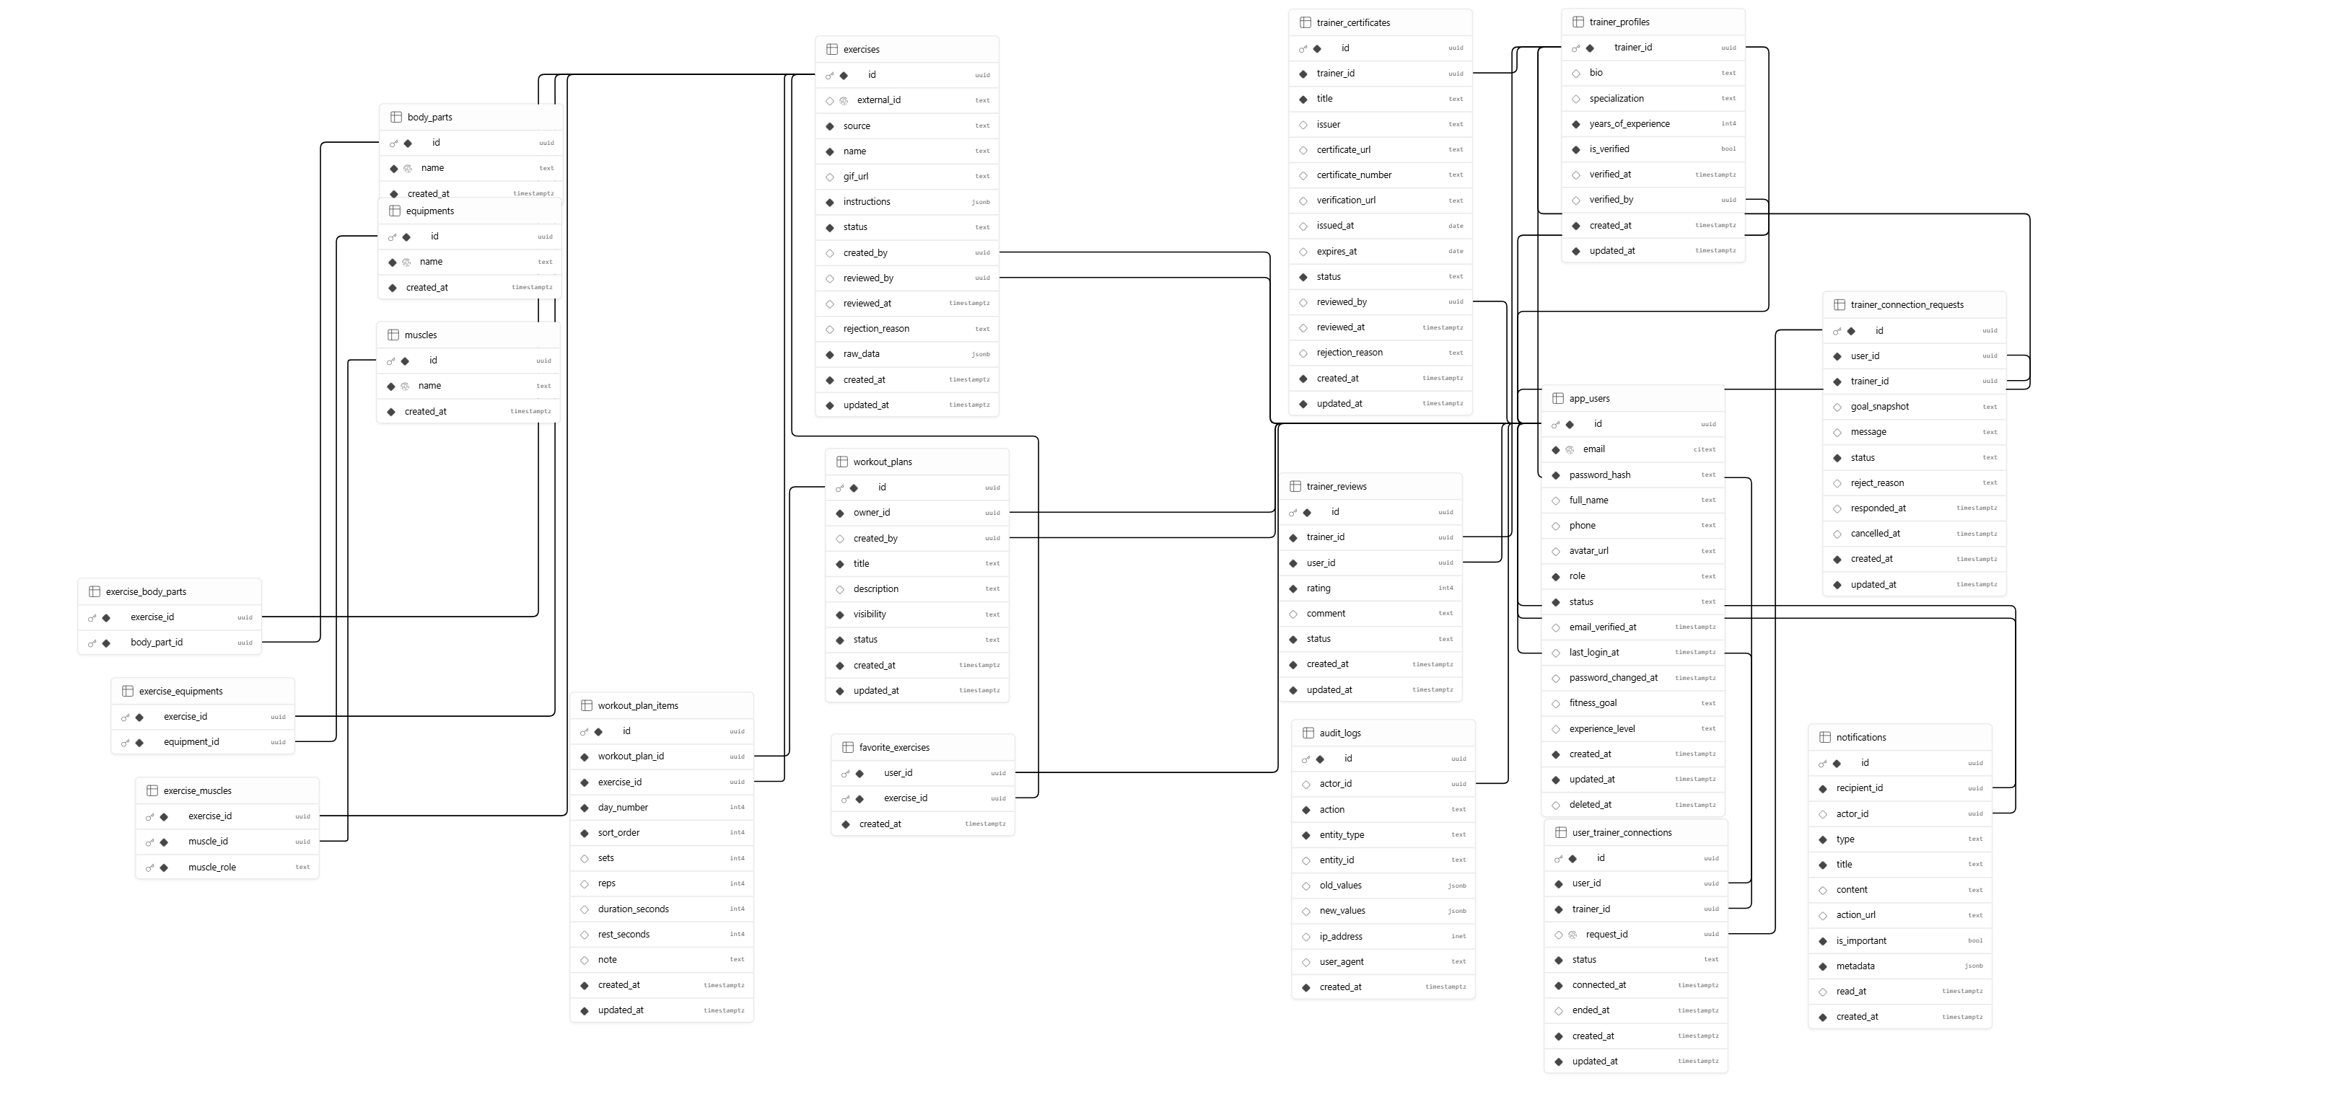

[Figure 4.3: Entity–Relationship Diagram]
The database consists of 19 tables across six logical groups:
Group 1: Users and Authentication
Table | Description
`app_users` | Core user table with email, password hash, role (user/trainer/admin), status (active/locked/disabled/pending_verification), fitness goal, and experience level. Supports soft delete via `deleted_at`.

Group 2: Trainer System
Table | Description
`trainer_profiles` | 1:1 extension of `app_users` for trainers. Contains bio, specialization, years of experience, and verification status.
`trainer_certificates` | Trainer-submitted certifications with status (pending/approved/rejected), reviewer, and rejection reason.
`trainer_reviews` | User ratings and comments for trainers (1–5 scale). Status can be `visible` or `hidden`.

Group 3: User–Trainer Connections
Table | Description
`trainer_connection_requests` | Connection requests with status workflow: pending → approved/rejected/cancelled. Includes goal snapshot and message.
`user_trainer_connections` | Formal established connections with status (active/ended), linked to the originating request.

Group 4: Exercise Library
Table | Description
`exercises` | Core exercise table with name, GIF URL, instructions (JSONB array), source (exercisedb_v1/admin/trainer_submission), status (pending/active/inactive/rejected), and raw imported data.
`body_parts` | Taxonomy: body parts (e.g., chest, back, legs).
`equipments` | Taxonomy: equipment types (e.g., barbell, dumbbell, cable).
`muscles` | Taxonomy: muscle groups (e.g., pectorals, biceps, quadriceps).
`exercise_body_parts` | Many-to-many: exercises ↔ body parts.
`exercise_equipments` | Many-to-many: exercises ↔ equipment.
`exercise_muscles` | Many-to-many with role: exercises ↔ muscles (target or secondary).

Group 5: Workout and Tracking
Table | Description
`favorite_exercises` | User-exercise favorites with composite primary key.
`workout_plans` | User-created plans with title, description, visibility, and status.
`workout_plan_items` | Ordered exercises within plans with day number, sort order, sets, reps, duration, rest, and notes.
`workout_sessions` | Workout occurrences with timestamps and optional plan linkage.
`session_exercise_logs` | Actual workout data: set number, reps, weight (kg), duration, and notes per exercise per session.

Group 6: System
Table | Description
`notifications` | In-app notifications with recipient, actor, type, title, content, importance flag, and read status.
`audit_logs` | Audit trail for sensitive operations with actor, action, entity type/ID, old/new values (JSONB), IP address, and user agent.
`chat_messages` | Persistent chat messages tied to connections, with sender, content, type (text/image/system), and read status.

4.5 Backend Implementation

4.5.1 API Endpoints
The backend exposes approximately 50+ API endpoints organized by resource:
[Bảng 4.3: API Endpoints Summary]
Resource | Endpoints | Description
Auth | 8 endpoints | Register, verify email, login, refresh, logout, get current user, change password, request/execute password reset.
Users | 4 endpoints | Get/update own profile; admin: list users, get user, change user status.
Trainers | 7 endpoints | List/get trainers (public); manage trainer profile, certificates, incoming requests, connections, and exercise submissions.
Trainer Connections | 6 endpoints | Send/list/cancel requests; approve/reject (trainer); list connections.
Exercises | 7 endpoints | List/get active exercises (public); admin: CRUD, review, deactivate exercises.
Exercise Taxonomy | 6 endpoints | List body parts, equipment, muscles (public); admin: create taxonomy items.
Favorites | 3 endpoints | List, add, remove favorite exercises.
Workout Plans | 5 endpoints | CRUD workout plans with items.
Workout Sessions | 7 endpoints | Create, list, detail, update sessions; add logs; stats; exercise progression.
Chat | 4 endpoints | Get unread count; list/send messages per connection; mark as read.
Notifications | 3 endpoints | List notifications; mark one/all as read.
Admin | 7 endpoints | User management, certificate review, exercise review/deactivation, audit logs, email deliveries.
Health | 1 endpoint | Health check returning `{ status: "ok" }`.

4.5.2 Middleware Pipeline
Each request passes through the following middleware pipeline:
- Request ID (`requestId`): Assigns a unique identifier to each request for tracing.
- Helmet: Sets security-related HTTP headers (CSP, HSTS, etc.).
- Compression: Applies gzip/deflate response compression.
- CORS: Validates request origin against configured allowed origins.
- JSON Parser: Parses request bodies with a 1MB limit.
- Morgan Logger: Logs HTTP requests including method, URL, status, response time, and request ID.
- API Rate Limiter: Enforces global API rate limits (60 req/min).
- Route-specific middleware: Authentication, role checks, Zod validation, and cache middleware applied per route.
- Not Found Handler: Returns 404 for unmatched routes.
- Error Handler: Catches all errors and returns standardized error responses.

4.5.3 Data Import
FiFB includes a data import script (import-exercisedb.js) that can fetch exercise data from the ExerciseDB API and import it into the database. The script:
- Paginates through the API response.
- Upserts exercises by external ID (insert or update on conflict).
- Automatically creates taxonomy entries (body parts, equipment, muscles) during import.
- Supports dry-run mode for testing.
- Uses configurable delay between API calls to avoid rate limiting.

4.5.4 Workout Statistics and Progression
The workout tracking system provides computed statistics:
- Total sessions: Count of all completed workout sessions.
- Weekly sessions: Sessions completed in the current week.
- Total volume: Cumulative weight × reps across all logs.
- Streak calculation: Current and longest consecutive workout day streaks, computed from session dates.
- Weekly volume chart data: Aggregated volume per week.
- Top exercises: Most frequently performed exercises.
- Exercise progression: Historical weight/rep data per exercise over time, including personal records.
Statistics are cached in Redis with a 30-minute TTL and invalidated when new sessions or logs are created.

4.6 Frontend Implementation

4.6.1 Application Structure
The React frontend is organized as follows:
client/src/
├── api/ # API client modules (httpClient, authApi, exerciseApi, etc.)
├── components/ # Shared reusable components (13 components)
├── contexts/ # React Contexts (AuthContext, SocketContext)
├── hooks/ # Custom hooks (useAsync, useNotifications)
├── layouts/ # Page layouts (AppShell, AuthLayout, PublicLayout, etc.)
├── pages/ # Page components organized by role
│ ├── admin/ # 6 admin pages
│ ├── auth/ # 5 auth pages
│ ├── trainer/ # 6 trainer pages
│ └── user/ # 13 user pages
├── routes/ # Route definitions (AppRoutes, ProtectedRoute, RoleRoute)
├── styles/ # Global CSS (Tailwind)
└── utils/ # Utility functions

4.6.2 Routing and Access Control
The frontend implements a hierarchical routing system using React Router v6:
- Auth Layout: Login, Register, Forgot Password, Reset Password, Verify Email.
- Public Layout: Exercise Library, Exercise Detail, Trainer Listing, Trainer Detail (accessible to all visitors).
- Protected Route (requires authentication):
- User Layout (role = `user` or `trainer`): Profile, Favorites, Workout Plans, Workout Sessions, Connections, Chat, Notifications.
- Trainer Layout (role = `trainer`): Dashboard, Profile, Requests, Certificates, Exercise Submission, Reviews.
- Admin Layout (role = `admin`): Dashboard, Users, Exercises, Certificates, Audit Logs, Email Deliveries.
Route protection is enforced by ProtectedRoute (redirects unauthenticated users to login) and RoleRoute (redirects unauthorized users to their role-appropriate home page).
All page components are lazy-loaded using React.lazy() and Suspense for code splitting and improved initial load performance.

4.6.3 HTTP Client and Token Management
The frontend HTTP client (httpClient.js) is built on Axios with the following features:
- Automatic token injection: Access tokens are attached to non-public requests via an Axios request interceptor.
- Transparent token refresh: When a 401 response is received, the client automatically attempts to refresh the access token using the refresh cookie. If successful, the original request is retried. A deduplication mechanism ensures only one concurrent refresh request is made.
- Graceful session expiry: If token refresh fails, all tokens are cleared and the user is redirected to the login page.
- Error normalization: API errors are normalized into a consistent format with `code`, `message`, `details`, and `status` fields.
- Public route detection: GET requests to public endpoints (exercises, taxonomy, trainers) are sent without authentication headers.

4.6.4 State Management
FiFB uses React Context API for global state management:
- AuthContext: Manages the authenticated user state, provides `login`, `logout`, `refreshCurrentUser`, and role-checking utilities. Performs automatic session bootstrapping on application load via token refresh.
- SocketContext: Manages the Socket.IO connection lifecycle, tracks connection status and unread notification count, handles real-time notification events with toast display, and provides a badge pulse animation.
Component-level state management uses React hooks (useState, useEffect, useCallback, useMemo) and a custom useAsync hook for managing loading, error, and data states of asynchronous operations.

4.6.5 Shared Components
The frontend includes 13 reusable shared components:
Component | Purpose
`ChatWindow` | Real-time chat interface with message display, input, and typing indicators.
`ConfirmDialog` | Modal confirmation dialog for destructive actions.
`DataTable` | Generic data table with sortable columns.
`EmptyState` | Placeholder displayed when no data is available.
`ErrorBoundary` | Catches and displays React component errors.
`ErrorState` | Standardized error display with retry option.
`FormField` | Reusable form field wrapper with label and validation message.
`LoadingState` | Loading spinner/skeleton display.
`NotificationBadge` | Unread notification count badge with pulse animation.
`PageHeader` | Consistent page header with title and optional actions.
`Pagination` | Page navigation controls.
`StatusBadge` | Colored status indicator badge.
`ToastBridge` | Integration bridge for the Sonner toast notification library.

4.7 Real-Time Features

4.7.1 Socket.IO Architecture
The Socket.IO server is initialized alongside the HTTP server and shares the same port. Authentication is performed during the WebSocket handshake by verifying the JWT access token. Each authenticated client is automatically joined to a personal room (user:{userId}).
[Bảng 4.4: Socket.IO Events]
Event | Direction | Description
`notification:new` | Server → Client | New notification push with title and content.
`notification:count` | Server → Client | Updated unread notification count.
`chat:join` | Client → Server | Join a chat room for a specific connection.
`chat:send` | Client → Server | Send a chat message.
`chat:receive` | Server → Client | Receive a new chat message.
`chat:typing` | Bidirectional | Typing indicator toggle.
`chat:read` | Client → Server | Mark messages as read in a connection.

4.7.2 Chat Implementation
The chat system operates in a dual-mode architecture:
- Real-time path: Socket.IO handles live message delivery, typing indicators, and read receipts.
- REST fallback: All chat messages are persisted in the `chat_messages` database table and can be retrieved via REST API endpoints (`GET /api/chat/:connectionId/messages`, `POST /api/chat/:connectionId/messages`).
Access control ensures that only participants of an active user_trainer_connections entry can access the corresponding chat channel.

4.8 DevOps and Deployment

4.8.1 Docker Containerization
The project includes Docker support at two levels:
- Server Dockerfile: Multi-stage build using `node:22-alpine` that separates dependency installation from application code, producing a lean production image.
- Docker Compose: Orchestrates three services:
- `api`: The Express backend with source code mounted for development.
- `client`: The Vite frontend development server.
- `redis`: Redis 7 Alpine for caching and rate limiting.

4.8.2 CI/CD Pipeline
[Hình 4.7: CI/CD Pipeline Overview]
GitHub Actions CI pipeline (.github/workflows/ci.yml) runs on:
- Push to `main`, `develop`, and `feature/**` branches.
- Pull requests to `main` and `develop`.
Pipeline stages:
- Server job: Install dependencies → ESLint → Jest tests.
- Client job: Install dependencies → ESLint → Vite production build.
- Notify job: Send CI results to Telegram (optional, requires configured secrets).
Both jobs use Node.js 22 with npm caching for faster builds.

4.8.3 Render Deployment
The Render Blueprint (render.yaml) configures:
- A web service (`fifb-api`) running the Docker container.
- Singapore region deployment.
- Health check on `/api/health`.
- Auto-deploy after CI checks pass.
- Environment variables for database, JWT secrets, CORS, SendGrid, and Upstash Redis.
- Production security settings (`AUTH_DEBUG_LOGIN=false`).

Chapter 5 – Results and Evaluation

5.1 Completion Status
[Bảng 5.1: Feature Completion Status]
Feature Category | Status | Notes
Authentication (register, login, verify email, password reset) | Completed | JWT + refresh token rotation, email OTP verification via SendGrid.
User profile management | Completed | View and update personal profile fields.
Exercise library with taxonomy | Completed | Full CRUD with many-to-many taxonomy, ExerciseDB import script.
Exercise filtering (body part, muscle, equipment, keyword) | Completed | Multi-filter support with pagination.
Favorite exercises | Completed | Add/remove/list with duplicate prevention.
Workout plans (CRUD with items) | Completed | Multi-day plans with ordered exercises, sets, reps, rest.
Workout session tracking | Completed | Session create/update, set/rep/weight logs, completion.
Workout statistics and streaks | Completed | Total sessions, weekly volume, streaks, top exercises, cached in Redis.
Exercise progression tracking | Completed | Historical weight/rep data with personal records.
Trainer profiles and verification | Completed | Profile management, certificate submission, admin verification.
User–Trainer connection workflow | Completed | Request/cancel/approve/reject with status tracking.
Trainer reviews | Completed | Rating (1–5) and comments, connection validation.
Real-time notifications | Completed | Socket.IO push, unread badge, database persistence.
Trainer–User chat | Completed | Socket.IO real-time + REST fallback, typing indicators, read receipts.
Admin panel | Completed | User management, exercise/certificate moderation, audit logs, email deliveries.
Role-based access control | Completed | Middleware-level enforcement for User, Trainer, Admin roles.
Redis caching and rate limiting | Completed | Response cache, auth/API rate limiters, Upstash support.
Docker containerization | Completed | Dockerfile + Docker Compose with api, client, and Redis services.
CI/CD pipeline | Completed | GitHub Actions: lint + test (server), lint + build (client), Telegram notification.
Render deployment config | Completed | Render Blueprint with environment variables and health check.
Unit tests | Completed | 9 test files covering services, repositories, schemas, and app setup.

5.2 Demonstration and Outputs
The following screenshots demonstrate the implemented functionality:
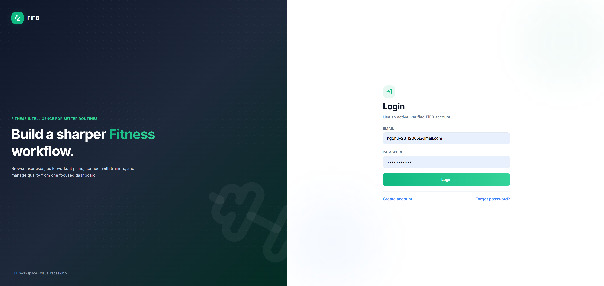
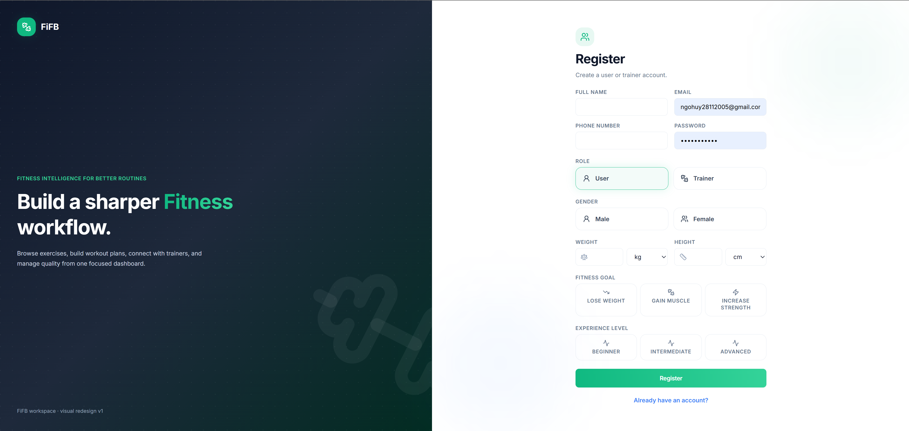
[Hình 5.1: Login and Registration Screens]
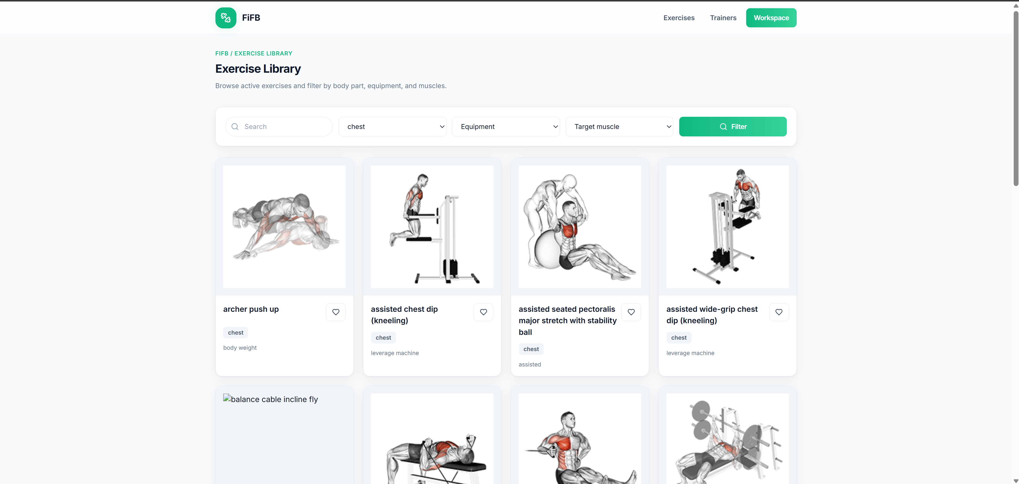
[Hình 5.2: Exercise Library with Filters]
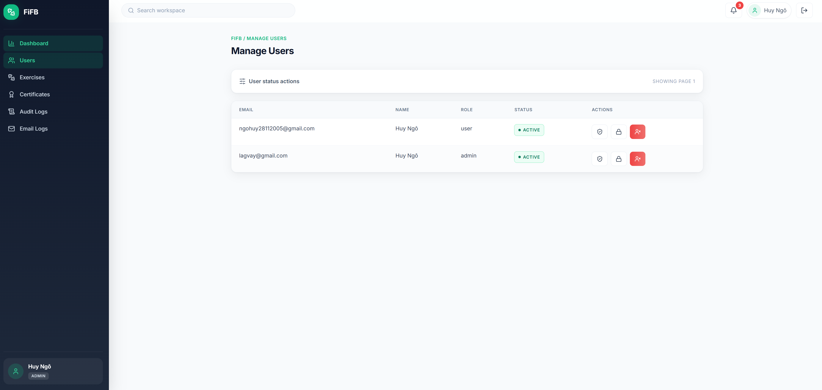
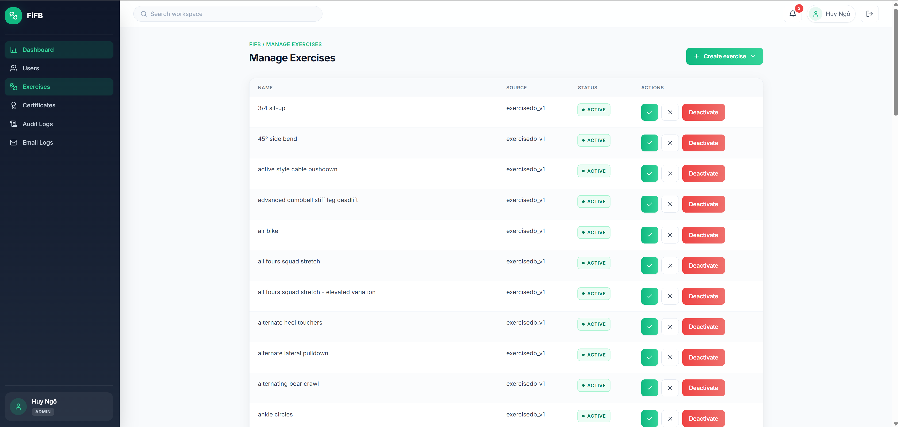
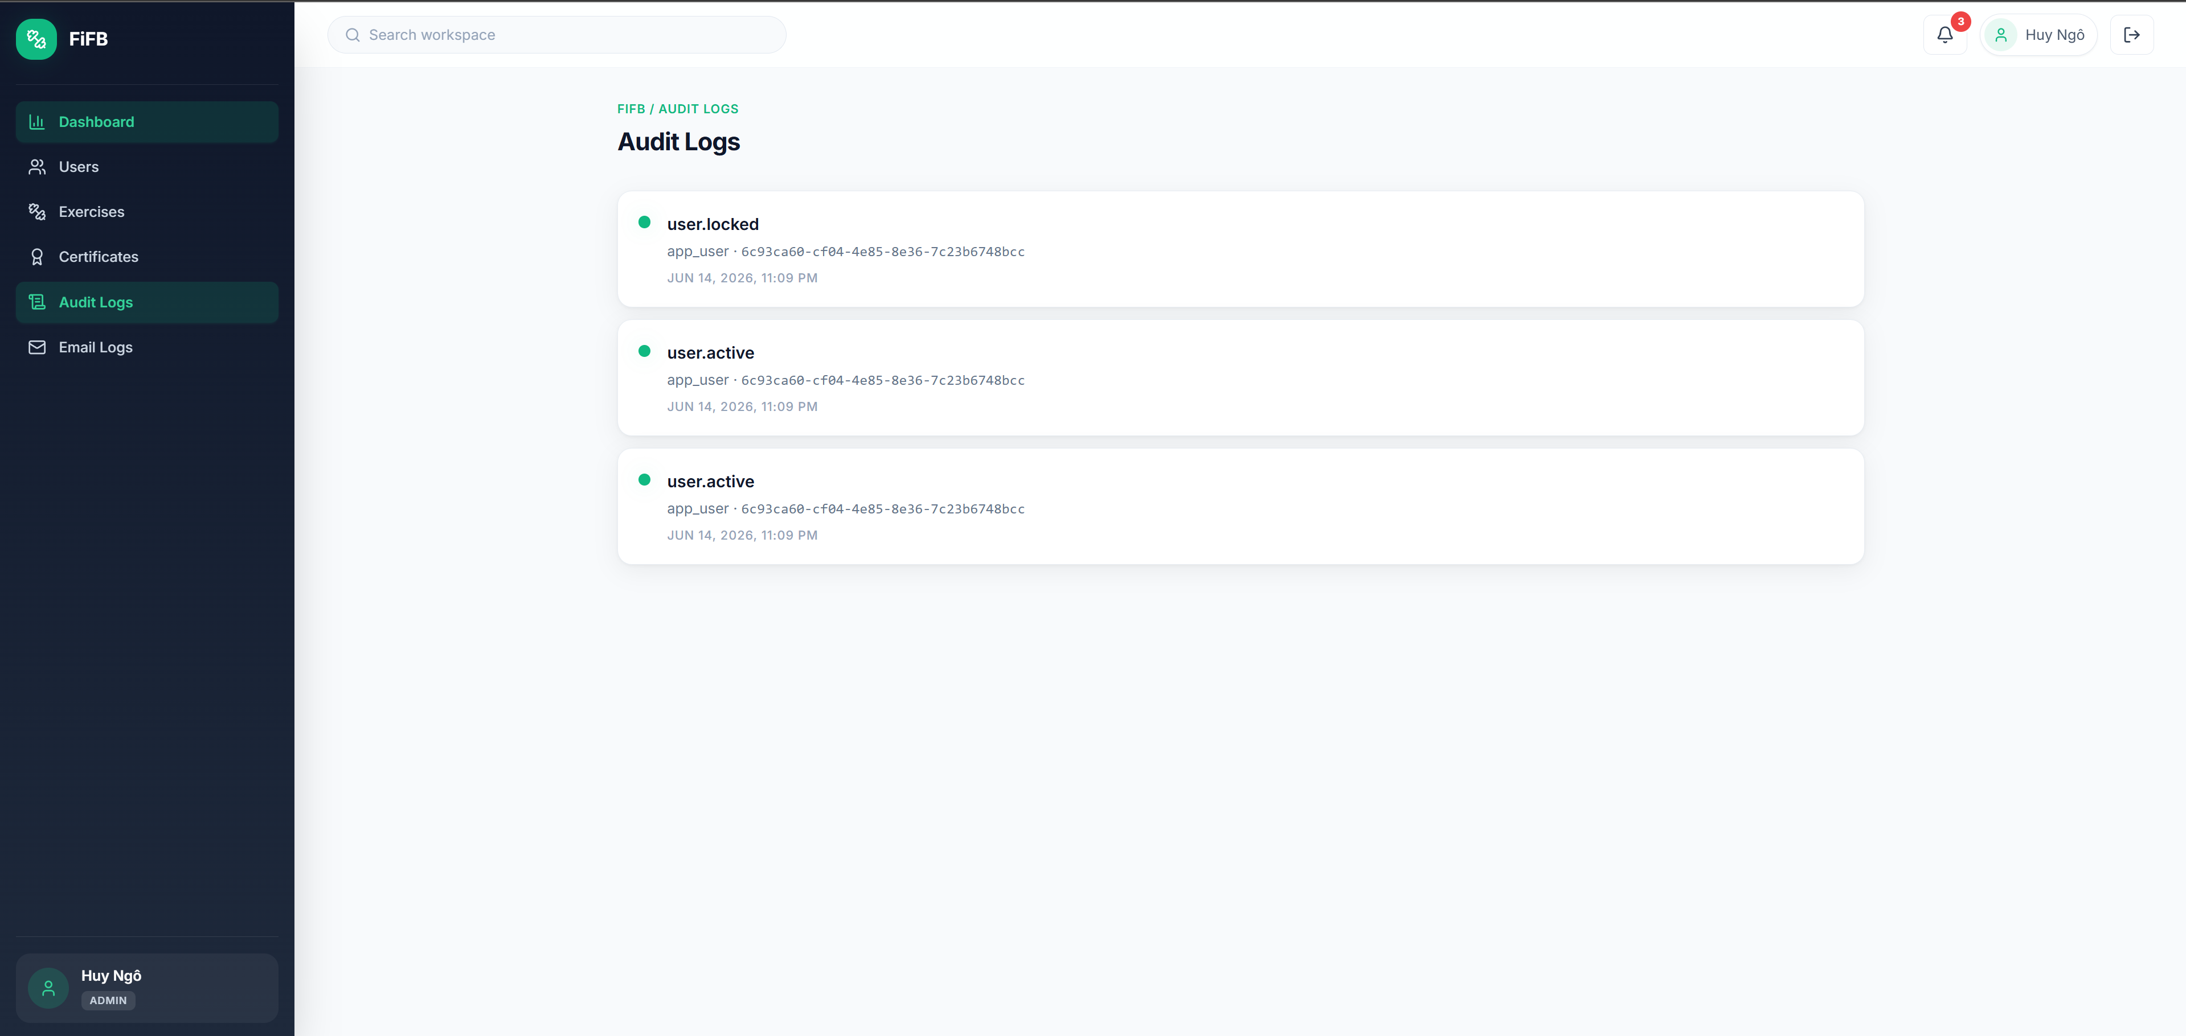
[Hình 5.3: Admin Dashboard — showing the admin panel with user management, exercise moderation, and audit logs]

5.3 Functional Evaluation

5.3.1 Authentication and Security
- All auth flows (register, verify, login, refresh, logout, password change, password reset) function correctly.
- JWT tokens are properly signed and verified with separate access and refresh secrets.
- Refresh token rotation invalidates old tokens on each refresh.
- Rate limiting successfully blocks excessive auth attempts (verified with manual testing).
- CORS properly restricts cross-origin requests to configured origins.

5.3.2 Exercise Library
- Exercise data can be imported from the ExerciseDB API using the provided import script.
- Taxonomy filtering works correctly across all three dimensions (body part, equipment, muscle).
- Keyword search operates across exercise names.
- Admin CRUD and trainer submission/review workflows function as designed.

5.3.3 Workout Tracking
- Workout sessions can be created, logged with set/rep/weight data, and completed.
- Statistics (total sessions, volume, streaks) are computed correctly and cached in Redis.
- Exercise progression shows historical data trends.

5.3.4 Trainer Ecosystem
- Connection request workflow (send → approve/reject/cancel) operates correctly.
- Only users with approved connections can review trainers.
- Chat messages are persisted and delivered in real-time via Socket.IO.

5.3.5 Code Quality
- ESLint passes with zero errors on both server and client.
- Prettier formatting is consistent across the codebase.
- 9 test files provide coverage for critical services, repositories, and schemas.
- CI pipeline validates all quality checks on every push and pull request.

5.4 Limitations
Despite the comprehensive MVP implementation, the following limitations are acknowledged:
- No AI features: The system does not yet include AI-powered chatbot, exercise recommendation, or posture analysis capabilities. These are planned for GR2 and the thesis.
- Limited test coverage: While 9 test files exist, they do not achieve comprehensive coverage of all modules and edge cases. Integration tests and end-to-end tests are not yet implemented.
- No file upload support: Certificate documents and avatar images reference URLs only; the system does not implement file upload or storage (e.g., Supabase Storage or S3).
- No mobile responsiveness validation: While Tailwind CSS provides responsive utilities, systematic mobile responsiveness testing has not been performed.
- No load/stress testing: Performance under concurrent user load has not been systematically evaluated.
- Single-region deployment: The Render deployment targets a single region (Singapore), which may introduce latency for geographically distributed users.
- No internationalization (i18n): The interface is English-only; Vietnamese language support is not yet implemented.
- In-memory fallback for Redis: When Redis is unavailable, session tokens and rate limiting fall back to in-memory storage, which does not persist across server restarts and does not scale across multiple instances.

5.5 Development Plan for GR2
Based on the limitations identified and the project roadmap, the following enhancements are planned for GR2:
Feature | Description
AI Service | Deploy a Flask/FastAPI microservice for AI-powered chat assistance, providing exercise guidance and form tips.
Exercise Recommendation | Implement a recommendation engine based on user workout history, fitness goals, and exercise taxonomy.
Equipment Recognition | Use image classification to identify gym equipment from user-uploaded photos.
File Upload Integration | Integrate Supabase Storage or AWS S3 for certificate documents, avatar images, and exercise media.
Comprehensive Testing | Expand unit test coverage; add integration tests and end-to-end tests using Playwright or Cypress.
Mobile Responsiveness | Systematic responsive design testing and optimization.
Performance Optimization | Load testing, query optimization, and connection pooling improvements.
Internationalization | Add Vietnamese language support using i18n framework.

References
- Express.js Documentation. (n.d.). Retrieved from https://expressjs.com/
- React Documentation. (n.d.). Retrieved from https://react.dev/
- PostgreSQL Documentation. (n.d.). Retrieved from https://www.postgresql.org/docs/
- Redis Documentation. (n.d.). Retrieved from https://redis.io/docs/
- Socket.IO Documentation. (n.d.). Retrieved from https://socket.io/docs/
- Vite Documentation. (n.d.). Retrieved from https://vitejs.dev/
- Tailwind CSS Documentation. (n.d.). Retrieved from https://tailwindcss.com/docs
- JSON Web Tokens (JWT) - RFC 7519. (2015). Retrieved from https://datatracker.ietf.org/doc/html/rfc7519
- ExerciseDB API. (n.d.). Retrieved from https://exercisedb.io/
- Zod Documentation. (n.d.). Retrieved from https://zod.dev/
- Docker Documentation. (n.d.). Retrieved from https://docs.docker.com/
- GitHub Actions Documentation. (n.d.). Retrieved from https://docs.github.com/en/actions
- Render Documentation. (n.d.). Retrieved from https://render.com/docs
- SendGrid Documentation. (n.d.). Retrieved from https://docs.sendgrid.com/
- Axios Documentation. (n.d.). Retrieved from https://axios-http.com/docs/intro
- React Router Documentation. (n.d.). Retrieved from https://reactrouter.com/
[Additional academic references (journal papers, conference papers, books) related to fitness technology, web application architecture, and software engineering should be added to strengthen the academic rigor of the report.]

Appendices
Appendix A: API Endpoint Reference
The complete API specification is documented in Document/API.md within the project repository. It includes:
- Full endpoint URLs with HTTP methods.
- Required roles and permissions.
- Request body schemas (JSON).
- Response formats with pagination.
Appendix B: Database Schema
The complete SQL schema (including V2 extensions) is available in:
- `Document/DatabaseSQL.txt` — Base schema.
Appendix C: Environment Configuration
The server configuration is managed via environment variables validated by Zod schemas. The full list of environment variables with their types, defaults, and descriptions is available in:
- `server/.env.example`
- `server/src/config/env.js`
Appendix D: Project Repository Structure
Graduation-Research-UniFit/
├── .github/workflows/ci.yml # GitHub Actions CI pipeline
├── Document/ # Project documentation
│ ├── API.md # Full API specification
│ ├── DatabaseSQL.txt # Base database schema
│ ├── DatabaseSQL-v2.txt # V2 schema additions
│ ├── Problem Statement.txt # Original problem statement
│ ├── Diagram/ # Use case diagram
│ └── ...
├── SystemDesign/ # Astah design files
├── Tools/ # Utility scripts
├── client/ # React frontend
│ ├── src/
│ │ ├── api/ # 12 API client modules
│ │ ├── components/ # 13 shared components
│ │ ├── contexts/ # 2 React contexts
│ │ ├── hooks/ # 2 custom hooks
│ │ ├── layouts/ # 6 layout components
│ │ ├── pages/ # 30 page components
│ │ ├── routes/ # 3 routing components
│ │ ├── styles/ # Global CSS
│ │ └── utils/ # Utilities
│ ├── package.json
│ └── vite.config.js
├── server/ # Express.js backend
│ ├── src/
│ │ ├── config/ # Environment configuration
│ │ ├── db/ # PostgreSQL connection pool
│ │ ├── middlewares/ # 7 middleware modules
│ │ ├── modules/ # 16 business modules
│ │ ├── redis/ # Redis client adapter
│ │ ├── routes/ # Route aggregation
│ │ ├── socket/ # Socket.IO setup and handlers
│ │ ├── utils/ # Errors, logging, responses, tokens
│ │ ├── app.js # Express app factory
│ │ └── server.js # HTTP server entry point
│ ├── scripts/ # Migration and import scripts
│ ├── tests/ # 9 test files
│ ├── Dockerfile
│ └── package.json
├── docker-compose.yml # Multi-service orchestration
├── render.yaml # Render deployment blueprint
└── README.md # Project overview

